License Plate Recognition of Vehicle on Roads by Camera

(ANPR) called,

**God’s Eye**

**A**

**Project Report**

**Submitted by**

***KEVAL* DHOLAKIYA *& VAITUL BHAYANI***

**FOR FULFILLMENT OF SIXTH SEMESTER IN**

**BACHELOR OF COMPUTER APPLICATION**



**Department of Computer Science & I.T.**

SHREE H.N.SHUKLA

GROUP OF COLLEGES

Our Profile

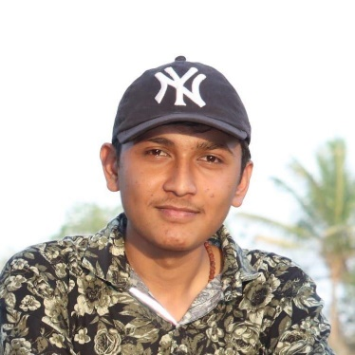

Name: Keval Dholakiya

Stream: BCA 6

Mobile: +91 7096 823 708

Email: kevald47@gmail.com

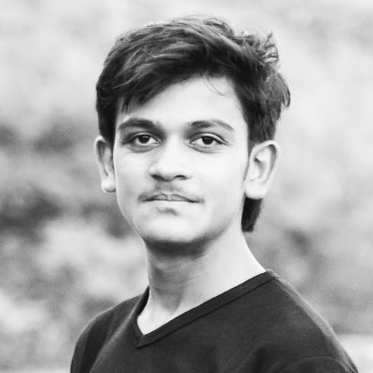

Name: Vaitul Bhayani

Stream: BCA 6

Mobile: +91 9904021519

Email: vaitul@gmail.com

Preface

Theory of any subject is important but without its practice it useless particularly for the computer student. A computer student cannot become perfect man of technologist without practical understanding of branch.

We can also say, “Experience is the best teacher” so our project is one Kind of Experience, the part of our life. Through the project we have learnt Good, Real, and Practical application.

The project training in the B.C.A of the course gives us the exposure to real world. The aim of the project training, by understanding a project, is to have practical experience of the real world. It also clears the picture of practical field to prompt the student to develop their qualities talents, etc. So that we can expand our view about the implication of the theoretical Knowledge in the practical field, we had the opportunity for the same at various field.

Acknowledgement

The present of this report gives us the feeling of the final frontier toward achieving the BCA Degree; the activity of going through industrials orientation has bridged the gap between the academics and practical real-life work for us.

It has prepared us to apply ourselves to become good IT professional. Naturally, it requires lot of people support to complete this project. We take this opportunity to acknowledge their support to us.

In the acknowledge, hear first of all we would like to thanks our College Shree H.N Shukla that they gave such Good opportunity for develop a project which would evaluate. We Thanks to our friends to give support for a development of this project.

We would also like to thanks all those people who made this project directly or indirectly possible.

*Thank You*

Keval & Vaitul

Index

|  |  |  |  |  |
| --- | --- | --- | --- | --- |
| **No.** | **Title** | | **Page No.** | |
|  | | Introduction of Project | | 05 | |
|  | | Project Profile | | 08 | |
|  | | Data Dictionary | | 09 | |
|  | | Data Flow Diagram | | 11 | |
|  | | Use Case Diagram | | 13 | |
|  | | E-R Diagram | | 14 | |
|  | | System Design | | 15 | |
|  | | Testing | | 20 | |
|  | | Conclusion | | 21 | |
|  | | Bibliography | | 22 | |

Introduction of Project

We Created Project Named “*God’s Eye*”, Here We Provide A Complete Solution for ANPR (Automatic Number Plate Recognition)

Our Main Goal is to automated working of to identify vehicles by cameras with help of today’s Power of processors and era of AI

Here is How It Works,

* We need some source of videos/image/camera
* Then those data processed by our software
* Our software detects the car and inside the car it finds the number plate and it recognize that plate and gives us license number
* We send the number to the government website to identify owner and it’s details
* Government website gives all data as response and we store that data into html file so we can see output with proper format by browser

SDLC

* Requirement Gathering:

For Requirement Gathering We see the problem of identify vehicle’s owner name by CCTV/Traffic camera but it’s very lengthy process like first we see the number of vehicle and note down license plate number one by one and search on government website/app so it’s very time consuming so we decide to make an application/software that makes that work autonomous without any interaction of human kind and its store the vehicle all details including photo in storage.

* Design:

After Analyze Problem We Decide To Design main Modules Of System. Video gathering, detecting plate, OCR and find owner’s Details. We decide to use python because huge library support. We Also Use GitHub for Version Control System and Collaboration Between us.

* Development:

After deciding which technology, we will use. We start developing. After Approx. 1 month, We Developed Project. Now we have to test it.

* Testing:

We tested various footage of roads and streets and we give this software to our Friends to Give Feedback About Project and Inform If Anyone Finds Bug.

* Deployment:

After Analyze Valuable Feedback of Our Friend and We Fix Bugs/Errors and then we Release our software officially.

* Maintenance:

After Releasing, We Continue Maintaining Our software. If Some One Reports Us About Bug or Anything. We try to solve it.

Project Profile

Project Name : God’s Eye

Programming Language : Python

Libraries : OpenCV, NumPy, Tesseract and

YOLO (algorithm)

Database : Directly on hard drive

Documentation Tool : Microsoft Word 2019

Platform : Desktop

Web Browser : Any browser

Source Code / VCS : GitHub

Project Duration : 1 Month

Prepared By : Keval Dholakiya & Vaitul Bhayani

Submitted To : Shree H.N Shukla College

Data Flow Diagram

* 0 Level DFD

File output

Footage source

System Design

* View: Region Selector
* Desc: when we start the software at first time then one user-interface appear for select the area of view which we’re looking for scan/detect like cropping an image from image editors

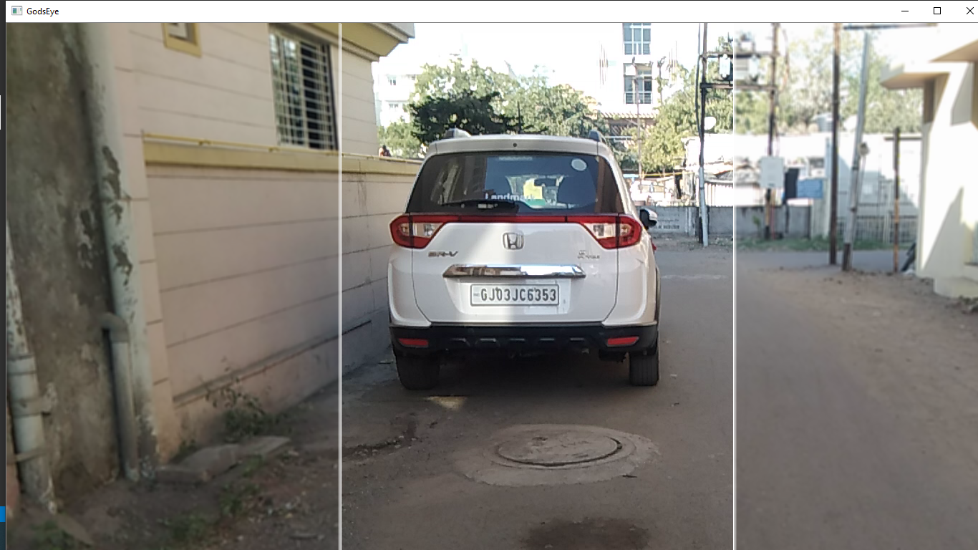

* View: Main Window
* Desc: which is display live video/camera footage and draw rectangle if plate detected

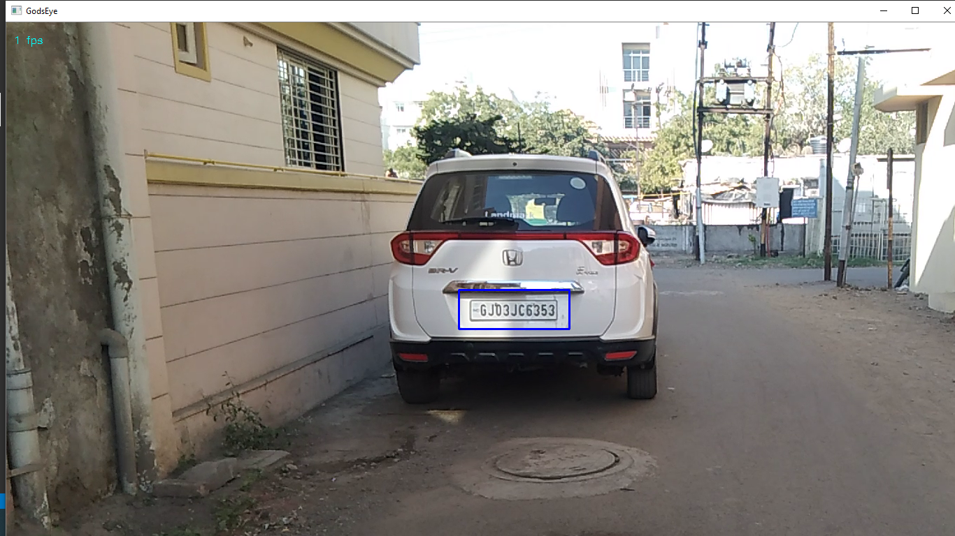

* View: File Explorer
* Desc: God’s Eye software store detected image and owners’ details in hard drive path is <currentdir>/storage/<number>_<datetime>.html

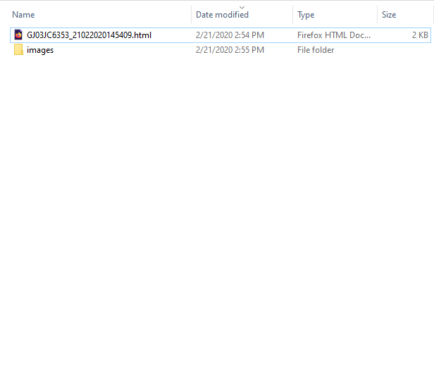

* View: Browser
* Desc: if we open that .html file it displays full details of vehicle with it’s picture

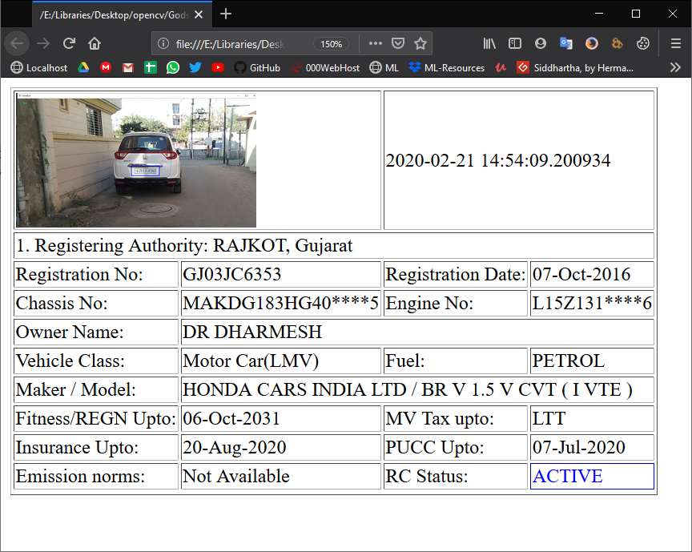

Testing

**Manual**

We use **Black Box** testing technique to test this software

We tested several times and we sorted out some issue which is we identified.

In addition, we launched Beta version for our College colleague to test and give the feedback or Suggestion to us.

We Also Perform **White Box** Testing by Our Selves and Our Colleagues Who have Experience of Web Developing.

Conclusion

The project report entitled "God’s Eye" has come to its conclusion

The new system has been developed with so much care that it is free of errors and at the same time, efficient and less time consuming

System is robust. In addition, provision is provided for future developments in the system

It was a wonderful learning experience for us while working on this project. This project took us through the various phases of project development and gave us a real insight into the world of software engineering. The joy of working and the thrill involved while tackling the various problems and challenges gave me a feel of developer’s industry.

It was due to this project we came to know how professional software is designed.

In this project we learned a lot we thankful to our college and Saurashtra University.

Bibliography

Here are the following names of website referred during the different system development life cycle. We referred this book and website at the time during difficulties and doubts. Really those websites are surely our best friends at the time of problems, they help a lot.

* Websites References:
  + [www.stackoverflow.com](http://www.stackoverflow.com)
  + [www.w3schools.com](http://www.w3schools.com)
  + [www.opencv-python-tutroals.readthedocs.io](http://www.opencv-python-tutroals.readthedocs.io)