**객체지향언어2**

**1차 과제**

학과 : 컴퓨터공학부

학번 : 1692165

이름 : 이재현

담당교수님 : 유상미 교수님

실습문제 1)

실행코드 :

package class02.homework;  
  
public class TV {  
  
 String brand;  
 int createDate;  
 int inch;  
  
 public TV(String brand, int createDate, int inch) {  
 this.brand = brand;  
 this.createDate = createDate;  
 this.inch = inch;  
 }  
  
 public void show(){  
 System.*out*.println(brand+"에서 만든 "+ createDate +"년형 " + inch+"인치 TV");  
 }  
  
 public static void main (String[] args){  
 TV myTV = new TV("LG", 2017, 32);  
 myTV.show();  
 }  
}

실행 화면 :

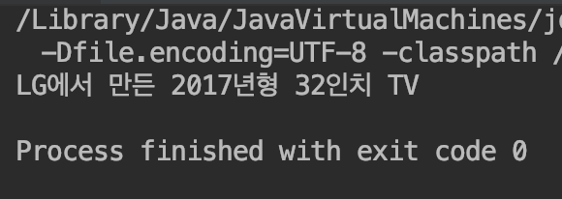

실습문제 2)

실행코드 :

package class02.homework;  
  
import java.util.Scanner;  
  
public class Grade {  
  
 int math;  
 int science;  
 int english;  
  
 public Grade(int math, int science, int english){  
 this.math = math;  
 this.science = science;  
 this.english = english;  
 }  
  
 public double average(){  
 return (math+science+english)/3;  
 }  
  
 public static void main(String [] args){  
 Scanner scanner = new Scanner(System.*in*);  
  
 System.*out*.println("수학, 과학, 영어 순으로 3개의 점수입력>>");  
 int math = scanner.nextInt();  
 int science = scanner.nextInt();  
 int english = scanner.nextInt();  
 Grade me = new Grade(math, science, english);  
 System.*out*.println("평균은 "+ me.average());  
  
 scanner.close();  
 }  
}

실행 화면 :

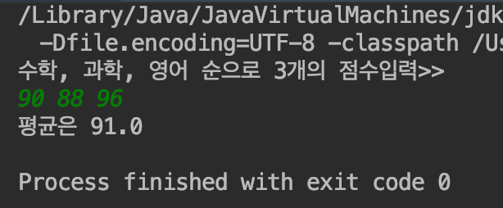

실습문제 3)

실행코드 :

package class02.homework;  
  
public class Song {  
  
 String title;  
 String artist;  
 int year;  
 String country;  
  
 public Song (String title, String artist, int year, String country){  
 this.title = title;  
 this.artist = artist;  
 this.year = year;  
 this.country = country;  
 }  
  
 public void show(){  
 System.*out*.println(year+"년 "+ country+"국적의 " + artist+"가 부른 "+ title);  
 }  
  
 public static void main(String[] args){  
 Song mySong = new Song("Dancing Queen", "ABBA", 1978, "스웨덴");  
 mySong.show();  
  
 }  
}

실행화면 :

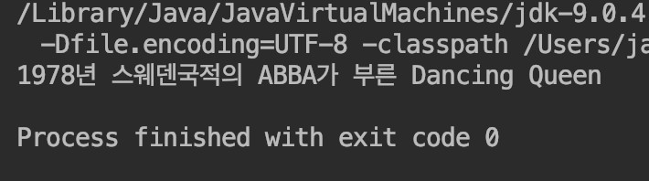

실습문제 4)

실행코드 :

package class02.homework;  
  
public class Rectangle {  
  
 int x;  
 int y;  
 int width;  
 int height;  
  
 public Rectangle (int x, int y, int width, int height){  
 this.x = x;  
 this.y = y;  
 this.width = width;  
 this.height = height;  
 }  
  
 public int square(){  
 return width*height;  
 }  
  
 public void show(){  
 System.*out*.println("("+x+","+y+")"+"에서 크기가 "+ width + "x" + height + "인 사각형");  
 }  
  
 public boolean contains(Rectangle r){  
 if( square() > r.square()) {  
 return true;  
 } else {  
 return false;  
 }  
 }  
  
 public static void main (String [] args){  
 Rectangle r = new Rectangle(2, 2, 8, 7);  
 Rectangle s = new Rectangle(5, 5, 6, 6);  
 Rectangle t = new Rectangle(1, 1, 10, 10);  
  
 r.show();  
 System.*out*.println("s의 면적은 "+ s.square());  
 if(t.contains(r)) System.*out*.println("t는 r을 포함합니다.");  
 if(t.contains(s)) System.*out*.println("t는 s를 포함합니다.");  
 }  
}

실행화면 :

