WATCHBOT: AI Powered Camera

Why am I making it

While there are many cameras that can detect human presence or objects, most of these devices offer limited customisation and low-level intelligence. They typically provide generic labels like “person detected,” without any deeper context or understanding of who the person is. Furthermore, commercial options are expensive and are not flexible for specific needs like home security, personalised authentication, or custom object detection. The most affordable solutions are often limited in functionality and require cloud-based processing, which raises concerns about data privacy and latency.

This project provides an affordable, local AI-powered object and person recognition system using a Raspberry Pi 5 and custom face recognition. The key innovations:

- local processing for real-time identification of people or objects, removing the need for internet connectivity or reliance on cloud services
- Instead of just detecting a “human” or “object,” the system can detect specific individuals by name and also classify non-human objects, giving more detailed and relevant insights.
- Unlike expensive alternatives, this solution provides customisability (users can upload images and teach the system to recognise different people), while maintaining privacy and being self-contained.

The system is ideal for applications like personalised access control (e.g., in smart homes), personal security, or even creating a custom smart camera system that fits specific needs without hefty costs.

Analysis of the Similar System

There are many good products such as Amazon Ring and Google Nest Cam and can send real-time alerts unlike the project I am going to do but they do not contain the detector that detects the users and even if they do they are for subscription with a huge cost but the notification it send is also quite general where when a man passes by it can detect it accurately but cannot determine who that person is and cannot detect other objects near it, it also heavily depends on internet connect ion which is needs a stable connection to operate and send notification to the user. My project to product can solve this by:

- Not having Internet Dependency: My project will not depend on the internet meaning it will operate offline, processing data locally on the Raspberry Pi 5.
- Affordable: It is made at home, so there are no subscription fees for cloud storage, which can add up to over time with services like Amazon Ring.
- Personalised Detection: You can customise the AI to recognise specific individuals, providing personalised alerts like “Person Detected: [Name]”, which most systems cannot do without premium features or some product cannot do.

These key points make my security system more better and allows a friendly environment for those who like privacy and security both

What Technology to Use
To develop my security detector which could be place to view a person object or a relative whose data have been stored I need specific tools and language to use to make this project or product:

Materials (Hardware):

1. Raspberry Pi 5 (16GB)
- This will run my AI models and handle HDMI display.

2. MicroSD Card (32GB or higher)
- To store my OS and AI model.
- Class 10 or UHS-I recommended for speed.

3. Raspberry Pi Camera Module or USB Webcam
- Use official Raspberry Pi Camera v2 or a decent USB webcam.
- Make sure it supports at least 720p resolution.

4. HDMI Cable + Monitor/TV
- To display detection results directly.
- Your Pi will output the detections live to this screen.

5. Power Supply for Raspberry Pi
- Official 5V 3A USB-C power supply is recommended.

6. Keyboard & Mouse
- Useful for setup if you're not SSH-ing remotely.

7. Case with Fan or Heatsinks
- Keeps the Pi cool when running AI inference.

8. Raspberry Pi AI HAT+(26 tops)
- This will increase the runtime of algorithm and program a lot faster

System Software & Tools:

- Operating System:

- Raspberry Pi OS (32-bit)
Using it with VNC to cast it in my laptop instead of connecting HDMI cable every time to the monitor
- PostgreSQL: To store data

B. Programming Language
- Python 3

C. AI & Computer Vision Libraries:

For object/person detection:
- TensorFlow or PyTorch (for deep learning models like YOLO or MobileNet)
- OpenCV – for image capture and processing
- numpy – for array manipulations
For face recognition:
- face_recognition – easy-to-use face detection and recognition library (built on dlib)
- dlib – for underlying ML functions
- scikit-learn (optional) – for training classifiers if needed

D. Model Files:

I will need pre-trained models, such as:
- YOLOv5 / YOLOv8 or MobileNet-SSD (for object/person detection)
- HOG + face encoding (via face_recognition) for identity recognition

End User For My Product

The user for my product would be people who want correct detection which also print the name of the people whose data has been entered in the database and will not depend on the internet of control like others. Currently the user for my product will be my parents who will try this and give review on the product for further improvement if needed.

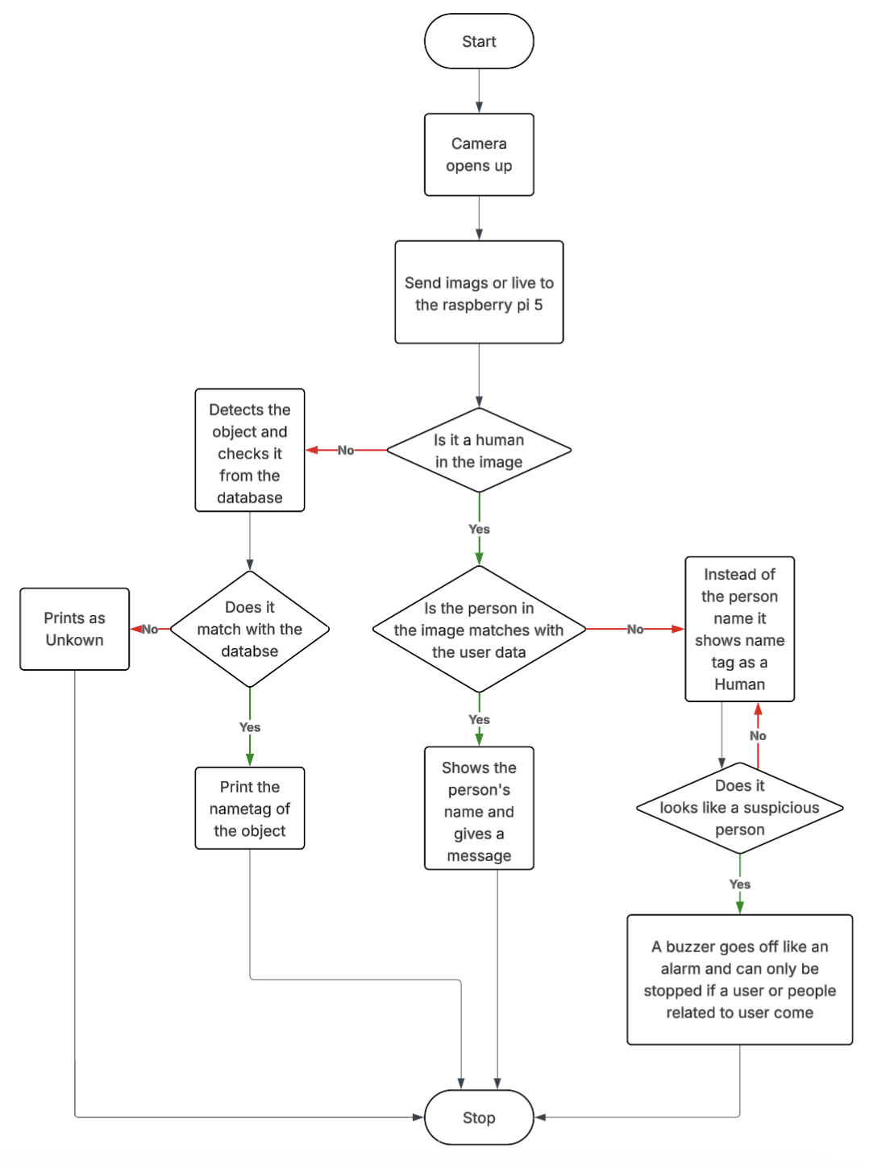
How Will It Work

The main operation is simple it will work like every other camera which are that it would shows that a person has been detected but to change that system it also show the person name if the data has been entered and will even shows the basic object identity if available at that time

Acceptable limitations

The device won’t be a perfect replica of the real products which are in the market and the main limitation for the project are:

- No notification and alerts: This allows the user to get the status with the help of email and messages. This all goes to a cloud and then to the user

- Limited Data logging: There would be limited data login which store the past information and allows the user to access it

- No Real-Multi Person Tracking: The system my sometimes struggle to recognise multiple people but that can be resolved.

- Recognition Accuracy in Challenging Conditions: While the camera would be night-visioned it will still might struggle with the detection at night and because of this it could affect the detection accuracy

Proposed Solution For The Limitations

To overcome this limitations, the best way is to add new features which would help solve this problem:

- Even thought it won’t have cloud storage where it stores the data into the cloud for future reference it would still have SQL database where it would contain information on what time does a person or an object appears in front of the camera

- The condition for real-multi person Tracking can be solved by adding Raspberry Pi AI HAT+ (Hardware Attached on Top). The Raspberry Pi AI HAT+ add-on board has a built-in Hailo AI accelerator compatible with Raspberry Pi 5. The one to use is the The 26 TOPS variant which can run larger networks, can run networks faster, and can more effectively run multiple networks simultaneously. This can help increase the program much faster and should affect the limitation by a lot.

Identification of User’s Needs

The users need a security camera which can show more classification of data rather than just a text message saying, “Person Detected”. The security camera should show names of objects or classification of the object detected and this can be achieved using pi camera for raspberry pi 5 and its camera module which can identify the classification of the object and it has two angles for the Pi camera module 3 which are 75°(standard view) and 120°(wide view) which helps even have more objects and people to appear just like the normal security camera.

Final Proposed Objectives

The overall purpose of the product is to provide a better security camera with a lot of features other than just printing “A person detected” like printing the name of the user and related to them which are stored in the database

I have determined the input and the output process of the camera and as told before the main components would be the pi camera module 3, raspberry pi 5 which would do the main process for the entire project which would be in the order of:

Taking Input:

- Taking the image with the help of OpenCV module in real time to detect living beings

Processing:

- The Raspberry pi 5 captures real time video frame, which are then processed as images which can take 15-30 frames per second with the help of Hailo Chip 26 tops which will help run smooth and fast detection
- Then to detect we need to match the object we want to detect in the image to the information we have which is represented by a vector of 128 (floating point) numbers which store face dimensions
- We first crop the image to which we want to detect and we crop it using OpenCV module and then convert the image to a vector format of 128 number as said before and match it with the data we have in the database

Output:

- After comparing the data and the crop image we check if the object matches with the data and if it does and is a human who is user or one of a person whose data is stored in database then it would be showed by a green led and if the person is not recognised then the person would be showed as Person detected as there data is not stored and if there is a suspicious person detected then the buzzer would go of until the user comes or user stops it.

DFD Models

The current system consists of the pi camera interacting or detecting the object or a person in front of the camera and try recognising it and the different scenario which can show up are:

- Camera detects an object :

    - The pi camera first detect the object and then run the detection program to check if there is information in the SQL or database

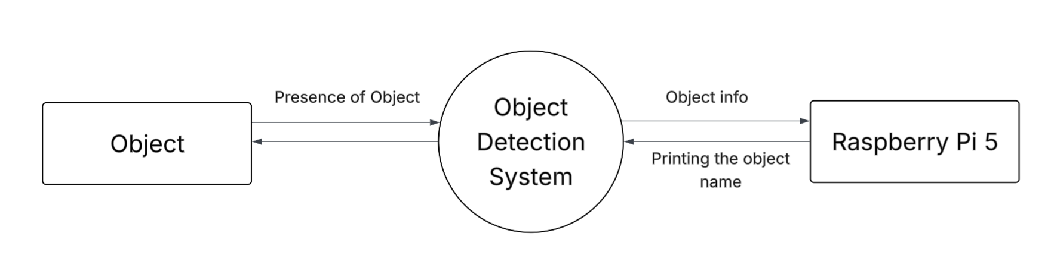
      - 0 Level Data Flow Mode:
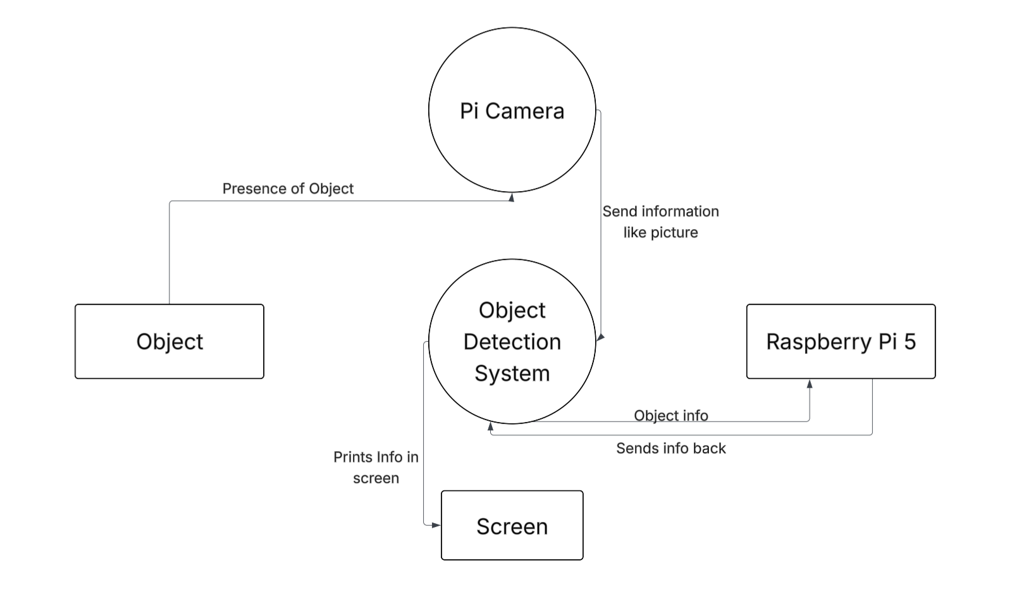
      - 1 Level Data Flow Model

      - 2 Level Data Flow Model
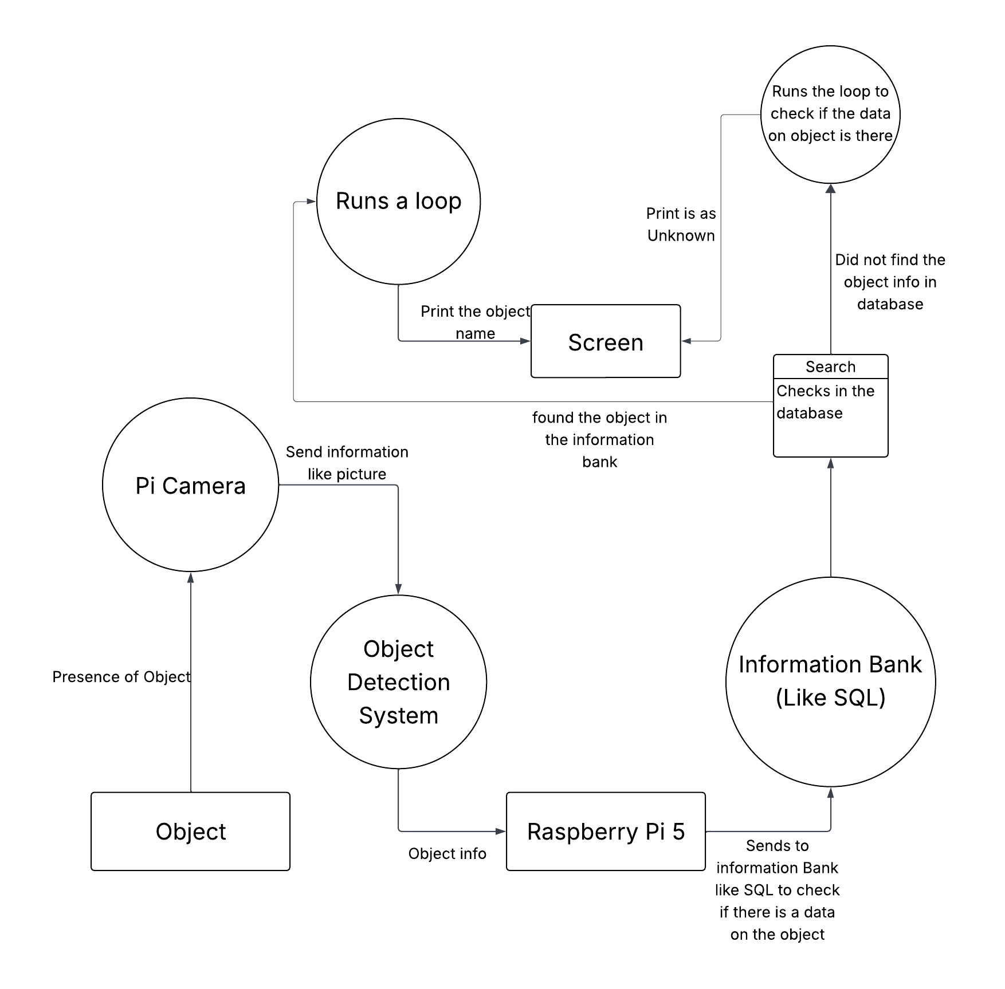

- Camera detects a person

  - User and User related and Unknown Person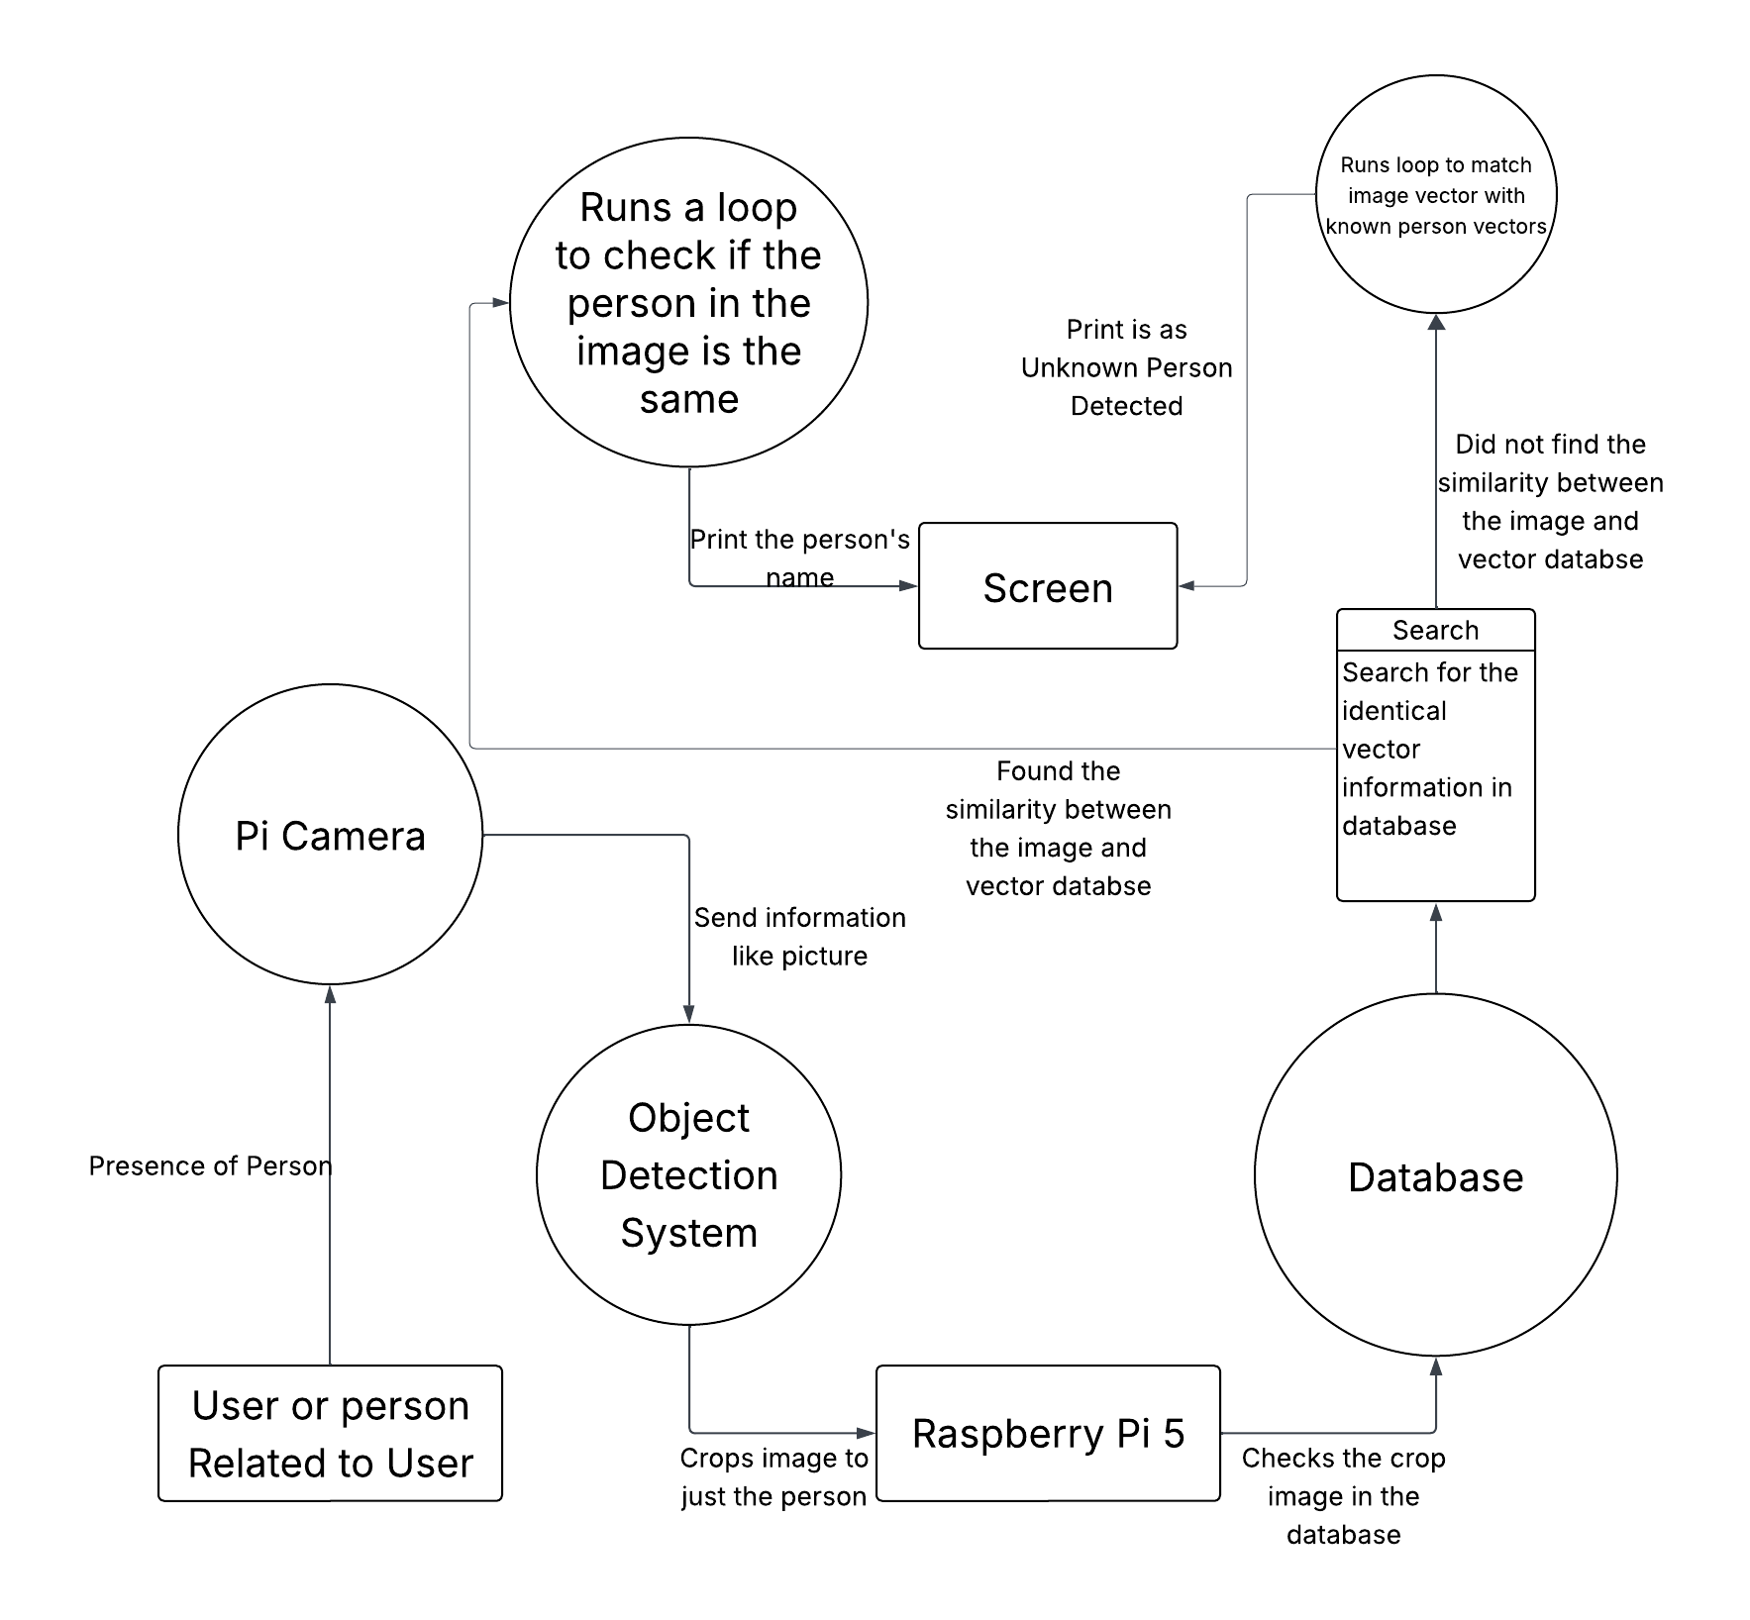

  - Suspicious Person
