**7-3)**

**I)** Given y=Sin(x)=f(x)

Let us assume we are finding it at x=π/4

Δx= 0.1, f’(x)= dy/dx(exact)=Cos(x)

The steps to the different processes are given as follows: -

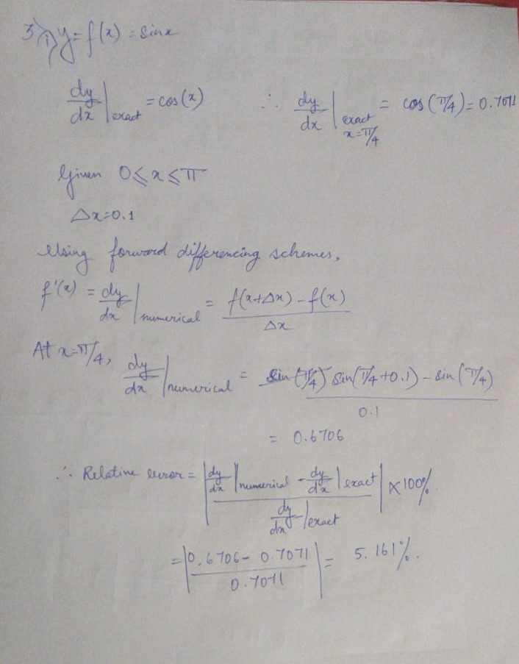

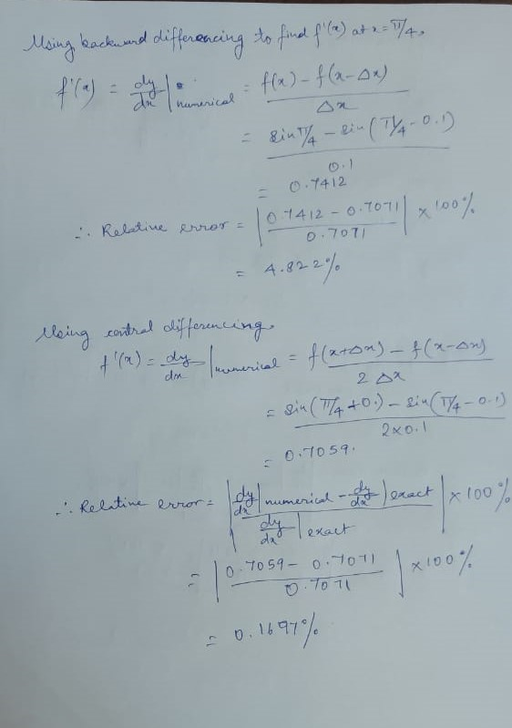

|  |  |
| --- | --- |
| **Process of differencing** | **Relative Error (%)** |
| Forward differencing | 5.161 |
| Backward differencing | 4.822 |
| Central differencing | 0.1697 |

**ii)** Given y=Sin(x)=f(x)

Let us assume we are finding it at x=π/4

Δx= 0.01, f’(x)= dy/dx(exact)=Cos(x)

The steps to the different processes are given as follows: -

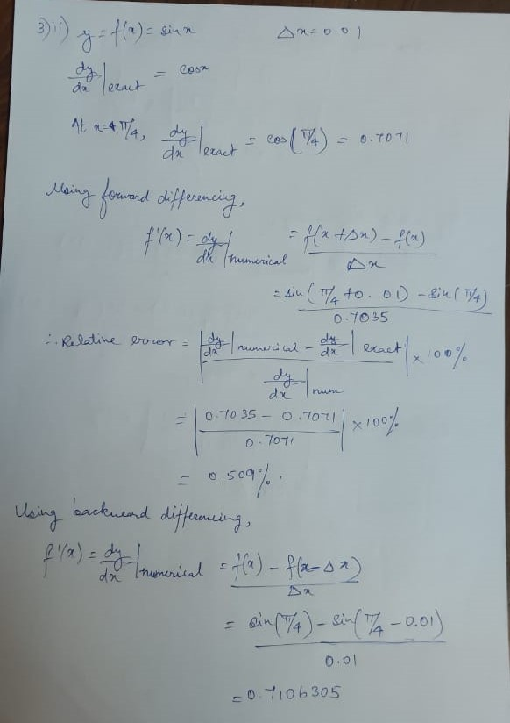

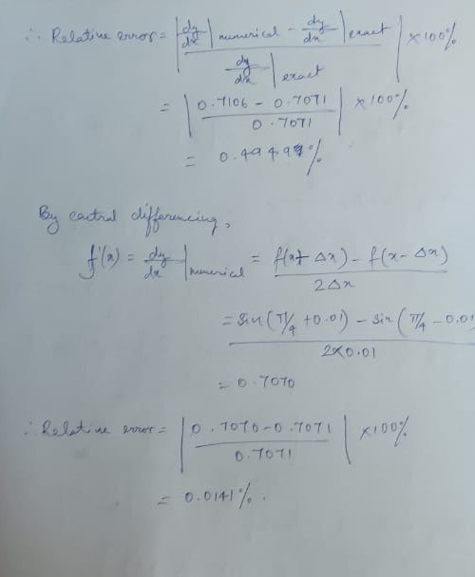

|  |  |
| --- | --- |
| **Process of differencing** | **Relative Error (%)** |
| Forward differencing | 0.7035 |
| Backward differencing | 0.509 |
| Central differencing | 0.0141 |