**Presentation-6**

1. Explain the Concept of Transaction
2. Explain the 4 ways of Ending Transaction.
3. What are the Properties of Transactions?
4. Tell the definition of Concurrency Control
5. What are the Three Potential Problems Caused by Concurrency?
6. Explain the following concepts.

* Schedule
* Serial Schedules
* Nonserial Schedule
* *serializable* schedule

1. Tell the objective of Serializability
2. Judge what kind of schedule the following 3 schedules are?

serial schedules, *serializable* schedule or *Non-serializable* schedule

Let *T*1 transfer $50 from *A* to *B*, and *T*2 transfer 10% of the balance from *A* to *B.*

1. (2)

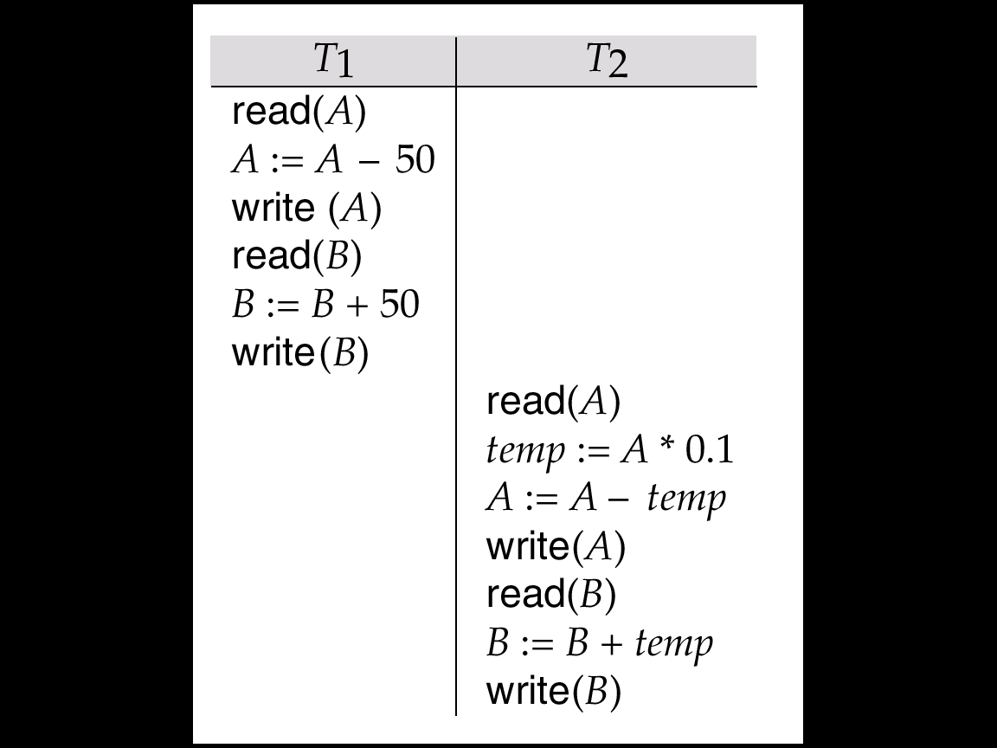 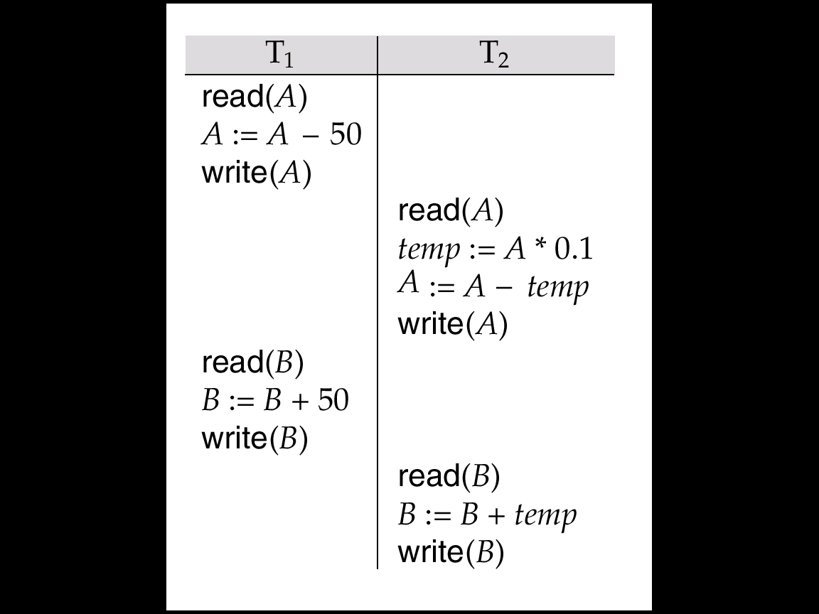

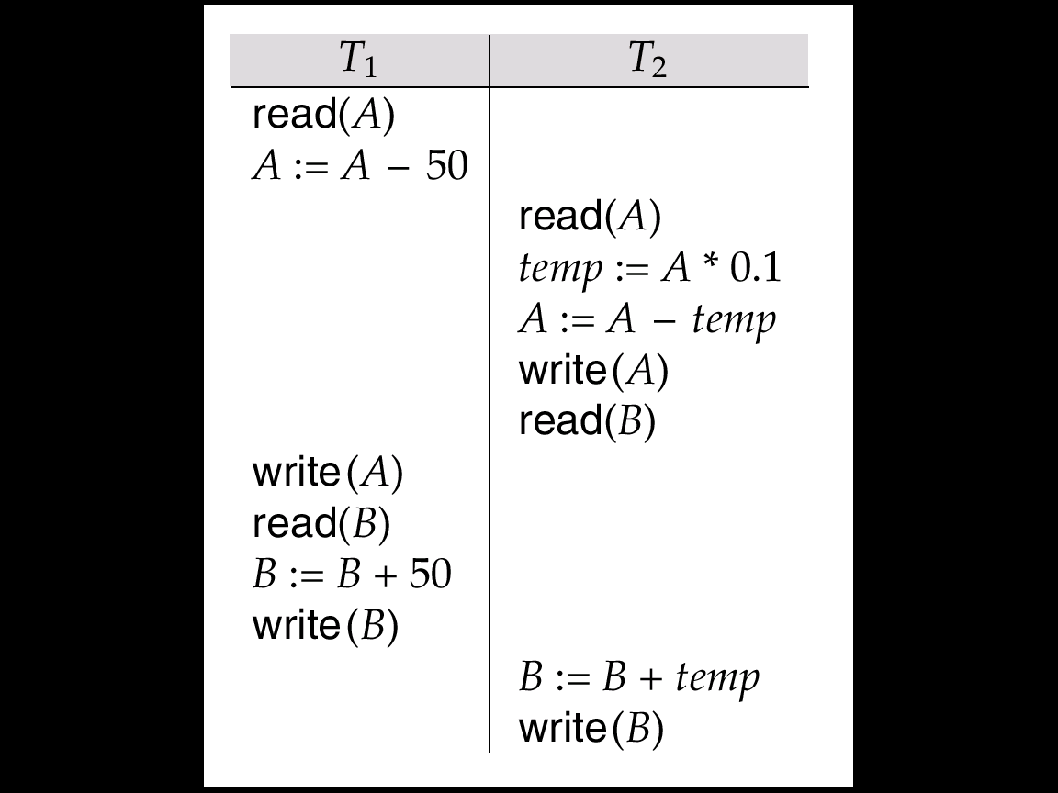

1. What is the definition and function of a lock?
2. Tell the two modes of a lock.
3. Tell the content of Two-Phase Locking Protocol.
4. Give an example to show the following Theorem:

If the schedule follows 2PL protocol，it must be a *serializable* schedule;

Even though the schedule does not follow 2PL protocol，it may be still a *serializable* schedule.