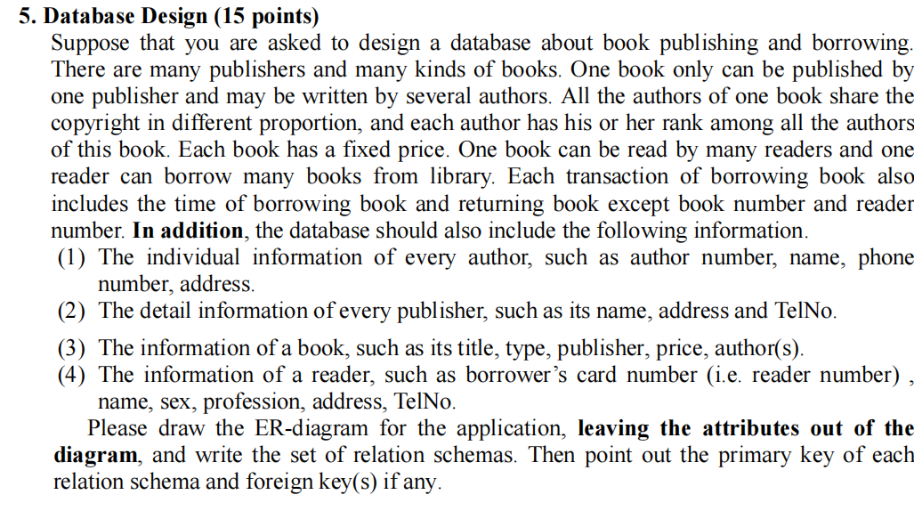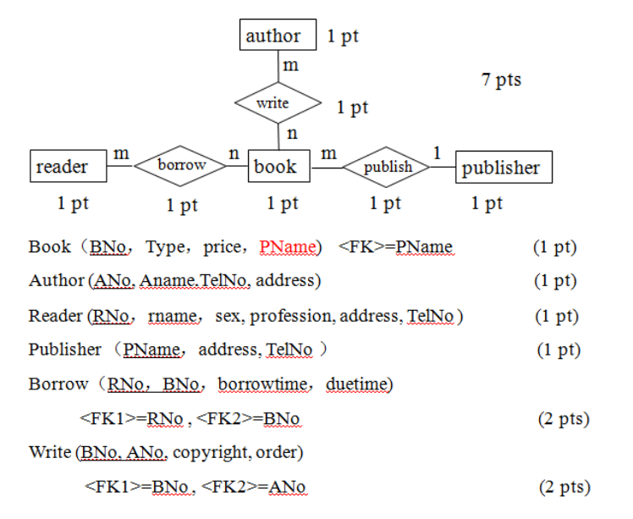

1:1的情况下，外键仍然必要， （3）的authors是不必要的，因为多对多关系另外拿出来了

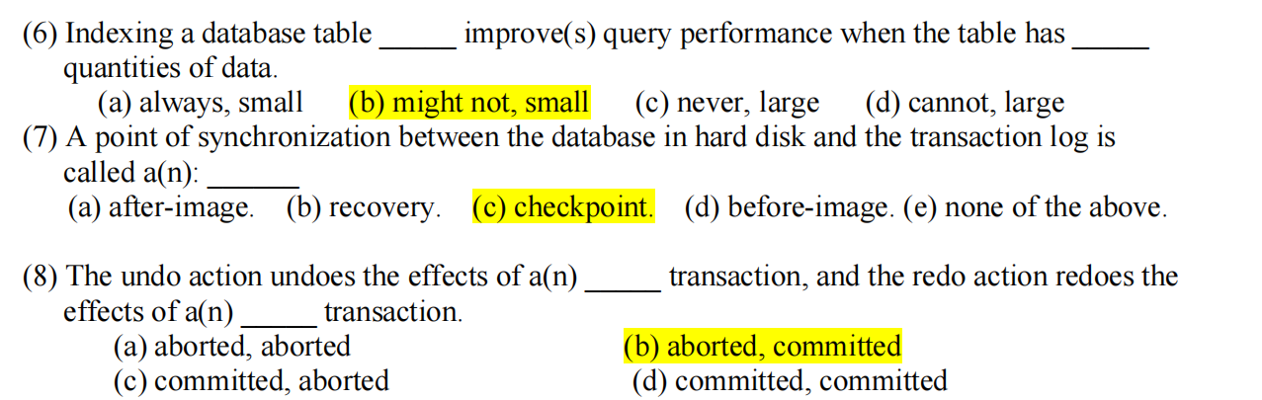

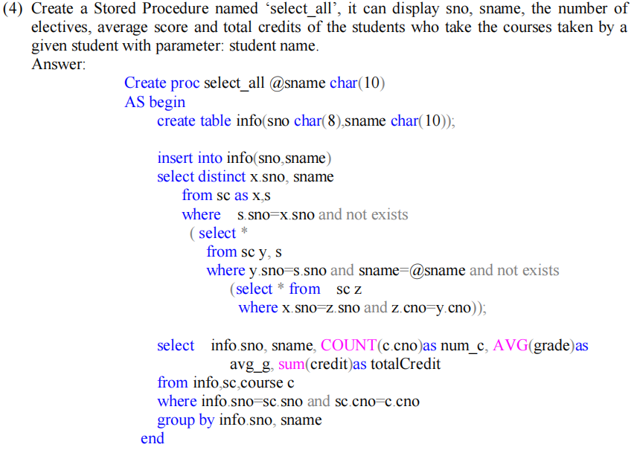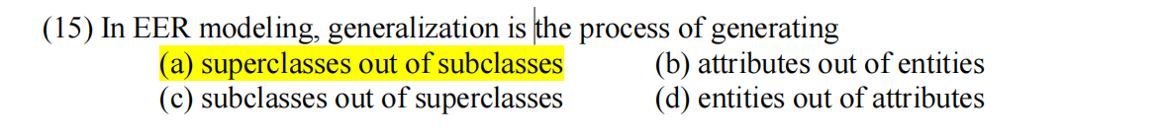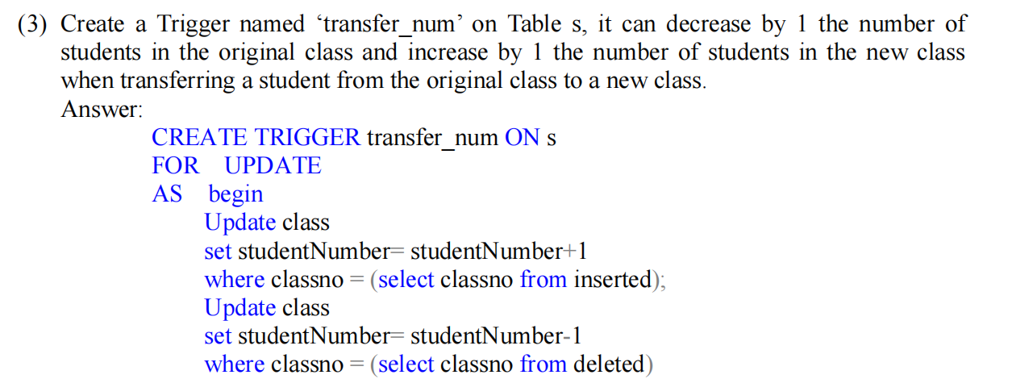b

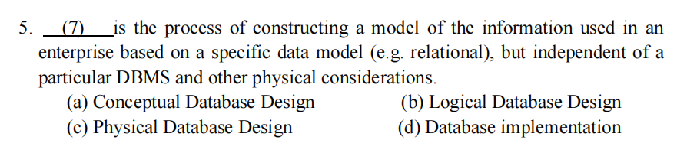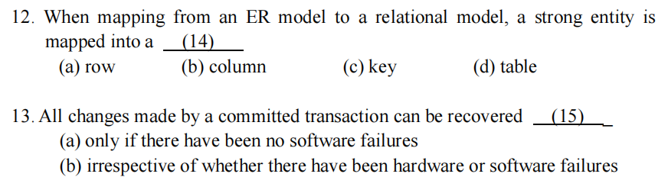d,c

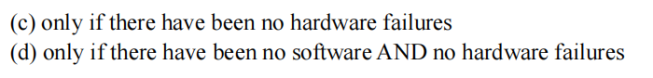

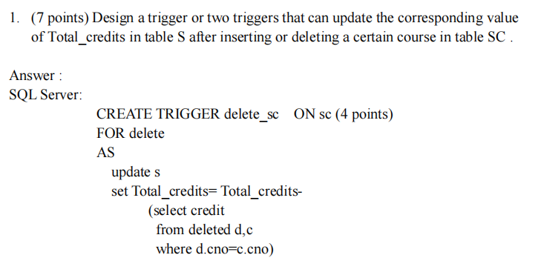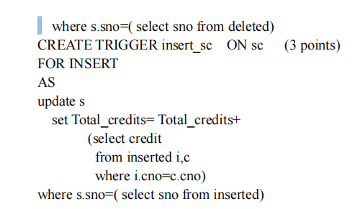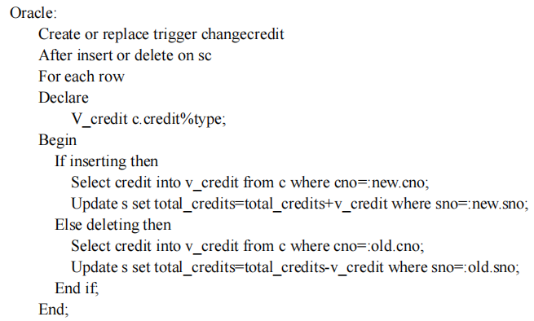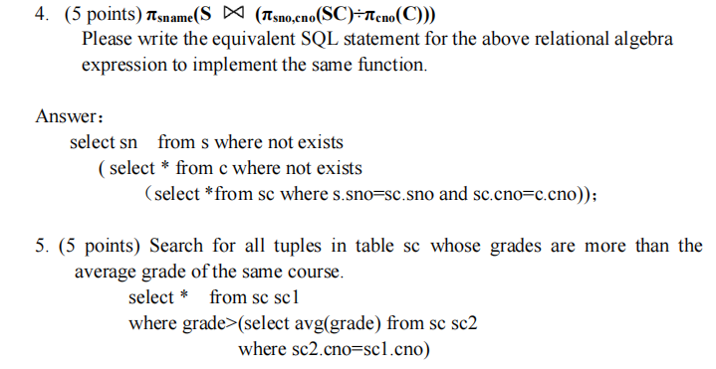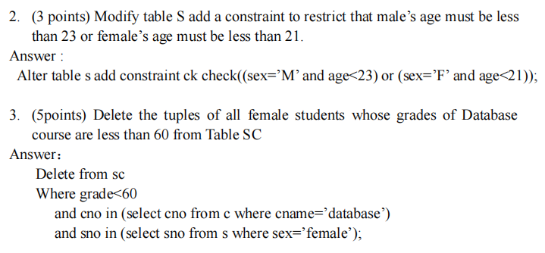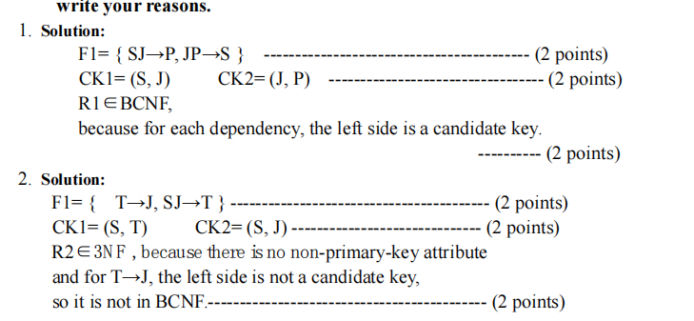

.1. Please tell the difference between Equi-join and Natural join.

1. Equijoin does not require that the names of two compared attributes be the same.butNaturali0in does
2. (2) The result of Equijoin keeps all the duplicate names of common attributes, butthat of Natural join does not.-----------------(2 points)
3. Potential to violate BCNF in 3NF may occur in a relation that:

(1)A relation contains two (or more) composite candidate keys, ---.

(2 points)(2) The candidate keys overlap (i.e. have at least one attribute in common). -- (2 points)



