Contents

1. Identifying and representing simple arguments 4

Arguments 4

Conclusion 4

A warning 4

Passages without conclusion indicators 4

Premise indicators 5

standard form 5

Argument map 6

2. Criteria for evaluating arguments 6

Truth 6

Example: 7

Support 7

Reliability, Two types of support: deductive and inductive 8

Deductive support 8

Inductive support 9

Biases in assessing support 10

Summary 10

3. Deductive Support 10

Deductively valid arguments 11

Deductively valid forms 11

Conditional statements 14

A second test for deductive validity: the counter-example method 15

4. Identifying unstated assumptions 16

identifying assumptions 16

Rule #1 (The Lonely Premise Rule) 16

Rule #2 (The Rabbit Rule) 16

Rule #3 (Holding hands rule) 16

Assumptions and support 17

Questionable assumptions and begging the question 17

5. Evaluating premises 17

Evaluating sources 18

Is the source in a position to know? 18

Is there any reason to suspect the reliability of the source? 18

Is there any corroborating evidence from independent sources? 18

Generalisations 18

Counter-examples 19

Reformulating generalisations 19

Statistical generalisations 20

Evaluating statistical generalisations 20

An example argument 20

6. Analysing complex arguments 22

Independent and co-dependent premises 22

Combining linked and independent premises 22

Sub-arguments 23

Evaluating 23

Success VS Soundness 23

complex arguments 23

7. Inference from a sample 24

Sample, Population and Target Property 24

A general pattern for inference from a sample 25

Sample size 25

The sample size principle 25

The sample size principle in action example 25

Random samples and margin of error 26

The size of the population does not matter 26

Biased samples 26

Self-selected samples 26

Availability samples 27

Problems with measuring the target property 27

Measurement bias 27

some important questions to ask are: 28

8. Arguments for causation 28

Types of causal claim: specific and general 28

‘Post hoc’ reasoning: a very common fallacy 29

Arguments for specific causal claims 29

Causal generalisations and correlations 30

Correlations between quantities 30

Strength of a correlation 30

Correlation is not sufficient for causation 31

9. Normative reasoning 32

Why care about normative arguments? 32

Evaluating normative arguments 32

Common problems with normative arguments 33

‘loaded’ or ‘emotionally charged 34

10. Informal fallacies 34

Questionable assumptions 34

begging the question 34

False dichotomy/False dilemma 35

slippery slope arguments 35

Red herring 35

Questionable language 35

Equivocation 35

Questionable authority and attacks on the authority 36

appeal to authority 36

personal attack (ad homine) 36

11. Critical thinking in the wild 37

Mindset 37

Soldier 37

Scout 37

Cognitive Biases 37

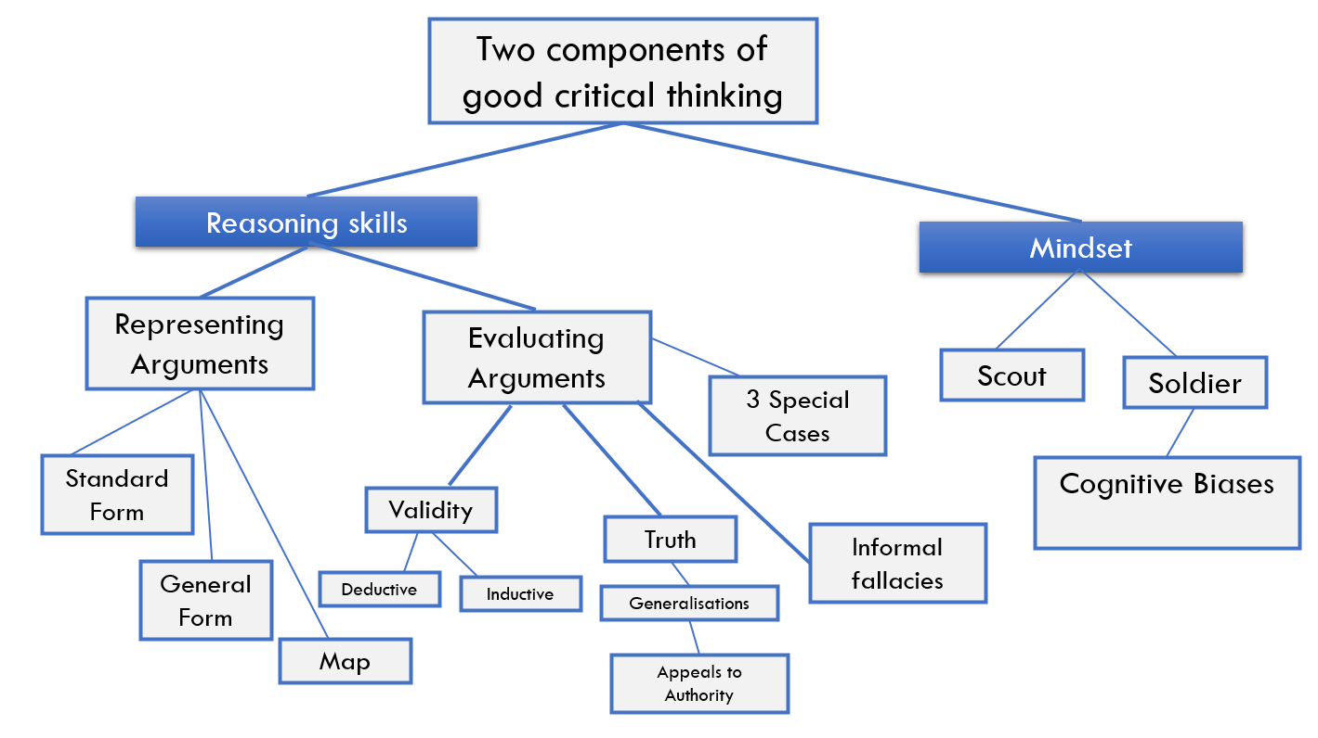

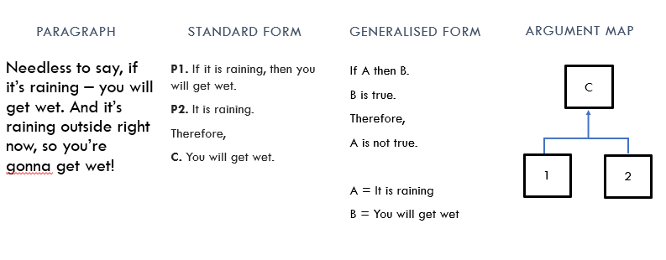

# Identifying and representing simple arguments

we are all susceptible to systematic errors and biases in our reasoning

## Arguments

Arguments - **must** consist of a **claim** (the conclusion), along with one or more **reasons** for thinking that the **claim (conclusion)** is true (premises)

Functions: asserting or denying something,

Both the conclusion and the premises must be **statements** or **propositions**

Example: 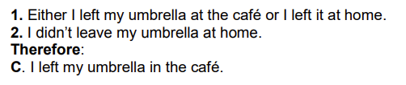

## Conclusion

conclusion indicators: Therefore; So; It follows that; Hence; Thus, for this reason; … must (be true that) …; ... cannot (be true that) …

‘must’ is used to signal the idea that the conclusion is a necessary consequence of these two supposed facts: that is, **the conclusion must be true if the premises are true**.

### A warning

the text does not guarantee that the passage is an argument; e.g.:



‘So’ means something like ‘to’ rather than ‘therefore’. Similar remarks apply to ‘must’ and ‘cannot

### Passages without conclusion indicators

The key question is whether the passage contains a conclusion **– a claim for which reasons are given**.

* Do some of the statements **provide reasons** for believing that a claim made in the passage is true? If so, then the passage contains an argument



the second sentence provides some support for that claim

## Premise indicators

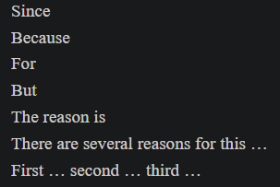

used to indicate that a reason in support of a claim

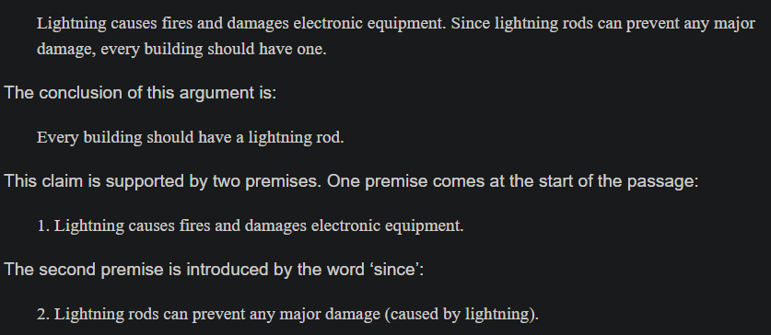

But the same, A warning, in some cases the indication does not work

### Standard form

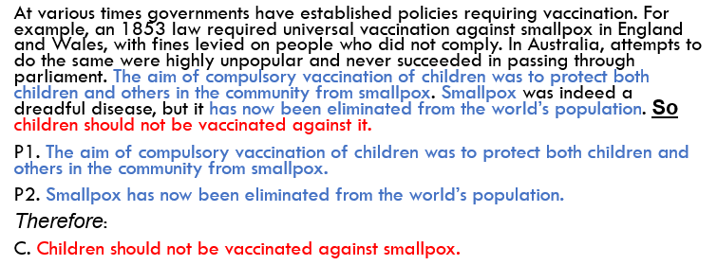

premises should be numbered, followed by the conclusion

### Argument map

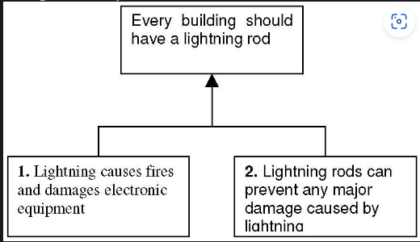

Advantage: more clearly reveal the structure of the argument, important when the argument is more complex

# Criteria for evaluating arguments

A good argument is one that the audience should be convinced by because it provides an objectively good reason for accepting the conclusion.

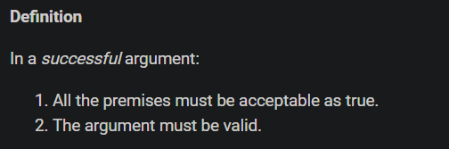

## Truth

A property of statements (e.g., premises or conclusions)! No arguments.

The argument to be successful must satisfy both conditions 1 and 2. If either one, or both of these conditions fail, then the argument is not successful – it does not provide a good reason to accept its conclusion.

1. Has an argument been given?

* Evaluate the argument before doing independent research

1. Is there an appeal to authority (source given as a reason)?

* Is the source: in a position to know, reliable, corroborate
* Is there any reason to suspect the reliability of the source?
  + Does the source have a motive for not telling the truth?
* Can you corroborate their claim?

1. Is there a universal generalisation?

* Can you think of a counter-example?
* Does it provide the best explanation of the available data?

1. Can you do some research to find out?

### Example:

In a successful argument, all the premises must be true



Fail: the premise on which it is based is false;

It is important to recognise that an argument with a false premise fails even *if the conclusion is true or plausible.*



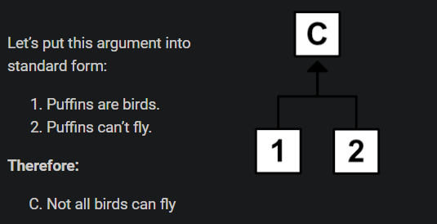

premise 2 is false – Puffins can fly; So, this argument does not successful – it does not provide a good reason to accept that its conclusion is true, even conclusion is true.

How do you make a judgement about the truth of the premises? 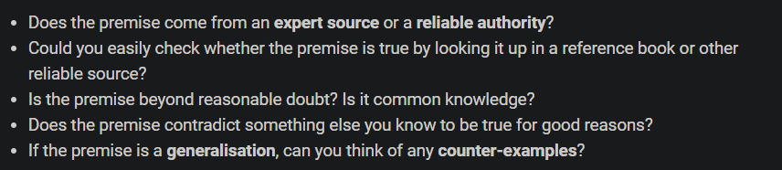

## Support

Premises must be trusted and *must also support the conclusion: premises entail or imply that the conclusion is true*

**Premises support**: the connection between the premises and the conclusion



If the conclusion does not follow from the premises in this sense, then the argument cannot be successful, because the premises do not provide a reason to the conclusion is true, or even that it is likely to be true.

## Reliability, Two types of support: deductive and inductive

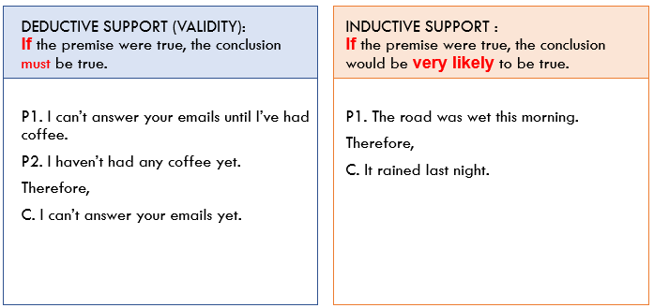

### Deductive support

If the premises of the argument were true, the conclusion must be true.

Perfectly reliable with given true premises, a deductively valid inference always produces true conclusions. When evaluating what support it is, truth is not required.

#### Example:

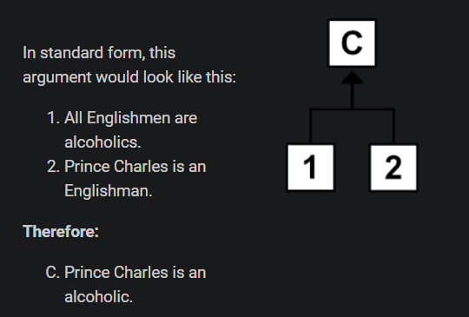

* premise 2 is true, premise 1 is not
* However, the argument does satisfy the second condition: If both premises were true, then Prince Charles would have to be an alcoholic.
* The premises of an argument can support the conclusion even if they are not all true

*Deductive support (aka validity)*

Validity is about the logical structure of the argument – the connection between the premises and the conclusion – **not** about the actual truth values of the premises or the conclusion. An argument can have premises and a conclusion that are false, but still valid.

##### Valid argument

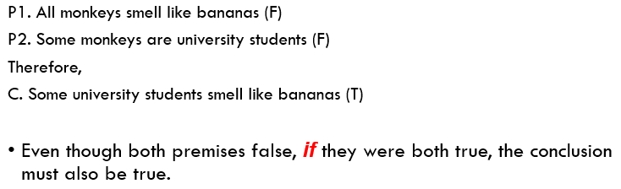

* an argument can be valid even if its premises and/or conclusion are false.

##### Invalid argument

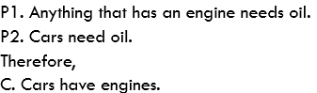

* An argument can have **true** premises and a **true conclusion** and yet be invalid
* validity do with the connection, nothing to do with the actual truth of the premises or conclusion

### Inductive support

If the premises were true, then it would be **very likely** that the conclusion is true.

Inductive support is less conclusive than deductive support

Example:

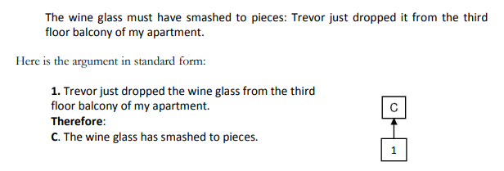

* the glass might have landed in something soft enough to prevent it from breaking
* Arguments like this are not deductively valid – it is still possible for the premises to be true and the conclusion false. But they do provide support for their conclusions.

## Biases in assessing support

It is very important to realise that an argument in which the premises do not support the conclusion fails even if the conclusion is true or plausible



The answer is clearly no, they could be one of the things that need oil even though they don’t have engines

## Summary

two fundamental criteria for evaluating arguments:

* Truth: The premises must be true
* Support: If the premises are all true, they would be providing sufficient support for the conclusion.

# Deductive Support

Deductive soundness = **validity (deductive support) + true premises.**

A detective investigating a murder must be left-handed. The detective has two suspects, Mr Brown and Miss Green. Miss Green is left-handed. Should the detective conclude that Miss Green is the murderer? Mr Brown is not left-handed. Should the detective conclude that he is innocent?

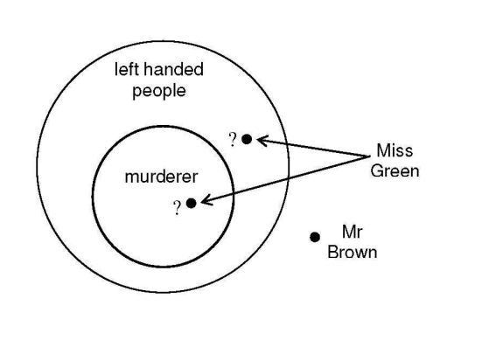

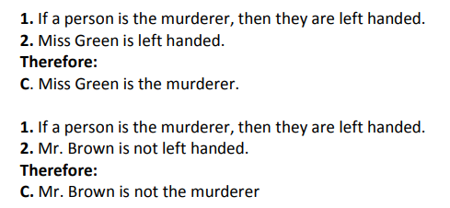

the conclusion of the first argument does not necessarily follow from the premises, while the conclusion of the second argument certainly does (deductively valid)

## Deductively valid arguments

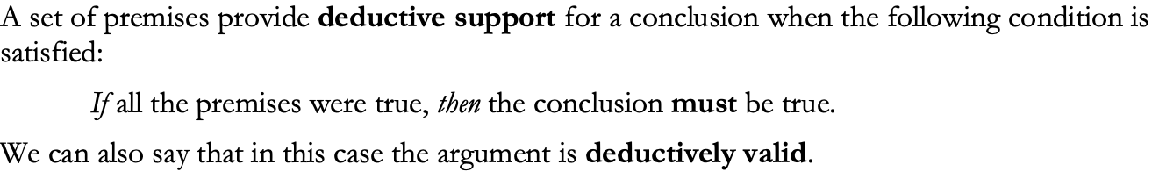

This does not mean the premises themselves are true: Mr Brown might be left-handed.

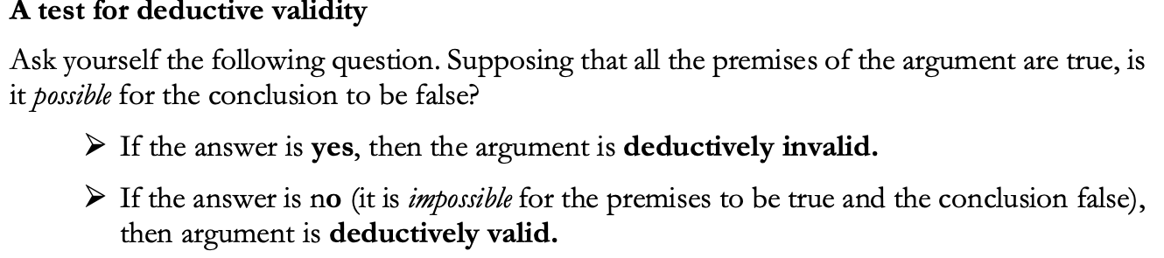

## Deductively valid forms

Generalised form – extracting the structure

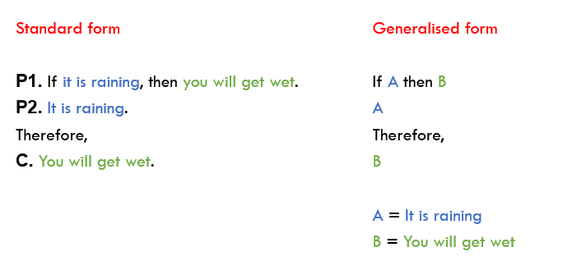

Reasons:

* Separates validity from the truth.
* We’re less likely to get tripped up by tricky cases.
* Helps us to quickly identify common argument forms that we already know are valid or invalid.

IMPORTANT: remember the name of the argument form

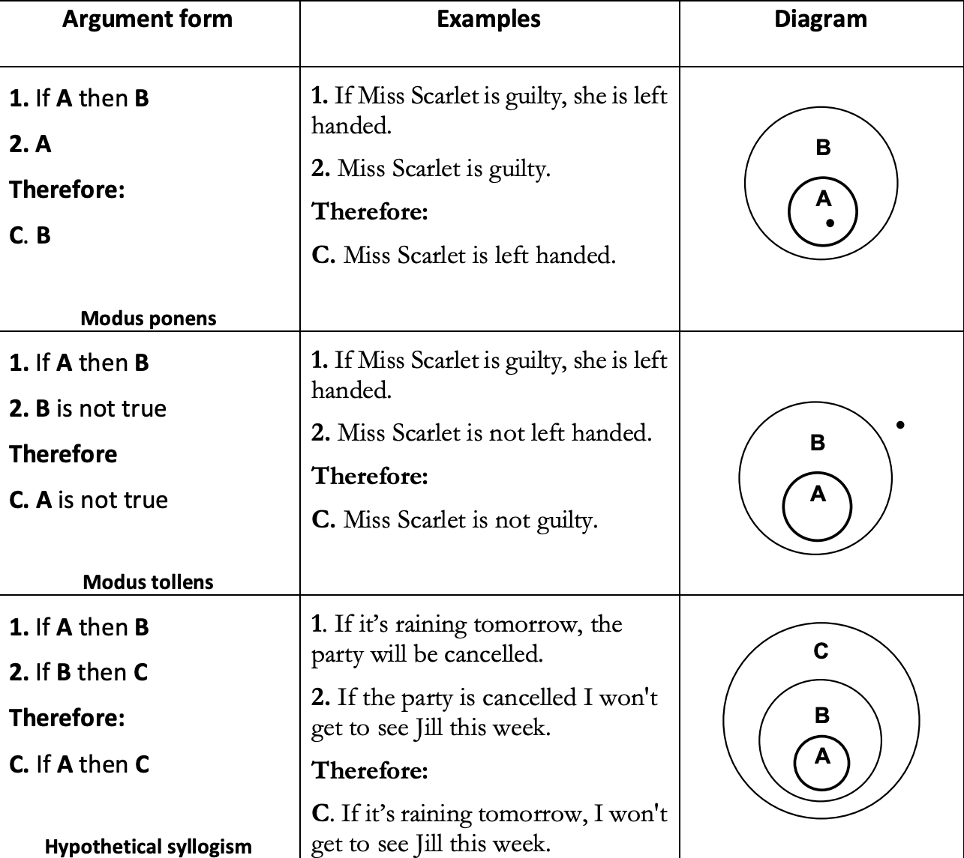 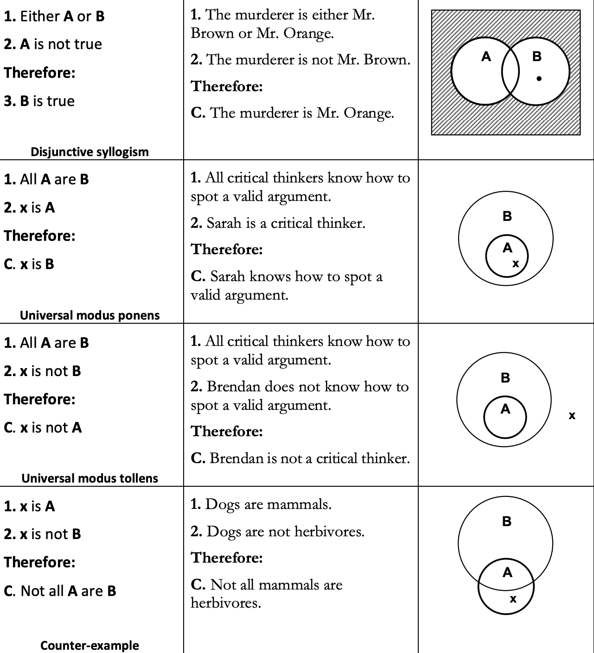

### Conditional statements

* A statement with an “if… then…” structure

The statement following the “if” is called the-

* + Antecedent

The statement following the “then” is called the

* + Consequent

Don’t confuse conditional statements with arguments.

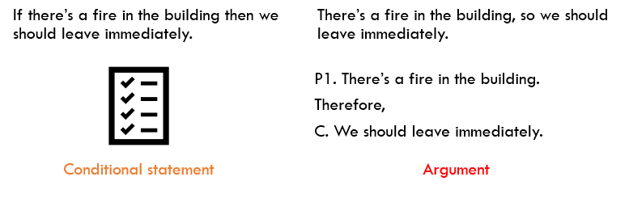

## A second test for deductive validity: the counter-example method

A counter-example to a form of argument is an example of the form which has true premises and a false conclusion.

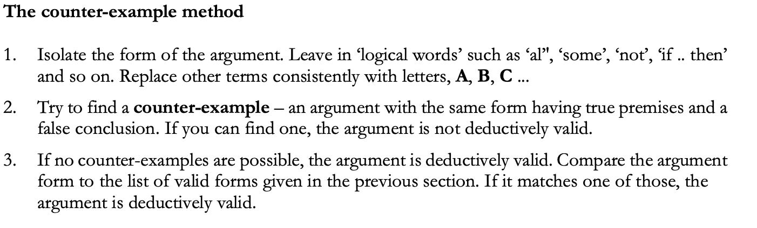 

EXAMPLE:

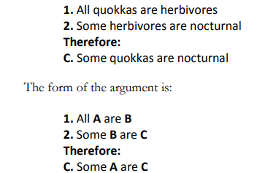

The argument doesn’t match any of those on the list of valid forms in the previous section

Let’s see then if we can construct a counter-example, Finding an example with true premises and a false conclusion. We first put A and C

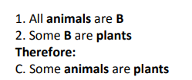

Then we try to put B and make both premises true

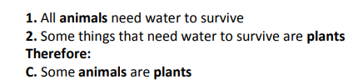

True premises and a false conclusion. This shows that the argument form is not deductively valid

# Identifying unstated assumptions

Assumption: assumption in an argument is an unstated premise that is required by the argument. That is, the conclusion of the argument would not follow from the stated premises without the addition of the assumption. Assumptions are also called implicit premises or unstated premises.

When we reconstruct someone’s argument – we should apply a principle of charity: You should interpret other people’s arguments in a way that makes the most sense of what they are saying and makes their argument as strong as possible.

## identifying assumptions

### Rule #1 (The Lonely Premise Rule)

An argument with only one premise usually depends on an unstated assumption.

But sometimes this method does not work

### Rule #2 (The Rabbit Rule)

If the conclusion contains a significant word or phrase that does not appear in any of the premises then the argument depends on an assumption.

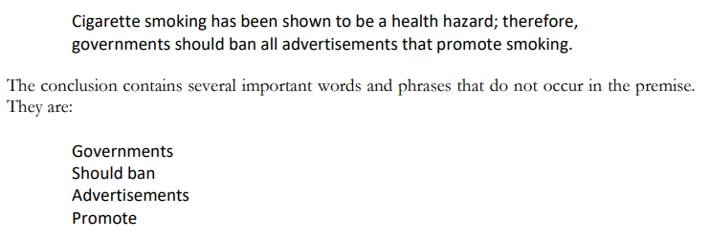

premise does not say anything about governments, or banning things or advertisements. So, the assumption must be: Governments should ban advertisements that promote …. what? we can turn to the third and final rule.

### Rule #3 (Holding hands rule)

The assumption will be a co-premise of the stated premise and will make use of the missing word or phrase.

Premises of an argument need to ‘hold hands’ with each other. If it does not appear in any of the stated premises, it must appear in an unstated assumption

## Assumptions and support

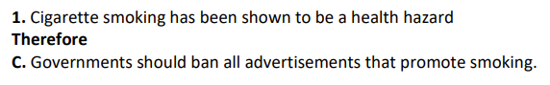

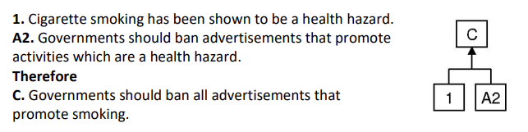

An argument is successful if it satisfies two conditions:

* all the premises must be true
* the premises must support the conclusion

stated premises do not support the conclusion, because by themselves they do not give you a reason for thinking that the conclusion is true. After adding this unstated premise, the argument will satisfy the second condition: the premises will support the conclusion

## Questionable assumptions and begging the question

Begging the question

An argument begs the question if it depends on a premise (stated or unstated) that is unacceptable given the context or debate in which the argument is presented.

For example, an argument that assumes the very conclusion it is intended to establish begs the question.

More generally, an argument presented in a debate about a specific issue begs the question if it depends on a premise that would not be accepted by the other side of the debate.

Other terms for this concept are circular argument or circular reasoning.

# Evaluating premises

Remember the two criteria for evaluating arguments from chapter two:

1. All the premises must be true.
2. The premises must provide sufficient support for the conclusion.

you can ask about the premises:

* Does the premise come from an expert source or a reliable authority?
* If the premise is a generalisation, can you think of any counter-examples?
* Could you check whether the premise is true by looking it up in a reference book or a reliable source?
* Is the premise beyond a reasonable doubt? Is it common knowledge?
* If the premise explains something, are there any plausible alternative explanations?

## Evaluating sources

some of the factors that affect the reliability of sources.

Questions for assessing the reliability of sources:

### Is the source in a position to know?

1. Does the source have the relevant expertise or training?

someone is an expert or authority in one area, that does not make them an expert in other areas

Arguments that appeal to authorities of the wrong sort engage in fallacious reasoning called the *illegitimate appeal to authority*.

1. If the source is a witness, were they in a position to have the relevant experience?

could the source have experienced what they claim to have experienced? Were they present at the time? If so, could they see clearly? Was their view obstructed?

### Is there any reason to suspect the reliability of the source?

1. What is the source’s reputation for reliability?
2. Does the source have a motive for not telling the truth?

If you ask the salesman in the shop which is the best DVD player to buy, it would be unwise to place too much trust. The salesman has a vested interest in getting you to buy something / in getting you to buy the most expensive thing.

1. Are there factors that might affect the reliability of the evidence?

### Is there any corroborating evidence from independent sources?

corroborating evidence should be independent. experts of a certain drug are not independent if they all work for the same pharmaceutical company is a bad example.

A warning: motive and bias are not always relevant

## Generalisations

Two Kinds:

* A universal generalisation is a claim which says something about all things of a certain kind.
  + Example: 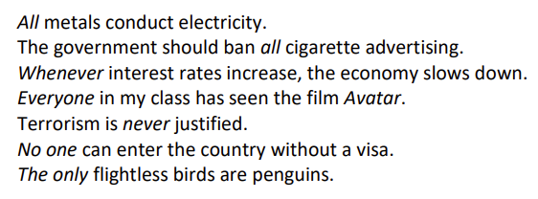
  + all, every, anyone, everyone, whenever are what we might call universal generalisation indicators
* Statistical Generalization: a claim that says something about some number of things of a certain kind
  + 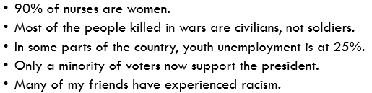
  + “some”, “many”, “25%”, “a minority”, “most”

## Counter-examples

you have found what is called a counter-example to the generalisation: an instance or case which shows the generalisation to be false

A counter-example to a universal generalisation is an instance that shows the generalisation to be false. If the generalisation is that All As are Bs, a counter-example is an A which is not B.

Example:

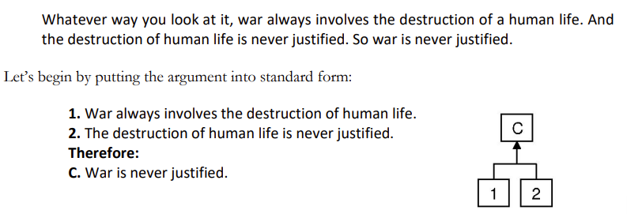

Both premises and the conclusion are universal generalisations

If you were convinced that killing in self-defence could even sometimes be justified, then you would have to reject the universal generalisation on which the above argument depends on P2.

## Reformulating generalisations

Although a counter-example shows that a universal generalisation as stated cannot be true, you should not rush to reject the generalisation.

it may be more reasonable to attempt to reformulate or restate the generalisation so that it avoids the counter-examples while continuing to hold for the known cases.

Example:

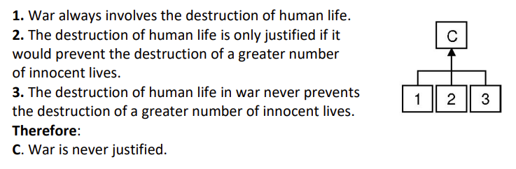

we could reformulate the conclusion of the original argument so that it matches the reformulated assumption:

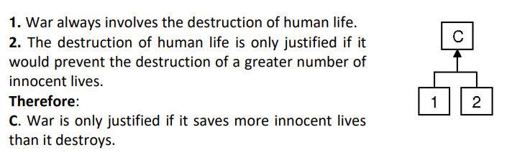

By digging down deeper to unearth the assumptions on which general principles like this depend, we may discover something we were not expecting and which could have radical implications.

## Statistical generalisations

A statistical generalisation is a claim that says something about the proportion or percentage of things of a certain kind.

EX: 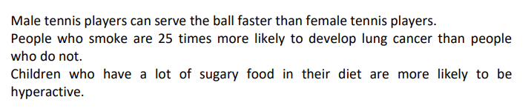

Phrases: ‘The majority’ and ‘most’ can be interpreted as meaning ‘50% or more’, and a ‘minority’ can be interpreted as ‘less than 50%’. Phrases like ‘Many’, ‘lots’ and ‘few’ have no precise interpretation, but do not think that makes generalisations meaningless

### Evaluating statistical generalisations

A claim like ‘Most people support the government’s immigration policies’ cannot be refuted by saying ‘Well, I know lots of people who do not support those policies. To refute it, you would have to present evidence to show that less than 50% of people support the government’s policies.

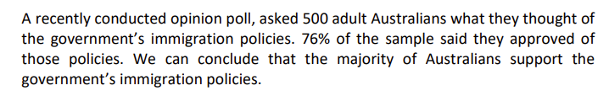

the sample is too small

Statistical generalisations are not straightforward to either prove or disprove, so in the absence of good evidence either way, you ought to remain undecided. If you encounter a statistical generalisation as a premise in an argument but are not told how it was derived or what the source is, the argument is in trouble

### An example argument



* the first premise is based on an appeal to authority
  + position to know (does the profiler have the relevant training and expertise?)
  + reliability (how reliable is this kind of psychological profile in general? How reliable is this particular profiler? Is there any reason to think they might be biased?)
  + corroboration (do other, independent relevant experts agree?)
* the second premise is a statistical generalisation
  + we should not accept that premise without further research. it is not the same as saying that the premise is false.

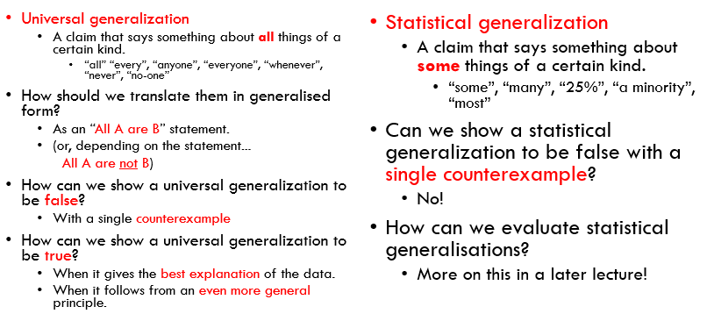

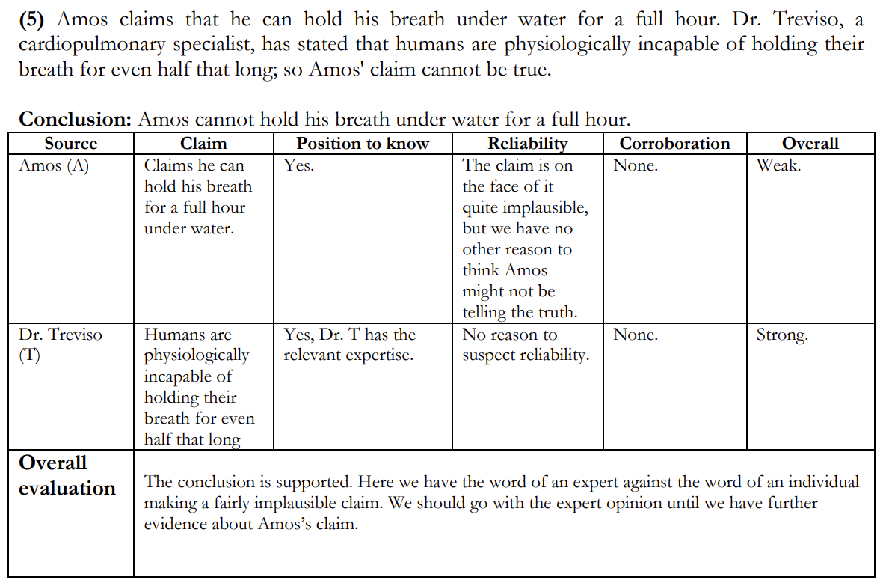

# Analysing complex arguments

## Independent and co-dependent premises

Co-dependent premises are premises that rely on each other to jointly support their conclusion. Co-dependent premises are sometimes called **linked or joint** premises.

* When an argument has co-dependent premises, all the co-dependent premises must be true.

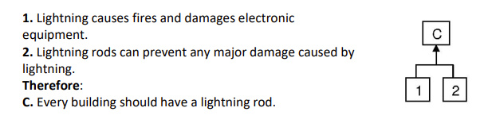

Independent premises are premises that support their conclusion without relying on each other. Each premise by itself provides some support for the conclusion. Independent premises are also sometimes called **convergent** premises.

* When an argument has independent premises, we can have a false premise and yet still have a successful argument – still have a good reason to accept the conclusion.

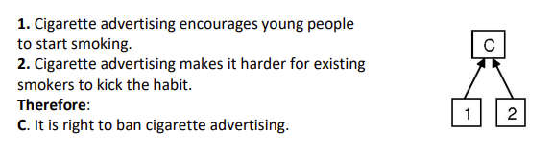

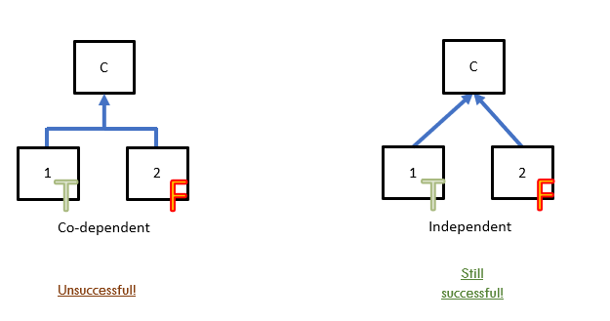

## Combining linked and independent premises

the argument has a mixture of linked and independent premises

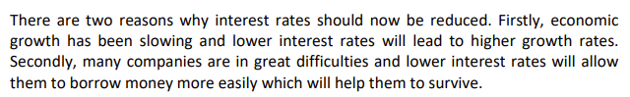

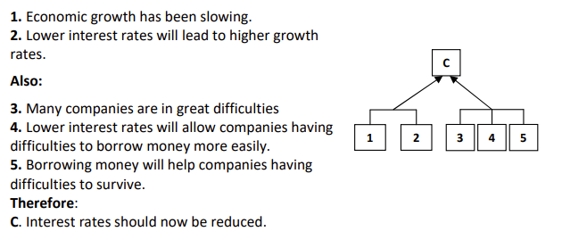

Two independent reasons for accepting the conclusions, we can use Also to connect them

## Sub-arguments

A sub-argument is an argument used to establish a premise of a further argument.

The conclusion of that further argument may then serve as a premise in another argument and so on, leading to a chain of arguments.

A conclusion of an argument which is used as a premise in a further argument is called an intermediate conclusion (because it occurs somewhere in the middle of a chain).

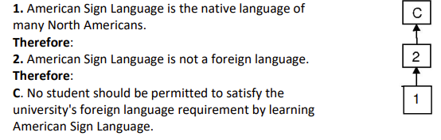

## Evaluating

### Success VS Soundness

Successful argument: an argument that provides a good/compelling reason to accept its conclusion. Deciding whether an argument is successful still requires thinking about support and the truth of the premises.

Sound argument: a deductively valid argument with ALL true premises.

## complex arguments

1. Evaluate sub-arguments and the main argument separately
2. If a premise has a sub-argument:
   1. FIRST, evaluate the sub-argument (support + true premises).
   2. THEN if the sub-argument is not successful (i.e., it doesn’t give us a good reason to accept the intermediate conclusion/premise) consider any independent reasons for accepting or rejecting the premise.
3. we can’t tell that an intermediate conclusion is false, just by showing that the sub-argument is unsuccessful

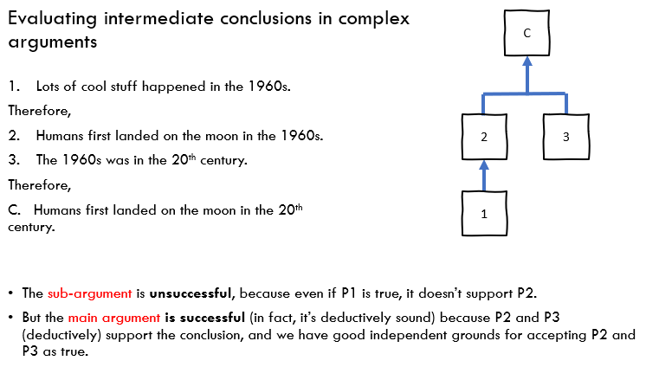

# Inference from a sample

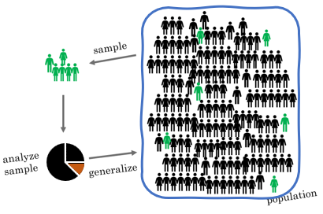

## Sample, Population and Target Property

* SAMPLE. The group of individuals or cases **examined** is called the sample.
* POPULATION. The entire group of individuals or cases the argument **attempts to conclude** about is the population.
* TARGET PROPERTY. The target property is the **feature or property** of the individuals or cases which the argument attempts to generalise.

EX:

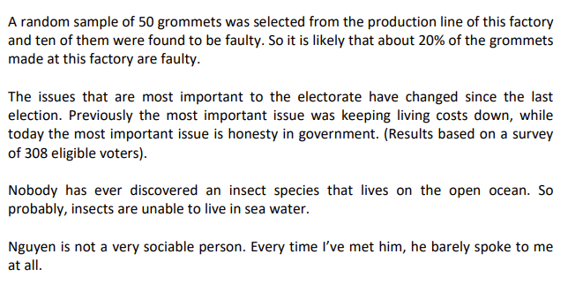

* first example
  + sample: 50 grommets that were randomly selected
  + population: all the grommets made at that particular factory (that’s what the argument concludes about)
  + target property: whether a grommet is faulty or not.
* second argument
  + sample: 308 voters who were surveyed
  + population: all current eligible voters in the country
  + target property: which is most important to a voter in the election

## A general pattern for inference from a sample

All arguments which generalize from a sample can be thought of as fitting the following pattern:

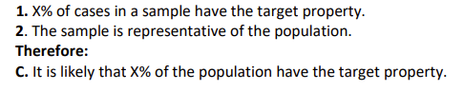

## Sample size

large sample of individuals is better than a small sample, but why are larger samples better?

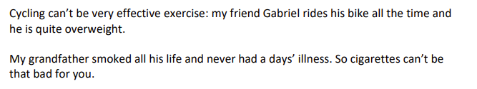

### The sample size principle

The smaller the sample, the **more** likely it is that you get an atypical or unrepresentative result.

A larger sample is **less** likely to give you an atypical or unrepresentative result.

### The sample size principle in action example

Knowing about the sample size principle, you are not so sure. The smaller hospital will carry out fewer operations each month than the larger hospital. So, the smaller hospital’s monthly success rate is based on a smaller sample of operations. Atypical results will occur more frequently with a smaller sample. So, a success rate of less than 50% will occur more often for the smaller hospital than for the larger one. In other words, the four reports filed by the smaller hospital are what you might expect to see just due to random variation and the smaller monthly sample.

## Random samples and margin of error

The margin of error depends on the sample size and tells you how much error you can expect from random sampling variation.

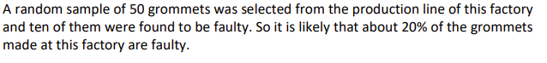

if you took repeated random samples of size 50 from the population, then 95% of the time, the sample proportion would be within 5% of the true proportion, so the margin of error for this sample size can be calculated and is approximately 5% at a 95% confidence level

## The size of the population does not matter

A random sample of 50 individuals from a population of 2 thousand is just as accurate as a random sample of 50 individuals from a population of 2 million

## Biased samples

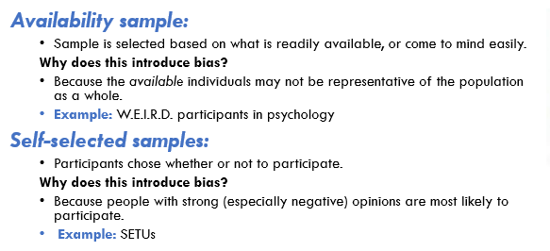

### Self-selected samples

A self-selected sample consists of people who choose themselves to be part of the sample by responding to a general appeal.

In opinion polls, self-selected samples are likely to be biased because people with strong opinions are more likely than others to respond.

* psychologist investigating the relationship between personality types (as measured by a questionnaire) and professions. She might publicise her study and ask for volunteers to complete the questionnaire and indicate their profession. Even if she obtains a large sample, it would probably be biased because people of certain personality types could be more willing to volunteer.

It may go not bias depending on the target property.

* E.g.: a medical study to test the effectiveness of a new treatment for a certain disease. By necessity, such a study will consist of volunteers

### Availability samples

An availability sample is one in which individuals are selected because they are easily accessible, rather than through a random process.

The availability fallacy occurs when we base a conclusion on a sample of cases that are memorable, striking or in some other way psychologically salient.

Samples obtained in this way are likely to be biased because what is psychologically salient is not necessarily representative.

Example: 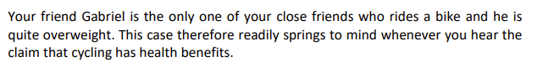

you make a judgement based on a case that easily comes to mind. This explains why arguments based on a sample size of one are so common and so compelling to people, especially if we don’t consider exactly what evidence we are basing our judgement on. I call this the availability fallacy.

memorable or psychologically salient cases might be memorable or psychologically salient exactly because they are not typical. The typical, average or normal case is often uninteresting and forgettable

## Problems with measuring the target property

questions like ‘Have you ever stolen stationery from the office?’ majority of people say ‘no’. People are not likely to admit to criminal or unethical behaviour, even if they are told their answers will be anonymous.

wording of a question, or the order in which questions are asked in a survey, can influence the answer people give.

## Measurement bias

Measurement biases are issues with the process of measuring the target property which leads to an inaccurate view of how that property is distributed in the sample.

* Inaccuracies in memory
* Motivations to lie
  + do you have racist attitudes?
* Wording of questions
  + Different wording can encourage participants to think about a question differently
    - ‘Do you support independence for Scotland?’ (51% yes)
    - ‘Do you support an independent Scotland, separate from the United Kingdom?’ (34% yes) B

## some important questions to ask are:

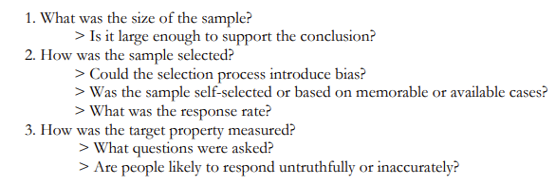

# Arguments for causation

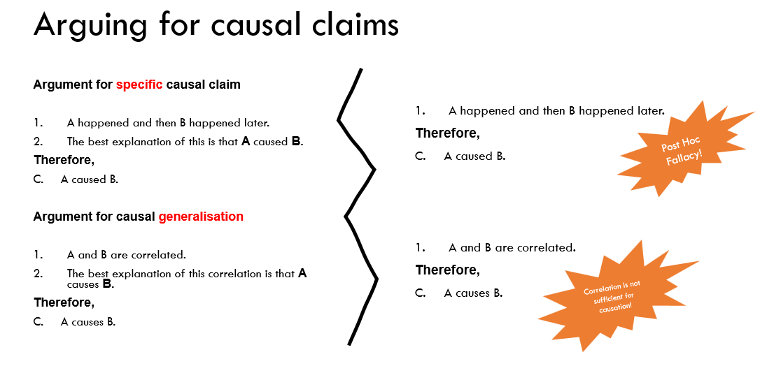

A causal claim explains why something is true by making a statement linking a cause to an effect.

Causal claims also play an important role in personal decision-making:

* people quit smoking because they accepted the causal claim that smoking causes lung cancer and other serious health problems

What evidence do we need to accept a causal claim?

What kind of arguments can there be for thinking there is a causal connection between two things?

## Types of causal claim: specific and general

Specific: one particular event caused another particular event

* The car crash was caused by the driver using his mobile phone while driving.
* Jane is anxious because she has two medical exams tomorrow.

General (causal generalisation): events of one kind tend to cause events of some other kind

* The main cause of criminal behaviour among adolescents is inadequate parenting.
* A diet high in fresh fruit and vegetables prevents heart disease.

Causal generalisations can be tricky

* because smoking causes lung cancer. Does it mean that everyone who smokes invariably gets lung cancer? No. Does it mean that everyone who gets lung cancer is a smoker? No.
* What the claim means is that smoking increases your risk of developing lung cancer
  + A causes B does not mean that A is sufficient for B and it does not mean that A is necessary for B
  + A might not be necessary for B because A need not be the only way for B to happen

## ‘Post hoc’ reasoning: a very common fallacy

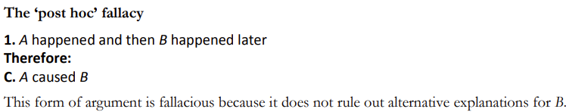

you can refute a causal claim by pointing out that A cannot have caused B because B was already true before A happened.

Example: The government’s economic stimulus program is working to reduce unemployment. Since its introduction, the unemployment rate has fallen by 15%.

* There are many other possible explanations
* A happened (the government introduced its policy) and then B happened later (unemployment fell)
* We do not have good evidence for a causal link between the economic stimulus program and the unemployment rate has fallen

## Arguments for specific causal claims

consider all the likely explanations and then eliminate all but one of them

Example: The lemon tree in my garden is dying. The most likely causes are insufficient water, poor soil or a disease. But the tree gets plenty of water and the soil is well suited for citrus trees. So, it is probably a disease that is killing my lemon tree.

* The first premise tells us that the most likely cause is either A, B or C.
* The second premise tells us that cause is not A and not B.
* It follows that C is the most likely cause
* the premises might not all be true, and the list of likely causes might not be complete

this kind of argument can be sufficient to establish beyond a reasonable doubt the cause of some event, provided that all the likely causes have been considered and the evidence which rules out all but one is sufficient

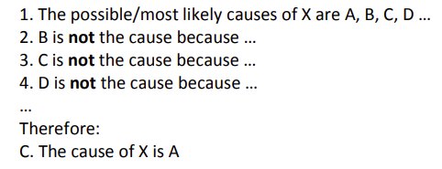

For the argument to be strong, each premise would have to be backed up by sufficient evidence.

## Causal generalisations and correlations

These claims do not tell us about the causes of a specific event, but instead tell us that in general, events or actions of type A are a causal factor in producing outcomes of type B. that A and B are correlated (or ‘associated’) with each other

Correlation between attributes

* There is a (positive) correlation between the attributes A and B when B is more likely if A is present than if A is not present.

Negative correlation between attributes

* There is a negative correlation between A and B when B is less likely to occur if A is present than if A is not present.

## Correlations between quantities

There is a positive correlation between the quantities A and B when individuals with higher values of A are more likely to also have higher values of B.

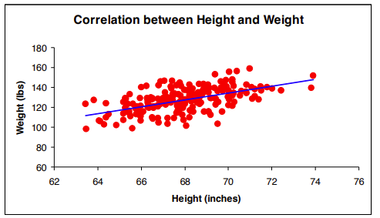

### Strength of a correlation

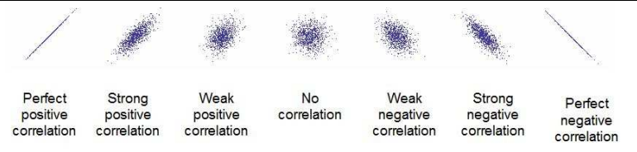

### Correlation is not sufficient for causation

Correlation alone is not sufficient to establish causation

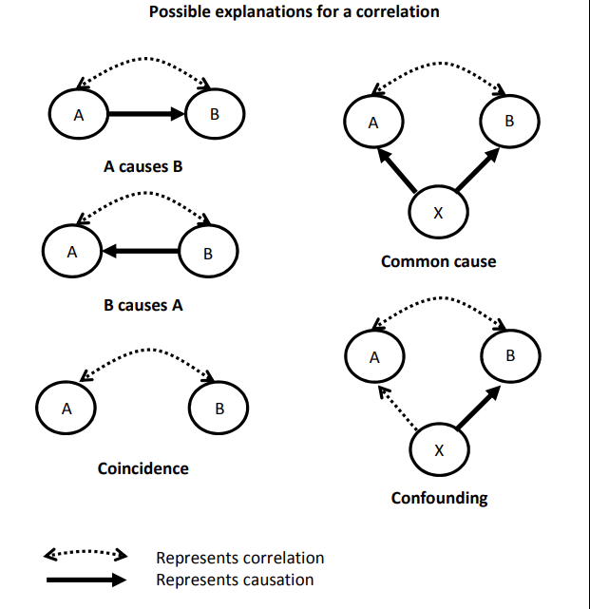

1. A and B are correlated because A causes B
2. A and B are correlated because B causes A
3. A and B are correlated because a third factor X causes both A and B (common cause)
4. A and B are correlated because a third factor X is correlated with A and X causes B (confounding)
5. The correlation is a coincidence – just due to chance.

*Randomized* controlled trials

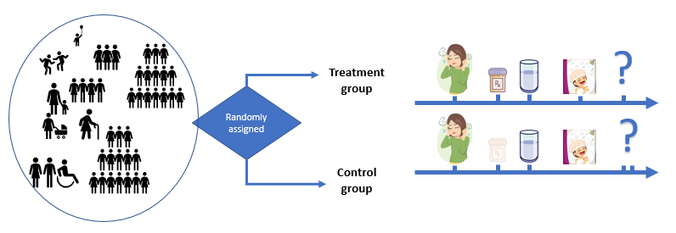

In a randomized controlled trial to determine if intervention A causes a change in an outcome B, the procedure is as follows:

1. Compare two large groups of individuals, the treatment group and the control group.

2. Use randomization to ensure that the two groups are equivalent at the start of the experiment.

3. Measure B at the start of the experiment.

4. As far as possible, make sure that everything that happens to the treatment group also happens to the control group except that the treatment group receives intervention A. (Equal treatment for both groups).

5. Measure B again at the end of the experiment and compare the two groups.

• If B has changed in the treatment group more than it has changed in the control group, you have good evidence that A causes B.

• If B has not changed more in the treatment group than in the control group, the experiment has not shown that A causes B.

# Normative reasoning

Normative (or prescriptive) claims say something about **how things should or should not be**.

* Common indicators: should, ought, must, need to, have to, fair, just, right, wrong, good, bad, responsible, irresponsible.
* Normative claims occur
  + about what a particular individual should do if they want to achieve a certain goal
  + and claims about government or social policies.
  + moral or ethical claims may be controversial
* Normative: Raju needs to lose weight.

Descriptive claims are about **what *is* the case**, how they were in the past, or how they could be in the future or hypothetical scenarios

* Descriptive: Raju weighs 200 pounds (91 kilograms).

## Why care about normative arguments?

Normative claims are:

* allow us to express our personal choices and decisions
* central to decisions about health and risk, business decisions, social policies, politics, and ethics
* a powerful way to lead us towards change or even just consider what change might look like
* allow us to envision a world in which things could be different from how they are, consider what things should be like, and find a path that can guide us in that direction
* great power and importance can also make normative arguments especially hard to evaluate. The more we care about a particular issue the harder it is to evaluate the reasons supporting our opinions in a calm and take competing positions seriously
* many people think normative claims and values are purely subjective

## Evaluating normative arguments

Normative arguments are arguments in which reasons are given for or against a course of action

two basic questions:

* Are the premises acceptable as true?
* Do the premises provide sufficient support for the conclusion?

Descriptive or factual claims on their own are not sufficient to support a normative conclusion. If the conclusion of an argument is a normative claim, there must be at least one normative premise; If no normative premise, there must be unstated normative assumptions

Example: Cigarette smoking is a health hazard. Governments should ban all advertising promoting

1. Cigarette smoking is a health hazard.

C. Governments should ban all advertising promoting cigarette smoking.

The assumption:

A2. Governments should ban advertising that promotes activities that are a health hazard

To evaluate this claim we can search for counter-examples and make the assumption reasonable.

The better assumption:

A2. Governments should ban advertising of products that contribute to serious public health problems.

## Common problems with normative arguments

The most common problem: they are one-sided. A good argument would weigh up the pros and cons to come to a reasoned conclusion about whether the positives outweigh the negatives.

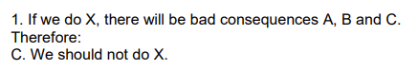 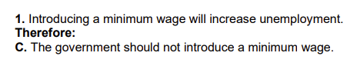

it is not sufficient to establish the conclusion: a minimum wage might have some positive effects. Depending on the size of the increase in unemployment, those positive effects might be enough to tip the balance in support of the policy

many debates involve people defending one-sided arguments.

* when people defend exaggerated positions. The ‘for’ side will tend to exaggerate the positives and downplay or not mention the negatives. Equally, the ‘against’ side will exaggerate the negatives and downplay or ignore the positives
* when both sides have their supporting experts. Evaluating the credibility of sources is difficult and time-consuming and can be especially tricky when different experts argue for different positions.

### ‘loaded’ or ‘emotionally charged

Loaded words and phrases can make factual claims look as if they provided support for normative claims

Example: 99% fat-free vs. 1% fat content; Credit card surcharge vs. cash rebate; Save money by doing X vs. lose money by not doing X

* What happens is that the emotional connotations of the words can make a big difference as to which option seems preferable
* These differences appeal to our cognitive biases and lead to fallacious arguments
* differences in language make no difference to the strength of support
* we are trying to ignore such irrelevant factors in assessing these arguments.

# 10. Informal fallacies

* Formal fallacies: A logical error due to the form or structure of an argument.
* Informal fallacies: An inappropriate form of argument that doesn’t involve an error in form or structure:
  + E.g., making flawed assumptions, adding irrelevant claims, misusing language, distorting an opponent’s position etc.

informal fallacies are not a matter of invalid structure or form. Informal fallacies result from making flawed assumptions, misusing language, or making questionable appeals to authority

Informal fallacies are extremely widespread

* It is used to spin the evidence in a way that seems to support one’s interests
* frequently used by politicians and on social media
* used with manipulative intent
* commit informal fallacies without realising it

## Questionable assumptions

### begging the question

if an argument depends on a questionable assumption, then it may fail to satisfy that all the premises are true

Example: Same-sex adoption is wrong because the welfare of children is more important than satisfying the parental cravings of gay and lesbian couples.

the unstated assumption that children’s welfare is in some way incompatible with same-sex adoption which is wrong

Circular reasoning

An argument is **circular** if the conclusion is used as support for itself (explicitly or implicitly).

Example: Paranormal activity is real because I have experienced what can only be described as paranormal activity

conclusion restates the supporting assumption in slightly different words

**Notice**: we cannot say that circular or question-begging arguments depend on a false assumption. Indeed, the whole point of the argument is to try to find out whether the hypothesis was true or false.

### False dichotomy/False dilemma

A **false dilemma**, or **false dichotomy**, incorrectly presents two opposing views, options or outcomes as if they were the only possibilities: if one is true, the other must be false, or if you don’t accept one, you must accept the other. In doing so, it leaves out other alternative options.

arguments assume there is no middle ground

Example: You’re either with us or you’re against us!

### slippery slope arguments

The purpose of an argument is to show that a proposition is unacceptable and that, if accepted, it will lead to a series of increasingly unacceptable events

Example: You seem to have a good excuse to hand in your assignment late. But if I don’t give you a late penalty, then I will be inundated with similar requests, and deadlines will just become meaningless. Sorry, I can’t make any exceptions!

To evaluate such an argument:

* Is each step likely to cause a slide to the next step?
* Is there a way to intervene and prevent the slide from happening?
* Has a similar slide occurred (or been prevented) in the past?
* were the circumstances similar to the ones we have now?

### Red herring

use premises that are logically unrelated to the conclusion to distract attention from the actual issue.

Example: We can't raise salaries, but we still provide great benefits for our employees.

## Questionable language

word or phrase is ambiguous if it can mean more than one thing

example: Broadcaster: Our radio station has a responsibility to serve the public interest. Hence, when our critics contend that our recent exposés of events in the private lives of local celebrities were excessively intrusive, we can only reply that the overwhelming public interest in these matters makes it our responsibility to publicize them.

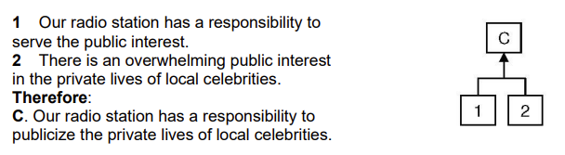

### Equivocation

* If an arguer uses an ambiguous word to mean one thing in one premise and another thing in another premise
* **Equivocations can be very subtle**, and a person may not realize that they are using the same term in two different senses.
* There can be **real disagreement** as to whether an argument involves an equivocation at all.

**Semantic ambiguity**: A word or phrase is ambiguous if it has more than one accepted meaning.

Yesterday, I sat on the bank and caught three fish.

Yesterday I went to the bank and deposited a cheque.

**Syntactic ambiguity** arises when there is more than one way to interpret the grammatical structure of a sentence.

Laurie calls her mother when she's alone.

Juvenile Court Tries Shooting Defendant

Squad Helps Dog Bite Victim

**Referential ambiguity** arises when it is unclear which thing or group is being referred to.

Everybody is coming to the party.

## Questionable authority and attacks on the authority

appeals to authority and attempt to undermine the authority of a real or imagined opponent.

### appeal to authority

appeal to authority goes wrong when it claims that the truth of a claim is established solely by the fact that a particular person said so. Even appeal to a credible expert and where the claim is likely true. If you accept a true claim for the wrong reasons, you are still committing a fallacy.

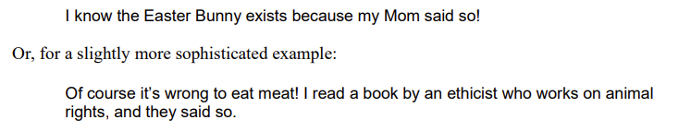

Even if the claim about expertise is legitimate, that in itself does not support the truth of the conclusion.

questions to ask:

* is the appeal to authority legitimate?
* Is the person an expert on the topic being discussed?
* does the fact that they are experts support the conclusion?

### personal attack (ad homine)

focuses on a personal detail or character flaw of the opponent. it is irrelevant to the issue at hand. The personal attack is therefore also closely related to red herring arguments.

#### guilt by association (or: you too!)

try to tarnish someone’s credibility by associating them with another person or group that has a bad reputation.



#### strawman

Strawman's arguments are related to personal attacks and guilt by association because they are designed to undermine the credibility of an opponent

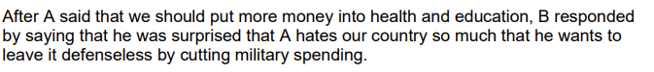

Questionable authority and attacks on authority make your position weaker. This is because, in all of these cases, you are not engaging with the actual argument, which makes your criticism virtually irrelevant

# Critical Thinking in the Wild

## Mindset

### Soldier

* The goal is to show that my beliefs are the right ones.
* New information that challenges something I believe is seen as a threat to be neutralized.
* Biased

### Scout

* The goal is to arrive at more accurate beliefs.
* New information that challenges something I believe is seen as an opportunity to update my beliefs.
* Unbiased

## Cognitive Biases

A cognitive bias is a systematic error in thinking often due to implicit psychological shortcuts.

Examples:

* Motivated reasoning
  + Forming or maintaining a belief at least partly **because**, at some level, **we want it to be true**.
  + 93% of American drivers rated themselves better than the median driver (Svenson 1981).
* Confirmation bias
  + The tendency **focuses on potential evidence for our pre-existing views**, and to **neglect or discount contrary evidence**
  + Confirmation bias can be present without an underlying motive to have the belief in the first place.
  + left-handed people are more creative than right-handed people
* Availability heuristic
  + Tendency to think that the examples that **easily come to mind** are more representative than is the case.
  + skewed by irrelevant factors:
    - intensity of emotion
    - framing of question
    - order effects
    - media biases
* Ingroup bias
  + We have more empathy for people we perceive to be like us (in-group).
  + How would I react to this evidence if it showed my belief to be false?