# What are information systems?

A set of components for collecting, storing, and processing data and for delivering information

Organization relies on it to carry out and manage their operations interact with their customers and suppliers, and compete in the marketplace.

**main components of an information system:**

* People
* Procedures
* Hardware
* Software
* Databases
* data warehouses
* telecommunications

**Assessing an information system:**

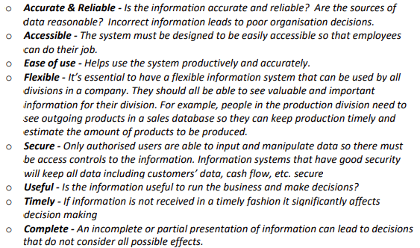

* Accuracy and reliability
* Accessibility
* Ease of use
* Flexibility ()
* Security
* Usefulness
* Timeliness
* Completeness

**How to develop Information Systems:**

1. Initiation: Feasibility
   * Can you afford?
   * any time constraints?
   * What do you really want?
   * If there is a good chance that you can get what you want ON TIME and WITHIN BUDGET
2. Analysis
   * Does the client know what they want?
     1. Important to show the client your understanding of requirement

* **Build or Buy?**

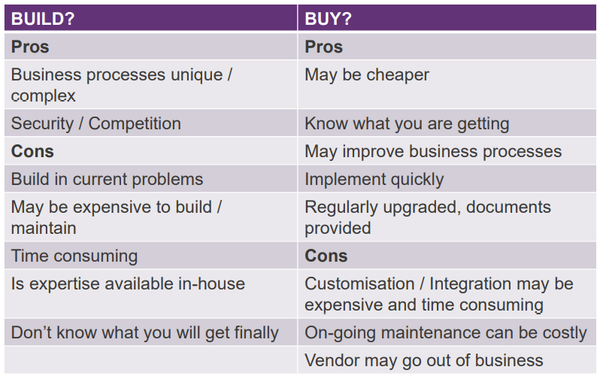

1. Design

* Detailed plans for the build
* Plans for every component

1. Implement-Build/Develop

* Good analysis and design are essential for a good build
* just building expertise is NOT enough

Deploy

* Does it meet: Government requirements CLIENT requirements
* Are your clients happy?

1. Support – Maintain it, Extend it

* Can it be easily maintained and fixed
* Can it be added to it easily?

**Systems Development Life Cycle SDLC:**

* Phase 1. Initiation
  + Review and prioritise project requests
  + Assess project feasibility
  + Develop the project plan
* Phase 2. Analysis
  + Determine detailed user requirements
  + Create system models to confirm requirements and design
  + Perform Build vs Buy analysis
* Phase 3. Design
  + Define technical architecture
  + Produce technical specs
  + Create database
* Phase 4. Implementation
  + Build, Test, Validate
  + Conduct Integration, System and Acceptance testing
  + Create User Docs, Train users
  + Install, Deploy new system
* Phase 5. Support
  + Conduct post-implementation system review
  + Identify errors and enhancements
  + Monitor system performance

**Effort distribution:**

It bases on type of project and size of project

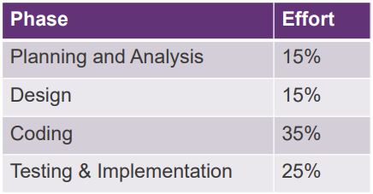

**Critical skills for:**

* Understanding business
* up-to-date understanding of technology
* Multiple Perspectives
* People/Soft Skills- ability to interact with other people
* Continuous Learning