**Development approaches:**

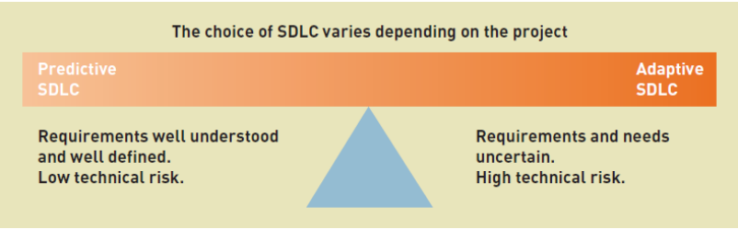

Most projects fall somewhere on this continuum

**Frameworks / Methodologies definitions:**

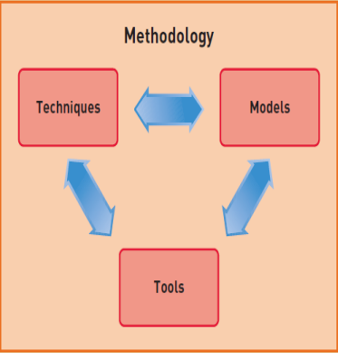

* Frameworks- Provide structure and direction on doing something
* Methodologies- A set of principles, tools and practices the team agree to follow to achieve a particular goal

**Traditional Waterfall framework:**

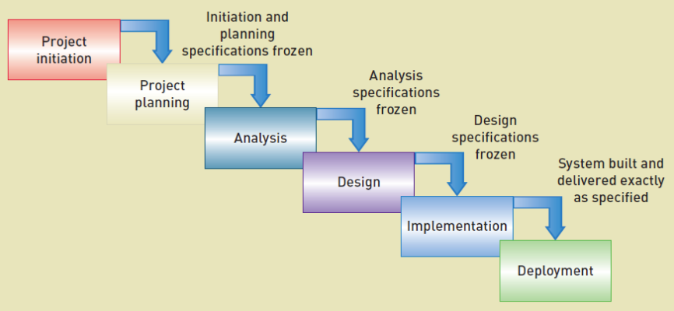

* Dominant 70s to 90s
* Sequential stages – no overlap or iteration
* Strong emphasis on planning and specifications development
* Works well for clearly defined projects - planning, extensive project documentation and tight control over the development process
* Issues - tends to be slow, costly and inflexible
  + Inability to adjust the product to market requirements often results in waste of resources

**Development often moved towards an Adaptive framework**

More flexibility but still assumes predictive planning and sequential phase

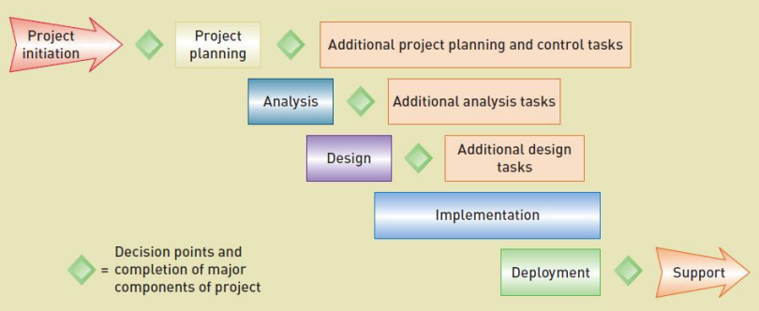

**Agile Iterative frameworks**

The system is “grown” piece by piece through multiple iterations

Agile vs. Waterfall:

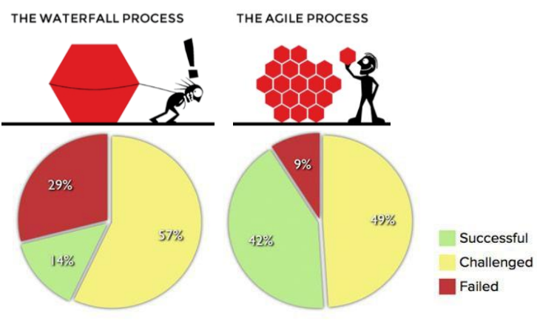

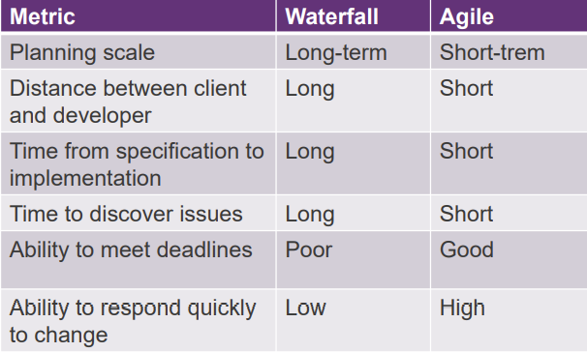

* Agile frameworks take an iterative approach
* Each iteration is a small project with the defined scope
* At the end of each sprint, a potentially shippable product increment is delivered.
* Every iteration sees new features added to the product

Framework example – SCRUM(?)

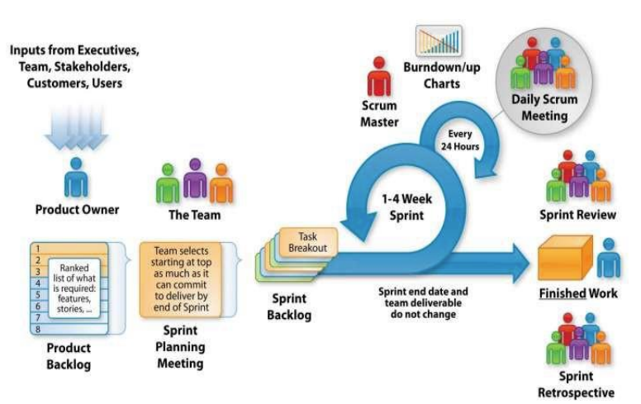

Product owner- defines and prioritises product features, accept or reject work items

Scrum Master- applying agile principles, ensures team's productivity, builds a team

Development Team- 5-9 members, high performance, cross-functional team

**Backlog & Sprint Backlog**

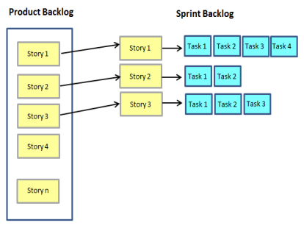

Product Backlog:

* single source of requirements
* every feature, enhancement, bug fix, documentation requirement, every bit of work required by the team
* Prioritised to maximise value

Sprint Backlog

list of tasks the team must complete delivering an increment of functional software at the end of each Sprint

**Sprint Burndown Charts**

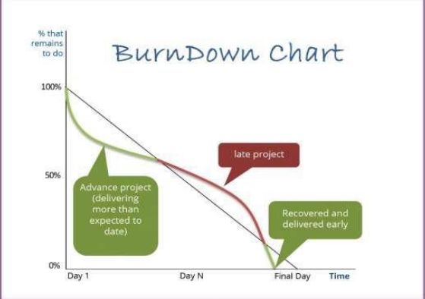

total estimated work remaining for the entire forecasted sprint backlog against time

**Task Board (Kanban)**

* visibility, transparency across the project
* Displays the live status of team work and focus
* Backlog, To-do, In Progress (Doing) and Done

**Product Increment**

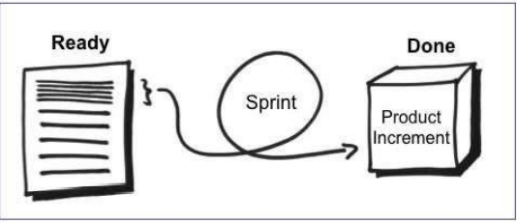

end product for each sprint：

* high enough quality to be given to users
* Scrum team's current definition of DONE
* acceptable to the product owner

**SCRUM Activities：**

A sprint cycles

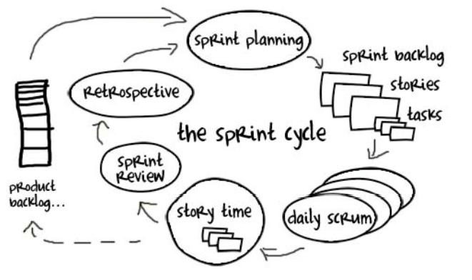

Start of the Sprint - Sprint Planning：

* Determine which items from the product backlog they will work
* The result of Sprint Backlog – defines the scope of the sprint
  + Discussion with product owner – WHAT will we do
  + Team – HOW will we do it

During the Sprint - Daily Stand Up：

* Short discussion following day activities:
  + What I work on today
  + Any Issues/blockers
  + What I did since last daily scrum meeting

End of the Sprint – Review and Retrospective：

Review:

* team does a review to get ‘Product Increment’ feedback from the Stakeholders
* Feedback goes into the ‘Product Backlog’ for future consideration
* Not intended to provide a status report

Retrospective:

* The team reflect upon how things went during the previous sprint
  + What went well
  + What could be improved

# STAKEHOLDER MANAGEMENT

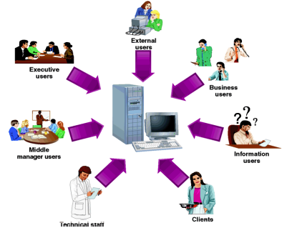

Stakeholders- People interested in the success

**Identify stakeholders:**

* Who gains and who loses?
* Who controls change management of processes?
* Who will make the decisions?
* Who controls resources?
* Who has influence?
* Who has specialist skills the project needs?
* who decides what to buy?

**Prioritise and understand your stakeholders:**

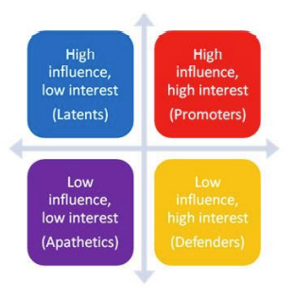

* Influence = Power
* Determines how you engage / communicate with them
* Systems fail if they don’t meet expectation