**What are requirements gathering?**

* Investigating requirements-Developing a deep understanding of the business domain
* Defining solution needs to meet the requirement
* Identifying opportunities improving business processes – Business Process Re-engineering (BPR)
* Requirements must be verified by the client

**What do you need to gather?**

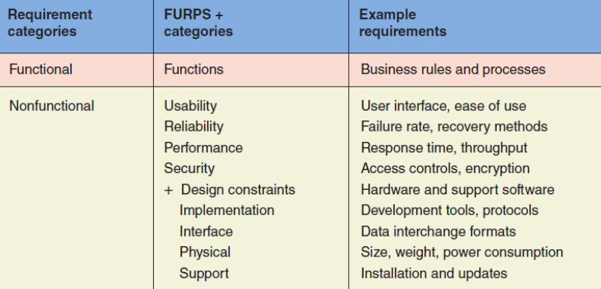

INVESTIGATING SYSTEM REQUIREMENTS

* Interview
  + Issues: time-consuming, resource intensive, multiple session
  + Preparing:
    - clear objectives
    - Select appropriate stakeholders
    - Determine the type of interview
    - Consider company documentation
    - Develop an Agenda

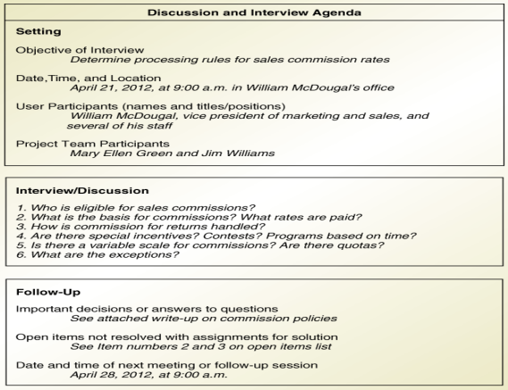

* + - Avoid long interviews: Hard to absorb, Participants often time poor, Several shorter interviews better
  + Logistics:
    - Planning: Location and time, Objectives and list of questions
    - Finalise: send reminders
    - Arrive early
    - room is prepared
    - Decide on a documentation method: Take notes, Recording, Video taped
  + successful interview
    - Lead the conversation with the information
    - Consider the interviewee’s knowledge and role
    - Use easy to understand words
    - open-ended questions: identifying new ideas, help analysts to identify a large number of business processes
    - closed questions to collect specific facts
    - Avoid biased or loaded questions
    - explain important findings
    - Ask for follow up after the interview
  + How to Get the Information You Want
    - Review current problems
    - Talk about activities and responsibilities for every role
    - Ask leading questions about each part of the process
    - Identify exception and error-handling
    - Ask questions to identify new system requirements and identify business opportunities
  + Follow up
    - All documentation after the interview should be reviewed
    - explain and verify the models with the interview participants, and ask further questions
* Questionnaires
  + gathering limited and specific information large number of stakeholders
  + Good when the people are widely dispersed
  + give a preliminary insight
  + Not well suited for gathering detailed
* Review existing reports
  + Existing business documents and procedure
  + Identify business rules, discrepancies, and redundancies
  + Can help guide interviews
* Observe
  + Not necessary to observe all processes at same level of detail
  + May make users nervous: Hawthorne effect
  + 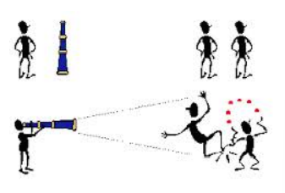
* Research competitor solutions
  + Positive
    - – Frequently provide new ideas
    - – May be state of the art
    - – Cheaper and less risky
  + Danger: May purchase solution before understanding problem
  + Validating the requirements
    - regularly to get feedback
    - must confirm that your understanding of the requirements
    - 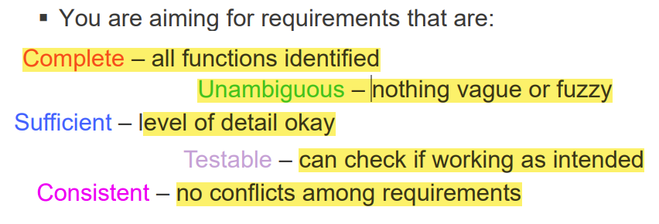
* Prototyping
* Story-writing workshops