# Video 1:

## Projects Cannot Be Run in Isolation:

* Must operate in an organisational environment
* managers need to use systems thinking: taking a holistic view

## Systems approach:

* Systems philosophy: an overall model for thinking about things as systems
* Systems analysis: problem-solving approach
* Systems management: address business, technological & organisational issues before making changes to systems

## Perspectives on organisations:

* Structural frame:

organization focuses on different groups' roles and responsibilities in order to meet the goals and policies set by top management

Roles & responsibilities, coordination & control

Organisational charts

* Human resources frame:

Harmony between needs of organisation & needs of people

* Political frame:

Coalitions composed of varied individuals & interest groups

Key issues: conflict & power

* Symbolic frame:

Symbols & meanings related to events

Culture, language, traditions & images

## Organisational structures:

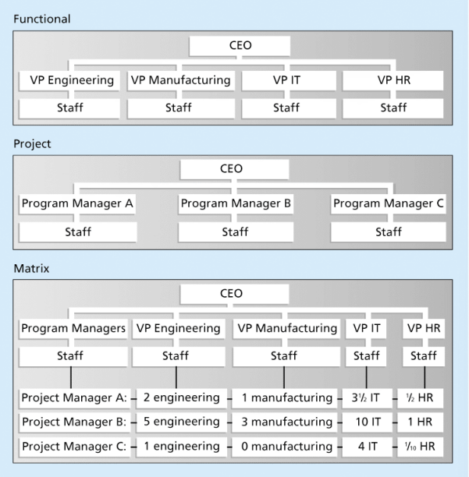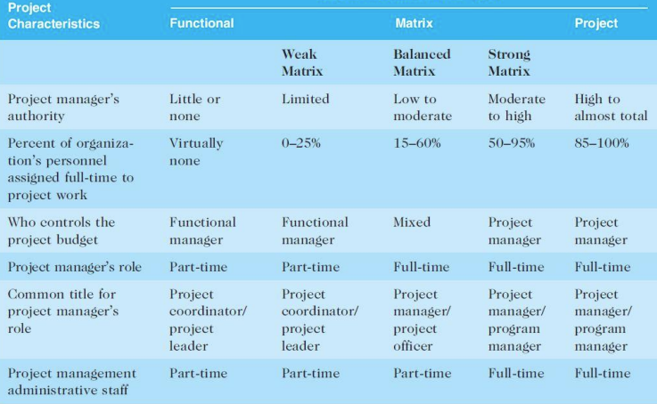

* Functional: functional managers’ report to CEO
* Project: program managers report to the CEO
* Matrix: middle ground between functional & project structures

personnel often report to 2+ bosses

## Organisational culture:

a set of shared assumptions, values, behaviours that characterise the functioning of an organisation

## 10 characteristics:

Strong/high:

* Member identity (the degree to employees identifies with the organization as a whole, rather than with their types of job or profession)
* Group emphasis
* Risk tolerance
* Reward criteria
* Conflict tolerance
* Unit integration (refers to the degree to which departments within an organization are encouraged to coordinate with each other)
* Open systems focus

Balanced:

* People focus
* Means-ends orientation
* Control

# Video 2:

## Stakeholder Management- Lecture 8:

* Project managers must identify, understand, and manage relationships with stakeholders
* Using the four frames of organisations can help meet stakeholder needs and expectations

## Top Management Commitment:

* the commitment and support project managers from top management lead project success

**How:**

* Providing adequate resources
* Approving unique project needs in a timely manner
* Getting cooperation from other parts of the organisation
* Mentoring and coaching on leadership issues

**IT Governance:**

Authority and control for key IT activities, including IT infrastructure, IT use, and project management

## Organisational Commitment to IT:

* the organisation has a negative toward IT, IT project difficult to succeed
* Chief Information Officer (CIO) at a high level is good
* Assigning non-IT people to IT projects and increasing involvement from end-users is good

## Organisational Standards:

Standards and guidelines help project managers be more effective

Senior management can encourage:

* use of standard forms and software for project management
* development and use of guidelines for writing project plans
* creation of a project management office

# Video 3:

## Project life cycle:

A collection of project phases that defines:

* What work will be performed in each phase
* What deliverables will be produced and when
* Who is involved in each phase
* How management will control and approve work produced in each phase

## Deliverable:

A product/service produced or provided as part of a project

## Project Phases:

The project passes through each of the project phases to continue on to the next.

Management reviews occur after each phase to evaluate the progress

Early:

* resource needs are the lowest
* uncertainty (risk) is highest
* stakeholders have the greatest opportunity to influence the project

Middle:

* certainty of completing a project improves
* more resources are needed

Final:

* ensuring that requirements were met
* sponsor approves completion of the project

## Traditional project life cycle:

Traditional project phases include：

* Project feasibility
  + 1. Concept
    2. Development
* Project acquisition
  + 1. Implementation
    2. Close-out

## Project life cycle (PLC) VS systems development life cycle (SDLC)

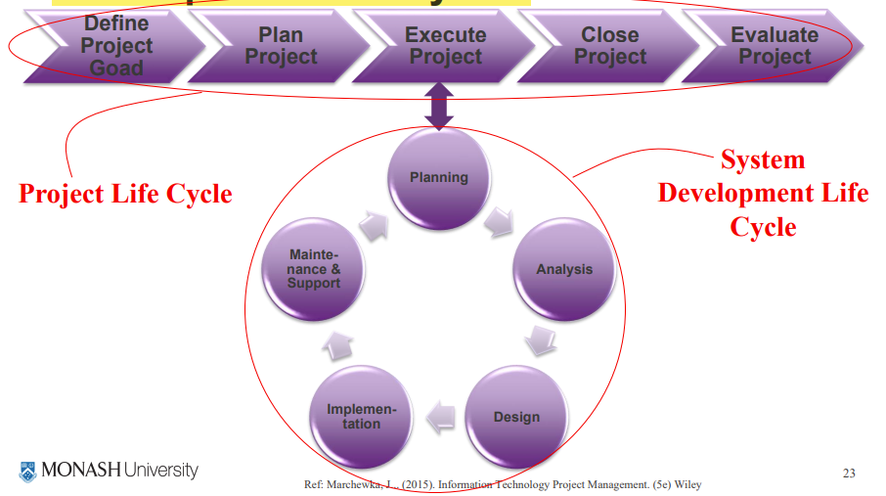

PLC:

* Defined project goal
* Plan project
* Execute project
* Close project
* Evaluate project

SDLC: a framework for describing the phases involved in developing and maintaining information systems

* Planning
* Analysis
* Design
* Implementation
* Maintenance & support

Can follow:

* Predictive life cycle: clearly articulated scope & predicted schedule, cost
  + 1. Waterfall model

Well defined, linear stages of systems development and support, traditional lifecycle model, well understood, easier to manage than agile when working on large complex applications

* + 1. Spiral model

Software is developed using an iterative/ spiral approach

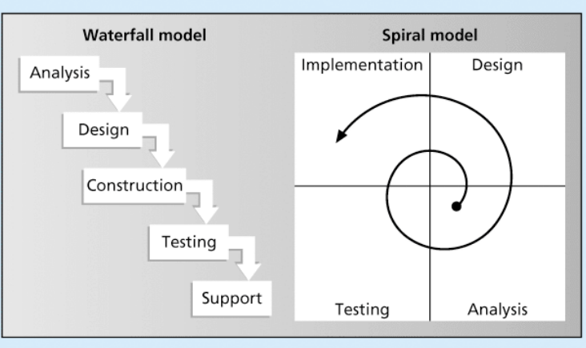

* + 1. Incremental build model

Progressive development of operational software

Each release provides added capabilities

Software from v0.01 – v0.10.01

* + 1. Prototyping model

Use a model to generate functional requirements & physical design specifications simultaneously

* + 1. Rapid application development (RAD) model

Work with an evolving prototype

Rapid prototyping & code generation: tools eg. computer-aided software engineering, joint requirements planning, joint application design

* Adaptive software development (ASD) life cycle:

Requirements cannot be clearly expressed

Mission-driven & Component-based

Time-based cycle

**Agile Software Development-Lecture 11:**

Extreme programming, feature driven development, dynamic systems development model

Focus on close collaboration between programming teams and business experts

# Video 4:

**Context of IT Projects:**

* very diverse in terms of size, complexity, products produced, application area, and resource requirement
* members often have diverse backgrounds and skill sets
* use diverse technologies that change rapidly
* within one technology area, people must be highly specialized
* Trends:
  + Globalization
  + Outsourcing
  + Virtual teams
  + Agile project management

**Globalization**:

Issues:

* Communications
* Trust
* Common work practices
* Tools

Suggestions:

* Employ greater project discipline
* Think global but act local
* Consider collaboration over standardisation
* Keep project momentum going
* Use newer tools and technology

**Outsourcing:**

* Organisations remain competitive by using outsourcing, reduce costs
* challenge make strategic IT investments with outsourcing by improving their enterprise architecture to ensure that IT infrastructure and business processes are integrated and standardised
* Project managers should more familiar with negotiating contracts and other outsourcing issues

**Virtual Teams:**

Advantage:

* increasing competitiveness and responsiveness by available 24/7
* Lowering costs do not require office space or support
* more expertise and flexibility members across the globe
* work/life balance for team members without office hours and the need to travel to work.

Disadvantage:

* Isolating
* Increasing communications problems
* Reducing the ability for team members to network and transfer information informally
* Increasing the dependence on technology
* factors that help virtual teams
  + team processes
  + trust/relationships
  + leadership style
  + team member selection

**Agile Project Management:**

* Agile means able to move quickly but does project management allow for that?
* Agile Project Management based on iterative and incremental development

# Video 5:

**Agile project management:**

Process by which projects can be managed and implemented in small deliverables

* Deliver value to the business in features (frequent small deliveries of product)
* Recommended when business needs are frequently changing / business wants to receive product benefits earlier
* Items are created in small logical chunks of work (iterations/sprints)

Characteristics of Agile projects:

* Sprints: normally 4-12 weeks long
* Communication critical: face-to-faced encouraged
* Teams should be co-located
* 100% sponsor commitment
* Changed to requirements are anticipated and accommodated

Scrum:

The leading agile development method for completing projects with a complex, innovative scope of work

Kanban:

Technique used in conjunction with scrum

Kanban cards show new work, work in progress, work completed

# Tutorial Extra

## Project driven vs. non-project driven:

Project Management:

* In project-driven is mature and respected.
* In non-project-driven, it in its infancy, and looked at with skepticism.

Income:

* In project-driven income through projects
* In non-project-driven income through production

Project Manager:

* responsible of the profitability and loss in project-driven
* responsibility for profitability and loss is ambiguous in non-project-driven

organisational structures:

* In project-driven, fully projectized or matrix
* In non-project-driven, functional organisational structure

career paths:

* In project-driven, people have flexible career paths
* In non-project-driven organisations moving upwards in the company ladder is very difficult.

Examples:

* project-driven
  + Construction
  + Aerospace
  + Research
* non-project-driven
  + Manufacturing
  + Services
  + Farming
  + Natural resources