# Video 1:

**Key to success:**

* Coordinate all knowledge areas throughout the project life cycle
* Fail to look big picture and want to focus too many details
* Project integration management is not the same thing as software integration

**Project integration management processes:**

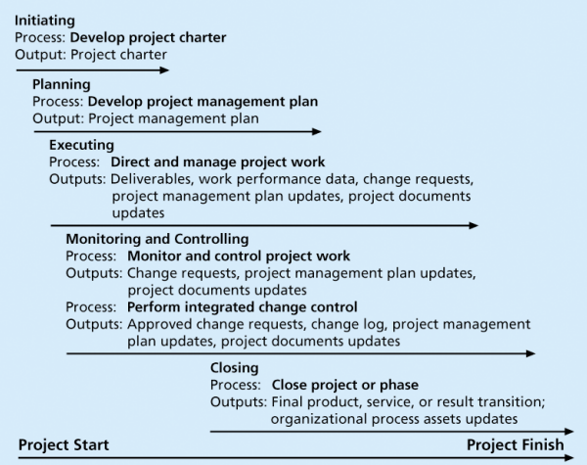

* Developing project charter  
  work with stakeholders to create the charter (the document that formally authorises a project)
* Developing a project management plan

Coordinate all planning efforts to create a project management plan (consistent coherent document)

* Directing & managing project work

Carry out the project management plan

* Monitoring & controlling project work

Oversee activities to meet performance objectives of the project

* Performing integrated change control

Identify, evaluate, manage changes through the project life cycle

* Closing the project phases

Finalise all activities to formally close the project

**Strategic planning:**

* Determine long-term objectives
* Predicting future trends
* Projecting the need for new products and services
* Organisations
  + identify potential projects
  + select which projects to work on
  + formalize project initiation by issuing a project charter

SWOT analysis

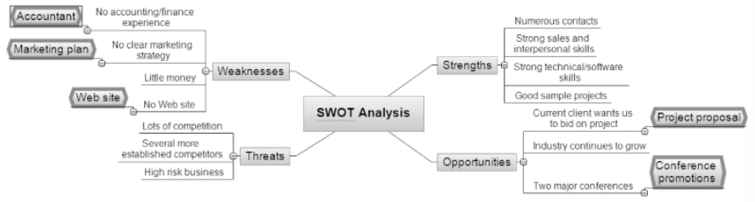

* Strengths
* Weaknesses
* Opportunities
* Threats

**IT planning process:**

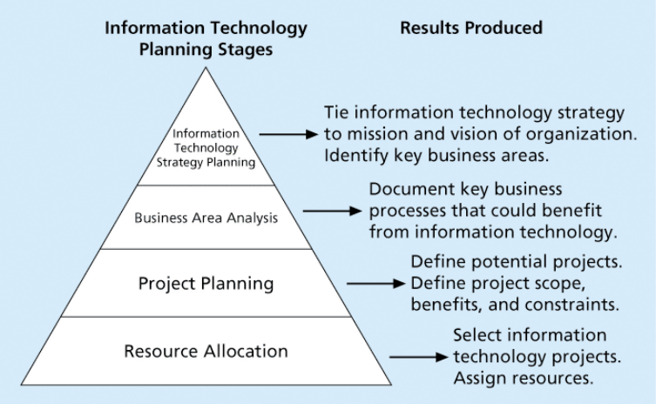

**4 forces behind new product development (NPD):**

* A product innovation & technology strategy for the business
* Resource commitment & focusing on right projects / solid portfolio management
* Effective, flexible & streamlined idea-to-launch process
* Right climate & culture for innovation, true cross-functional teams & senior management commitment to NPD

# Video 2:

Methods for selecting projects

* Focus on broad organisational needs
  + 1. A need for the project
    2. Funds available
    3. Strong will to make the project succeed
* Categorise information technology projects
  + 1. Impetus: address a problem/an opportunity/a directive
    2. Time window
    3. Overall priority
* Perform other financial analyses
  + 1. NPV (net present value) analysis

NPV= total discounted benefits – total discounted costs

Better: higher NPV

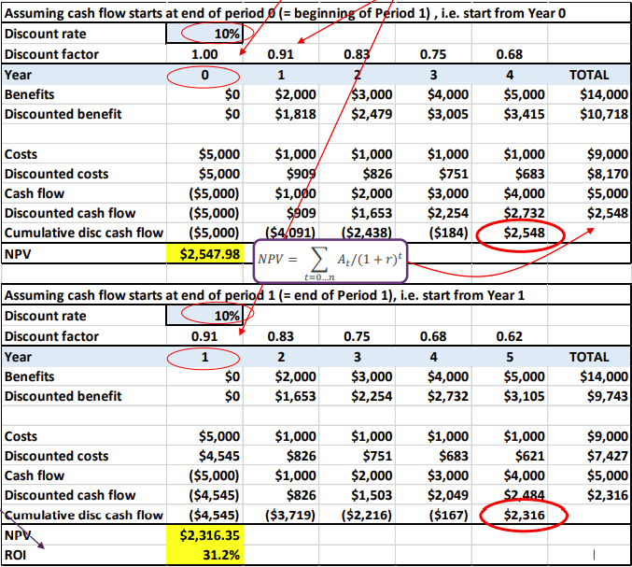

* + 1. ROI (return on investment)

ROI= NPV/discounted costs

Better higher ROI

Many organisations have a required ROI

IRR (internal rate of return): discount rate that makes the NPV=0

* + 1. Payback analysis

Payback period: the amount of time it will take to recoup in the form of net cash inflows

Occurs when the net cumulative discounted benefits = costs

Better: short

* Use a weighted scoring model
* 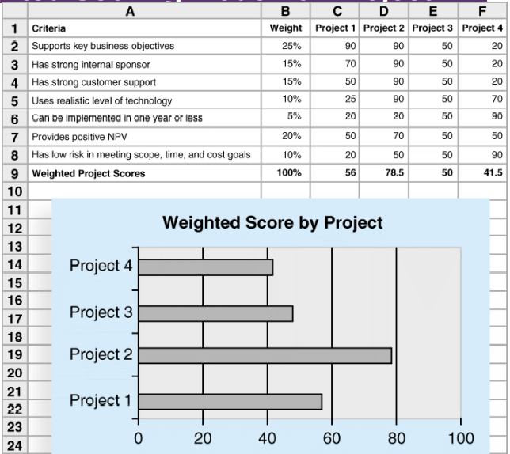

Assign weights to each criterion

Assign score to each criterion for each project

* Implement a balanced scorecard

A methodology that converts an organisation’s value drivers (eg. customer service, innovation, operational efficiency & financial performance) to a series of defined metrics

# Video 3:

**1 - Project charter:**

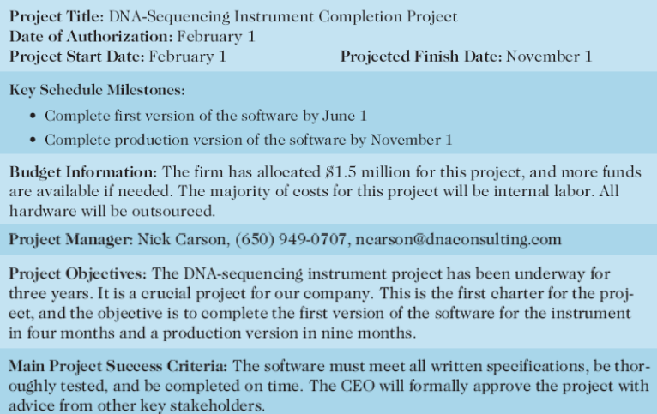

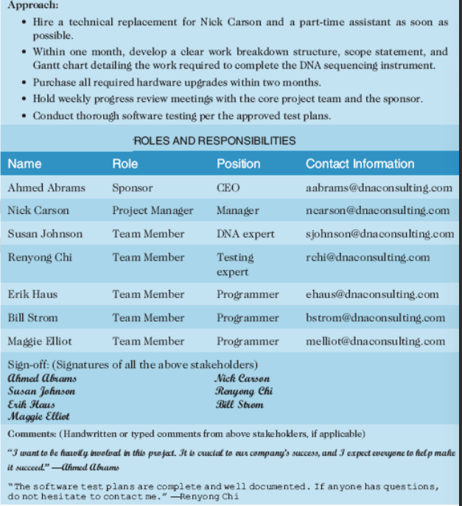

A document that formally recognises the existence of a project and provides direction on the project’s objectives and management

Key project stakeholders should sign a project charter to acknowledge agreement on the need and intent of the project

A signed charter is a key output of project integration management

Inputs:

* A project statement of work (SOW)
* A business cases
* Agreements
* Enterprise environmental factors
* Organisational process assets:

Formal & informal plans

Policies

Procedures

Guidelines

Information systems

Financial systems

Management systems

Lessons learned

Historical information

Tools & techniques:

* Expert judgement
* Facilitation techniques

**2. Developing a Project Management Plan**

* Project management plan used to coordinate project planning documents and guide a project’s execution and control
* Plans created in the other knowledge areas are subsidiary parts of the project management plan
* Dynamic, flexible, and subject to change when the environment or project changes
* Inputs: project charter, outputs from planning processes, enterprise environment factors, and organisational process assets
* Output: project management plan

**3. Directing and Managing Project Work**

* managing and performing the work described in the project management plan
* majority of time and money on execution
* application area project affects project execution: the products are produced during execution
* Planning and Execution: around activities
  + who will do the work should help to plan the work
  + managers must ask suggestion from the team for develop realistic plans
* Leadership and a Supportive Culture
  + managers must lead by example: importance of creating and then following good project plans
  + culture can help project execution:
    - – providing guidelines and templates
    - – tracking performance based on plans
  + managers may need to break the rules to meet goals, and senior managers must support those action

**4. Monitoring and Controlling Project Work**

* Changes are inevitable
* Monitoring: collecting, measuring, and share performance information
* Inputs: The project management plan, schedule and cost forecasts, validated changes, work performance information, enterprise environmental factors, and organizational process assets
* baseline: approved project management plan + approved changes

# Video 4:

**5. Performing Integrated Change Control**

main objectives:

* Influencing the factors that create changes to ensure that changes are beneficial
* Determining that a change has occurred
* Managing occurred changes
* Same input

Change Control on Information Technology

* change control board: responsible for approving or rejecting changes on a project
  + preparing change requests
  + evaluate change requests
  + manage the implementation of approved changes

Making Timely Change

* CCBs only meet occasionally, take too long for changes to occur
* policies in place for time-sensitive changes
  + “48-hour policy” allows make decisions, have 48 hours to undo the decision
  + keep everyone informed of changes

Configuration Management

* ensures that the descriptions of products are correct
* specialists:
  + - identify configuration requirements
    - control changes
    - record changes
    - audit the products to verify conformance(一致性) to requirements

Communicating changes

* Communication is an important factor in change control
* formal or informal:
  + Formal: written and oral performance reports
  + Informal: Phone or meeting
* Everyone is coordinated and informed
* Easier to integrate all project changes so that the project stays on track

**6. Closing Projects or Phases**

* finalize all activities and transfer the completed or cancelled work to the people
* inputs:
  + project management plan, accepted deliverables, and organisational process assets
* outputs:
  + Final product, service, or result transition
  + Organisational process asset update