# Video 1:

**Project scope management:**

Define & control what is or what is not included in a project

develop two important outputs

* scope management plan: subsidiary part of the project management plan
  + scope statement-describes the characteristic of the product
    - Project justification
    - description of the project’s deliverable
    - Summary of all project deliverables
    - what determines project success
  + Contents-How
    - prepare a detailed project scope statement
    - create a WBS
    - maintain and approve the WBS
    - control requests for changes
    - obtain formal acceptance of the completed project deliverable
* requirements management plan
  + need to be elicited, analyzed, and recorded in enough detail
  + included in the scope baseline and be measured once project execution begins
  + Methods for Collecting:
    - Interviewing
    - group creativity and decision-making techniques
    - Questionnaires
    - Observation
    - Prototyping
  + Documentation
    - Functional and non-functional requirements
      * non-functional - how the system works,
      * functional - what the system should do
    - Business rules
    - Impacts on any other systems
    - training requirements
    - acceptance criteria
    - Quality requirements
  + requirements traceability matrix (RTM)
  + 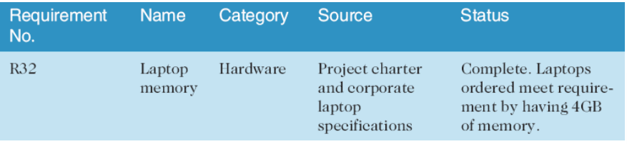

Scope:

All work involved in creating the products of the project and the processes used to create them

Deliverable:

A product produced as part of a project (eg. hardware/ software, planning documents, meeting minutes)

**Project scope management processes**

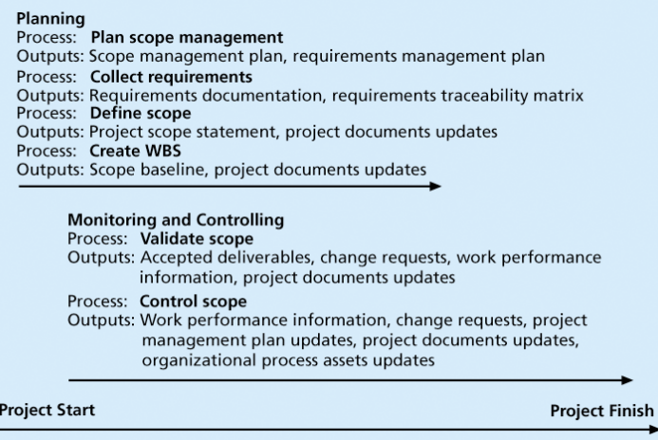

Planning:

* Planning scope:

Determine how the project’s scope & requirements will be managed

* Collecting requirements:

Define & document the features and functions of the products produced during the project as well as the processes used for creating them

* Defining scope:

Review the project charter, requirements documents & organisational process assets to create a scope statement

* Creating the WBS:

Subdivide the major project deliverables into smaller, more manageable components

Monitoring & controlling:

* Validating scope:

Form acceptance of the project deliverables

* Controlling scope:

Control changes to project scope throughout the life of the project

# Video 2:

**Defining Scope:**

Project scope statements include

* product scope description
* product user acceptance criteria
* detailed information on all project deliverables

**Creating the Work Breakdown Structure (WBS):**

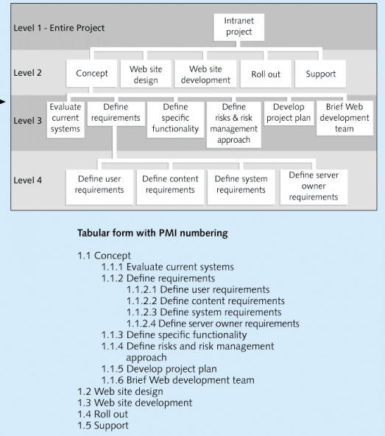

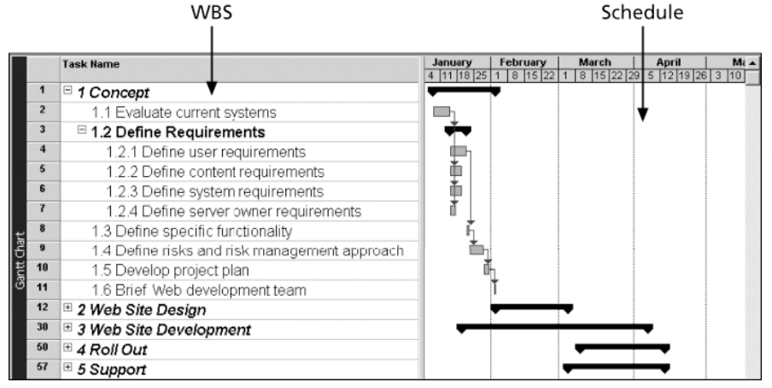

* WBS is a deliverable-oriented grouping of the work involved in a project that defines the total scope of the project
* WBS provides the basis for planning and managing project schedules, costs, resources, and changes
* Decomposition- subdividing project deliverables into smaller pieces
* work package is a task at the lowest level of the WBS
* scope baseline includes the project scope statement and WBS and WBS dictionary

**Approaches to Developing WBSs**

* analogy approach
  + similar projects and tailor to your project
* top-down approach
  + Start with the largest items break them down
* bottom-up approach

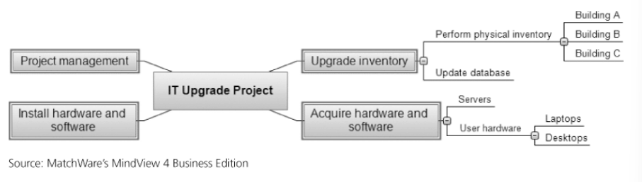

* + Mind mapping-radiating out from a core idea to structure ideas

**Dictionary and Scope Baseline**

* must be explained more so people know what to do
* can estimate how long it will take
* what it will cost to do the work
* WBS dictionary describes detailed information about each WBS item

# Video 3

**Validating Scope**

* Scope validation formal acceptance of the completed project deliverables
* Acceptance is often achieved customer inspection and then sign-off on key deliverables

**Controlling Scope**

* Goals of scope control
  + influence the factors that cause scope changes
  + assure changes are processed according to procedures developed as part of integrated change control
  + manage changes when they occur
* Variance is the difference between planned and actual performance

# Video 4

Scope Creep: changes scope baseline of a project (i.e., addition features after scope determined)

The Agile Lifecycle

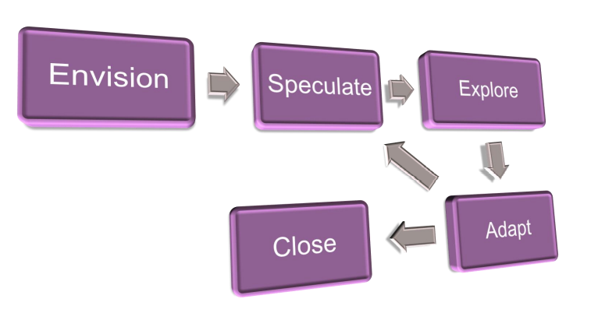

**Envision**

* Determine requirements
* Confirm team
* Set up team collaboration
* project charter –describing scope and overall objectives
* Product Data Sheet (PDS)
  + Project description
  + Project objectives
  + Timelines
  + Cost estimates
  + Constraints
  + Prioritisation

**Speculate**

* Feature based delivery plan
* Estimates for each feature
* requirements for the Sprint
* features to be developed
* Effort estimates for each feature
* Risks will be identified

**scope throughout the project**

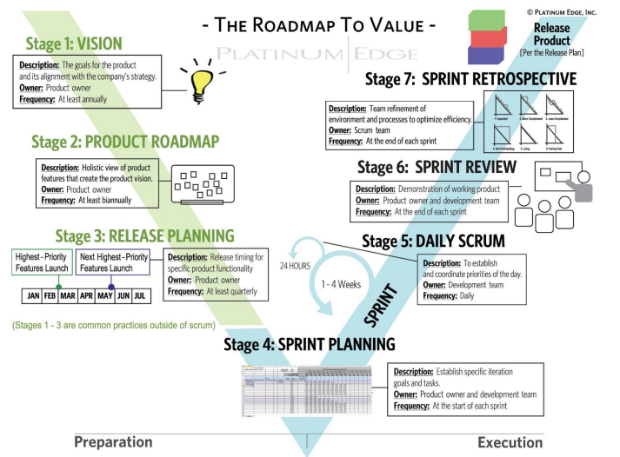

Flipping the Triangle (DSDM Consortium)

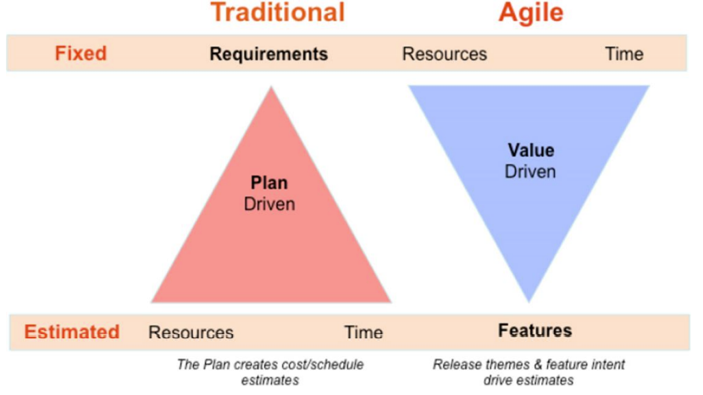

**different between traditional and Agile Scope Management**

