# Video 1:

**Importance of Project Schedules**

* often cite delivering projects on time as biggest challenge
* Schedule issues are the main reason for conflicts on projects
* Time has the least amount of flexibility

**Project schedule management processes**

* Planning schedule management

The project team uses expert judgement, analytical techniques & meetings to develop the schedule management plan

Schedule management plan:

* + 1. Project schedule model development
    2. Scheduling methodology
    3. Level of accuracy & units of measure
    4. Control thresholds
    5. Rules of performance measurement
    6. Reporting formats
    7. Process descriptions
* Defining activities-further defining scope
* Develop a more detailed WBS and supporting explanations to understand all the work to be done
* Activity/task: an element of work normally found on the WBS (work breakdown structure) that has an expected duration, a cost and resource requirements
* Goal: To ensure project team completely understand all the work

Outputs:

* + 1. activity list: a tabulation of activities to be included on a project schedule
       1. Activity name
       2. Activity identifier/number
       3. Brief description of activity
       4. Activity attributes provide more information
    2. activity attributes
       1. Predecessors
       2. Successors
       3. Logical relationships
       4. Leads & lags
       5. Resource requirements
       6. Constraints
       7. Imposed dates
       8. Assumptions related to activity
    3. a milestone lists
* a significant event that normally has no duration
* often takes several activities & a lots of work to complete a milestone
* useful tools for setting schedule goals & monitoring progress
* e.g., obtaining customer sign-off on key documents
* completion of specific products
  + 1. project management plan updates

Sequencing activities-further defining time

* + reviewing activities and determining dependencies
  + dependency or relationship is the sequencing of project activities or tasks
  + Relationships or dependencies among activities has a significant impact on project schedule
  + Identifying & documenting the relationships between project activities
* Estimating activity durations-further defining time and cost
* Developing the schedule

Analysing activity sequences, activity resource estimates & activity duration estimates

To determine the start & end date of the project

Tools & techniques:

Gantt charts

Critical path analysis

Critical chain scheduling

PERT analysis

* Controlling the schedule

# Video 2

**Sequencing Activities**

* reviewing activities determining dependencies
* dependency or relationship is the sequencing of project activities or tasks
* Relationships or dependencies among activities has a significant impact on project schedule

**Three types of Dependencies**

* Mandatory dependencies - (hard logic) inherent in the nature of the work being performed on a project
* Discretionary dependencies – (soft logic) should be used with care since they may limit later scheduling options
* External dependencies- involve relationships between project and non-project activities

Network Diagrams

* Network diagrams for showing activity sequencing is a schematic display of the logical relationships among, or sequencing of, project activities
* Two main formats
  + ADM Arrow diagramming (Activity-on-Arrow AOA)
    - Activities are represented by arrows
    - Nodes are the starting and ending
    - Can only show finish-to-start dependencies
    - Process
      * Find all of the activities
      * working from left to right.
      * no arrows should cross

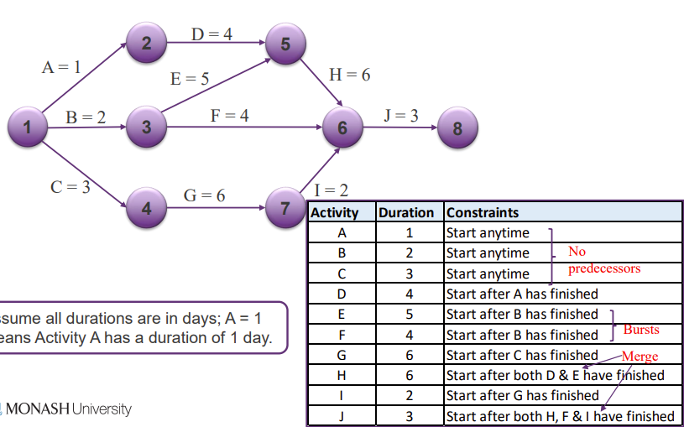

* + PDM Precedence diagramming (Activity-on-Node)
    - Activities are represented by boxes
    - Arrows show relationships
    - Better at showing different types of dependencies

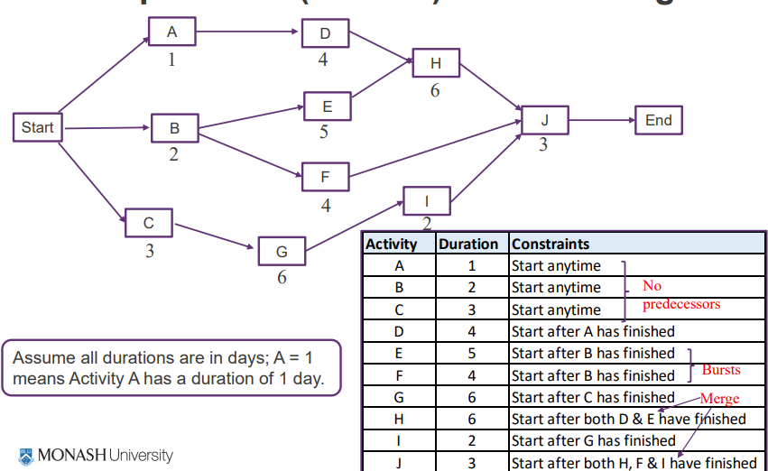

* + Task Dependency

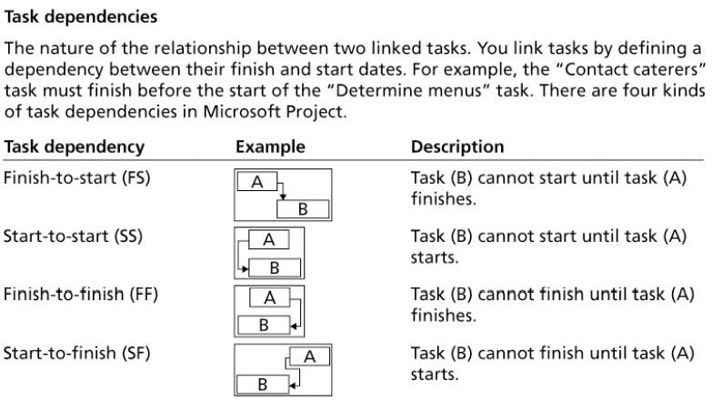

# Video 3

**Estimating Activity Resources**

* Before estimating activity durations, must have good idea of the quantity and type of resources that will be assigned to each activity
* resources are people, equipment, and materials
* resource breakdown structure is a hierarchical structure that identifies the project’s resources by category and type

**Activity Duration Estimating**

* Duration includes actual amount of time worked on an activity plus elapsed time
* Effort is the number of workdays or work hours and does not normally equal duration
* People doing the work should help create estimates
* Three-Point Estimates

**Program Evaluation and Review Technique** PERT

* network analysis technique to estimate project duration when there is a high degree of uncertainty about the individual activity duration estimates
* PERT uses probabilistic time estimates
  + applies the critical path method (CPM) to a weighted duration estimate
  + duration estimates based on three-point estimate

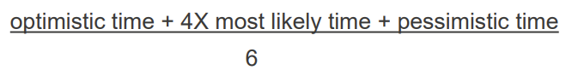

**Developing the Schedule**

* Ultimate goal is to create a realistic project schedule provides a basis for monitoring project progress
* tools and techniques:
  + Gantt charts,
    - displaying project schedule
    - Adding Milestones- emphasize important events or accomplishments
    - Milestones: Specific, Measurable, Assignable, Realistic, Time-framed

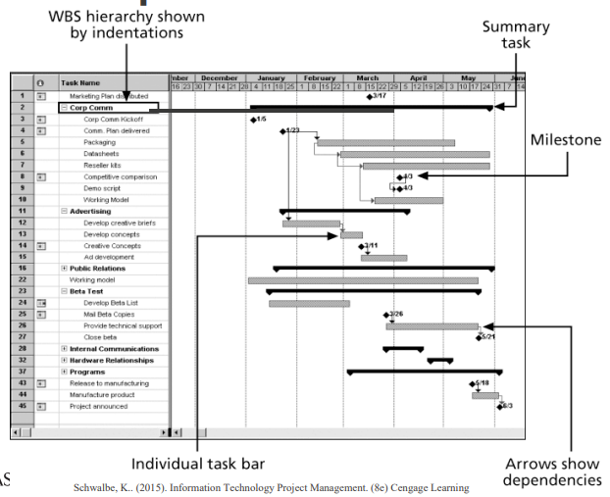

* + critical path analysis
    - network diagramming technique to predict total project duration
    - critical path is the series of activities determines the earliest time
    - longest path
    - Slack or float is the amount of time an activity may be delayed

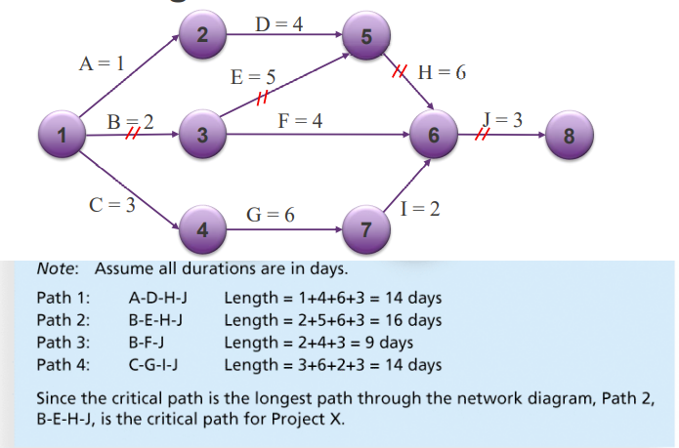

Free slack or free float: the early start of any immediately following activities

Total slack or total float: the planned project finish date

forward pass: determines the early start and finish dates

backward pass: the late start and finish dates

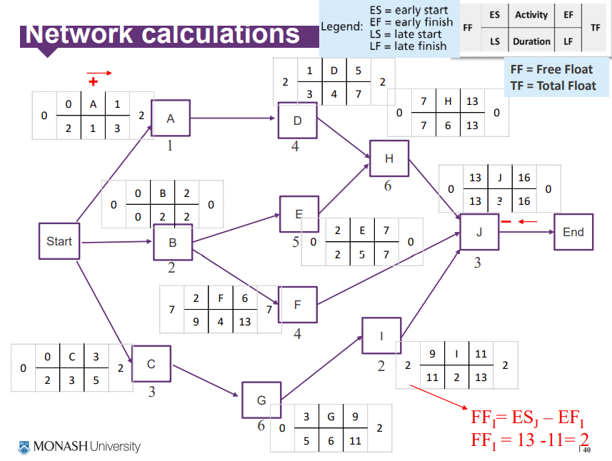

* + - Critical Path to Shorten a Project Schedule
    - Three main techniques
      * Shortening durations of critical activities- adding more resources or changing their scope
      * Crashing activities- greatest amount of schedule compression for the least incremental cost
      * Fast tracking activities- parallel or overlapping
  + critical chain scheduling
    - method of scheduling considers limited resources and includes buffers to protect the project completion date
    - Uses the Theory of Constraints (TOC)
      * improving other things besides the constraint does nothing to improve the system
      * important concept is the availability of scarce resources
    - Attempts to minimize multitasking when a resource works on more than one task at a time

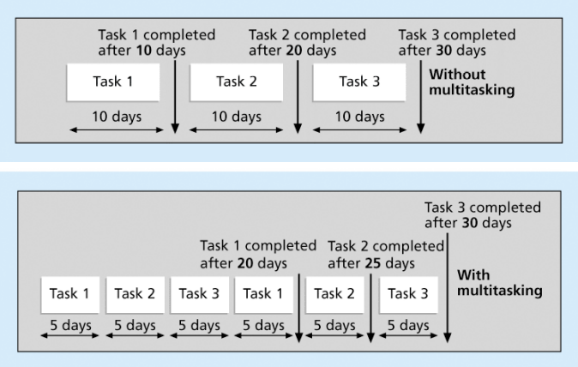

* Buffers and Critical Chain
  + - buffer is additional time; people often add a buffer to each task and use it if it’s needed or not
    - Critical chain scheduling removes buffers
      * project buffer or additional time added before the project’s due date
      * feeding buffers or additional time added before tasks on the critical path

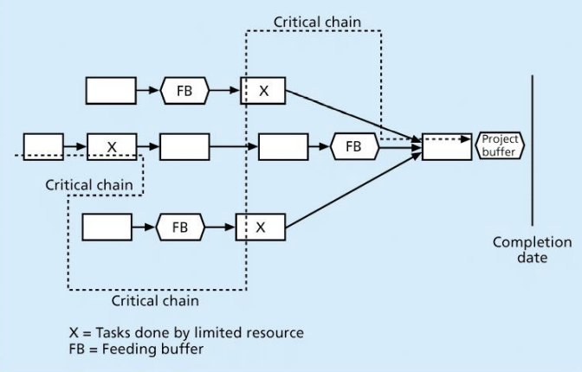

* + PERT (Program Evaluation and Review Technique) analysis

# Video 4

**Controlling the Schedule**

* Goals are to know the status of the schedule, influence factors cause schedule changes, determine that the schedule has changed, and manage changes
* Tools and techniques: Progress reports, schedule change control system, Project management software, Variance analysis, Performance management, Resource optimization techniques

**Agile and Time Management**

* Core values Agile Software Development are:
  + Customer collaboration over contract negotiation
  + Responding to change over following a plan
* product owner defines and prioritizes the work to be done within a spring, so collaboration and time management are designed into the process
* Teams focus on producing a useful product
* Don’t emphasize defining all the work before scheduling it

**Schedule Control Suggestions**

* Perform reality checks on schedules
* Allow for accident
* Don’t plan for everyone to work at 100% capacity all the time
* Hold progress meetings with stakeholders and be clear and honest in communicating schedule issue

**Reality Checks on Scheduling**

* review the draft schedule or estimated completion date
* Prepare a more detailed schedule
* Make sure the schedule is realistic and followed
* High-level periodic reviews
* Alert top management well if there are schedule problems

**Working with People Issues**

* Strong leadership helps projects succeed more than good PERT charts
* Project managers should
  + Empowerment
  + Incentives
  + Discipline
  + negotiation

**Using Software to Assist**

* Software for facilitating communications helps people exchange schedule-related information
* Decision support models help analyze trade-offs that can be made
* Project management software can help in various time management areas

**Video 2:**

**Sequencing activities:**

Review activities and determine dependencies

Dependency/relationship: the sequencing of project activities/tasks

3 types of dependencies:

* Mandatory:

inherit in the nature of the work being performed on a project

sometimes referred to as hard logic

* Discretionary:

Defined by project team

Sometimes referred to as soft logic

May limit later scheduling options

* External:

Relationships between project & non-project activities

**Networking diagrams:**

Preferred technique for showing activity sequencing

Schematic display of the logical relationships among or sequencing of project activities

Main formats:

* Arrow diagramming method (ADM)

Also called Activity-on-Arrow (AOA)

Nodes/circles: starting & ending points of activities

Can only show finish-to-start dependencies

Burst: a single node followed by 2+ activities

Merge: 2+ nodes precede a single node

* Precedence diagramming method (PDM)

Also called Activity-on-Node (AON)

Activities represented by boxes

Arrows show relationships between activities

More popular

Used by project management software

Better at showing different types of dependencies

Task dependency:

* Finish-to-start (FS)
* Start-to-start (SS)
* Finish-to-finish (FF)
* Start-to-finish (SF)

**Video 3:**

Resources: people, equipment & materials

Resource breakdown structure: a hierarchical structure that identifies the project’s resources by category and type

Duration:

Actual amount of time worked on an activity + elapsed time

Effort:

The number of workdays or work hours required to complete a task

Three-point estimates:

* Optimistic
* Most likely
* Pessimistic

Program evaluation and review technique (PERT):

A network analysis technique used to estimate project duration when there is a high degree of uncertainty about the individual activity duration estimates

Use probabilistic time estimates:

* Apply critical path method (CPM) to a weighted average duration estimate
* Duration based on three-point estimate

Weighted average= (optimistic + 4*most likely + pessimistic)/6

Gantt chart:

Provide a standard format for displaying project schedule information by listing project activities & corresponding start and finish dates in a calendar format

SMART criteria for milestones:

* Specific
* Measurable
* Assignable
* Realistic
* Time-framed

**Supplementary video:**

**CPM (critical path method):**

A network diagramming technique used to predict total project duration

Critical path:

the series of activities that determine the earliest time by which the project can be completed

longest path through the network diagram

least amount free slack/float (the amount of time an activity may be delayed without delaying a succeeding activity/project finish date)

total slack/float:

the amount of time an activity may be delayed from its early start without delaying the planned project finish date