# Video 1:

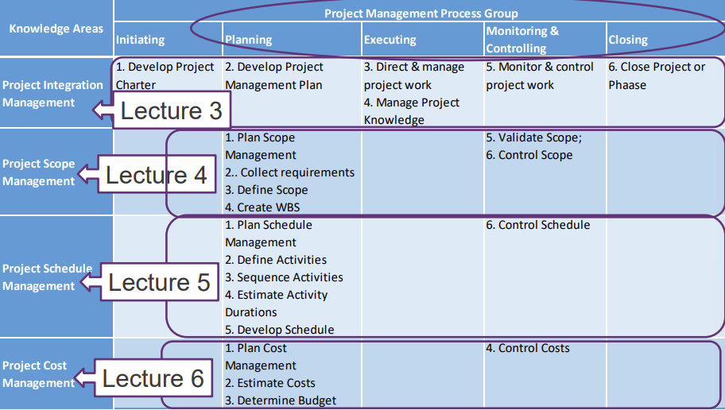

**Importance of Project Cost Management**

* IT projects have a poor track record
* A perceived reason for cost overruns is involve new technology or business processes pose an inherent risk
* using good project cost management can change this

**Cost overrun:** the additional percentage or dollar amount by which actual costs exceed estimates

**Cost**: a resource sacrificed/ foregone to achieve a specific objective or sth given up in exchange

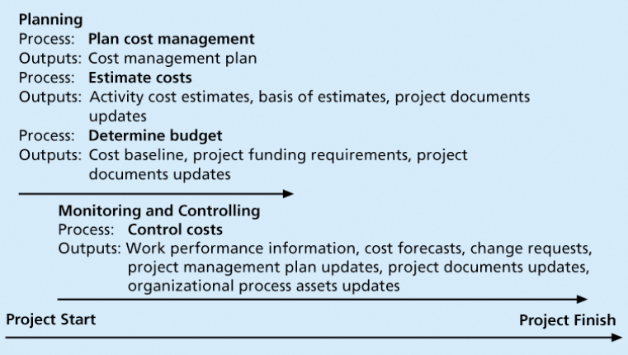

**Project cost management:** the processes required to ensure that the project is completed within an approved budget

* Planning cost management: determine policies, procedures, documentation that will be used for planning, executing and controlling project cost
* Estimating costs: develop an approximation or estimate of the costs of the resources needed to complete a project
* Determining the budget: allocate overall cost estimate to individual work items to establish a baseline for measuring performance
* Controlling cost: control changes to the project budget

**Profits:** revenues – expenditures

**Profit margin:** revenues/profits

**Life cycle costing:** consider total cost of ownership (development + support)

**Cash flow analysis:** estimated annual costs & benefits for a project

**Types of costs & benefits:**

* Tangible costs/benefits: can easily measure in dollars
* Intangible costs/benefits: difficult to measure in monetary terms
* Direct costs: directly related to producing the products & services
* Indirect costs: not directly related to producing the products & services
* Sunk cost: money that has been spent in the past

Basic principles:

* Learning curve theory:

When many items are produced repetitively, the unit cost of those items decreases in a regular pattern as more units are produced

* Reserves:

Dollars included in a cost estimate to mitigate cost risk by allowing for future situations that are difficult to predict

* + 1. Contingency reserves:

known unkowns (future situations that may be partially planned for)

included in the project cost baseline

* + 1. Management reserves:

Unkown unkowns (future situations that are unpredictable

**Video 2:**

Cost management plan:

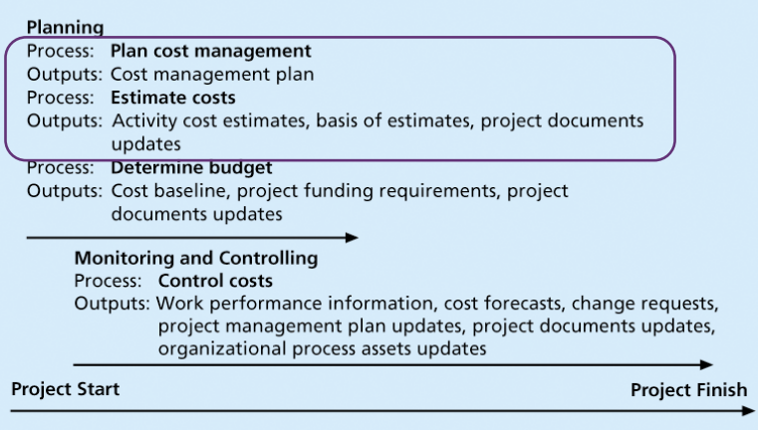

* Level of accuracy & units of measure
* Organisational procedure links
* Control thresholds
* Rules of performance measurement
* Reporting formats
* Process descriptions

**Estimating Costs**

* Project managers must take cost estimates seriously
* Estimates done at various stages of a project and should become more accurate as time
* Most project costs are labour costs
* Types of Cost Estimates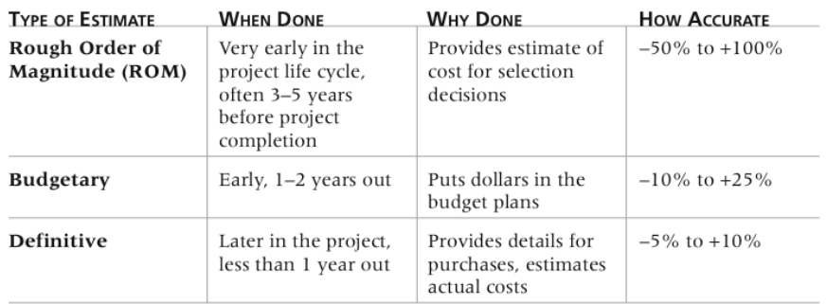

**Cost estimation tools & techniques:**

* Analogous/top-down: use actual cost of pervious, similar project as the basis
* Bottom-up: estimate individual work items/activities and sum up
* Parametric modelling: use project characteristics/parameters in a mathematical model

Problems with IT Cost Estimates

* Estimates are done too quickly
* lack experience
* biased toward underestimation
* Management desires accuracy

# Video 2

Determining the Budget

* Cost budgeting allocating the project cost estimate to individual work items over time
* WBS is a required input to the cost budgeting process since it defines the work items
* Important goal cost baseline:
  + project managers use to measure and monitor cost performance
  + members should document any assumptions made when developing the cost baseline

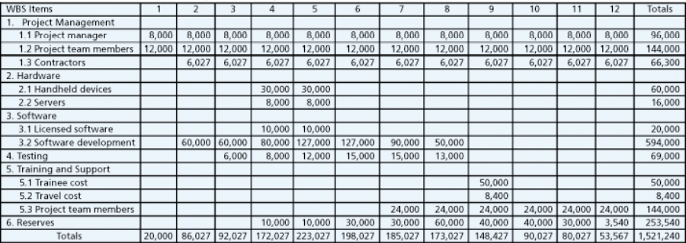

Controlling Costs

* cost control includes
  + Monitoring cost performance
  + Ensuring that only appropriate project changes are included in a revised cost baseline
  + stakeholders of authorised changes to the project that will affect costs
* Change control system to define procedures for changing the cost baseline is necessary
* Tools
  + Performance review meetings
  + Performance measurement
  + Earned value management
    - integrates scope, time, and cost data
    - Given a baseline determine how well the project is meeting its goals
    - must enter actual information
      * whether or not a WBS item was completed
      * how much of the work was completed
      * how much completed work cost
    - planned value (PV) called the budget, is that portion of the approved total cost estimate planned to be spent
    - Actual cost (AC) total of direct and indirect costs incurred in accomplishing work
    - earned value (EV) is an estimate of the value of the physical work actually completed
    - EV is based on the original planned costs the rate at which the team is completing work
* Rate of Performance
  + actual work completed to the percentage of work planned to have been completed at any given time

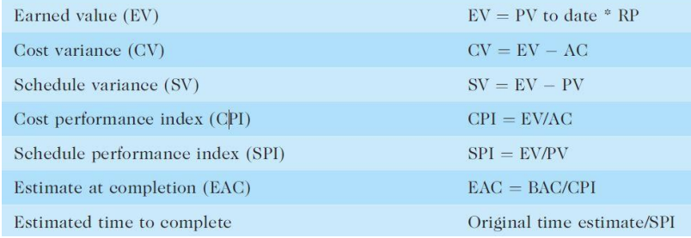pv is planned value

Rules:

* Negative numbers for cost and schedule variance indicate problems
* CPI and SPI less than 100% indicate problems
  + the project is costing more than planned or taking longer than planned
* CPI can be used to calculate the estimate at completion estimate of what it will cost to complete the project based on performance to date.
* budget at completion BAC original total budget for the project

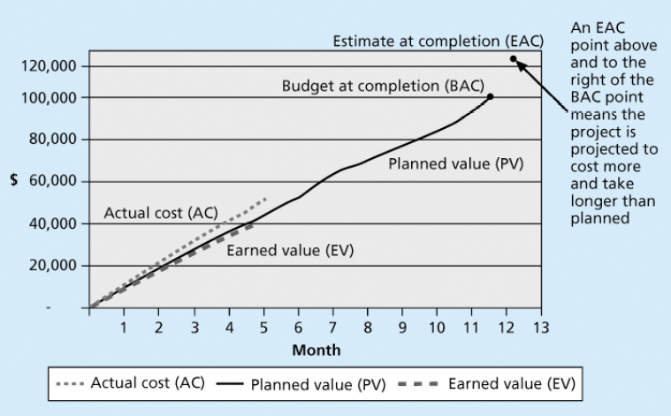

Project Portfolio Management

* collect and control an entire suite of projects or investments in a portfolio
* Five levels
  + Put all your projects in one database
  + Prioritize the projects in your database
  + Divide your projects into two or three budgets based on type of investment
  + Automate the repository
* Benefits
  + Reduced redundant projects and coordinated those with overlap
  + it makes sense to view them as portfolios and track their progress as a whole
  + help reduce costs

# Video 4:

traditional and Agile Cost Management

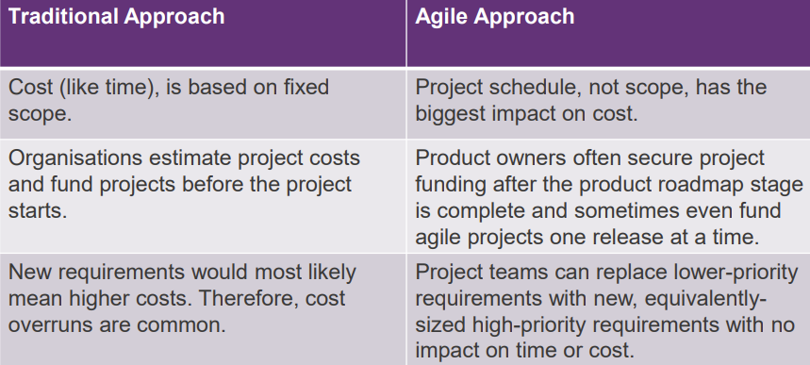 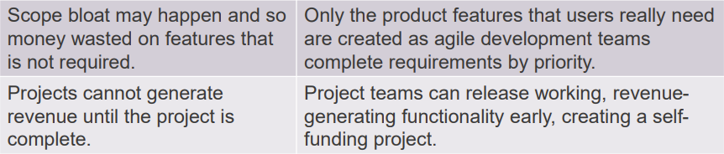

Managing Cost in Agile

* cost is a direct expression of project time
* Quite easy to determine team cost scum team have a set team cost that be the same for each sprint
* Once we estimate the development speed, determine how many sprints the project will take and know how much the scrum team will cost

Ways to lower project costs

* Self-funding project
* Lowering cost by increasing velocity
* Lowering cost by reducing time