# Video 1:

**Importance of Project Risk Management**

* science of identifying, analysing, and responding to risk
* Risk management is often overlooked in projects
* improve project success by helping select good projects
* determining project scope, and developing realistic estimates
* Helps project stakeholders understand the nature of the project
* helps to integrate other project management knowledge areas

Negative risk:

Potential problems that might occur in the project and might impede project success

Actions:

* Avoid
* Lessen
* Change
* Accept

Positive risk:

Result in good things happening, sometimes called opportunities

Risk management:

* Goal: minimise potential negative risks while maximising potential positive risks
* Is an investment: costs are associated
* Cost for risk management should not exceed potential benefits

**Terms:**

Risk appetite:

The degree of uncertainty an entity is willing to take on, in anticipation of a reward

Risk tolerance:

The maximum acceptable deviation an entity is willing to accept as the potential impact

Risk utility:

The amount of satisfaction/pleasure received from a potential payoff

Known risks:

Risks that the project team has identified and analysed and that can be managed proactively

Unknown risks:

Risks that have not been identified and analysed and cannot be managed

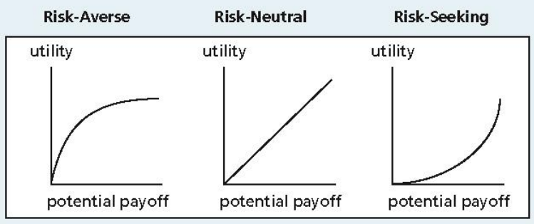

**Project risk management processes:**

* Planning risk management:

Decide how to approach and plan the risk management activities for the project

* Identifying risks:

Determine which risks are likely to affect a project and document the characteristics of each

* Performing qualitative risk analysis:

Prioritise risks based on their probability and impact of occurrence

* Performing quantitative risk analysis:

Numerically estimate the effects of risks on project objectives

* Planning risk responses:

Take steps to enhance opportunities and reduce threats to meeting project objectives

* Controlling risk:

Monitor identified and residual risks, identify new risks, carry out risk response plans and evaluate the effectiveness of risk strategies throughout the life of the project

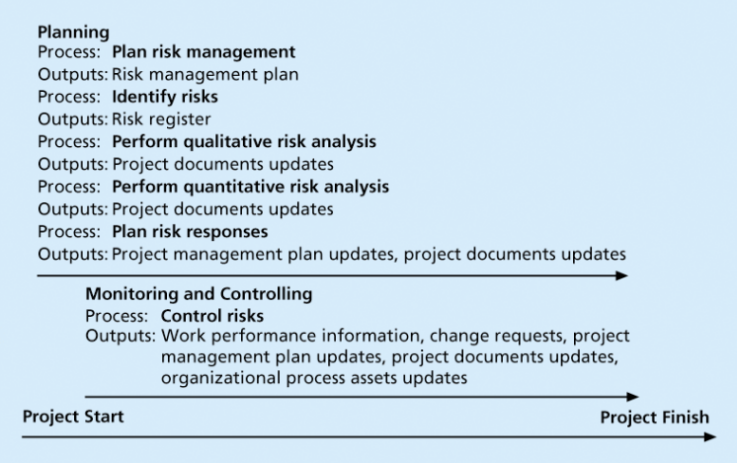

**Planning Risk Management**

* main output is a risk management plan-documents the procedures for managing risk throughout a project
* team should review project documents
* understand the organizations and the sponsor’s approaches to risk
* level of detail will vary with the needs of the project

# Video 2

Categories of Risk

* Market risk
* Financial risk
* Technology risk
* People risk
* Structure/process risk

**Risk Breakdown**

* risk breakdown structure is a hierarchy of potential risk categories for a project
* Similar to a work breakdown structure but used to identify and categorize risks

**Risk identification tools and techniques:**

* Brainstorming
  + Be careful not to overuse or misuse brainstorming
  + Group effects often inhibit idea generation
* Delphi technique
  + 1. Derive a consensus among a panel of experts
    2. A systematic, interactive procedure based on independent and anonymous input from project risk experts
    3. Facilitator uses repeated rounds of questioning and written responses
    4. Consensus may be reached in a few rounds of the process
    5. Avoid the biasing effects possible in oral methods (eg. brainstorming)
* Interview
* SWOT (strengths, weaknesses, opportunities & threats) analysis
* Root cause analysis
  + identify a problem, discover the underlying causes and then develop preventive measures
* Diagramming techniques:
  + 1. Cause & effect diagrams (Ishikawa/fishbone diagram)
    2. Systems/process flowchart: show how various elements of a system interrelate
    3. Influence diagram: causal influences & relationships among variables & outcomes

**Risk Register**

* document that contains the results of various risk management processes
* tool for documenting potential risk events and related information
* 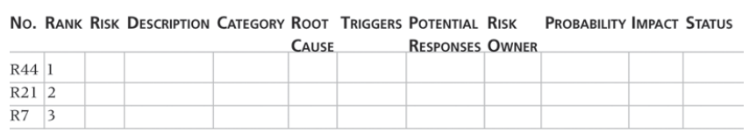

# Video 3

Risk quantification tools & techniques:

* Probability/impact matrix
  + 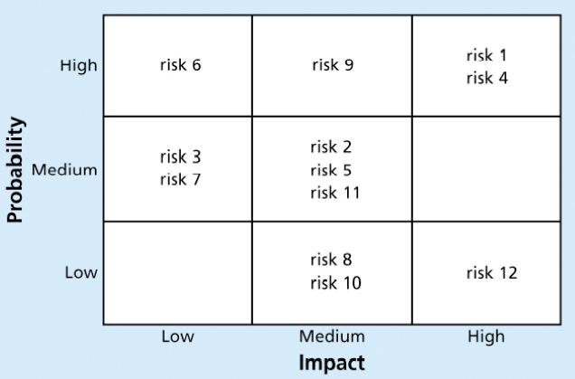
* Top ten risk item tracking
  + qualitative risk analysis tool that helps to identify risks and maintain an awareness of risks
  + review of the top ten project risk items
  + current ranking, previous ranking, number of times the risk appears on the list

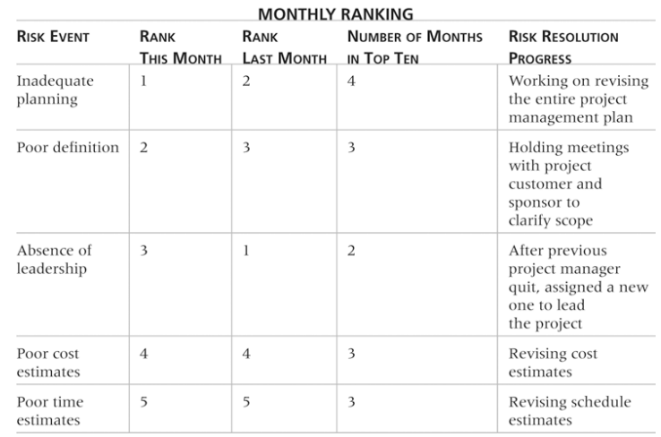

* Expert judgement

Risk Management Review

* Objectives
  + keeps management aware of major influences that could prevent or enhance success
  + consider alternative strategies for addressing risks
* watch list is a list of risks low priority, but are still identified as potential risks
* Qualitative analysis can also identify risks that should be evaluated on a quantitative basis

# Video 4

Performing Quantitative Risk Analysis

* follows qualitative risk analysis
* Large, complex projects involving leading edge technologies often require extensive quantitative risk analysis
* Data gathering: Interviewing, collecting probability distribution information
* Analysis and modelling: Decision tree analysis, Simulation, Sensitivity analysis

Decision Trees and Expected Monetary Value

* decision tree help select the best course of action in situations
* Estimated monetary value (EMV), product of a risk event probability and the risk event’s monetary value, can draw a decision tree to find the EMV

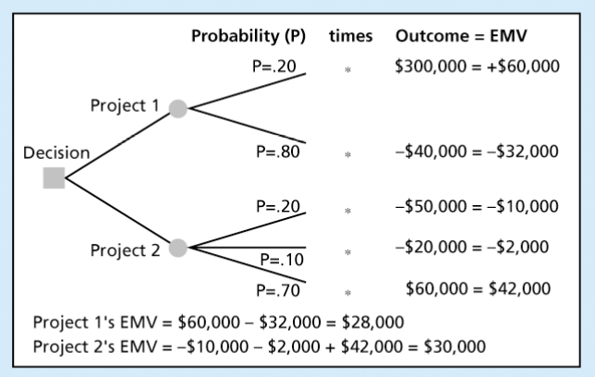

**Simulation**

* uses a representation or model of a system analyze the expected behaviour or performance of the system
* Monte Carlo analysis must have three estimates plus an estimate of the likelihood of the estimate being between the most likely and optimistic values
* Steps of a Monte Carlo Analysis
  + Assess the range for the variables
  + Determine the probability distribution of each variable
  + select a random value based on the probability distribution
  + deterministic analysis or one pass through the model
  + Repeat steps 3 and 4 many times
* Sensitivity analysis
  + effects of changing one or more variables on an outcome
  + sensitivity analysis may be used to determine the monthly payments for a loan at different interest rates or periods of the loan, determining break-even points based on different assumptions

# Video 5:

Planning Risk Responses- decide how to respond to risks

* Developing options and defining strategies for reducing negative risks and enhancing positive risks
* 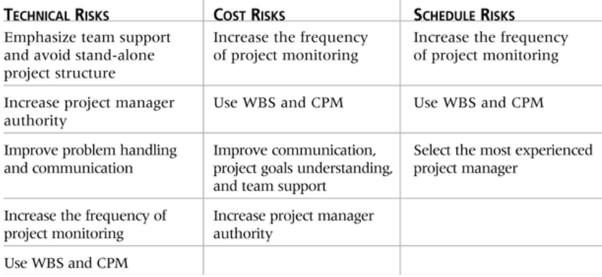
  + TARA
  + Risk Transference
  + Risk Avoidance
  + Risk Mitigation (Reduction)
  + Risk Acceptance

Residual and Secondary Risks

* Residual risks are risks that remain after all of the response strategies
* Secondary risks are a direct result of implementing a risk response

Controlling Risks

* Monitoring risks based on defined milestones and making decisions
* Workarounds unplanned responses to risk events there are no contingency plans

Contingency and Fallback Plans

* Contingency plans
  + predefined actions
* Fallback plans
  + high impact risk
* Contingency fund or allowances
  + provisions held by the project sponsor or organization to reduce the risk of cost
* Management reserves
  + funds held for unknown risks ARE part of the budget and funding requirements