# Video 1

**Project Quality**

(ISO9000:2000) degree to which a set of inherent characteristics fulfils requirements

Other experts define quality

* Conformance to requirements: products meet written specifications
* Fitness for use: used as it was intended

**Project quality management**

Ensures project satisfy needs

Processes:

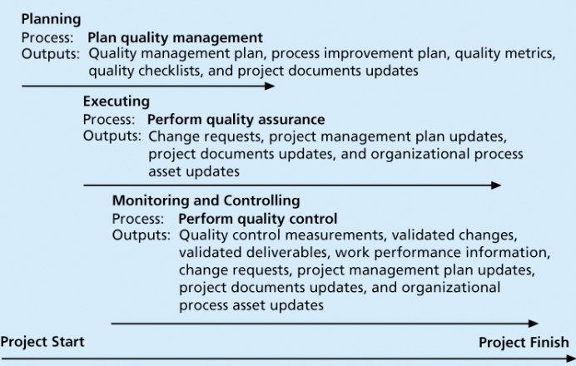

Planning quality management: Identifying which quality are relevant to the project and how to satisfy them

* ability to anticipate situations and prepare actions
* Important to prevent defects:
  + Selecting proper materials
  + Training people in quality
  + Planning a process that ensures the appropriate outcome
* Design of experiments: technique that helps identify which variables have the most influence
* Scope Aspects of IT Projects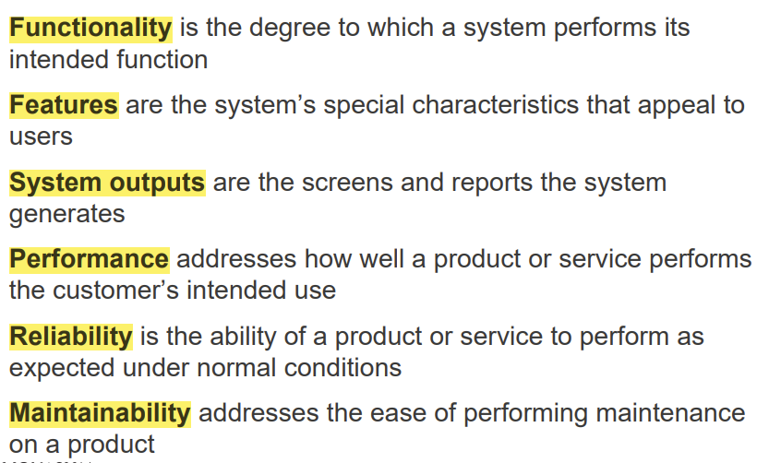

Performing quality assurance: Periodically evaluating, ensure the project will satisfy

* Quality assurance includes all the activities, satisfying the relevant quality standards for a project
* goal is continuous quality improvement
* Lean evaluating processes to maximize customer value while minimizing waste
* Benchmarking generates ideas for quality improvements by comparing specific project practices or product characteristics
* quality audit structured review of specific quality management activities that help identify lessons learned that could improve performance on current or future projects

Modern Quality Management

* Requires customer satisfaction
* Prefers prevention to inspection
* Recognizes management responsibility for quality

ISO Standards

* ISO 9000
  + Is a three-part, continuous cycle of planning, controlling, and documenting quality in an organisation
  + Provides minimum requirements needed for an organisation to meet its quality certification standards
  + Helps organisations around the world reduce costs and improve customer satisfaction
* Improving IT Project
  + Establish leadership that promotes quality
  + Understand the cost of quality
  + Focus on organisational influences and workplace factors
  + Follow maturity models
* Cost of Quality
  + Conformance means delivering products that meet requirements and fitness
  + Cost of nonconformance means taking responsibility for failures or not meeting quality expectations
* Cost Categories Related to Quality
  + Prevention cost- Cost of planning and executing a project error-free or within an acceptable error range
  + Appraisal cost- Cost of evaluating processes their outputs to ensure quality
  + Internal failure cost- correct an identified defect before the customer receives the product
  + External failure cost- not detected and corrected before delivery to the customer
  + Measurement and test equipment costs- Capital cost of equipment perform prevention and appraisal activities
* Maturity Models- frameworks for helping organisations improve their processes and systems
  + Software Quality Function Deployment Model focuses on defining user requirements and planning software projects
  + Capability Maturity Model Integration is a process improvement approach that provides organisations with the essential elements of effective processes
* PMI’s Maturity Model
  + Help organizations assess and improve their project management capabilities

# Video 3

Performing quality control: Monitoring project results

* Controlling Quality main outputs：
  + Acceptance decisions, Rework, Process adjustments

Cause-and-Effect Diagrams

* help you find the root cause of a problem
* fishbone or Ishikawa diagrams 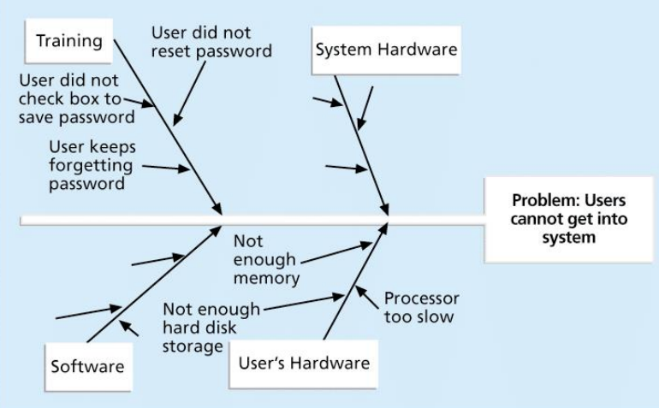
* 5 whys technique

Quality Control Charts- prevent defects, rather than to detect or reject them

* allow you to determine whether a process is in control or out of control

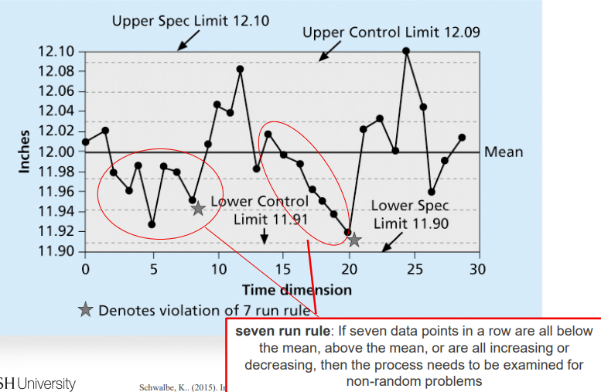

Check sheet

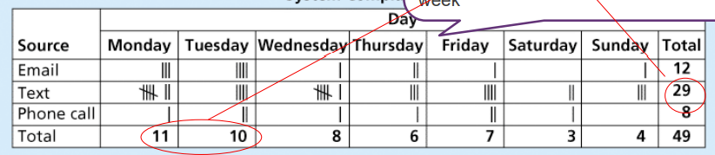

most complaints arrive via text message, and there are more complaints on Monday and Tuesday than on other days of the week

Scatter diagram

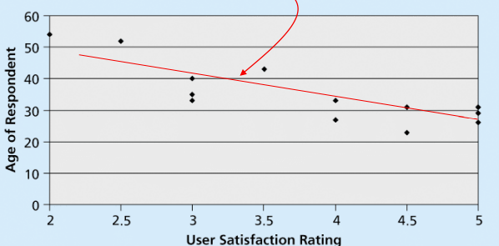

closer data points are to the ‘line of best fit’, the more closely the two variables are related

Pareto Charts

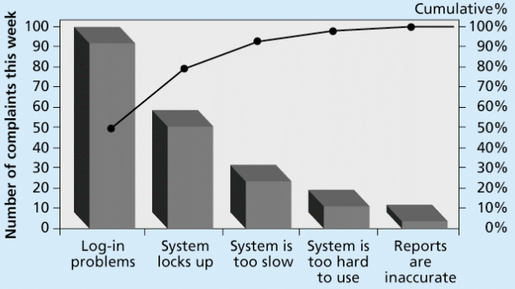

help you identify and prioritize problem areas

**Run Charts**

* run charts are also used for stratification, a technique that shows data from a variety of sources to see if a pattern emerges
* displays the history and pattern of variation of a process over time

