## Enterprise Resource Planning (ERP):

coordinate information in every area of business

* Manage companywide business processes
* Use common database and shared management tools

## Functional business model VS Process business model

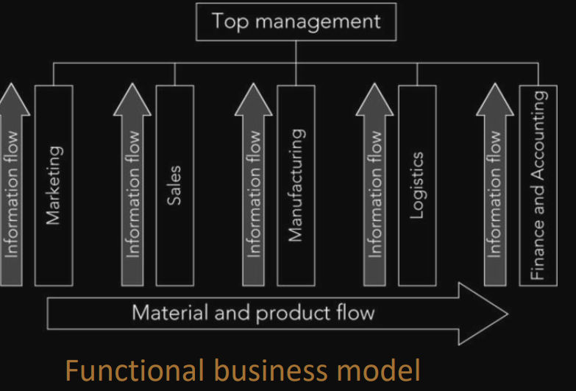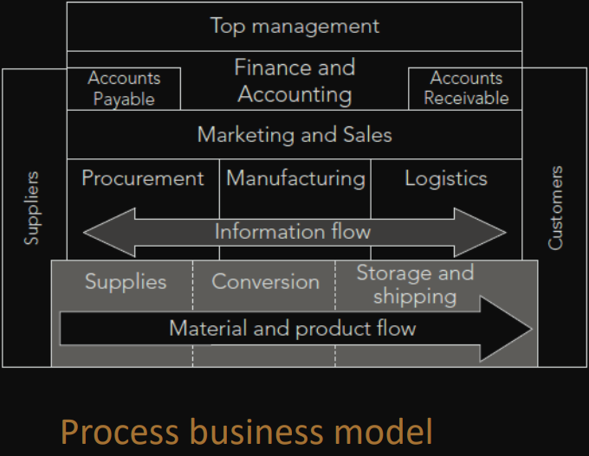

Functional silo

* leads to short-sighted view of improving the division or department rather than the entire organization

Business process

* focus improves organization’s efficiency
* focus has moved management thinking away from a functional department to business process view

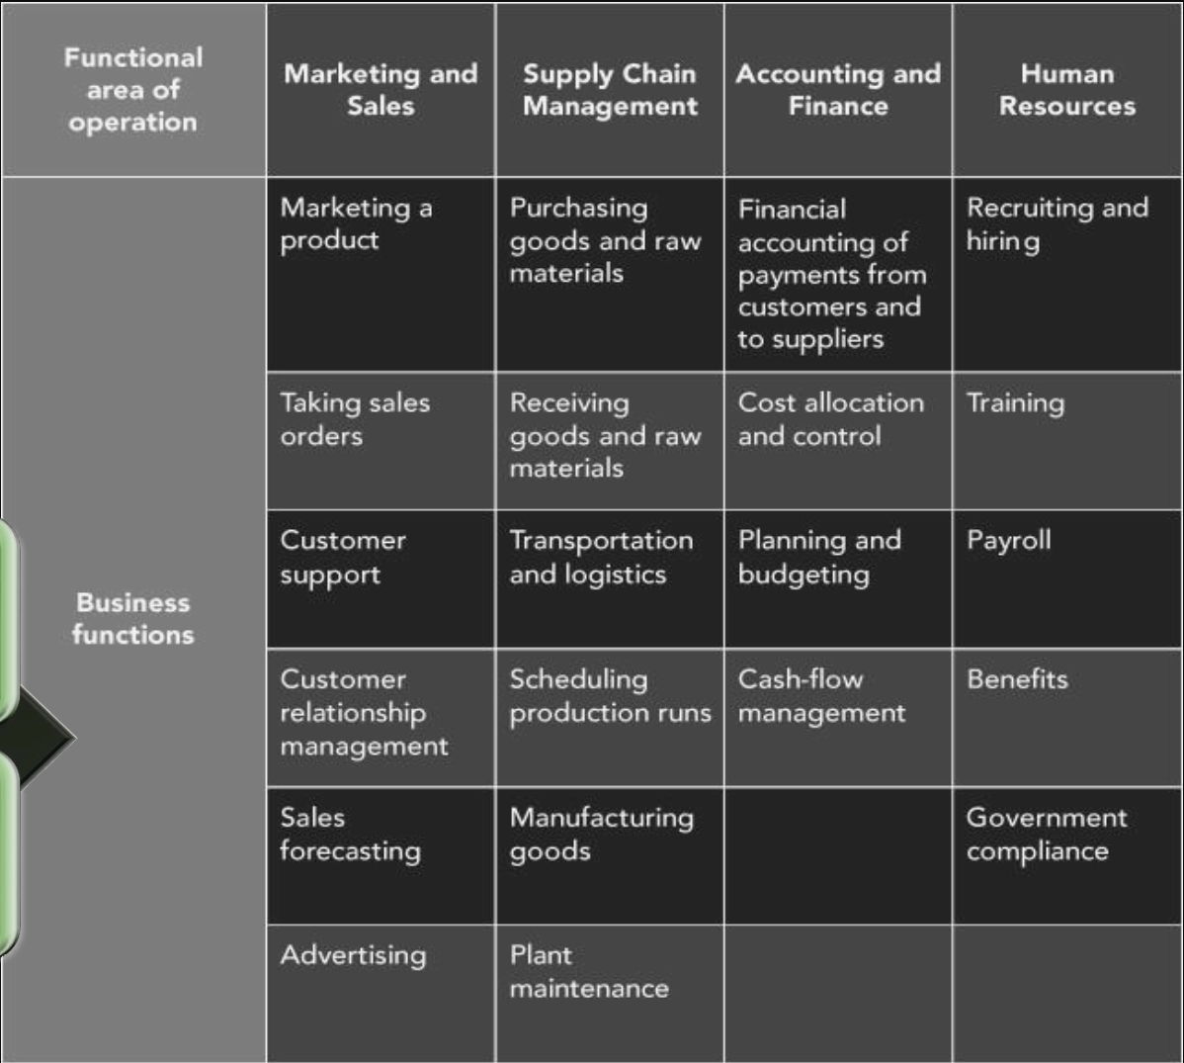

Functional Areas of Operation - Broad categories of business activities

* Marketing and Sales (M/S)
  + Functions:
    - Developing products
    - Pricing
      * determined based on a product’s unit cost
      * Requires information A/F, and SCM data
    - Promoting
    - Taking orders
    - sales forecast
  + Needs information from all areas
  + Inputs
    - Customer data
    - Order data
    - Sales trend data
    - Per-unit cost
    - Company travel expense policy
  + Outputs
    - Sales strategies
    - Product pricing
    - Employment needs
* Supply Chain Management (SCM)
  + Production plans based on information about product sales from M/F
  + Minimize of stock
  + Provide data to Accounting and Finance - each resource was used
  + Support the M/S function by information about what has been produced and shipped – eg customer know where is my coffee
  + Inputs
    - – Product sales data
    - – Production plans
    - – Inventory levels
    - – Layoff and recall company policy
  + Outputs
    - – Raw material orders
    - – Packaging orders
    - – Resource expenditure data
    - – Production and inventory reports
    - – Hiring information
  + 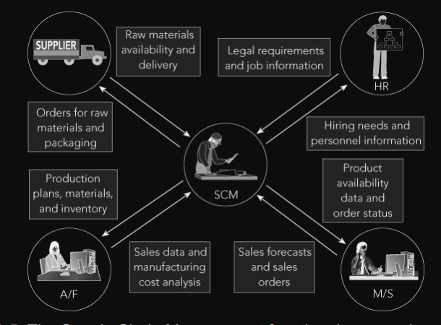
* Accounting and Finance (A/F)
  + Recording raw data about transactions- material purchases, payroll, and receipt of cash
  + Raw data: Numbers collected from sales without any manipulation, calculation, or arrangement for presentation
  + Records important component of sales forecast
  + making staffing decisions and in production planning
  + personnel
    - Record transactions
    - Record accounts payable when raw materials are purchased and cash outflows
    - Summarize transaction prepare reports
  + Inputs
    - – Payments from customers
    - – Accounts receivable data
    - – Accounts payable data
    - – Sales data
    - – Production and inventory data
    - – Payroll and expense data
  + Outputs
    - – Payments to suppliers
    - – Financial reports
    - – Customer credit data
  + 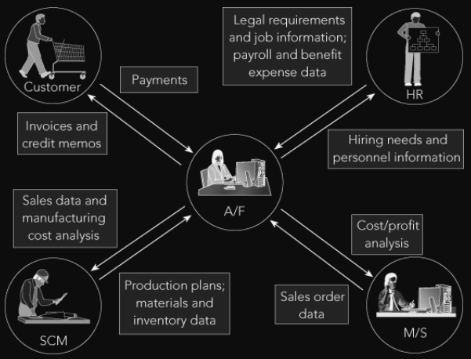
* Human Resources (HR)
  + Recruit, train, evaluate, and compensate employees
  + uses sales forecasts to plan personnel needs
  + Tasks related to employee hiring, benefits, training, and government compliance
  + accurate forecasts of personnel needs
  + know what skills are needed to perform a particular job
  + Inputs
    - – Personnel forecasts
    - – Skills data
  + Outputs
    - – Regulation compliance
    - – Employee training and certification
    - – Skills database
    - – Employee evaluation and compensation
  + 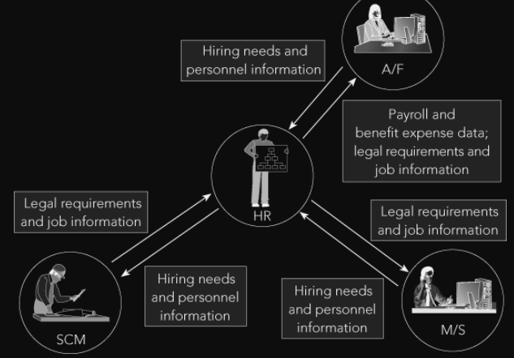

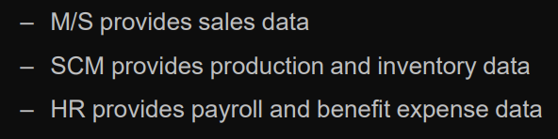

Functional areas are interdependent – Each requires data from the others

Better integration of functional areas improvements in communication, workflow

Business Functions - Activities specific to a functional area of operation

* E.g. Customer Relationship Management

## Business Processes

Collection of activities that takes input and creates an output that is of value to customer

* Customer can be traditional external customer or internal customer
* helps managers to look at their organisation from the customer’s perspective

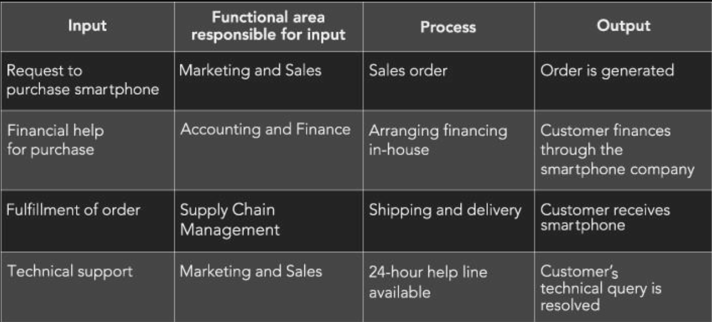

* Businesses consider customer’s viewpoint in any transaction
* Successful customer interaction: interact with each business function involved in the process
* Successful business managers view business operations from the perspective of a satisfied customer
* Sharing data effectively within functional areas leads to more efficient business processes
* Integrated information systems: Systems in which functional areas share data

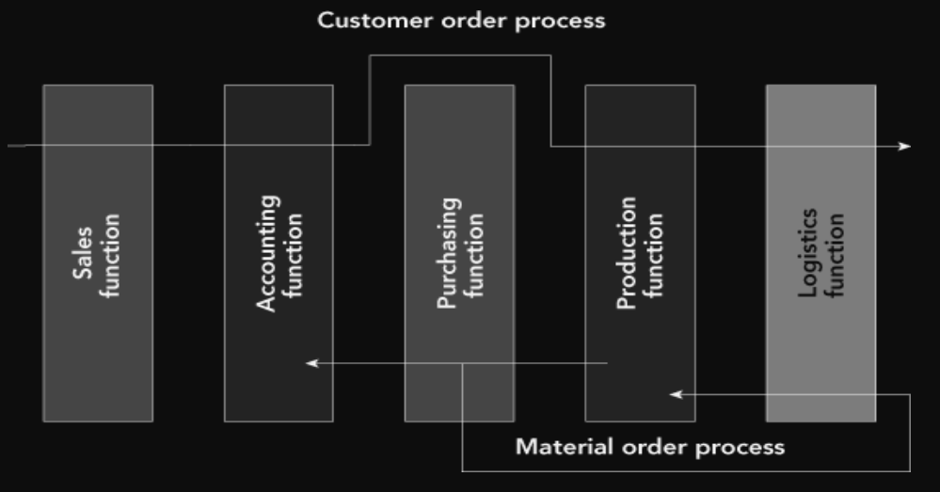

* Managing business processes effectively requires accurate and up-to-date information

## ERP and Systems Integration

* integrated, multi-module application software packages, designed to serve and support several business functions
* logical level-
  + require organisations to focus on business process rather than on functions
  + allow organisations to share data
* physical level-
  + upgrade or install middleware to integrate with their existing system
  + connectivity between heterogeneous application systems
* Integration is required at the data level, client level and application level
* allow companies the ability to respond quickly to market conditions

