## Enterprise Systems Architecture (ESA) Model

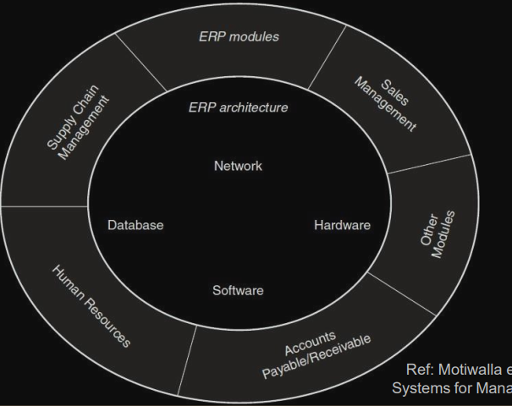

Current ERP systems evolved as a result of:

• Advancement of hardware and software technology

• Development of a vision of integrated information systems

• Reengineering of companies to shift from a functional focus to a business process focus

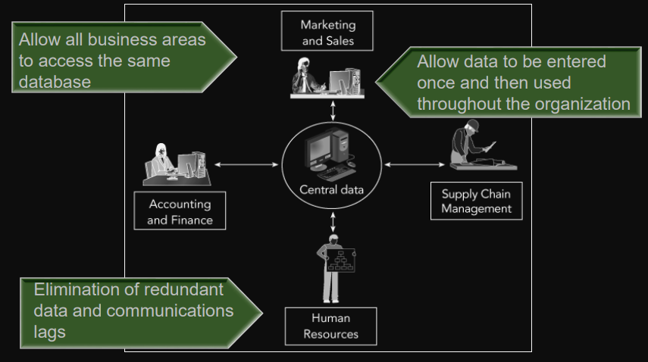

Early Attempts to Share Resources

The 1980s

* allowed users to share data and peripherals on local networks
* Client-server architecture

the mid-1980s

* Database management systems (DBMS)

end of the 1980s

* hardware needed to support the development of ERP systems
* Scalability (The ability to increase capacity by adding new hardware)

Manufacturing Roots of ERP

* during the 1960s and 1970s: simple inventory-tracking systems to material requirements planning (MRP) software
* Electronic data interchange (EDI)
  + Direct computer-to-computer exchange
  + Allowed companies to handle the purchasing process electronically

## Management’s Impetus to Adopt ERP

* Inefficiencies caused by the functional model of business organization
* Functional mode led to top-heavy and overstaffed organizations incapable of reacting quickly
* Process-oriented business model Information flows between the operating levels

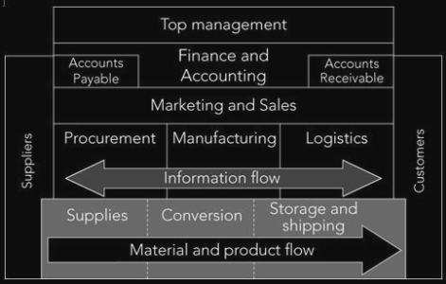

## History of ERP

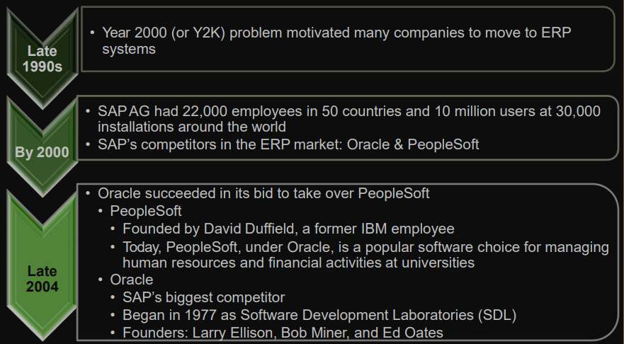

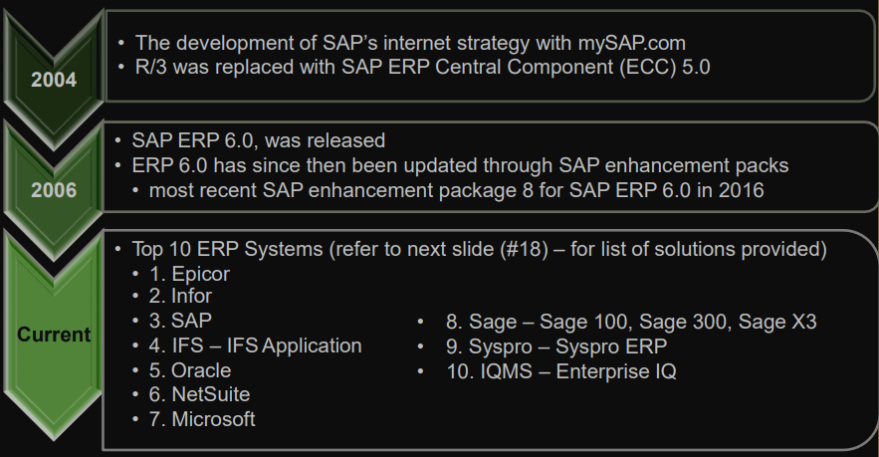

## ERP Features

▪ Enables a company to support and optimize its business processes

▪ Ties together disparate business functions (integrated business solution)

▪ Helps the organization run smoothly

▪ Real-time environment

▪ Scalable and flexible

▪ Automation of data updates

▪ Applicability of best practices

## ERP Modules

ERP vendors provide modules that support the major functional areas of the business

* Sales and Distribution (SD) – sales order processing
* Production Planning (PP)
* Financial and Accounting (FI-CO)
* Materials Management(MM) – inventory and procurement
* Human Resources (HR)

Selectively ERP modules that are both economically and technically feasible

Customization or changes implementing the ERP modules.

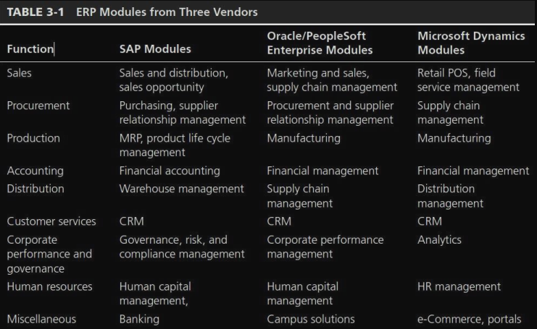

## 1972-2002 ERP Software: SAP and R/3

Goals:

* Develop a standard software product that can meet the needs of each company
* Data in real-time
* Users working on computer screens

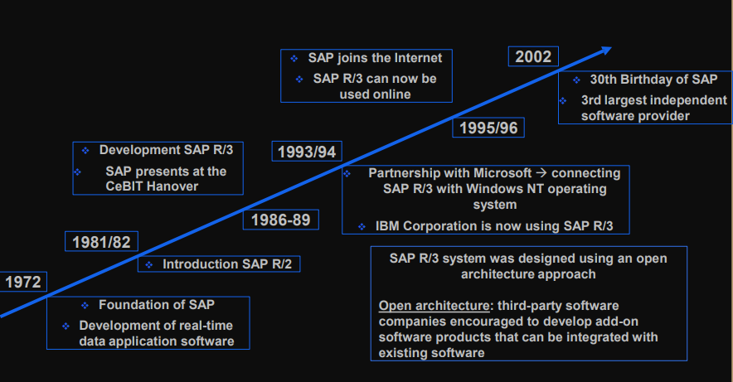

## 2005-2015 ERP Software: SAP S/4HANA

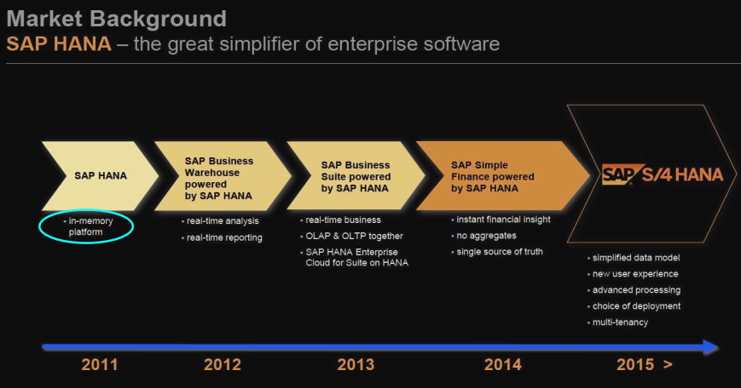

New:

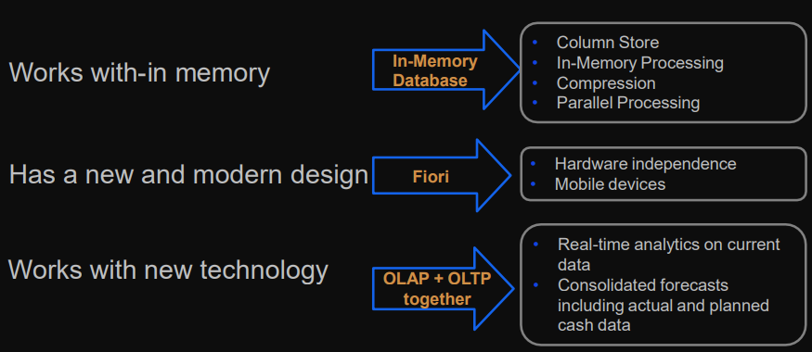

In-Memory Database that allows you to process data

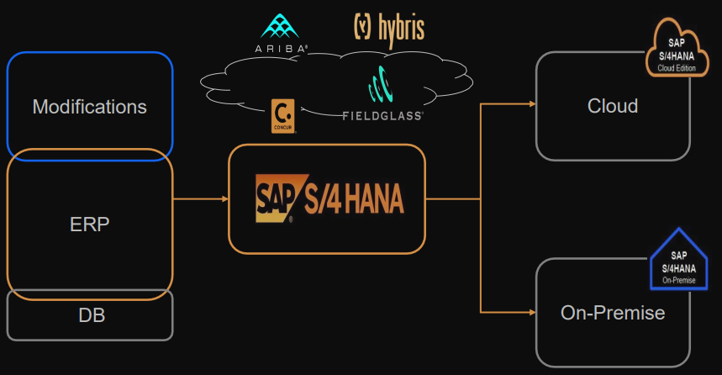

On-Premise Vs Cloud

* No hardware investments needed
* Cloud and On-Premise can be used as a hybrid
* Protection of investment
* Possible migration of SAP Business
* 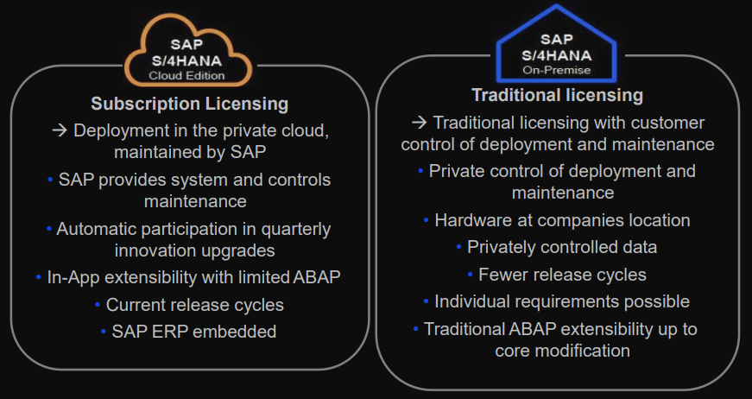

## Benefits of ERP

* efficient business processes that cost less than those in unintegrated systems
* Easier global integration
* Integrates people and data, eliminating the need to update and repair
* Allows to manage operations, not just monitor
* reduce costs and improve operational efficiency

## Choosing Consultants and Vendors

* One person cannot fully understand a single ERP system
* Study their needs
* Hire an external team of software consultants

## ERP System Cost

* depends on
  + • unique business needs.
  + • The size and complexity of the business.
  + • Number of users.
  + • Customization required.
  + • Need for new hardware or hardware upgrade.
  + • Consultants and Analyst fees
  + • Time for implementation
  + • Training required
* 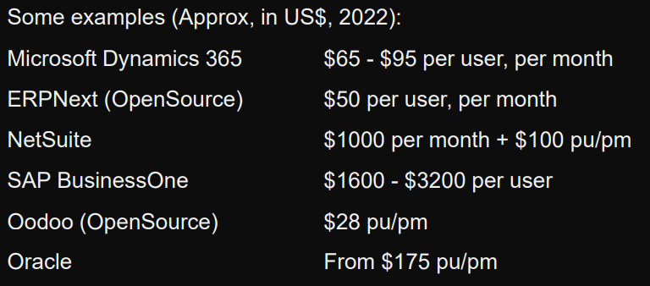

## Should Every Business Buy an ERP

* Some of a business’s operations, and some segments of its operations, might not be a good match with the constraints of ERP
* ERP implementation difficulties result when management does not fully understand its business processes and cannot make implementation decisions on time

## ERP Software Inflexible?

* Options for customization offered by SAP ERP
  + configuration options that help businesses customize the software to fit their needs
  + Programmers can write routines using **Advanced Business Application Programming (ABAP)**
* trying to reconfigure it while retaining data integrity is expensive and time-consuming

## Return of ERP Investment

* ERP eliminates redundant efforts and duplicated data, and generates savings in operations expense
* can help produce goods and services more quickly
* A company that doesn’t implement an ERP system might force out by competitors that have an ERP system
* save a company’s personnel, suppliers, distributors, and customers much frustration
* Cost savings and increased revenues
* ERP implementations take time
  + business factors affecting the company’s costs and profitability
  + Difficult to isolate the impact of the ERP system
* provide real-time data
  + Improve external customer communications

## How Long Does It Take to See a Return?

**Return on investment (ROI)**

* ERP system’s ROI can be difficult to calculate
* The Penistone Research study
  + 63 per cent of companies that performed the calculation reported a positive ROI for ERP
  + Most companies felt that nonfinancial goals were the reason behind their ERP installations

## Why do Companies Have More Success with ERP?

Losing company:

* blindly hoping that new software will cure fundamental business problems that are not curable by any software
* not taking enough time for a proper analysis during planning and implementation
* skimping on employee education and training
* not placing ownership or accountability for the implementation project on the personnel who will operate the system
* Unless a large project such as an ERP installation is promoted from the top down, it is doomed to fail
* implementation brings a tremendous amount of change for users
  + it takes years before they can take advantage of many of an ERP system’s capabilities

## Continuing Evolution of ERP

ERP vendors are working to solve adaptability problems that plague customers

