# ERP in Sales & Marketing and CRM

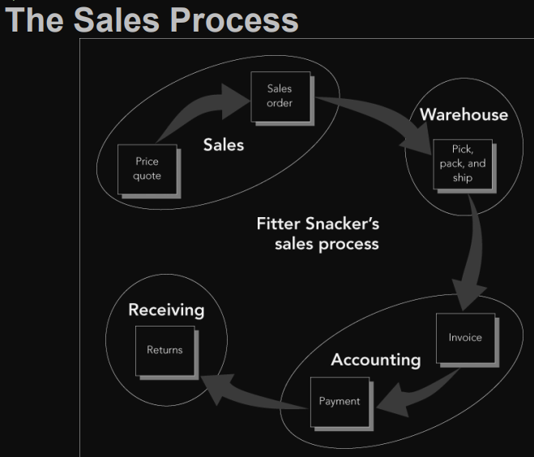

process more accurate and efficient:

* ERP allows business processes to cut across functional area lines
* minimize data entry errors and provide accurate information in real time
* can track all transactions

Taking an Order in SAP ERP

* ERP system allows the user to group customers and salespeople
* Master data maintained in the central database and available to all ERP modules
* unique number is assigned to each customer
* determines whether data entered is valid
* Search

## SD Organisational Structure

▪ Client

* An independent environment in the system

▪ Company Code

* Smallest org unit for which you can maintain a legal set of books
* Can have more than one sales organisation

▪ Credit Control Area

* grants and monitors a credit limit for customers.
* It can include one or more company codes

▪ Sales Organisation

* An organisational unit responsible for the sale of certain products or services.
* The responsibility of a sales organisation may include legal liability for products and customer claims
* A sales organisation is uniquely assigned to a company code.

▪ Distribution Channel

* The way in which products or services reach the customer
* Typical examples of distribution channels are wholesale, retail, or direct sales

▪ Division

* A way of grouping materials, products, or services

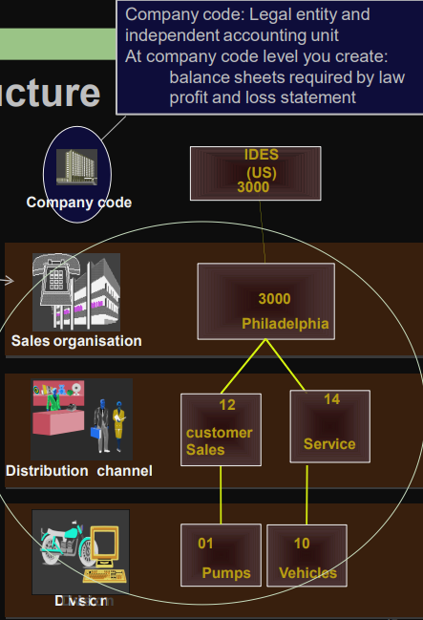

▪ Sales Area

* Combination of Sales Organisation, Distribution Channel and Division
* Determines conditions (i.e. pricing) for sales activities

▪ Plant (eg: Delivering Plant)

* Plant from which the goods should be delivered to the customer

▪ Other SD organisation units:

* Shipping Point
* Loading Point
* Sales Office
* Sales Group
* Sales Person

## GBI Structure for Sales & Distribution

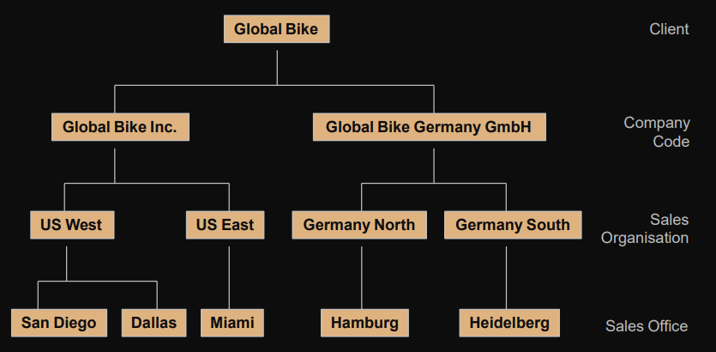

## SD Master Data

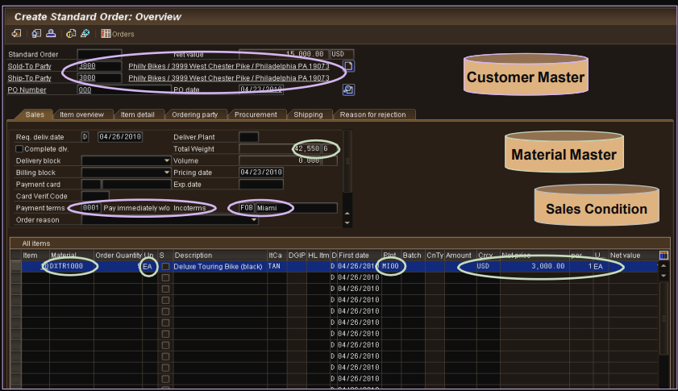

Data entry fields

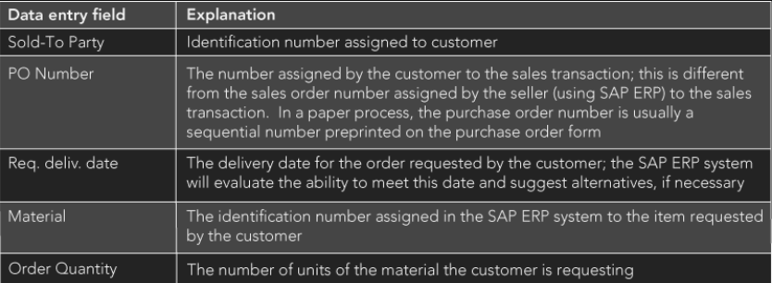

## Customer Master Data

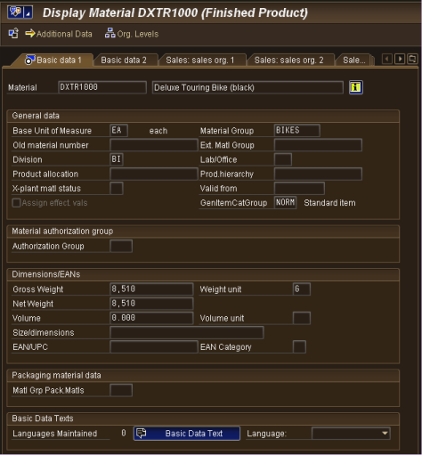

▪ Customer Master

* Contains processing orders, deliveries, invoices and customer payment
* Every customer MUST have a master record

▪ Created by Sales Area

* Sales Organisation
* Distribution Channel
* Division

▪ The customer master information is divided into 3 areas:

* General Data
* Company Code Data
* Sales Area Data

## Material Master

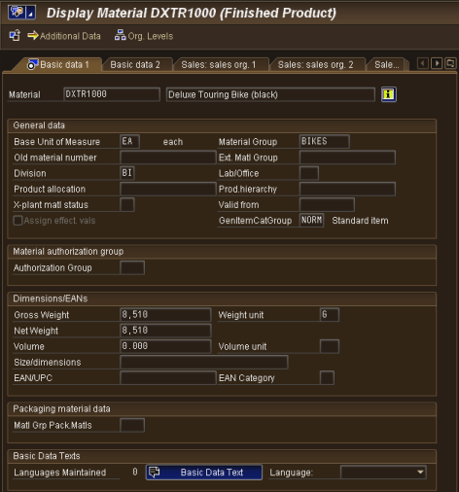

* manage about a material
* It is used by most components within the SAP system
  + Sales and Distribution
  + Materials Management
  + Production
  + Plant Maintenance
  + Accounting/Controlling
  + Quality Management
* Material master data is stored in functional segments called Views

## Condition Master Data (Pricing)

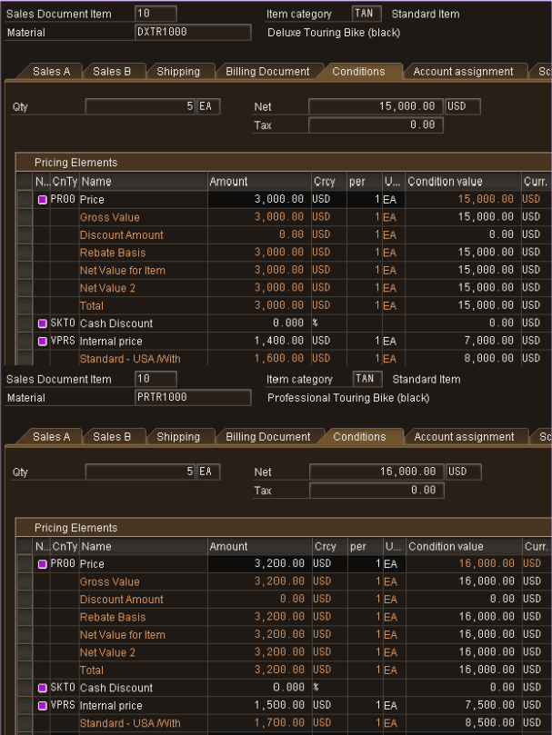

▪ Condition master data includes:

* Prices
* Surcharges
* Discounts
* Freights
* Taxes

▪ You can define the condition master to be dependent on various data:

* Material specific
* Customer specific

▪ Conditions can be dependent on any document field

## Condition Master: Discount Pricing in SAP ERP

▪ ERP system can configure it for a number of pricing strategies

▪ Various kinds of discounts can be allowed

▪ As a safeguard, system can enforce limits on the size of discounts

▪ Condition technique

* Control mechanism developed by SAP to accommodate various ways that companies offer price discounts

## Sales and Distribution in ERP

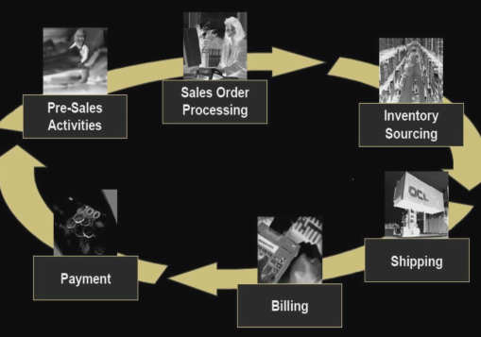

### Pre-Sales Activities

Sales Support assists in the sales, distribution, and marketing of a company’s products and services to its customers

– Creating and tracking customer contacts and communications

* Phone call records
* On-site meeting
* Letters
* Campaign communication

– Implementing and tracking direct mailing, internet, and trade fair campaigns based on customer attributes

Pre-sales documents need to be managed within the presale’s activities: Inquiries and Quotations. These documents help identify possible sales related activity and determine sales probability.

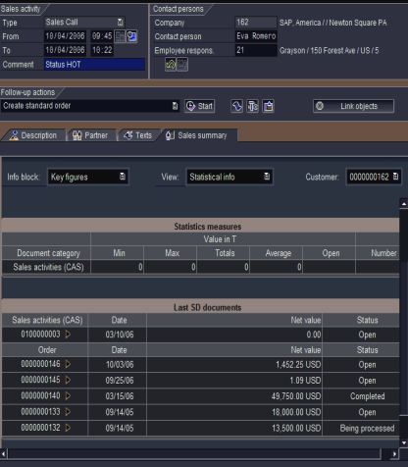

ultimate goal is to equip the sales technician with all the information necessary to negotiate and complete the potential sale

#### Inquiry

customer’s request to a company for information or quotation in respect to their products or services without obligation to purchase

* How much will it cost
* Material/Service availability
* May contain specific quantities and dates

The inquiry is maintained in the system and a quotation is created to address questions for the potential customer

#### Quotation

presents the customer with a legally binding offer to deliver specific products or a selection of a certain number of products in a specified timeframe at a pre-defined price.

#### Creating a Sales order

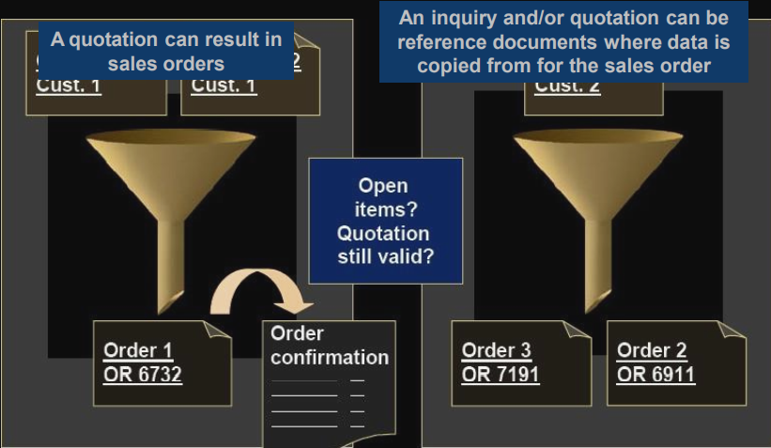

### Sales Order Processing

* series of activities that must take place to record a sales order
* can start from a quotation or inquiry or just a call-in from customers
* Information collected from the customer to support the quotation is immediately included in sales order
* Steps:
  + Recording the items to be purchased
  + Determining the selling price
  + Recording the order quantities
* Users can define various pricing alternatives in the SAP ERP system
* SAP ERP system checks the Accounts Receivable tables in the SAP ERP database to confirm the customer’s available credit
* If customer has sufficient credit available
  + Order is completed
* If customer does not have sufficient credit available
  + ERP system prompts sales personnel to take one of the possible appropriate actions

### Sales Order

– Header

* Data relevant for the entire sales order: Ex: customer data, total cost of the order

– Line Item(s)

* Information about the specific product: Ex: material and quantity, cost of an individual line

– Schedule Line(s)

* Uniquely belongs to a Line Item, contains delivery quantities and dates for partial deliveries

contains all of the information needed to process your customer’s request:

* Delivering Schedule
* Shipping point and route determination
* Availability Check
* Transfer of requirements to MRP
* Pricing
* Credit limit check

### Delivery Scheduling

* When an order is created you must enter a requested delivery date for the order or each line item.
* system will then determine a delivery timeline, this will be used when determining our material availability, or ATP (Availability to Promise) date
* system will determine this date using forward and backward scheduling rules you have defined

#### Backward Scheduling

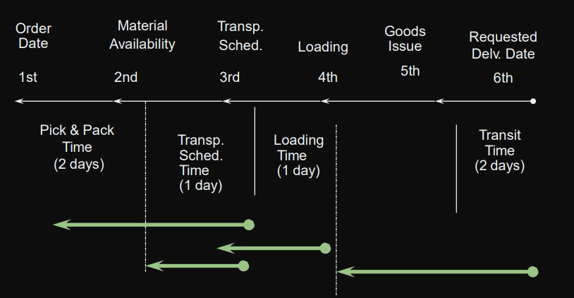

#### Forward Scheduling

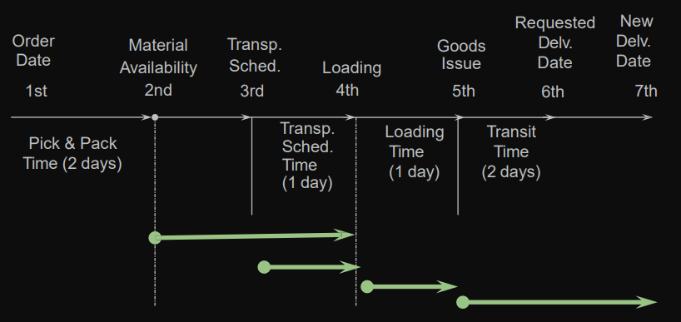

### Shipping & Route Determination

* system must determine the shipping point from which the material will be shipped and the route the material will take to get from your warehouse to your customers location
* shipping point is determined for each line item within the order
* route determination is used to define the transit time of the material that we used in scheduling

### Pricing

* system displays pricing information for all sales documents on the pricing screens at both the header and the line-item level
  + Header pricing is valid for the whole order it is the cumulative of all line items within the order
  + Line-item pricing is for each specific material.
* The system will automatically search for price, discounts, surcharges, calculate taxes and freight. You have the ability to manually manipulate the pricing at both the header and line-item level within the sales order by entering a condition type and amount
  + Taxes and freight can be calculated automatically

### Credit Check

* Allows company to manage its credit exposure and risk for each customer by specifying credit limits
* During the sales order process the system will alert the sales rep about the customer’s credit situation that arises, if necessary, the system can be configured to block orders and deliveries

Rest high light

Page.41