## Integer Linear Programming (ILP)

– When one or more variables in an LP problem must assume an integer value

occur frequently：

* Scheduling workers
* Manufacturing products

allow us to build more accurate models：

* Quantity discounts
* Setup and lump sum costs
* Batch size restrictions

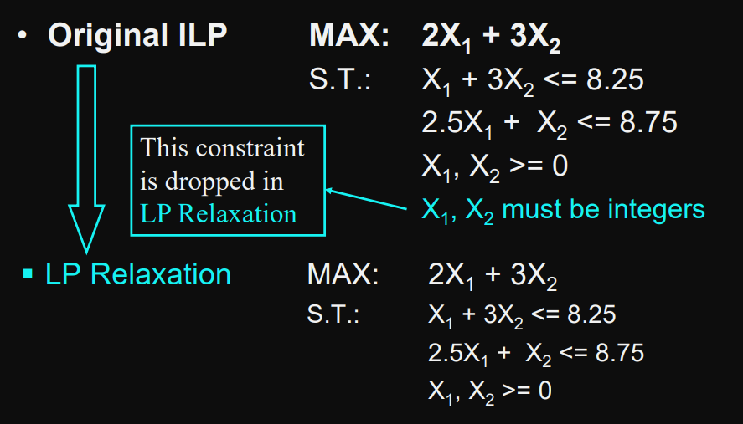

# Method:

## Bounds

optimal solution to an LP relaxation of an ILP problem gives us a bound on the optimal objective function value

* maximization problems, optimal relaxed objective function values is an upper bound on the optimal integer value
* minimization problems, relaxed objective function values is a lower bound on the optimal integer value.

## Rounding

does not work reliably:

* solution may be infeasible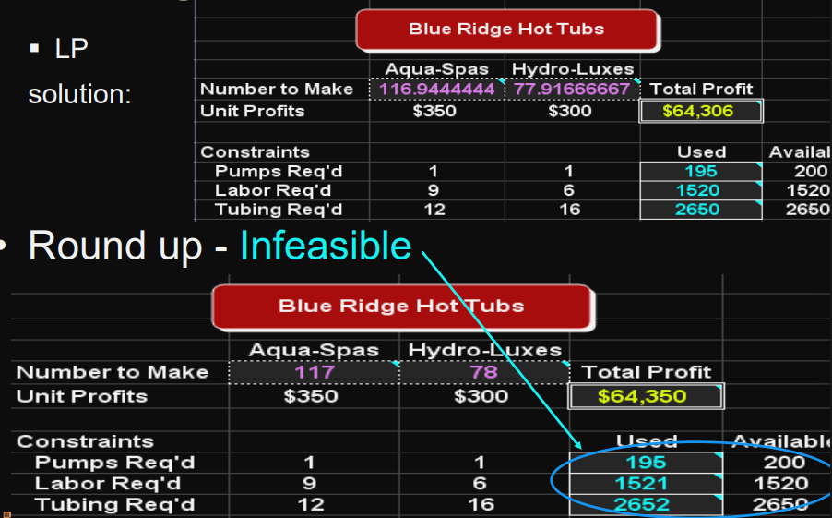
* solution may be suboptimal. 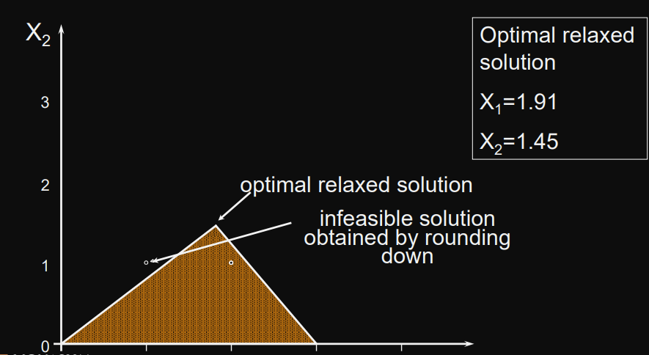

## Branch-and-Bound

Theoretically, this can solve any ILP, but it often takes LOTS of computational effort

But most ILP packages allow you to specify a sub-optimality tolerance factor.

* stop once an integer solution is found that is within some %
* eg. 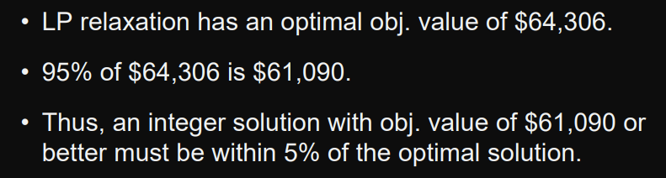

# Practise in Excel:

## Using Solver

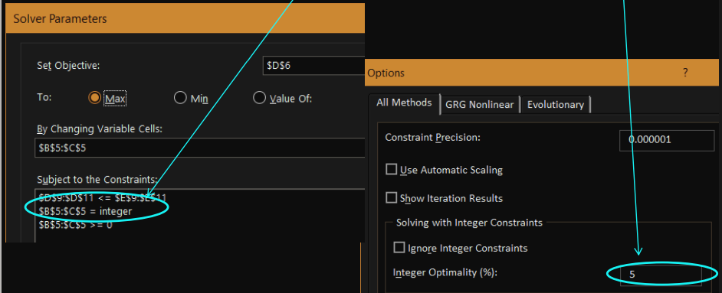

## Binary Variables

only two values: 0 or 1

Binary variables are also useful in modeling a number of logical conditions.

* 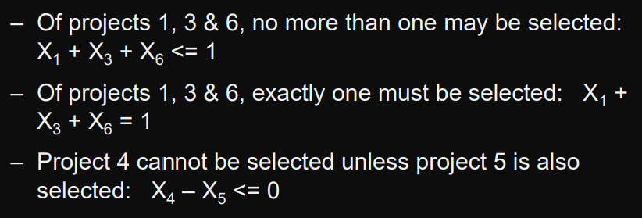

## The Fixed-Charge Problem

* cost to lease, rent, or purchase a piece of equipment or a vehicle that will be required if a particular action is taken
* setup cost required to prepare a machine or to produce a different type of product
* cost to construct a new production line that will be required if a particular decision is made.
* The cost of hiring additional personnel that will be required if a particular decision is made

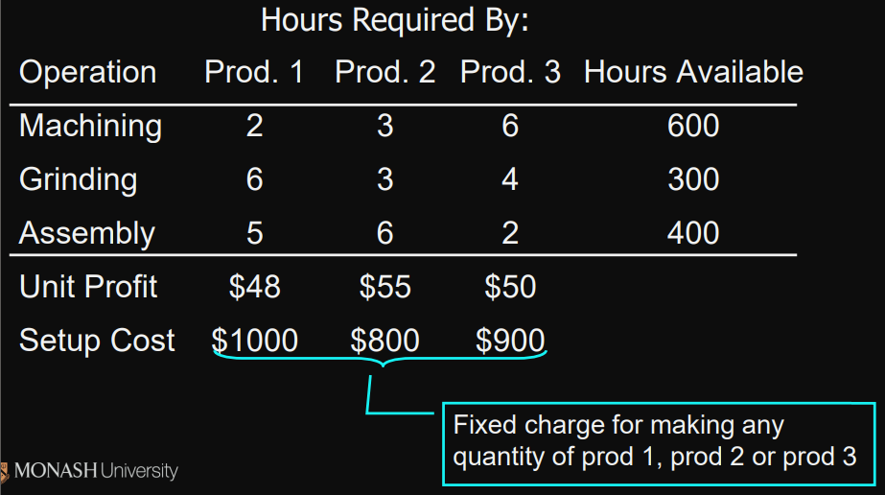

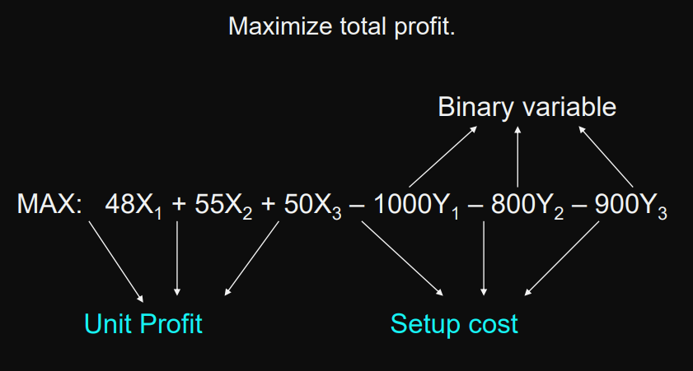

we need to ensure that Yi =1 if Xi >0

## Linking Constraints

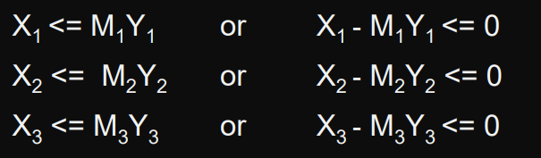

Mi imposes an upper bounds on Xi