Review For W1&2

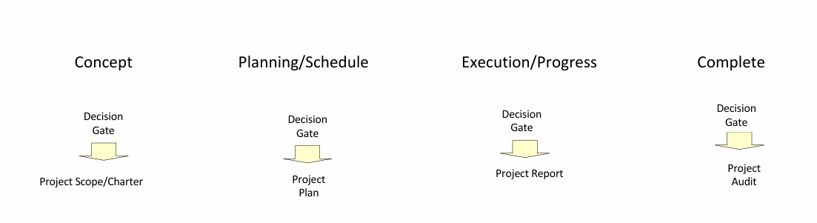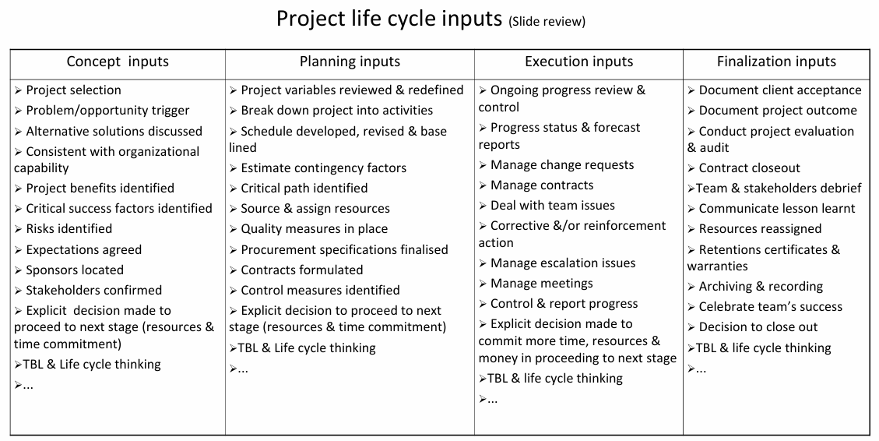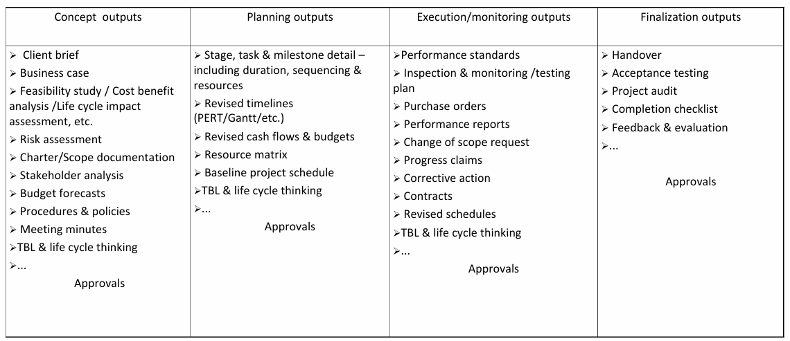

## Planning scope management

**Key Components of Planning Scope Management**

1. **Scope Management Plan**: This document outlines how the scope will be defined, validated, and controlled. It includes the processes for preparing a detailed project scope statement and managing both the project and product scope.
2. **Requirements Management Plan**: Part of the scope management process, this plan specifies how project requirements will be analysed, documented, and managed throughout the project lifecycle. It ensures that all requirements are collected accurately and are traceable, prioritized, and maintained.

**Steps in Planning Scope Management**

* **Collecting Requirements**: Gathering what project deliverables need to meet stakeholders’ needs.
* **Defining Scope**: Developing a detailed project scope statement that describes the project’s deliverables and the work required to create those deliverables.
  + EXPECTATIONS DON’T ALWAYS MATCH CAPABILITY
  + 明确确定项目将产生什么、预期结果以及这些结果将给利益相关者带来的好处。这种清晰度有助于集中精力和衡量项目成功。
  + Project Scope Statement
    - Title
    - start and finish date
    - stakeholders
    - deliverables
    - set all objectives, characteristics & requirements
      * SMART Framework
      * Specific •Measure •Achieve •Realistic •Time frame
    - milestones
    - risks
    - assumptions
    - TBL & life cycle thinking
* 概念阶段的意图
  + Document stakeholders
  + project status on the idea/initiative/change
  + Time, cost, quality, resources, TBL and life cycle
  + Identify how much is to be achieved
  + complexity/potential risks, TBL & life cycle & interdependencies of the project
* **Creating the Work Breakdown Structure (WBS)**: Dividing project deliverables into smaller, manageable parts, which helps in organizing team efforts and assigning responsibilities.
  + What work must be performed?
  + How long will each activity take?
  + What resources can perform the work?
  + How much investment is required?
  + Example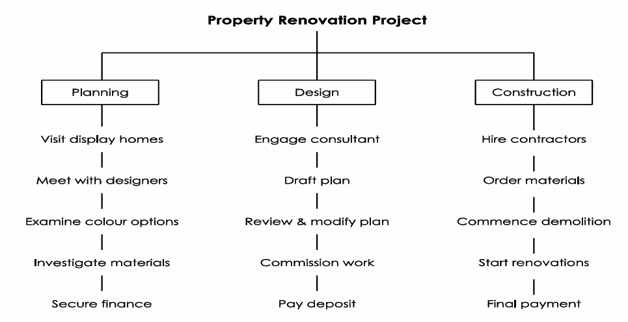
* **Validating Scope**: Formalizing acceptance of the completed project deliverables, ensuring they meet the agreed standards and requirements.
* **Controlling Scope**: Monitoring the status of the project and managing changes to the scope baseline, which helps in ensuring that all requested changes are processed through the established change control process.
  + Scope will always change over time (scope creep)
  + May be innovation, continuous improvement, not always bad

**Importance of Planning Scope Management**

* **Clear Direction**: Provides a clear direction and boundaries, which helps to prevent scope creep, where the scope of a project gradually expands beyond its initial objectives.
* **Resource Allocation**: Helps in effective resource planning and allocation by defining what is to be done.
* **Stakeholder Satisfaction**: Ensures that the project will satisfy the needs for which it was undertaken by aligning project objectives with stakeholder expectations and requirements.

## Planning/Scheduling

Refining project goals & documenting the best way to achieve them

variety of project plans are produced include:

* Project timeline
* cost & budget plan
* risk plan (identification, assessment, analysis, management /response, monitoring)
  + What work must be performed?
  + How long will each task take?
  + What resources can perform the work?
  + How much investment is required?
* scope should provide well defined, achievable

divide the scope into activities. These activities should be grouped into a hierarchical, deliverable oriented decomposition: The work break down structure (WBS)

WBS should be formally approved for the project manager

## WBS: A multi-level perspective

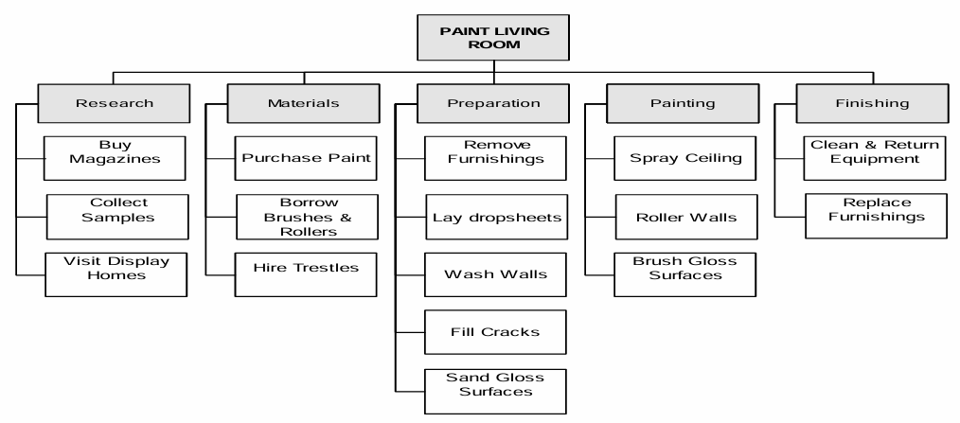

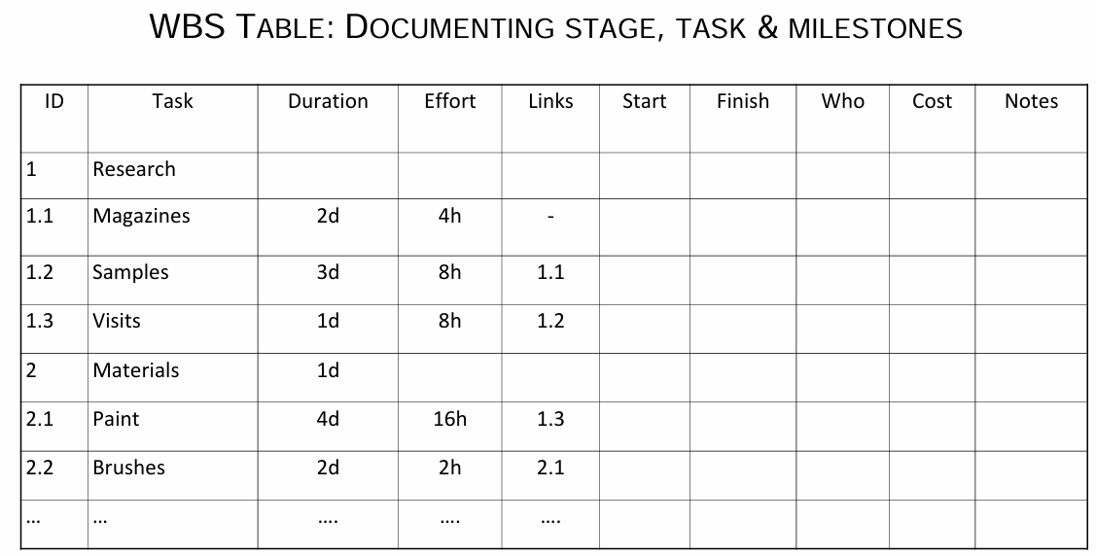

Breaking down the project Factors influencing:

* information captured by the charter & scope(inclusions & exclusions
* complexity of the project
* accuracy required in the estimates
* quality definitions, standards & requirements
* TBL and life cycle requirements

Advantages

* Identifies tasks relationships
* Easy to read in the table format
* Makes possible to visualize a complex project
* Captures tasks to complete the project

Disadvantages

* Time consuming
* No timeline
* inconsistency between table
* Potential differences between projected and available resources

## Common estimating techniques

1. **Analogous Estimating**:
   * **What It Is**: Estimating based on the comparison with similar past projects.
   * **How It Works**: Looks at historical data and projects that are very similar.
   * **Pros and Cons**: Quick and easy but depends heavily on the accuracy of past data and the relevance of the projects compared.
2. **Using Resource Unit Rates**:
   * the lower the unit rates the more resources you get with your money
3. **Bottom-Up Estimating**:
   * **What It Is**: A detailed estimating technique that breaks tasks down into smaller components.
   * **How It Works**: Estimates each small component individually, then adds these estimates together to form a total estimate for the entire project or task.
4. **Expert Judgment**:
   * **What It Is**: Relying on the knowledge and experience of experts.
   * **How It Works**: Experts use their experience and understanding of the project to make informed guesses or judgments about the project’s needs.
5. **Vendor Bid Analysis**:
   * **What It Is**: Estimating based on bids from potential vendors.
   * **How It Works**: Typically involves requesting bids or expressions of interest from at least three vendors to compare costs and choose the best offer.
6. **Three-Point Estimate/Wide Band Delphi**:

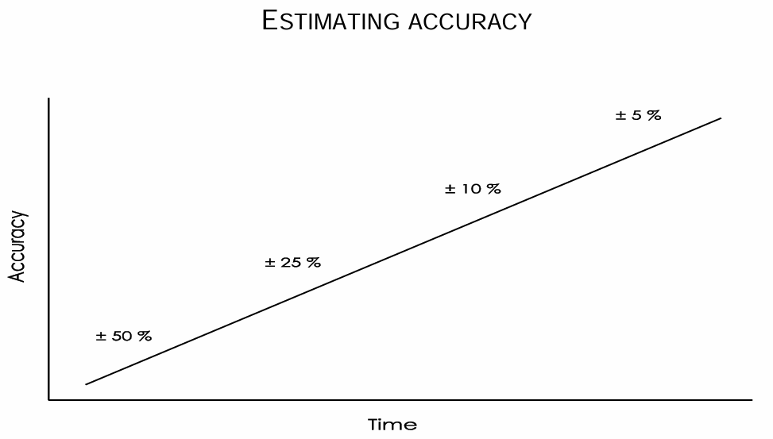

The graph is from beginning of project the accuracy is the lowest, till project finish

* + **What It Is**: A technique that uses three figures to define the approximate range of an estimate: most likely, optimistic, and worst.
  + **How It Works**: Often combined with team discussions where team members can correct each other, improving the accuracy and realism of the estimate.
  + 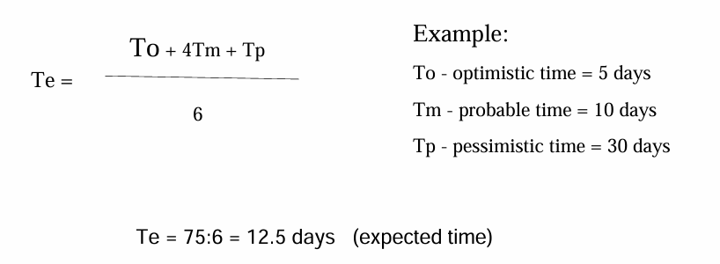
  + Example: 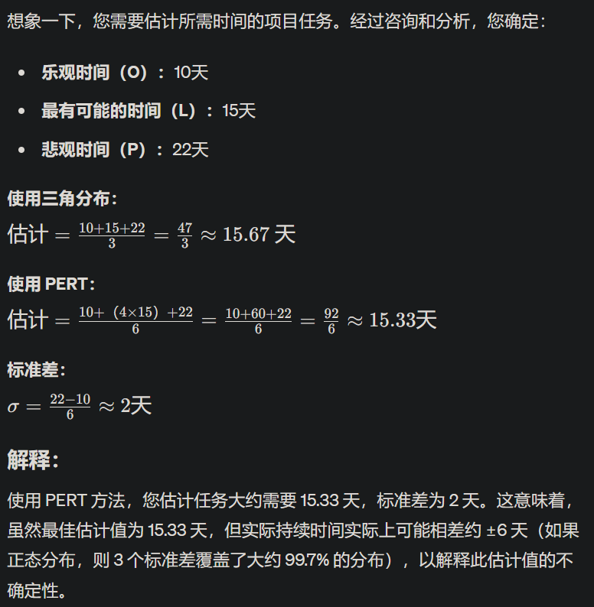

1. **Parametric Estimating**:
   * **What It Is**: Using statistical modelling to estimate project parameters.
   * **How It Works**: Uses the relationship between variables to calculate the duration or cost of a project based on the mathematical model of these variables.

Estimation guidelines

Since no estimates will ever be entirely accurate, we should record

* How the calculation was determined
* assumptions and impacting constraints
* confidence level (+/-)
* optimistic, pessimistic & most likely range
* All source data and stakeholders involved

## PERT (Program Evaluation Review Technique) NETWORK DIAGRAM FROM WBS

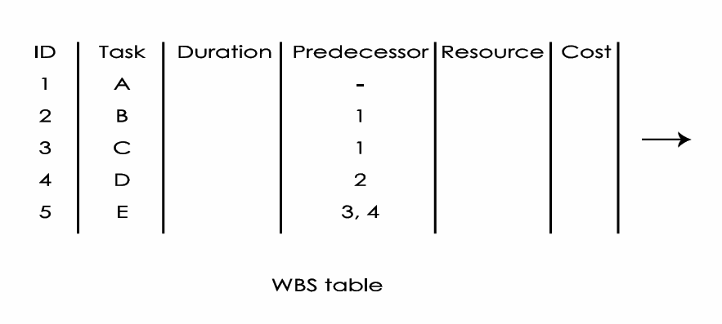 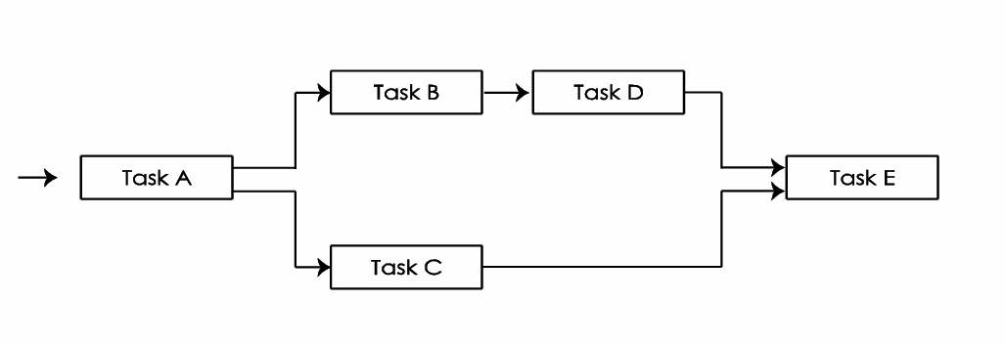

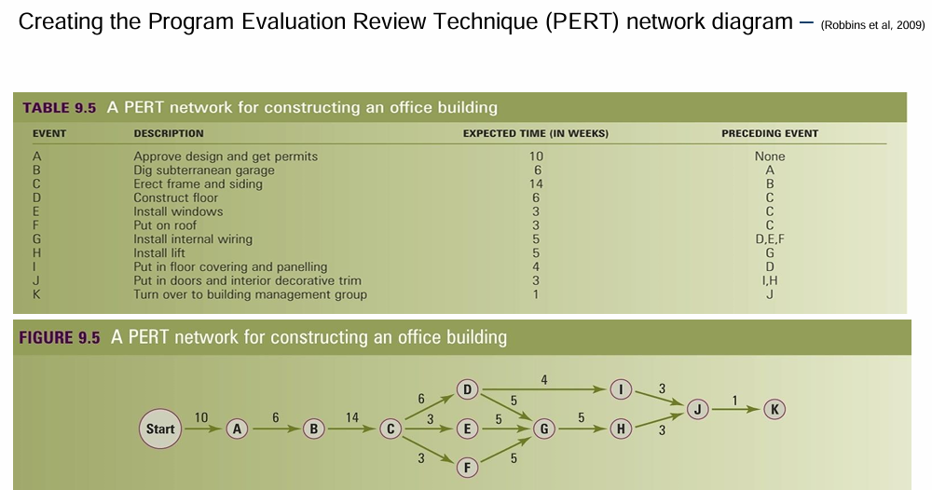

The PERT illustrates:

* project’s logic and how it is tied together
* relationships, flow
* critical path lies throughout the project
* bottlenecks

Advantages

* Excellent visual & interactive graphic
* Participative decision making
* Eliminates idle time
* Shows Critical Path

Disadvantages

* Difficult to read if the project is large
* Not always easy to understand
* Limited amount of information

## Critical path analysis

* shortest project completion time

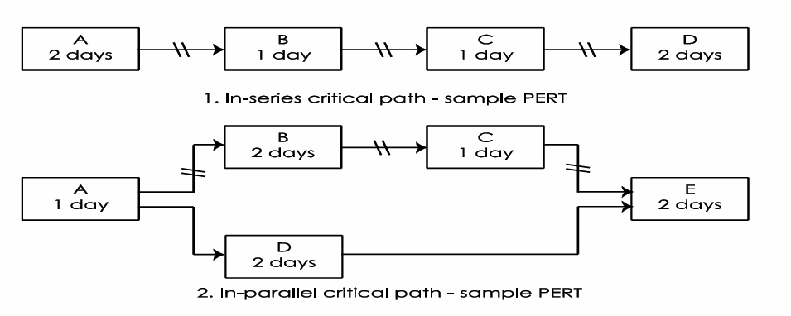

Aim:

* Timely corrective action
* Accurate estimates
* No delays

## The Gantt chart

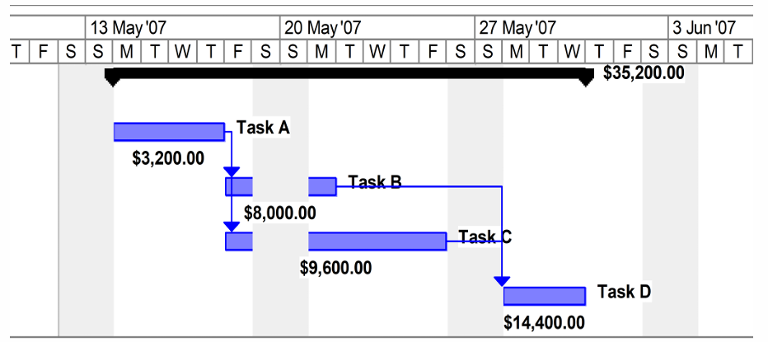

Advantages

* ideal for monitoring actual progress to date
* Easy to allocate resources
* critical path
* read from top down & from left to right
* Illustrates task duration

Disadvantages

* Difficult to read
* Time consuming to update & report
* Need software to avoid excessive time