## Review: Planning for cost management

Estimating Project Costs

* Pre-determined历史
* Expert judgement
* Analogous类似
* Group decision making利益相关者或专家
* Unit rates特定工作单位的标准化费率
* Published commercial data
* Vendor bid
* Reserve
* 3-point estimation乐观、悲观和最有可能

## Budgeting

Approaches

* Traditional: Based on previous performance.
* Zero-based: Justifies every activity and outlay from zero.
* Program: Groups activities by programs for cost projection.
* Top-down: Estimates from senior managers, broken down further.
* Bottom-up: Detailed estimates from those responsible for tasks.

Advantages:

* Improves decision-making.
* Effective cost control.
* Reliable profit determination.
* Identifies and diagnoses problems.
* Useful for long-term objectives.
  + 主要原理是跟踪支出和预算相比使得利润/结果/成本可控，问题可诊断（什么地方花多钱了）

Disadvantages:

* Difficult top-to-bottom support.
  + 管理层可能会设定不切实际的预算目标
* Time-consuming planning.
* Inflexible and restrictive.
  + 预算一旦设定，就可能变得僵化且难以调整
* Ignores cyclical fluctuations.
  + 忽略周期
* Based on unreliable estimates.

Remember Sample project budget:

* Budget cost, How estimation, actual cost, variance & percentage (Difference between actual cost), confidence level, assumptions, constraints, contingency (additional reserve funding), work completion %, actual cost & percentage, tolerance (acceptable difference between budget & actual), corrective actions, remaining budget.

## The ROI of Sustainability

* **Sustainability Metrics**:
  + Paper, facilities, energy, waste/disposal, packaging, transport/logistics costs.
* **Driving Factors**:
  + Environmental/social stewardship, brand reputation, competitive advantage, stakeholder expectations, rising energy costs, regulatory compliance.
* **Challenges**:
  + Budget constraints, demonstrating ROI, fear of disrupting processes.

How companies make the trade-offs at various levels and simultaneously manage social, environmental and financial performance

# Quality Management

Focuses on achieving technical excellence and customer satisfaction.

The Challenges of Quality

1. **Personal Dimension**:
   * Framed by individual experiences and expectations.
   * Implies reliability, customer satisfaction, value for money, and compliance with specifications.
2. **Measurement**:
   * Quality must be measurable to ensure conformance, compliance, and improvement.
   * Defined as excellence and attainment.
3. **Project Success**:
   * Measured against benchmarks: time (schedule), deliverable compliance (specification), cost control (budget), Triple Bottom Line (TBL), and lifecycle.
   * Client’s identified needs (not just wants) and intangible expectations of quality are key metrics.

## The road to quality

1. **Quality Planning**:
   * Identify and agree on mandated quality standards, operational definitions, and business requirements.
   * Ensure standards are achievable and measurable from project start.
   * **Examples**:
     + Reviewing scope documents and technical specifications.
     + Examining operational procedures.
     + Aligning with business quality policies.
     + Benchmarking against other projects.
     + Designing checklists for consistency.
     + Accessing relevant standards and regulations.
2. **Quality Assurance**:
   * Guarantee that project performance (input, process, output) is regularly evaluated.
   * **Examples**:
     + Quality management plan.
     + Business rules and operational definitions.
     + Internal systems for waste elimination and process variation control.
     + Regular quality audits and team meetings.
     + ISO standards compliance (ISO 9000, 14000, 26000).
3. **Quality Control**:
   * Monitor specific tasks and project results to identify, measure, and eliminate causes of unsatisfactory performance.
   * Ensure continuous quality compliance.
   * **Examples of Tools**:
     + Peer reviews.
     + Physical inspections.
     + Control charts, scatter diagrams, checklists, Pareto diagrams, statistical sampling, flowcharts, cause and effect diagrams,
     + trend analysis
   * processes
     + monitors specific task and project results
     + measure and eliminate the causes of unsatisfactory performance
     + used through the implementation and finalisation stages of the project
   * Benefit
     + Elimination of rework
     + Confirmation of acceptance
     + Process adjustments
     + Documented quality improvement
4. **Quality Continuous Improvement**:
   * Foster a culture of innovation and improvement. project is delivering and ultimately
   * **Examples**:
     + Regular performance reporting.
     + Meetings and debriefs.
     + Decision gates and approval processes.
     + Walkthroughs, peer reviews, scenario analysis.
     + Evaluation reports, suggestion boxes, user feedback.

## Balanced Scorecard (BSC) for projects

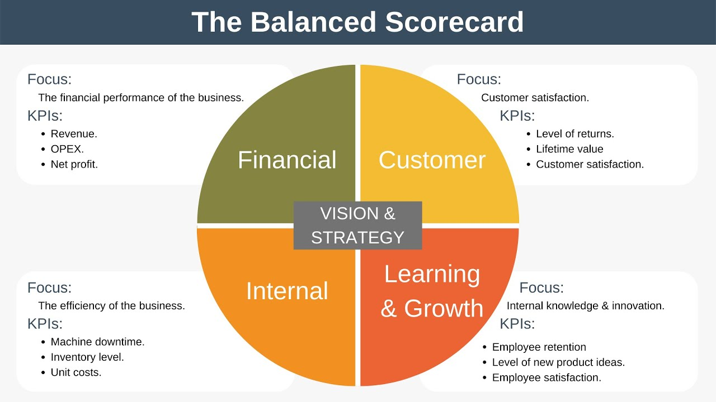

Performance measurement framework which includes strategic performance metrics

Example:

**1. Customer Perspective**

* **Objective**: Increase customer satisfaction and loyalty.

**2. Financial Perspective**

* **Objective**: Achieve financial sustainability and profitability.

**3. Internal Business Processes Perspective**

* **Objective**: Improve efficiency and effectiveness of internal processes.

**4. Growth and Innovation Perspective**

* **Objective**: Foster continuous improvement and innovation.

**Implementation Stages of BSC for the Project**

**Stage 1: Initial Measurement (Baseline Establishment)**

* **Activities**:
  + Conduct initial surveys and assessments to establish baseline metrics for customer satisfaction, financial performance, internal processes, and innovation.
  + Document current performance levels and identify areas for improvement.

**Stage 2: Integrating BSC into Project Plan**

* **Activities**:
  + Include BSC benchmarks in the overall project plan.
  + Align project goals with the strategic objectives and metrics of the BSC.
  + Assign responsibilities for tracking and reporting on each metric.

**Stage 3: Monitoring and Comparing Performance**

* **Activities**:
  + Implement BSC measurements and track progress against initial benchmarks.
  + Regularly review performance data and compare it with targets.
  + Identify gaps and areas for improvement, and take corrective actions as needed.

**Stage 4: Final Review and Documentation**

* **Activities**:
  + Conduct a comprehensive review of BSC metrics at the end of the project.
  + Document performance outcomes and lessons learned.
  + Use the final report to support best practices and continuous improvement efforts.

Example

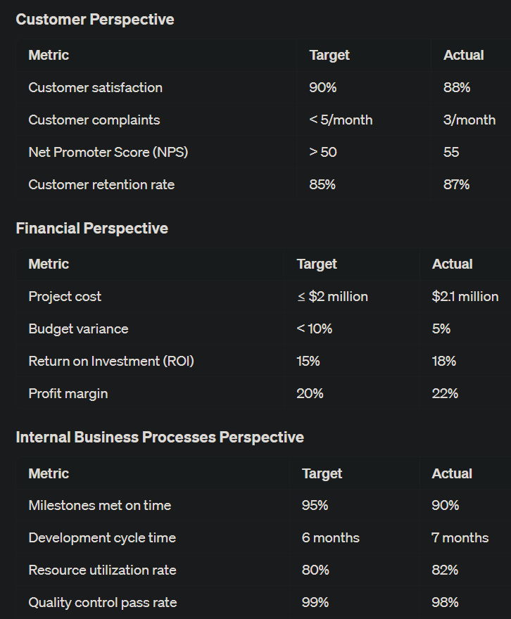

## Indicators to Measure Sustainability Performance

1. **Economic**:
   * Prosperity generation, economic enhancement.
2. **Social**:
   * Social responsibility, community benefits.
3. **Environmental Quality**:
   * Long-term environmental impact.
4. **Use of Natural Resources**:
   * Protection and enhancement of natural capital.

## Assessment Matrix for Sustainable Development

Levels:

A: Awareness of sustainable development issues.

B: Set objectives and select the best project option.

C: Demonstrate achievement of sustainable targets.

D: Select suppliers/contractors to achieve targets.

E: Measure performance, identify gaps, and improve future predictions.