**1. Planning for Human Resource Management**

* **Human Resource Management Plan:** Establishes baseline HR needs and skills for project success.
* **Components:** Acquisition strategy（识别和利用组织内的员工，并且雇佣新的）, roles and responsibilities, timetables, development needs（认识到成员需要发展的技能和知识规划培训计划）, team-building strategies, recognition and rewards, performance management procedures.
* **Planning for human resource management:** Organizational chart, responsibility matrices, position descriptions, training registers, performance reviews, application forms, and employment contracts.

**2. Acquiring the Multi-Generational Project Team**

* **Strategies:**
  + Negotiate with managers to release/share resources.
  + Investigate market conditions for contractor availability and rates.
  + Review preferred supplier arrangements.
  + Communicate consequences of resource acquisition failure to stakeholders.
  + Evaluate resources against legal and regulatory criteria.
  + Consider professional development plans and budget implications.
  + Manage resources across multiple locations and time zones.
  + Measure and evaluate performance throughout the project.
  + Manage diverse resources empathetically, encouraging continuous feedback and individual strengths.

**3. Developing the Project Team**

* **Goals and Objectives:** Clear, communicated, and recognized goals.
* **Success Opportunities:** Unqualified opportunities for success, tolerance for calculated risk, mutual appreciation of skills, defined roles, and endorsed procedures.
* **Communication:** Open, honest, and continuous.
* **Leadership Support:** Essential for team development.

**4. Valuing Project Team Diversity**

* **Inclusivity:** Acknowledge, understand, and value diverse demographic and cultural backgrounds.
* **Equality and Diversity:** Create an inclusive environment that promotes equality and values diversity.

**5. Five Stages of Team Development**

1. **Forming:** Initial gathering, introductions, break the ice, tentative relationships, little trust, ambiguous goals but hide the cards.
2. **Storming:** Natural conflicts due to personality clashes and team role issues.
3. **Norming:** Development and agreement on team norms and codes of conduct.
4. **Performing:** United, cohesive, and productive work towards project goals.
5. **Adjourning:** Project completion and team disbandment.

In practice, the stage may go back due to some reasons

Learning and development

* Job rotation
* Private research
* Online learning

**6. Managing the Project Team**

* **Energize and Direct:** Complete work on time, on budget and milestones, and as specified.
* **Cohesion:** Draw the team together, enable self-directed work, and allow self-correction.
* Motivation: Maslow’s hierarchy of needs and Herzberg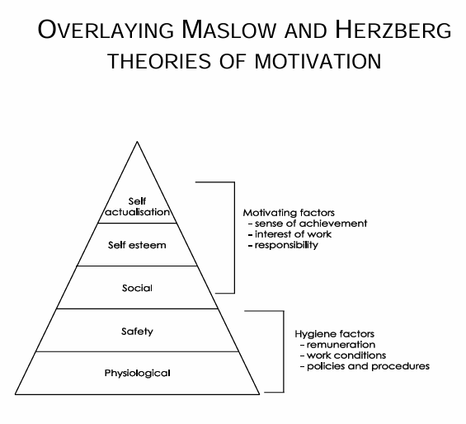

**7. Measuring Team Performance**

* **Criteria:** Performance against objectives, schedule, budget, and scope.

**8. Teams and Their Personalities**

* **Personality Considerations:** Understand natural preferences, response styles, communication styles, and unique way in how they make contributions, strength and weakness.
* **MBTI (Myers-Briggs Type Indicator):** Assess personalities to predict behaviour and solve problems effectively.
* 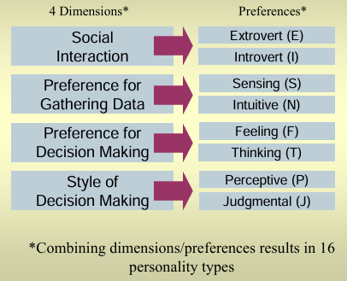

**9. What Effective Team Members Need**

* **Clear Goals:** Recognized and accepted long-term goals and objectives.
* **Defined Roles:** Communicated and accepted roles and procedures.
* **Experience and Knowledge:** Project methodology and mutual appreciation of skills.
* **Communication:** Open, honest, continuous communication and constructive feedback.
* Trust & support each other and support leader

**10. Indicators of Team Cohesion**

* **Positive Indicators:** Cooperative climate, trust, open support, clear expectations, resolved disputes.
* **Negative Indicators:** Decision delays, withheld information and feedback, competing agendas, underperformance, distrust, Subgroups.

**11. Managing Conflict**

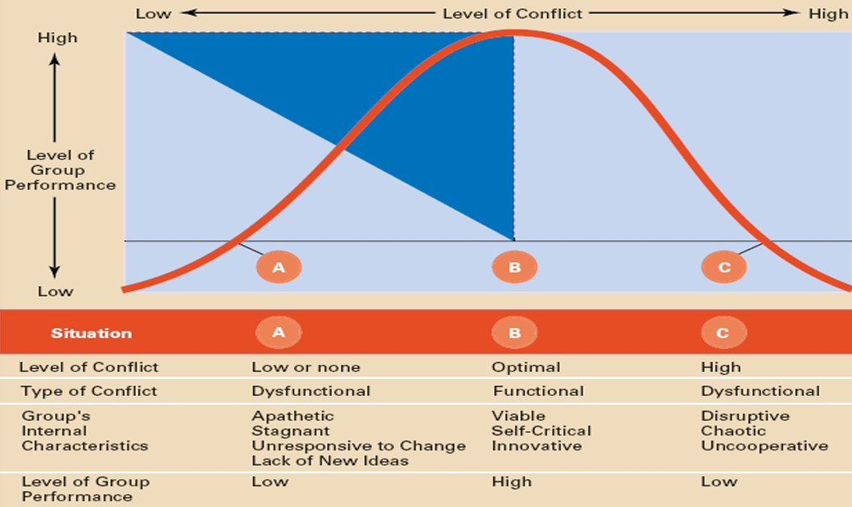

* **Conflict Causes:** Deadlines, mismatched tasks and skills, personality clashes, operational priorities, performance issues, role insecurity, communication gaps, scope changes, multiple supervisors, disagreements, hidden agendas.
* 12. Balancing Conflict
* Positive Outcomes:
  1. Exploration of new ideas.
  2. Consideration of other people’s perspectives.
  3. Adjustments/modifications made.
  4. Clarification of different positions/interests.
  5. Postponed decisions.
  6. Time to reconsider, clarify, and communicate a proposal.
* Negative Outcomes:
  1. Breakdown in communication.
  2. Increased hostility.
  3. Cessation of project work.
  4. Legal action for contract breaches.
  5. Replacement of project personnel.
* **Conflict Management Approaches: page 27**

1. Avoiding (Low Assertion, Low Cooperation):
   1. Strategy: Neither assertive nor cooperative; no attempt to address conflict (lose-lose).
   2. Effective When: Cannot win, issue is minor, confrontation may cause more damage, time-out needed, imbalance of power.
2. Competing/Forcing (High Assertion, Low Cooperation):
   1. Strategy: Assertive and uncooperative; power and dominance to gain compliance (win-lose).
   2. Effective When: You are right, high stakes, quick action needed, unpopular decisions required, show of force needed.
3. Accommodating (Low Assertion, High Cooperation):
   1. Strategy: Unassertive and cooperative; other’s view considered more important (lose-win).
   2. Effective When: Other’s evidence is compelling, peace and harmony valued, tactical concession needed, acknowledge weakness, avoid further damage to relationship.
4. Collaborating (High Assertion, High Cooperation):
   1. Strategy: Assertive and cooperative; seeks mutual and optimal outcomes (win-win).
   2. Effective When: Building alliances, needing enduring commitment, encouraging diverse perspectives, mutual solutions needed, optimal outcomes without sacrificing own.
5. Compromising (Mid Assertion, Mid Cooperation):
   1. Strategy: Moderate assertiveness and cooperation; mutually acceptable outcome (partially satisfies both).
   2. Effective When: Outcomes moderately important, no other option works, balanced power, gesture of moving forward needed, decision required.

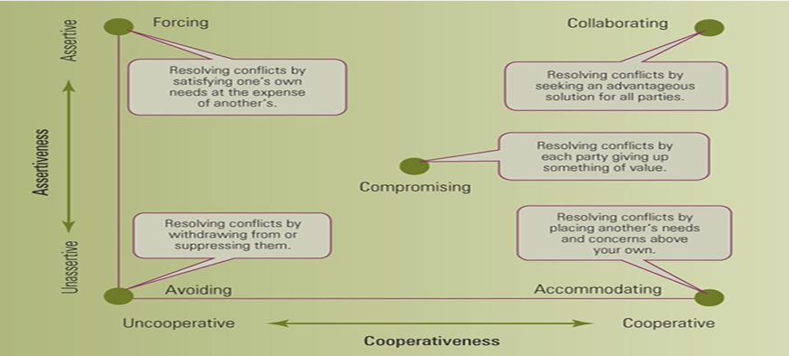

# PART B

**1. Planning Communications Management**

* **Communication Importance:** 75-90% of time spent on communication (writing, reading, talking, and listening).
* **Impact of Poor Communication:** Leads to workplace frustration and undermines effectiveness.
* **Effective Information Delivery:** Provide information in the right format, at the right time, to the right audience, and with the right impact.

**2. Communicating Effectively with Stakeholders**

* **Communication Process Model:** Sender and receiver interaction, ensuring clear message delivery and understanding.

**3. Communication Barriers**

* **Common Barriers:**
  + Lack of client involvement.
  + Poorly informed stakeholders.
  + Ineffective meeting management.
  + Inadequate reporting requirements.
  + Poor documentation.
  + Frequent scope changes.
  + Changing project personnel.
  + Lack of project audits for lessons learned.

**4. Managing Project Communications**

* **Communication Management:** Involves planning, collection, creation, distribution, storage, retrieval, management, control, monitoring, and disposal of information.
* **Types of Information:**
  + **Fact:** Indisputable, objective truth.
  + **Fantasy:** Opinion or interpretation.
  + **Folklore:** Rumor or gossip.
  + **Feelings:** Intuition, ego, or emotion.

1. **Project Meetings**

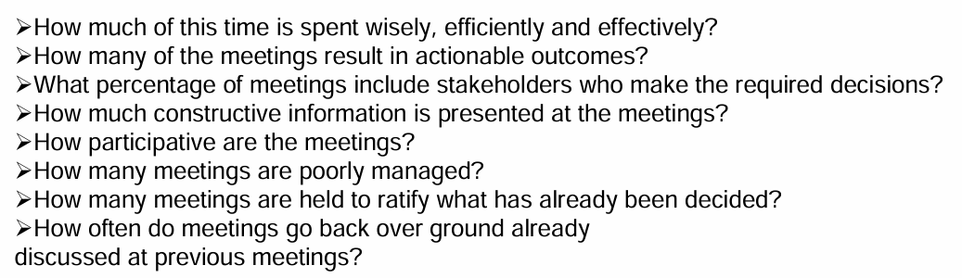

* **Time in Meetings:** Up to 85% of project time.
* **Meeting Efficiency:** Focus on wise, efficient, and effective use of time.
* **Actionable Outcomes:** Ensure meetings result in actionable decisions.
* **Stakeholder Participation:** Include decision-makers in meetings.
* **Constructive Information:** Present valuable and constructive information.
* **Participation:** Encourage active participation.
* **Meeting Management:** Avoid poorly managed meetings and redundancy.

**6. Types of Meetings**

* **Kick-off Meeting:**
  + Detail project objectives, expectations, deliverables, outcomes, and benefits.
  + Meet clients or their representatives.
  + Review scope inclusions and exclusions.
  + Clarify roles and responsibilities.
  + Explain project management methodology and plans.
  + Discuss stakeholder and team member views.
* **Kick-out Meeting:**
  + Formally closes the project.
  + Ensures all aspects are closed out before disbanding the team.

**7. Project Performance Reports**

* **Report Content:** Accurate, complete, and timely information.
* **Report Purpose:**
  + Reflect true project progression.
  + Detect problems early.
  + Enable decision-making.
  + Track scope changes and revisions.
  + Sustain project momentum and commitment.

**8. Navigating the Project Lifecycle**

* **Phases:**
  + Concept.
  + Planning/Schedule.
  + Execution/Progress.
  + Completion.
* **Documents:**
  + Project Plan.
  + Project Audit.
  + Project Charter.
  + Project Report.

**9. The Reporting Continuum**

* **Types of Reports:**
  + **Progress Report:** Covers time zero to present, achievements, budget, milestones, issues, risks, changes, approvals, deliveries.
  + **Status Report:** Current project position against the plan (time, budget, specifications).
  + **Forecast Report:** Future projections, scope changes, risks, approvals, delays, cost overruns.

**10. Project Change Control**

* **Scope Change Requests:** Must be in writing and signed by the initiating stakeholder.
* **Impact Assessment:** Evaluate time, cost, specification, resources, and risks.
* **Communication:** Document and communicate changes to all relevant stakeholders.
* **Project Documentation:** Reflect changes in project charter/scope and schedule.

**11. Causes of Scope Creep**

* **Common Causes:**
  + Poor initial requirement definitions.
  + Unanswered deliverable questions.
  + Lack of stakeholder involvement.
  + Evolving expectations.
  + Discovery of new solutions.
  + Ineffective project management.
  + External environmental factors.

**12. Benefits of Project Control**

* **Performance Monitoring:** Assess, improve, adjust, document, forecast, and evaluate project performance.

**13. Measuring 'Actual' Achievement**

* **Performance Metrics:**
  + Performance milestones.
  + Time completed.
  + Deliverables (including Triple Bottom Line - TBL).
  + Level of effort.
  + Budget spent.
  + Remaining duration.
  + Issues resolved.
  + Risks managed.
  + Decisions reached.
  + Reviews conducted.
  + Approvals received.
  + Team cohesion.
  + Stakeholders managed.

**14. Taking Corrective Action**

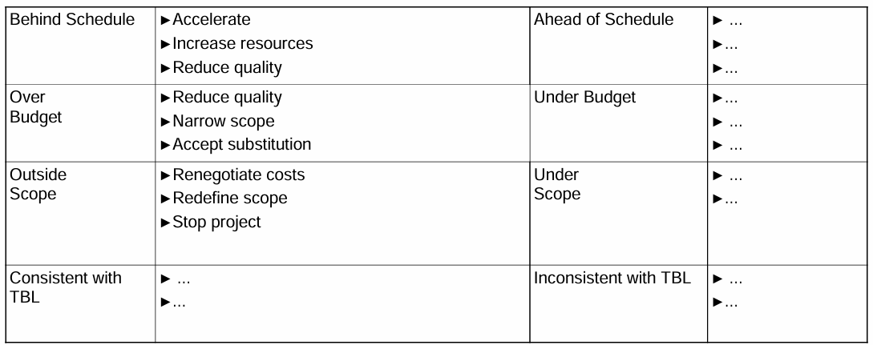

* **Strategies for Schedule and Budget Management:**
  + **Behind Schedule:** Accelerate work, increase resources, reduce quality.
  + **Ahead of Schedule:** ...
  + **Over Budget:** Reduce quality, narrow scope, accept substitutions.
  + **Under Budget:** ...
  + **Outside Scope:** Renegotiate costs, redefine scope, stop project.
  + **Under Scope:** ...

**15. Effective Project Control**

* **Control Steps:**
  + Establish standards for measurement.
  + Monitor standards through inspections.
  + Measure performance against standards.
  + Take corrective action to address deviations or reinforce compliance.
* **Control Tools:**
  + Milestone charts.
  + Budget charts.
  + Control charts.
  + Earned value reports.
  + Action plans.
  + Change request register.
  + Contingency plans.
  + Risk management register.

