**1. Defining Risk & Management**

* **Risk:**
  + Possibility of loss or injury.
  + Situation with a measured impact (positive or negative) on an outcome.
  + Exposure to an uncertain outcome.
* **Risk Management:**
  + Iterative process of identifying, assessing, analyzing, managing, monitoring, evaluating, and reviewing risk.

**2. Potential Sources of Risk**

* **Internal (Controllable):**
  + Ambiguous project charter.
  + Communication bottlenecks.
  + Managerial incompetence.
  + Lack of reporting.
  + Decision-making lags.
  + Poor deliverable definition.
  + Inaccurate estimates.
  + Limited resources and capability.
  + Lack of accountability.
  + **Analysis Tools:** SWOT, PESTELG.
* **External (Uncontrollable):**
  + Economic cycles.
  + Changing technology.
  + Law limited.
  + Environmental factors.
  + Social changes.
  + Supplier capability.
  + Stakeholder expectations.
  + Variable contractor performance.

**3. Identifying Risk: Tools & Techniques**

* **Common Tools:**
  + Risk registers.
  + Project completion reports.
  + Lessons learned.
  + Historical research.
  + Checklists.
  + Fishbone diagrams.
  + SWOT analysis.
  + PESTELG analysis.
  + Brainstorming.
  + Critical incident reports.
  + Risk specialists.
  + Strategic plans.
  + Interviews and workshops.
  + Project charter.
  + Feasibility studies.
  + Impact assessment studies.
  + Industry databases.
  + Subject matter experts.
  + Specification descriptions.
  + Simulations.

**4. Assessing Risk: The 5 by 5 Priority Grid**

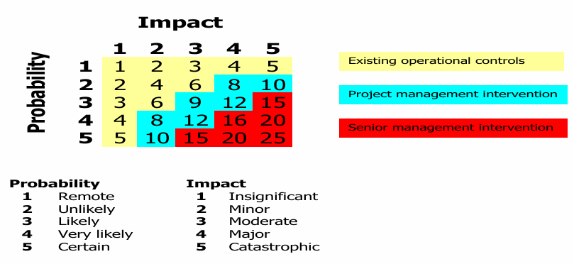

* **Grid Values:**
  + **1-6:** Dealt with by existing procedures.
  + **8-12:** Project manager intervention.
  + **15-25:** Senior management intervention.
* **Grid Details:**
  + Probability (1-5: Remote to Certain).
  + Impact (1-5: Insignificant to Catastrophic).

**5. Analyzing Risk**

* **Techniques:**
  + PERT analysis (Program Evaluation & Review Technique).
  + SWOT and PESTELG consider issues impacting.
  + Expert judgment opinions, perspectives & viewpoints.
  + Stakeholder forums expectations, objectives & deliverables.
  + Decision trees possible paths & expected values.
  + Sensitivity analysis demand, feasibility, take-up.
  + Impact analysis action & consequences.
  + Scenario scheduling alternative scheduling options.
  + Contingency planning options & recovery.
  + Financial modelling funding & cash flows.

**6. Managing Risk: Possible Risk Responses**

* **Responses:**
  + **Reject:** Modify plan to eliminate risk.
  + **Accept:** Address risks as they arise.
  + **Mitigate:** Proactive action to minimize impact.
  + **Share:** Partner with a third party.
  + **Transfer:** Outsource to a third party.
  + **Enhance:** Increase the probability and/or positive impacts of an opportunity.
  + **Exploit:** Ensure the identified opportunity is realized by eliminating uncertainty.

**7. Monitoring & Evaluating: Documenting the Risk Register**

* **Risk Register Elements:**
  + Risk event, probability, impact, priority, strategy, responsibility, review.
  + 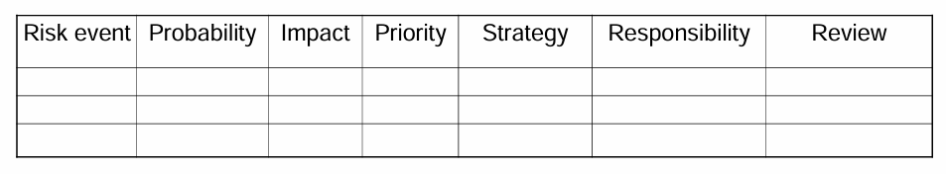
* **Key Points:**
  + Detailed risk events lead to targeted responses.
  + Managed risk requires the right owner.
  + Risk is communicated and owned by all stakeholders.
  + Risk impacts project schedule and other variables.
  + Ongoing risk control is essential.
  + Update the risk register at every project phase.

**8. Management of Risks, Uncertainties & Opportunities**

* **Strategic Approach:**
  + Recognize and proactively manage project complexity.
  + Decision making based on strategic approaches.
  + Project lifecycle thinking.
  + Include variables in line with Triple Bottom Line (TBL).

**9. Risks with Global Projects**

* **PESTELG Framework:**
  + Political.
  + Economic/financial.
  + Social (including culture, values, language, religion, negative impact on community).
  + Technological.
  + Environmental.
  + Legal.
  + Global.

**10. Aligning the Risk Profile**

* **Risk Profiles:**
  + **Risk Averse:** Low tolerance, conservative approach, caution focused.
  + **Risk Neutral:** Dispassionate tolerance, reaction-oriented, balance focused.
  + **Risk Taking:** High tolerance, innovative approach, experimentation focused.

**11. Critical Thinking Question**

* **Reflection:** Relationship between change and perceived risk from perspectives of being risk averse, risk neutral, and risk taking.

Part 2

**1. Overview of Procurement Management**

* **Key Processes:**
  + Planning procurement management.
  + Separating scope of work from specifications.
  + Selecting potential suppliers.
  + Contract considerations.
  + Conducting procurement activities.
  + Controlling procurement activities.
  + Closing out procurement activities.

**2. Planning Procurement Activities**

* **Processes:** Necessary to purchase or acquire products, services, or results needed from outside the project team.
* **Value-Adding Function:** Focuses on the efficient attainment of goods, services, or results that deliver specific and measured benefits to the project. Best use of supplier’s products & or services supporting the changing scope.
* **Core Principles:** Triple Bottom Line (TBL) and life cycle thinking.

**3. Procurement Drivers**

* **Goals:**
  + Supply the project with goods and services as specified and required.
  + Improve relationships with key suppliers.
  + Balance output with value and quality.
  + Increase accountability in the supply chain.
  + Access innovative technology, premium materials, workplace competencies, and expertise.

**4. Procurement Planning Questions**

* What is required?
* How much will it cost?
* From where will it be sourced?
* When will it be needed?
* Who will be involved?
* How will it be managed?
* Why is it the best option?
* Will contracts be required?

**5. The 8 Rs of Procurement**

* Right materials (consider disposal issues)
* Right price
* Right quantity
* Right quality
* Right source
* Right reasons
* Right time
* Right return

**6. Procurement Planning Decisions**

* **Make Decision (In-House):**
  + Currency of skills, known availability, cost-effective resource allocation, excess capacity, existing management protocols, opportunity to upskill in-house resources.
* **Buy Decision (Out-House):**
  + Insufficient capability, conflicting priorities, enhance project scope, access to existing solutions, statutory requirements, partnering opportunities, mitigate risk, access independent advice, need for contractual arrangement.

**7. Differentiating Scope of Work and Specification**

* **Scope of Work (SOW):** Defines the component of work included in the project (what is required without specifying how).
* **Specification:** Defines the technical detail of the work to be performed (how it must behave or function).

**8. Improving Specifications**

* Clear understanding of project scope and specification.
* User-friendly solicitation documents.
* Clear and unambiguous contract clauses and conditions.
* Comprehensive glossary of terms.
* State evaluation criteria for assessing responses.
* Include response templates.
* Use a third party to review documents.
* Encourage alternative and/or innovative responses consistent with TBL and life cycle approach.

**9. Selecting Potential Suppliers**

* Criteria for Supplier Selection:
  + Understanding of the requirement.
  + Technical capability.
  + Management capability.
  + Financial capability.
  + Resource capability.
  + Price.
  + Past performance.
  + Warranty.
  + Legislation compliance.
  + References.
  + TBL and life cycle thinking.
  + Necessity of a legal document.

**10. Essential Contract Elements**

* Offer (capable of being accepted).
* Acceptance (capable of being communicated).
* Intention/consent to be legally bound.
* Consideration (something given back for the promise, e.g., money).
* Mutuality (neither party disadvantaged).
* Capacity (no duress).
* Legality (not an illegal activity).

**11. Types of Contracts (REMEMBER)**

* **Fixed-Price Contract:** Delivery of a well-defined product for a fixed price.
  + Customer risks: Dependency on sole source contractor, incomplete specifications.
    - E.g: The client relies entirely on the software company to deliver the project. If the company faces issues or goes out of business, the client may have difficulty finding a replacement.
  + Contractor risks: Cost estimation accuracy, cost growth leading to unprofitable projects.
    - If the initial project specifications were not detailed enough, any changes or additional features requested by the client may lead to additional costs.
* **Cost-Reimbursable Contract:** Seller is paid for actual costs incurred plus a fee. 客户同意向建筑公司偿还所有实际产生的费用，外加10%的利润费用
  + Customer risks: Final cost unknown, poor specifications lead to more costs. 客户可能会面临项目最终成本的不确定性，因为它取决于施工期间发生的实际费用
  + Contractor risks: Fee percentage declines as costs rise. 如果成本大幅上升，客户可能会协商降低费用百分比或推动成本节约措施，从而影响承包商的利润率
* **Time & Materials Contract:** Features of both fixed fee and cost-plus contracts. 聘请 IT 咨询公司来升级公司的网络基础设施。合同规定了所用劳动力和材料的固定小时费率
  + Customer risks: No specification, open-ended. 项目范围可能会扩大，导致成本增加; 项目的总成本和持续时间是不确定的，这使得预算和规划对客户来说具有挑战性
  + Contractor risks: Fixed rates, no defined tasks. 不包括意外成本或随着时间的推移而增加的费用;公司可能会面临范围蔓延，客户在没有正式协议或调整合同的情况下不断增加新要求

**12. Conducting Procurement Activities**

* Obtain seller responses.
* Select a seller and award a contract.
* Use requests for proposal, quotation, bid, expression of interest, or tender.
* Evaluate responses and conduct negotiations if required.
* Award the contract and trigger contract administration phase.

**13. Evaluating Potential Suppliers Example**

| **Criteria** | **Weight** | **Supplier 1 Score** | **Supplier 1 Total** | **Supplier 2 Score** | **Supplier 2 Total** |
| --- | --- | --- | --- | --- | --- |
| Quality / TBL | 4 | 2 | 8 | 5 | 20 |
| Technical capability | 4 | 4 | 16 | 3 | 12 |
| Past performance | 4 | 3 | 12 | 5 | 20 |
| Price | 3 | 3 | 9 | 3 | 9 |
| Timely supply | 5 | 5 | 25 | 5 | 25 |
| **Total** |  |  | 70 |  | 86 |

**14. Controlling Procurement Activities**

* Contract manager, administrator, or project manager responsibilities:
  + Directing and managing authorized work.
  + Inspecting and verifying completed work before payment.
  + Ensuring all variations are assessed and approved.
  + Confirming rectification of corrective work.
  + Maintaining accurate historical records.

**15. Closing Out Procurement Activities**

* Review procurement documentation.
* Update and archive records.
* Conduct financial reconciliations.
* Analyze requested and approved contract changes.
* Complete inspection and testing procedures.
* Report and rectify defects or damages.
* Audit the procurement process.
* Confirm project or supplier's involvement completion.

**16. Common Procurement Issues**

* Types of contracts.
* Documentation.
* Transparency.
* Performance metrics.
* Managing multiple providers and issue escalation.
* Constraints, risks, assumptions.
* Objective evaluations.

**17. Negotiation Strategies (Fisher & Ury, 1991)**

* Separate people from the problem.
* Focus on interests, not positions.
* Invent options for mutual gain.
* Insist on using objective criteria.

**Preparation for Negotiation:**

* Get the facts right (who does what).
* Consider negotiation power, relationship importance, cultural, language, and saving face issues.
* Know what can be compromised.
* Set the negotiation tone.
* Develop your BATNA (Best Alternative to a Negotiated Agreement) and be patient.
* Remember: Negotiations are 50% psychology and 50% sales.