**1. What is Ethics? A Two-Dimension Foundation**

* **Moral Dimension:**
  + **Moral Philosophy:** Studies principles of right and wrong in human conduct (customary behavior).
  + **Set of Guidelines:** Models/frameworks constructed by society to direct appropriate values and behaviors.
  + **Cultural Determination:** What is right or wrong can vary between cultures.
* **Normative Dimension:**
  + Asks: What is the right thing to do?
  + **Moral Correctness:** Based on personal values shaped by family, religion, experience, and personal feelings on how we should treat people and the environment.

**2. Why Ethics? (Martin et al., 2009)**

* **Moral Awareness:** Recognizing moral issues.
* **Moral Reasoning:** Assessing opposing arguments on moral issues.
* **Moral Coherence:** Forming consistent viewpoints based on facts.
* **Moral Imagination:** Looking for alternative responses to moral issues.
* **Moral Communication:** Using ethical language.
* **Moral Reasonableness:** Ability and willingness to be morally reasonable.
* **Respect for People:** Genuine concern for the well-being of others and oneself.
* **Tolerance of Diversity:** Respect for ethnic and religious differences, acceptance of reasonable moral perspective differences.
* **Moral Hope:** Appreciation of using rational dialogue in resolving moral conflicts.
* **Integrity and Honesty:** Maintaining moral integrity and honesty, integrating professional life with personal convictions.

1. 道德意识

例：项目经理注意到供应商的做法可能涉及童工。认识到这是一个道德问题，他们决定进一步调查，以确保他们的项目不支持不道德的劳工行为。

2. 道德推理

例：在决定是否批准降低安全标准的成本节约措施时，团队会评估节省资金的论据与对员工的潜在伤害。他们得出的结论是，保持高安全标准是道德选择。

3. 道德连贯性

例：公司始终如一地遵循其对客户的透明度政策。当项目面临延误时，他们会立即通知客户，提供事实和更新，以保持一致和诚实的关系。

4. 道德想象

例：面对环境合规问题，项目团队集思广益，寻求创新解决方案，例如采用绿色技术或重新设计流程，以在不影响项目目标的情况下解决问题。

5. 道德沟通

例：在利益相关者会议期间，项目经理使用清晰和尊重的语言来解释拟议决策的道德影响，确保所有各方都了解所涉及的道德考虑。

6. 道德合理性

例：在对项目优先级的分歧中，团队领导会倾听所有观点，表现出妥协的意愿，并寻求考虑所有利益相关者福祉的平衡解决方案。

7. 尊重他人

例：一家工程公司实施灵活的工作时间，并为员工提供心理健康支持，真正关心他们的福祉和个人生活。

8. 对多样性的宽容

例：多元文化项目团队鼓励成员在规划会议期间分享他们的文化观点，营造一个尊重和考虑不同观点的环境。

9. 道德希望

例：在两个部门之间的冲突中，经理促进理性对话，旨在通过理解和相互尊重解决分歧，相信有可能取得积极成果。

10. 正直和诚实

例：员工在他们准备的财务报告中发现错误。他们立即通知他们的主管，纠正错误，并采取措施确保不再发生，保持他们的正直和诚实。

**3. Growing Social Responsibility Movement**

* **Social Expectations:**
  + Social equality and distribution of welfare.
  + Happiness at work, leisure life satisfaction, and overall quality of life (QOL).
  + Environmental quality, human health, bioethics, animal welfare, and impact on future generations.
  + Recognition of the importance of environment and natural resource balance for achieving good QOL.
* **Regulatory Control:** Protection of workers, consumers, citizens, stakeholders, and environment rights (related to TBL).

**4. Demonstrated Successes**

* **New Models:**
  + Sustainable business and project management models.
  + New paradigms like "coopetition" (cooperative competition).
  + Success involves a long-term view, strong internal values, careful selection of compatible partners, and changes to technology, systems, and processes.
* **Sustainable Development:** Meets present needs without compromising future generations' ability to meet their own needs.
  + **Financial Bottom Line:** Make a profit while balancing social, environmental, and natural resource needs.
  + **Social Bottom Line:** Focus on society as a whole, not just shareholders.
  + **Environmental Bottom Line:** Control pollution, preserve biological diversity.
  + **Natural Resources:** Conservation and finding substitutes for non-renewable resources.

**5. Engineering Ethics Defined (Martin et al., 2009)**

* **Definition:** Responsibilities and rights endorsed by those engaged in engineering, and desirable ideals and personal commitments in engineering.

**6. Resource/Product Life Cycle Thinking – 'Cradle to Grave' (Mont et al., 2007)**

* **Stages:**
  + Raw materials.
  + Manufacture.
  + Distribution.
  + Usage/consumption.
  + Waste disposal.

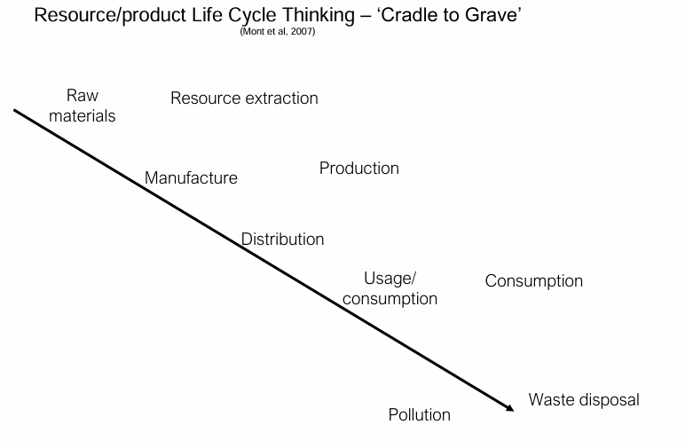

**7. Engineering Tasks/Responsibilities and Possible Ethical Problems (Martin et al., 2009)**

1. **Conceptual Task:**
   * **Problems:** Unrealistic assumptions, untrue feasibility studies, patent violations, incomplete prototype tests.
2. **Design:**
   * **Problems:** Unchecked design changes, lack of risk management plan.
3. **Manufacture:**
   * **Problems:** Unrealistic completion dates, bribes, inadequate testing of purchased parts.
4. **Implementation:**
   * **Problems:** No formal procedure for monitoring project/product effects on society and environment.
5. **Final Task:**
   * **Problems:** Lack of attention to product disposal, failure to notify the public of hazards.

**8. Examples of Ethical Issues in Engineering Practice**

* Intellectual property (IP) issues.
* Environmental ethics.
* Ethics and research.
* Risk management, safety, and health issues.
* Gift giving, bribery, and corruption.
* Whistle-blowing.
* Computer ethics.

**9. Key Takeaway Quote**

* **Howard Gardner (2007):** "If you are not prepared to resign or be fired for what you believe in, then you are not a worker, let alone a professional. You are a slave."

Part 2

**1. The Three Greek Philosophers**

* **Socrates (469 - 399 BCE):** Focused on the inquiry into the 'Good life' and 'Happiness.'
* **Plato (427 - 347 BCE):** Emphasized the balance of the soul's three levels: rational (mind), spirited (will/want), and appetitive (emotion/desire). Virtue results when these are in balance.
* **Aristotle (384 - 322 BCE):** Believed in Eudaimonia (well-being) as the flourishing state of the soul, achieved through the moderation of reason and desire (The Mean).

**2. Main Ethics Theories**

1. **Utilitarian/Consequences-Based Theory:**
   * Founders: Jeremy Bentham & Stuart Mill (19th Century).
   * Principle: “The end justifies the means.”
   * Focus: Actions are judged ethical if they produce the greatest net benefit for the greatest number.
   * Example: A pharmaceutical company releases a drug beneficial to many, despite minor side effects for a few.
2. **Deontological/Duty-Based Theory:**
   * Focus: Actions are judged ethical based on adherence to fundamental rules and principles, regardless of consequences.
   * Founder: Immanuel Kant (1724-1804).
   * Principle: Act according to maxims that can be universalized (categorical imperative) and treat individuals as ends in themselves.
   * Examples: Resist bribery, respect employee safety, and avoid misleading customers.
3. **Virtue-Based Theory:**
   * Focus: Ongoing quest for goodness and virtue, emphasizing individual character over specific actions.
   * Examples: Egoism, Humanism, Relativism, Eastern philosophy.

**3. Utilitarian/Consequences-Based Theory**

* **Principles:**
  + Maximizing benefits and minimizing costs.
  + Predominates in Western thinking, especially in business and marketing (e.g., cost-benefit analysis).
  + Issues: Minority rights at risk, defining 'good,' and the assumption that ends justify means.
* **Ford Pinto Case:**
  + Ford decided against design changes that would have cost $11 per model, leading to fatal collisions. The decision prioritized cost savings over safety.

**4. Deontological/Duty-Based Theory**

* **Principles:**
  + Morality based on duty, not consequences.
  + Kant's Categorical Imperative: Act as if your actions were universal law, treat individuals as ends, and consider yourself a member of a community of moral legislators.
  + Issues: Determining and adhering to duties, respecting future generations' rights, and balancing categorical and conditional imperatives.

**5. Review of Ethical Theories**

* **Business Relevance:**
  + Both utilitarian and deontological theories are relevant.
  + Business must make a profit (utilitarian) but not at all costs (deontological).
  + Consider social, psychological, and environmental impacts, respecting ethical restrictions.