Assignment 3 question 3

Code:

[Flags]

public enum Days

{

None = 0b_0000_0000,

Monday = 0b_0000_0001,

Tuesday = 0b_0000_0010,

Wednesday = 0b_0000_0100,

Thursday = 0b_0000_1000,

Friday = 0b_0001_0000,

Saturday = 0b_0010_0000,

Sunday = 0b_0100_0000,

Weekend = Saturday | Sunday

}

public class FlagsEnumExample

{

public static void Main()

{

Days meetingDays = Days.Monday | Days.Wednesday | Days.Friday;

Console.WriteLine(meetingDays);

Days workingFromHomeDays = Days.Thursday | Days.Friday;

Console.WriteLine($"Join a meeting by phone on {meetingDays & workingFromHomeDays}");

bool isMeetingOnTuesday = (meetingDays & Days.Tuesday) == Days.Tuesday;

Console.WriteLine($"Is there a meeting on Tuesday: {isMeetingOnTuesday}");

var a = (Days)37;

Console.WriteLine(a);

}

}

Output:

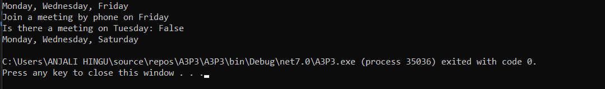

Indexers in C#

Here, how indexers works:

[access_modifier] [return_type] this [argument_list]

{

get

{

// get block code

}

set

{

// set block code

}

}

Below is the example:

class SampleCollection<T>

{

private T[] arr = new T[100];

//

public T this[int i]

{

get { return arr[i]; }

set { arr[i] = value; }

}

}

class Program

{

static void Main()

{

var stringCollection = new SampleCollection<string>();

stringCollection[0] = "Anjali Here!";

Console.WriteLine(stringCollection[0]);

}

}

Output:

