Detailed Technical Documentation
Akasa Air — Data Engineering Assessment

Environment Setup & Library Choices

To develop and execute a scalable data engineering solution, it is essential to prepare a reliable and isolated Python environment and use the right tools to manage data ingestion, transformation, and analytics. Below is a detailed explanation:

Python provides strong libraries for data engineering, allowing efficient data processing, database connectivity, and automation. A compatible and updated version ensures long-term support and better security.
Create a Dedicated Project Folder
Organizing all source code, datasets, and dependencies in a single structured directory ensures: Better project maintainability, Easier team collaboration, Avoids file path confusion
Create a Virtual Environment
A virtual environment isolates dependencies for each project.Library versions may clash between projects and System-wide installation can create conflicts
Advantages:
- Safe dependency upgrades
- Clean project execution
- Industry development standard
Required Libraries
Dependencies are installed only inside the virtual environment, improving reproducibility and deployment readiness.
Library | Why it is used | Industry Relevance
pandas | Provides fast data cleaning, transformation & analytical operations in memory | Widely used in data pipelines, ML, dashboards
SQLAlchemy | Simplifies secure DB connections & allows SQL to remain parameterized | Core library for enterprise data backend
pymysql | Necessary DB driver used underneath SQLAlchemy for MySQL | Ensures efficient communication with relational DB
python-dotenv | Loads database credentials from .env instead of code | Critical for security to avoid exposure in Git
lxml / XML parser | Converts raw XML orders into structured DataFrames | Used in ETL pipelines, supports complex XML schemas
zoneinfo (builtin) | Handles timezone conversion accurately | Essential for aviation where timing is mission-critical

Project Overview

This project demonstrates a secure, scalable, and production-ready Data Engineering workflow

Key Functionalities Used in load_to_mysql.py
This script is responsible for Extracting, Transforming, and Loading (ETL) the CSV/XML data directly into a MySQL database.

Secure Database URL Handling
Reads credentials from .env file securely, Prevents exposing usernames & passwords in code, Uses SQLAlchemy-compatible connection format, Passwords encoded using quote_plus()

Data Loading & Cleaning

Load Customers (CSV)

Loading structured customer data, Removes duplicate mobile numbers to avoid multiple identities, Forces string datatype to preserve phone numbers & leading zeros, Ensures clean master data before loading into DB

Load Orders (XML)

Parses XML efficiently
Handles hierarchical data from airlines → multiple items per order

Time Zone Conversion (Very Important in Aviation)
Converts flight timestamps from Asia/Kolkata → UTC, Handles ambiguous/non-existent times (DST issues), Enables consistent reporting across time zones

Avoid Double Counting of Orders: Converts multiple XML line items into one final order record, Prevents duplicate rows affecting revenue & repeat customer KPIs

Fast & Safe MySQL Upload: Bulk insert into MySQL tables, Auto-creates schema if not present, Uses SQLAlchemy → no SQL injection risks, Executes inside a transaction (engine.begin()), ensures atomicity.

Robust Error Handling:Provides clear feedback on failures, Prevents partial loads from corrupting database, Makes debugging easier & secure (no sensitive logs).

Output

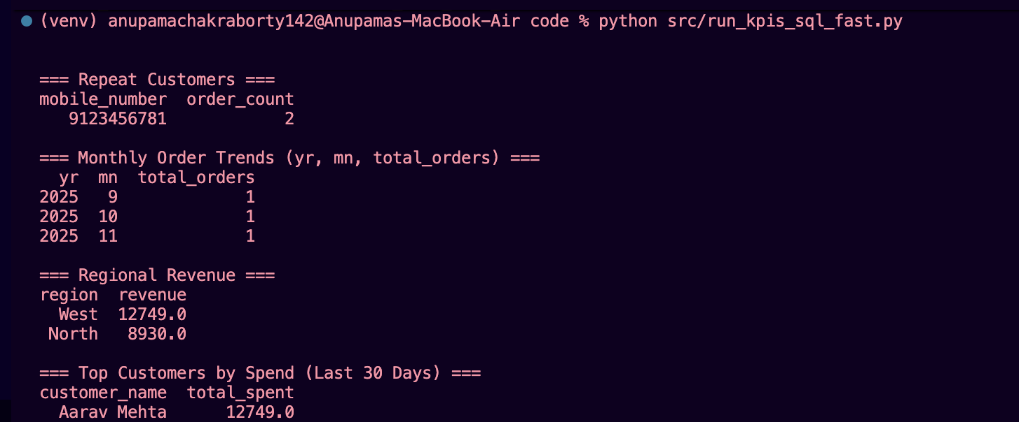
Key Functionalities Used in test_db_connection.py
Loads Database Credentials Securely: Automatically reads sensitive values like host, username, and password from .env file instead of hardcoding them. Improves security and configurability.

Builds Safe MySQL Connection URL: Ensures special characters in passwords (@, :, #, &) do not break the DB URL. Protects against connection errors.

Creates the SQLAlchemy Engine: Establishes a reusable database connection handler with connection pooling enabled (pool_pre_ping=True) for production safety.

Executes a Test SQL Command: Runs a lightweight query to validate database access and connection.

Retrieves Connected Database Name: Confirms that the script connected to the correct target schema.

Handles Failures Gracefully: Prevents crashes, captures errors, and prints a helpful failure message.

Key Functionalities Used in run_kpis_sql_fast.py

We first create a database connection using secure credentials stored in a .env file.
We summarize large data efficiently by creating a compact table named orders_monthly.
Instead of scanning the entire orders history each time, we clear the table, refill it with latest aggregated order counts by year and month. This gives us high-performance KPI querying even as data grows.
We compute KPIs purely using SQL
- Repeat customers
- Monthly order trends (using summary table → faster!)
- Regional revenue
- Top customers in the last 30 days (timezone-aware)
We handle data freshness by applying a 30-day cutoff in database time.
This ensures results reflect recent business trends.
We include strong error handling to prevent pipeline crashes and display helpful messages.

Key Functionalities Used in in_memory_pipelines .py

We load CSV (customers) and XML (orders) directly into Pandas DataFrames.

We apply data cleaning & validation by removing bad mobile numbers, fixing missing regions, dropping duplicates and converting timestamps from airline timezone → UTC

We normalize time correctly because airlines operate across regions, timezone accuracy is important (ensures 30-day KPI and monthly reports are correct)

We convert XML into unique orders many XML rows belong to the same order → we group by order_id to avoid overcounting
We compute all required KPIs using Pandas by repeating customers, monthly order trends, regional revenue,top spenders in the last 30 days
Results are printed neatly in terminal ,no external saving required.
Output
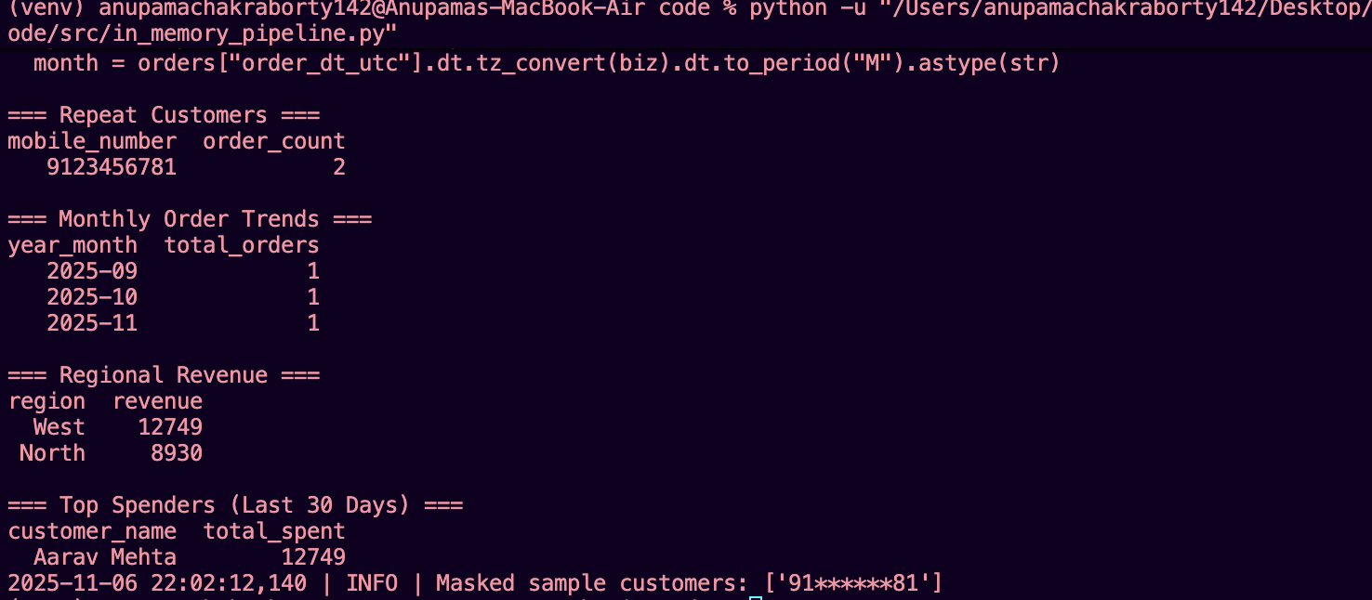

Data Privacy & Masking Theory
Since mobile numbers are considered personally identifiable information (PII), it is critical to ensure they are not directly exposed in logs or test output.
To address this, we implemented a masking mechanism where only the first two and last two digits of the mobile number remain visible.
All other digits are replaced with “*”.

