*Assignment 5*

*Instructor: Faisal Khan*

|  |  |  |
| --- | --- | --- |
| *Name* | *Student ID* | *Group#* |
| *Bibek Shrestha* | *C0929407* | *BMS Group* |
| *Megha Magar* | *C0933272* | *BMS Group* |
| *Shreyash V. Patel* | *C0934529* | *BMS Group* |

1-Use Documentation Comments where needed and use Javadoc to create HTML files for documentation.

2-In your project src folder add this word document with all your group members names and paste the screen shots of your output after each question.

3-Right Click on your Project Folder in Eclipse, Copy Option is available. Create a copy of the Project and upload the zipped folder using Moodle.

**Note : For reference about Assignment 5 Click on the**

**Spring Web Mvc Web Crud Recordings link on your Moodle page.This word document contains the links to all recording for Spring Web MVC.You can also download Spring Web Mvc Crud Complete for a quick reference.**

**Create a web based application using Spring Web Mvc . Your web application should maintainBank Account Records. You can use a model class named BankAccount**

**with fields like.**

**accountId, accountType, accountHolderName,**

**accountHolderContact, accountBalance,accountSetupDate.**

**You should be able to perform all these CRUD Operations.**

**a)Create a Database BankAccounts for your application.**

**Create a table named Accounts in this database.**

**Insert 5 to 6 Records in this table. 10**

**b) Display all the Bank Accounts in your jsp view page by**

**using controller class .**

**20**

**c) Add a new Bank Account in to the database using a button on your jsp view page. 20**

**d)Update an existing Bank Account using an Update Button on your jsp view page. 20**

**e)Delete a Bank Account using a Delete Button on your jsp view page.**

**20**

**f)Use @Component and @Autowired annotations where needed. Create separate DAO class for Crud operations using Spring Jdbc Template and properly configure your Data Source and Jdbc Template beans in Config file for smoothly completing all crud operations.**

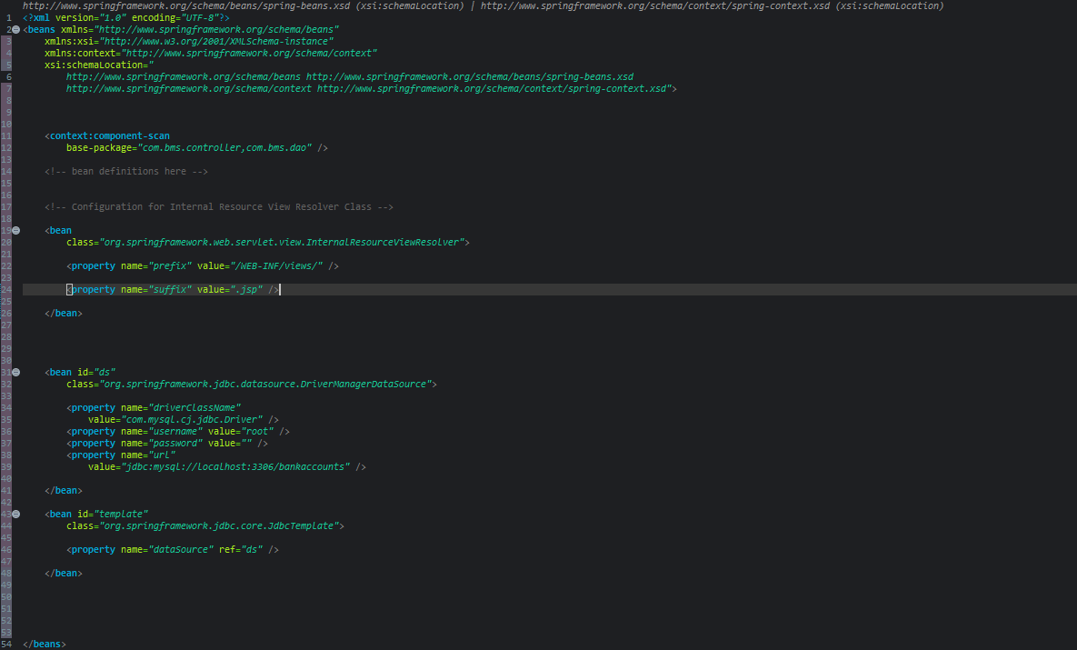 **30**