0th This paragraph started with some other text and was overwritten and made bold.**and more text**

This adds another picture with 500x500

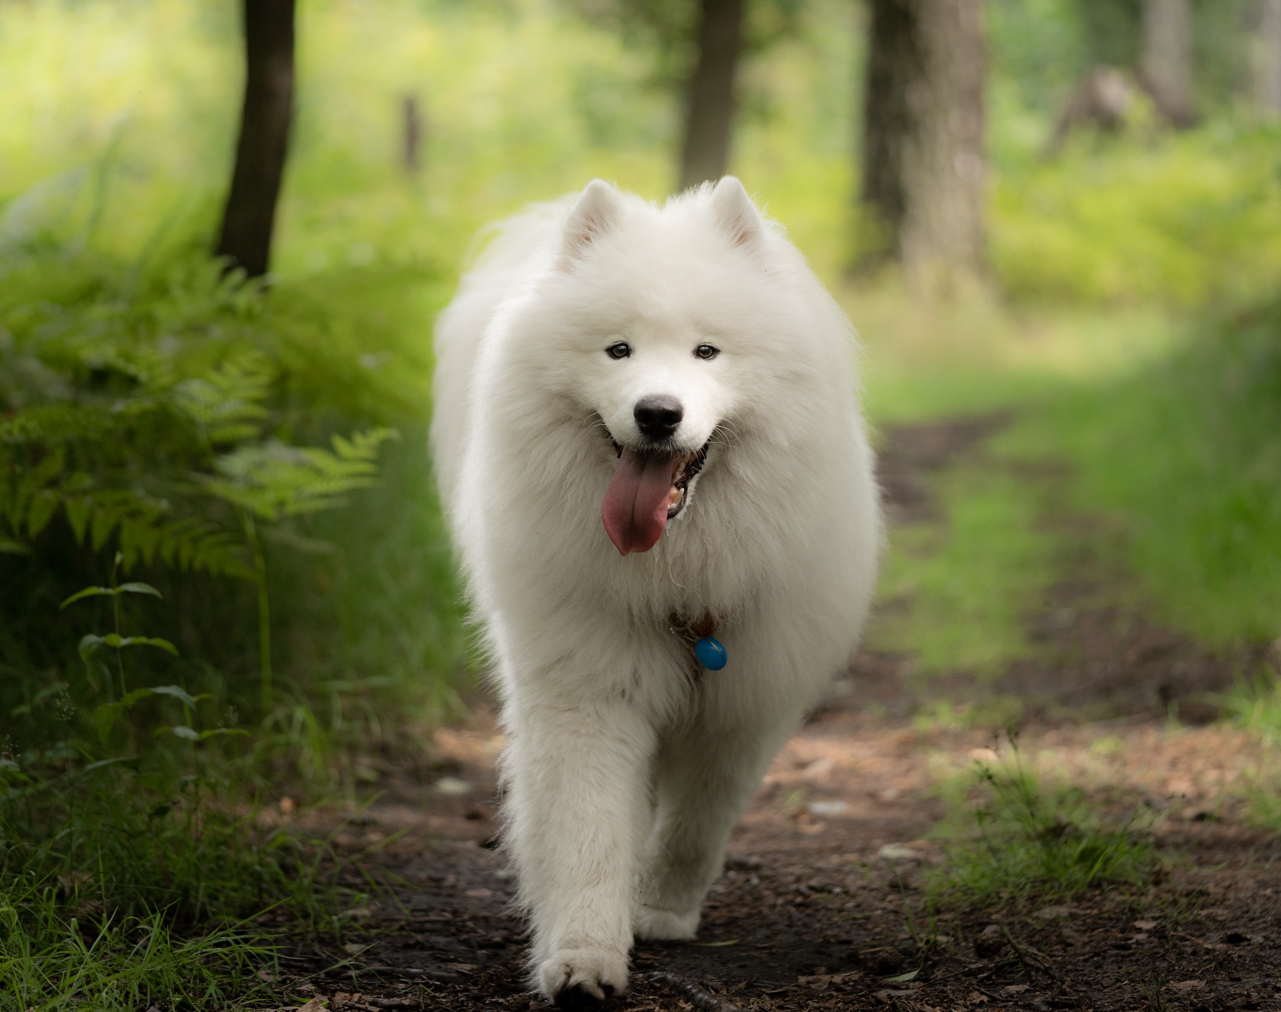

This adds another picture with 100x100



