

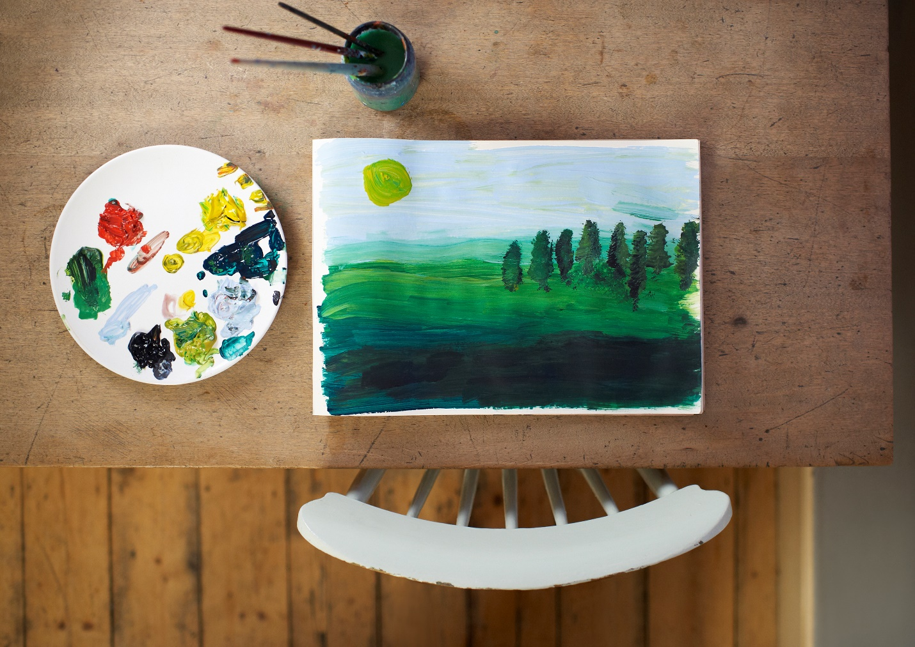



This

Is text

and continue writing