áGitHub Markdown Styling for Word

This file contains the different formats we’re using for GitHub Markdown-style styling. Here’s some examples:

# Heading 1

Normal Text

## Heading 2

### Heading 3

#### Heading 4

##### Heading 5

###### Heading 6

**Bulleted list:**

* First element
* Second element
* Third element

**Numbered list:**

1. First Element
2. Second element
3. Third element

### In order to use these styles:

1. Press the little arrow in the corner of Styles: 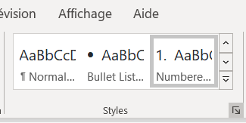
2. Press the little A check-mark button at the bottom: 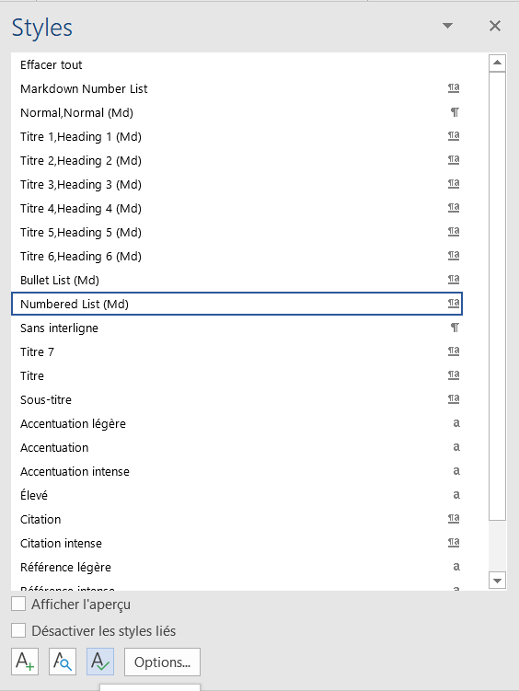
3. Press Import/Export -> Close File -> Open File
4. Navigate to this file and choose it. You’ll probably have to change the little dropdown from “All Word Templates” to “all files *.*”
5. Highlight all the styles you want: Normal (Md), Headings 1-6 (Md), Markdown Number and Bullet, etc.
6. Press <- Copy
7. Press Close
8. Now you can use these styles in any word document you want!