1. Make sure you have install.php and index.php file in inoerp folder

If you don’t find install.php file in the home directory then copy the file 'install_backup.php' located at

C:\xxx\www\ dev-inoerp\engine\install and rename to install.php

2. Make sure the dbsettings.inc file is empty, if you are doing a fresh installation

C:\xx\www\dev-inoerp\includes\basics

3. In browser open <http://inoerp>. You should see below page. Click on continue

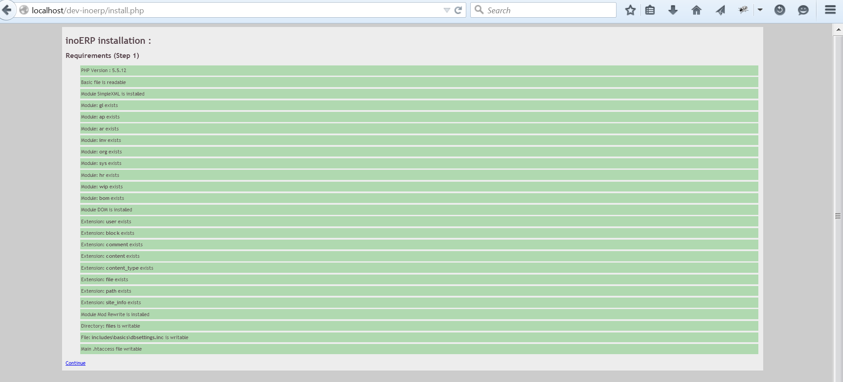

4. Next Enter the DB details

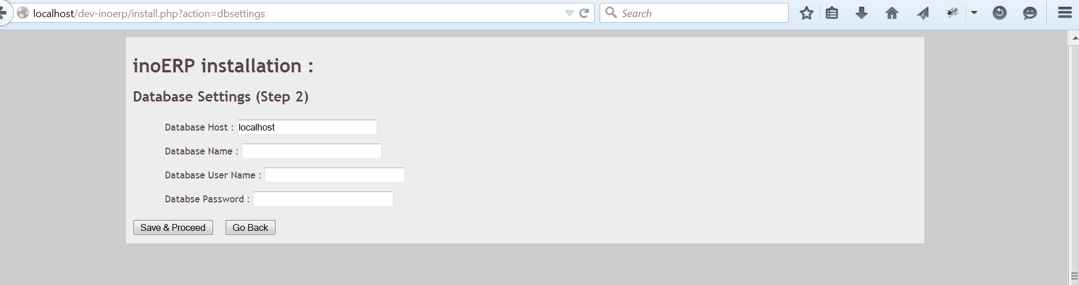

5. If you are new to MySQL then you can use phpMyAdmin or Toad for creating database from a simple user interface

5.1 Navigate to phpmyadmin

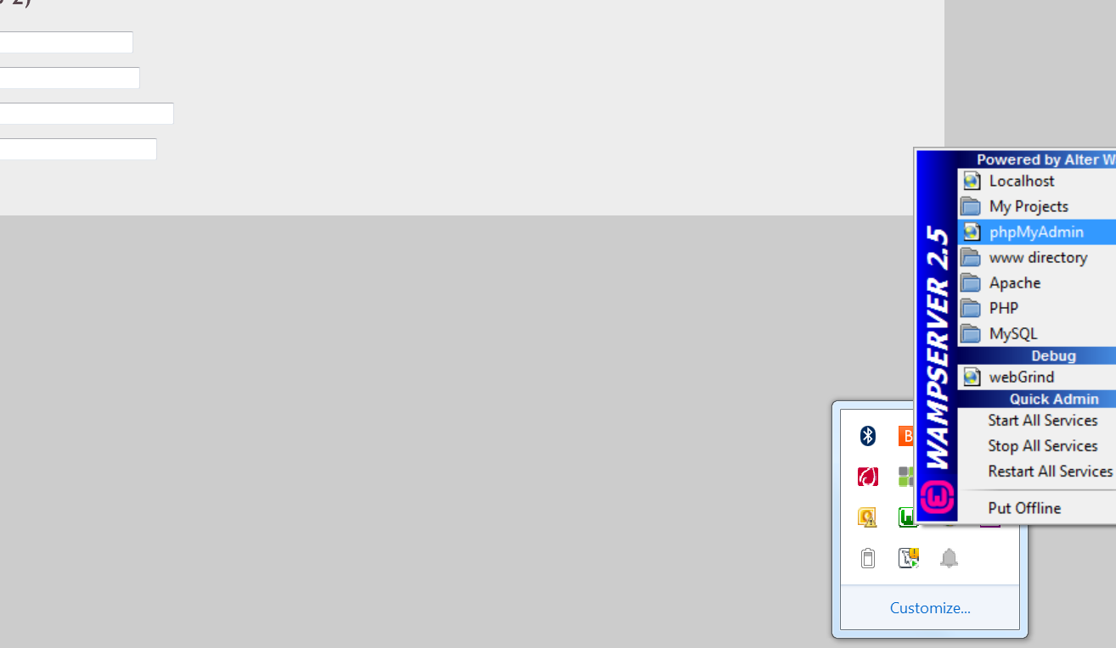

5.2 Click on new in the left side

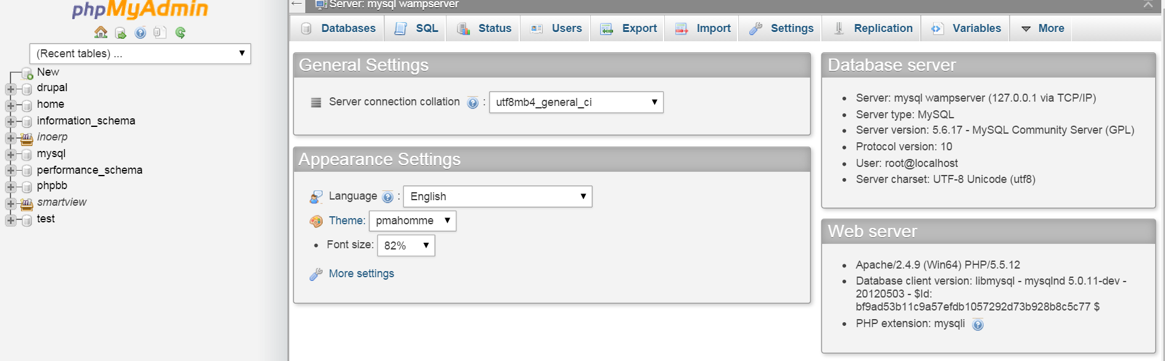

5.3 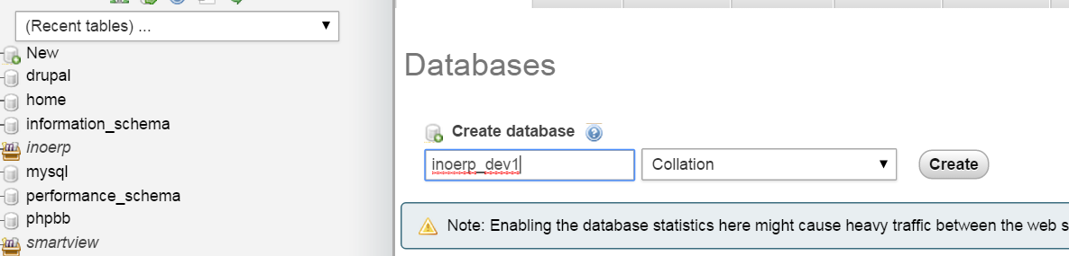

5.4

Enter the DB name in inoERP

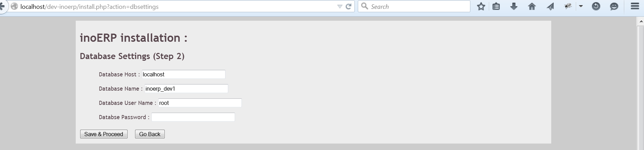

Host is local host

DB Name : Name of the database created in previous step

DB User Name : use the default root user

DB Password : Enter your db password / leave blank if you have not set any password in local installtion

Click on save & proceed

6. 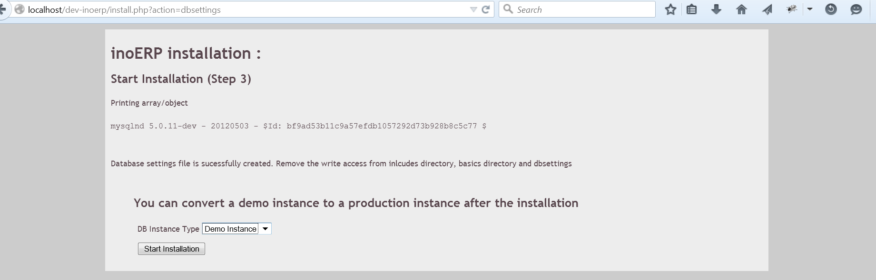

Select the instance type – Demo instance comes with a lot of seeded data but you can convert the demo instance to a production instance later by running some programs

Click on start installation

7. You should not see any error message in the completion page. If you see any errors then delete all the database details and manually import them (You can use Toad/MySQL)

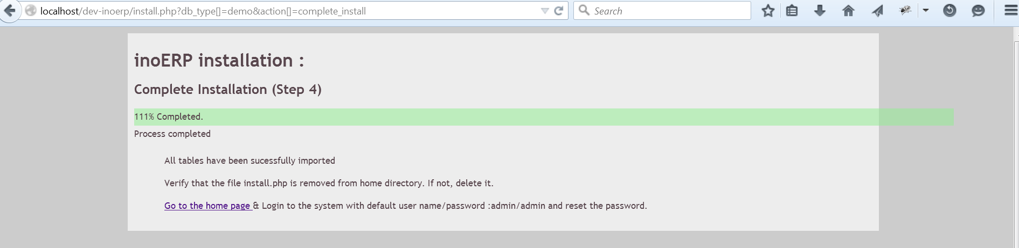 Ignore the % completed as it can show more than 100% if you are using the latest version from gitHUB. Any released version should show 100%

Next manually delete the install.php file from the home directory  
ex : C:\xxx\www\ dev-inoerp\

8. Navigate to <http://dev-inoerp>

Login with id : inoerp/inoerp and change the password

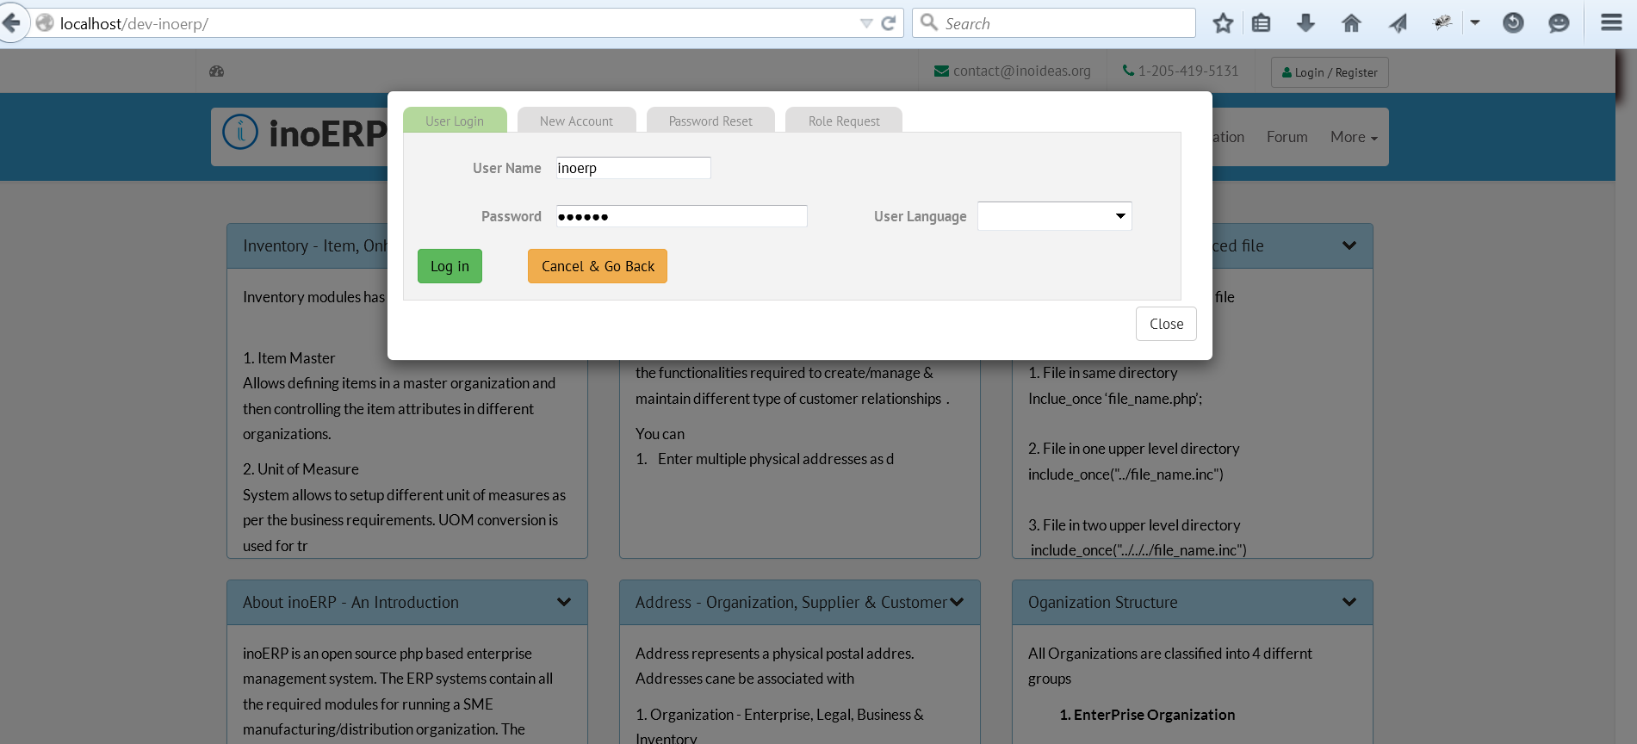

9. Click on Dashboard (there are 2 links in home page) to go to ERP dashboard

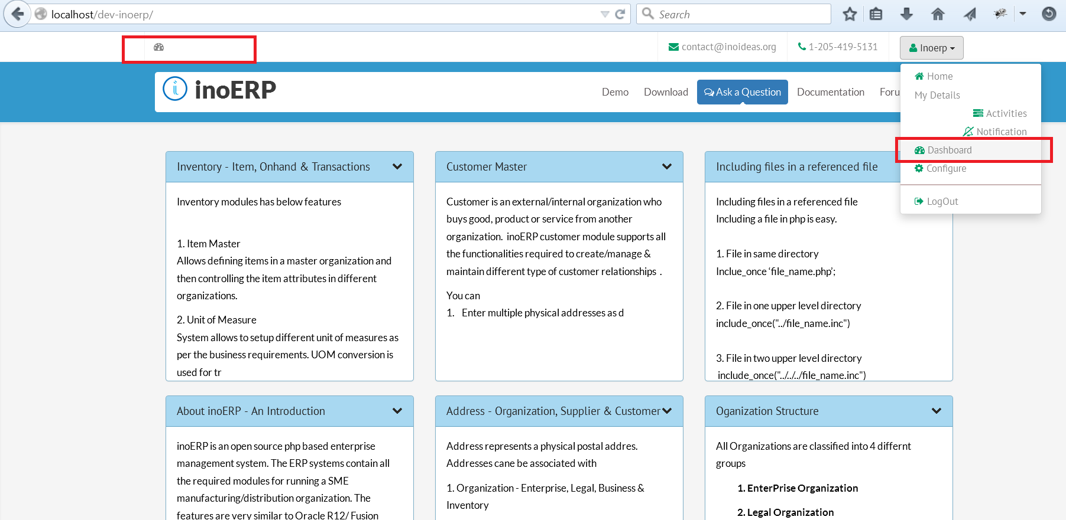

10. Happy Exploring ino ERP (Can be challenging if you have not worked in Oracle R12/Fusion Application)

