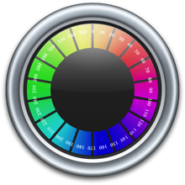**Science Wand**

Usage Instructions

1. Installation
   * Download and install ImageMagick using this link: <http://www.imagemagick.org/download/binaries/ImageMagick-6.9.1-2-Q16-x64-dll.exe>, making sure to check “Install development headers and libraries for C and C++”
   * Download the latest Science Wand binaries from the project page: <https://github.com/2chen/colorlevels/blob/master/Science%20Wand.zip>
   * Unzip “Science Wand.zip” into a folder of your choice
   * Run “vcredist_x64.exe” from your install directory
2. Startup
   * Double-click the file “ScienceWand.exe” from your install directory
3. Image Loading
   * With the Science Wand window open,
   * Open the directory containing the images you would like to analyze
   * Drag and drop the image you want to analyze into the Science Wand window
   * **KNOWN ISSUE**: Some TIFF files may cause Science Wand to crash. Until this is resolved, it is recommended to save images in the PNG format for analysis
4. Analysis
   * Movement
     1. Once an image is loaded, LEFT-CLICK and drag to pan around on the image
     2. Scroll up with the MOUSE WHEEL to zoom into the image
     3. Scroll down with the MOUSE WHEEL to zoom out of the image
   * Marking
     1. Once you have identified a pixel to mark, RIGHT-CLICK to mark the pixel
     2. You will see a portion of the image colored in bright green, indicating the portion of the image matching the pixel:

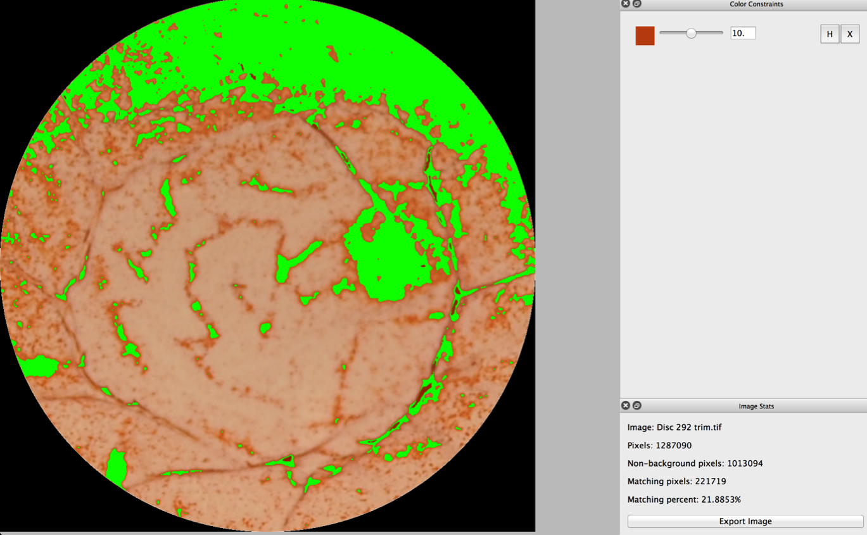

* + Adjusting
    1. Note the new set of buttons created on the top-right side of the window:

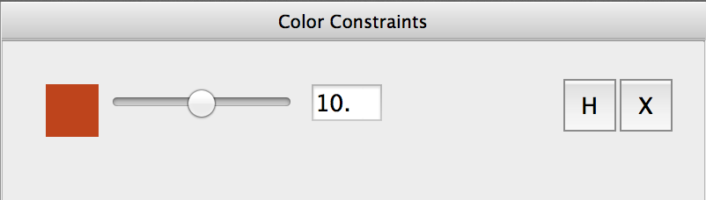

* + 1. Use the SLIDER to increase or decrease the sensitivity of the constraint. Higher numbers will match a broader range of colors
    2. For fine-tuning, you can enter a number into the TEXT BOX
    3. If you are unhappy with the pixel selected, you can press the X button to remove the constraint
    4. To temporarily disable the constraint, press the H button. Note that the button becomes an S button. Press it again to re-enable the constraint
  + Repeating
    1. Once you are happy with the constraint you have created, you can RIGHT-CLICK on another pixel in the image to create a new set of constraints
    2. You can repeat the previous steps as often as necessary:

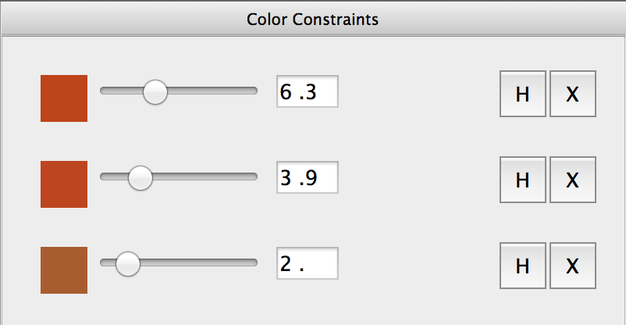

* + 1. The green mask in the image represents the union of the pixels that match all of the constraints you have created
    2. **To view the original, unmasked image, press the SPACE BAR. Press the SPACE BAR again to toggle off this effect**

1. Export
   * Every time you add or remove a constraint (e.g. right-click the image), the image statistics are copied to the CLIPBOARD
   * You can paste the statistics for the image into Excel
   * If you would like to export the MASKED IMAGE for further manipulation (e.g. in Photoshop), you can click the Export Image button
   * The exported image will appear in the original folder as “*Original Filename*_masked.png”
   * For example, 317.png will become 317_masked.png
2. Support
   * Please use the project website for support: <https://github.com/2chen/colorlevels>