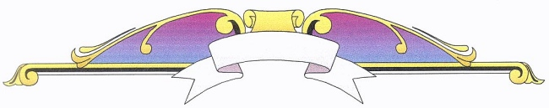

WINFIELD HISTORICAL SOCIETY

Southeast District Fair of Winfield
1883 – 1935

“Remembering the Fair”
by
Frances Lowe
at
Sunrise Terrace Care Center

Winfield, Iowa

Monday, July 25, 2011 at 7 p.m.

Complimentary Ice Cream Social Afterward

COME ONE, COME ALL!
