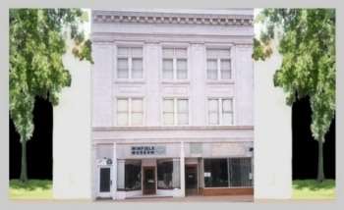

WINFIELD HISTORICAL SOCIETY & MUSEUM
Post Office Box 184, Winfield IA 52659
www.winfieldhistoricalsociety.com

January 12, 2011

Mullen’s Body Shop
101 South Locust St
Winfield IA 52659

To whom it may concern:

The Winfield Historical Society & Museum invites you to sponsor our website – www.winfieldhistoricalsociety.com - for the year 2011.

Previous sponsors have been:
2003 – Robert Robinette
2004 – Honts Funeral Home
2005 – Peoples State Bank
2006 – Pilot Grove Savings Bank
2007 – William D. Klopfenstein
2008 – Haight Electric
2009 – CounTREEStore
2010 – Orin K. “Bub” Kepper

The cost of $99.50 for sponsorship of our website is fully tax deductible, and you may use any major credit card. To sponsor our site for 2011, please contact our web host (gate.com) at 1-866-856-7165 to credit the annual fee of $99.50 to Account # GT0472861 using any major credit card.

We will use your logo (if you have one) or create one for our Home Page.

Please contact me within the next seven days regarding this matter.

Judith R-Robinette, Webmaster
319-257-3663

