Depots of Yesterday

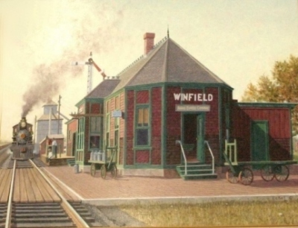

C. B. & Q. R. R. Depot
Chicago, Burlington & Quincy
1880s – 1966
Still Standing

1882 – 1965
Iowa Central to M. & St. L.
Minneapolis & St Louis
“Misery & Short Life”

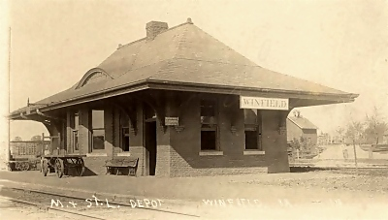
Meet Our Town

Get to know the “soul” of Winfield. Explore how it was founded in the mid 1800s. Learn how a bustling railroad and agricultural center of yesterday evolved into the busy bedroom community it is today.

Visit the Winfield Historical Museum which is “on-growing” in the Masonic Temple, located at 114 South Locust Street.

The exhibits include an old school room, Senator Carden artifacts, Beacon press, fire-hose cart, a 1950s toy store and much more.

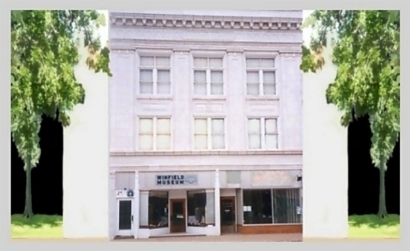

www.winfieldhistoricalsociety.com



Read “The Gambell Story”
on our web-site above

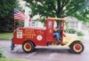

Enjoy photos of
Crooked Creek Days

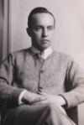

View slideshows of
Winfield’s Harry E. Stinson
World renowned sculptor

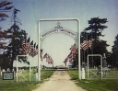

Winfield Scott Township Cemetery
access alphabetical burial lists…
Membership

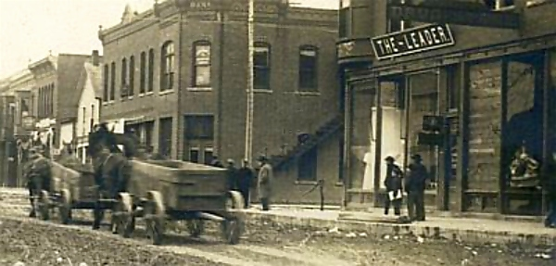

The Winfield Historical Society and Museum is proud to be the driving force in preservation and restoration of our community’s rich heritage and historical importance.

Run solely by volunteers, our society would not be possible were it not for the financial support of membership, donations, and gifted or loaned items.

Thank you for your help and thoughtful giving which allows us to reach our goals and, above all, to achieve and serve our purpose.

Annual Dues

Individual Membership….$10.00
Couple………………...…$20.00
Lifetime………...………$100.00
Business Membership…...$25.00
Lifetime…………...……$250.00

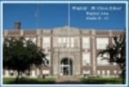

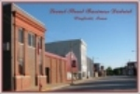

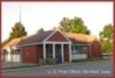



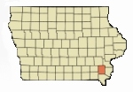

Above are a few of the Winfield town view postcards offered for sale in our gift shop. Also available in the gift shop are booklets relating to Winfield history, authored by William D. Klopfenstein and Bob Lindell.
Winfield
Historical
Society

“Until 1851 the present site of Winfield was open prairie. It was used as feed by deer, huge flocks of prairie chickens, and wolves. The buffalo had long before migrated west of the Missouri River.”

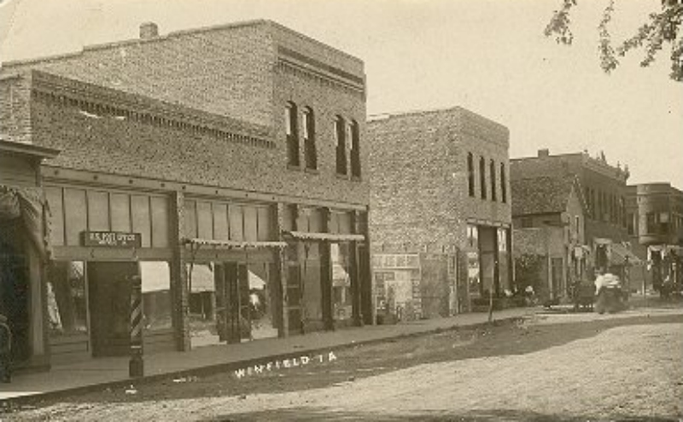

Hours
Monday 10 to Noon
Or by appointment
319-257-6661
No Charge

