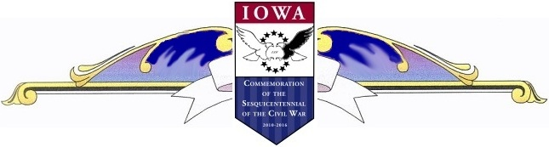
WINFIELD HISTORICAL SOCIETY
12th ANNUAL RAILROAD DAY

Monday, February 21, 2011 at 1 p.m.

Henry County, Iowa

Civil War 150th Commemoration Task Force

“Importance of Civil War Railroads”

Guest speaker, Rev. Phil Borleske

Winfield-Mt Union School Small Gym

NO CHARGE

We welcome you and your comments.

Bring your “Show and Tell” items.

A lot of table room will be available.

EVERYONE IS INVITED! - REFRESHMENTS WILL BE SERVED!
Reminisce about Iowa’s involvement with Civil War Railroads!

Endorsed by Henry County, Iowa Civil War 150th Commemoration Task Force

