Operations and Supply Chain Management in Engineering - EMS772P

Group 4

Student Name | Student ID
Bei Dei Teoh | 220812542
Abdiwak Benti Debella | 260890962
Ghanima Albaidan | 220164061
Otabek Muradov | 260885670

Table of Contents
1. Company’s Operations 1
2. Process Analysis and design 2
2.1 Selected process 2
2.2 Process mapping 2
2.3 Process analysis 5
2.3.1 Commitment precedes confirmation. 5
2.3.2 Defects are found late. 6
2.3.3 Waiting is mostly queue. 6
2.4 Evaluation and Redesign 6
3. Supply Chain management strategies 7
3.1 Supply chain structure and key partners 7
3.2 Supply chain strategy: lean, agile or hybrid? 8
3.3 Evaluation 9
3.3.1 Responsiveness 9
3.3.2 Cost-efficiency 9
3.3.3 Competitiveness 9
3.4 Overall judgement 10
4. Inventory management and control 10
4.1 The Profile of Held Inventory 11
4.1.1 Raw Materials and Bought-In Components 11
4.1.2 Work-in-Progress (WIP) 11
4.1.3 Finished Goods and Heritage Parts 11
4.2 Inventory Control Techniques in Practice 12
4.2.1 Just-In-Time (JIT) and Just-In-Sequence (JIS) 12
4.2.2 ABC Stratification (Pareto Analysis) 12
4.2.3 Adapting Economic Order Quantity (EOQ) via Modular Platforms 13
4.3 Evaluating Operational Performance 13
4.3.1 The "Incomplete Car" Trap and Cash Flow Volatility 13
4.3.2 Moving from "Push" to "Pull" to Protect Margins 13
4.3.3 Balancing JIT with "Just-In-Case" Resilience 14
5. Sustainability in Operations and Supply Chain Management 14
6. Conclusion 15
References 16
Group Contribution Table 20

Figure 1: Analytical 4Vs Operational Profile and Input-Process-Output Transformation Flow 1
Figure 2: Cross-functional map of the car-order-to-delivery process 3
Figure 3: Flowchart of the Gaydon core-car build 4
Figure 4: Flowchart of the Gaydon core-car build 5
Figure 5: Aston Martin’s simplified supply network (compiled from Aston Martin Lagonda, 2026a; 2026c; Attwood, 2020) 8
Figure 6: Greenhouse Gas Accounting Boundary and Value-Chain Decarbonisation Profile 14

Table 1: SIPOC summary of the car-to-order delivery process 2
Table 2: Evaluation of Aston Martin’s supply chain strategy 10
Table 3: djd 12

1. Company’s Operations
Aston Martin Lagonda manufactures ultra-luxury vehicles across two specialised UK facilities: Gaydon, Warwickshire, for front-engine sports cars and coach-built specials, and St Athan, South Wales, for the DBX luxury SUV. Operating through an Input-Process-Output transformation model, the manufacturing system converts bonded extruded-aluminium chassis structures and outsourced Mercedes-AMG powertrains into finished vehicles through manual leather upholstery and multi-coat painting. Under the 4Vs operational typology, this production system exhibits low volume (6,030 wholesale units in 2024 and 5,448 units in 2025), high variety, high demand variation, and moderate-to-high customer visibility during bespoke client commissioning at Gaydon.
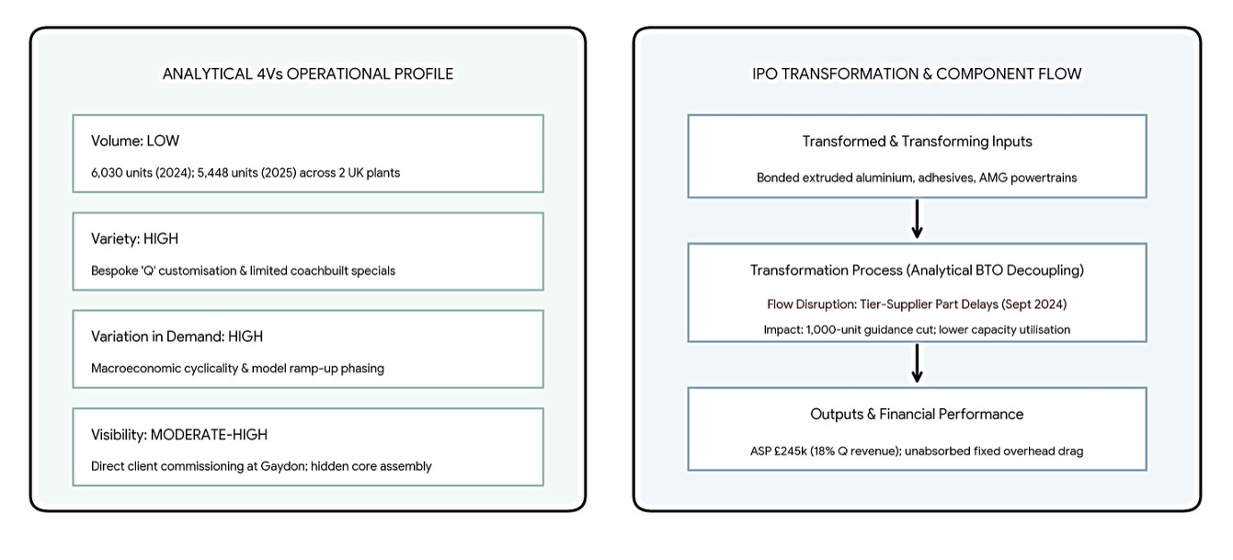
Figure 1: Analytical 4Vs Operational Profile and Input-Process-Output Transformation Flow
Operations functions alongside marketing and finance as a core value-adding activity to sustain brand scarcity. While marketing generates demand for bespoke personalisation through the ‘Q by Aston Martin’ service, operations executes these custom specifications through an analytical build-to-order decoupling structure. This customisation capability raised the total average selling price to £245,000 in 2024 and generated 18% of core vehicle revenue. Evaluated against the five operations performance objectives, prioritising specification flexibility and craftsmanship quality inflates unit production costs and extends throughput times, while manual cycle-time variability restricts volume flexibility.
These operational vulnerabilities materialised in September 2024 when external tier-supplier component shortages disrupted production flow across four renewed model lines, forcing a 1,000-unit reduction in annual wholesale guidance. Because fixed facility overheads across Gaydon and St Athan remained rigid, lower throughput depressed plant capacity utilisation. Alongside development amortisation and macroeconomic headwinds, this unabsorbed fixed overhead contributed to operating losses of £100 million in 2024 and £259 million in 2025, prompting workforce restructuring to protect corporate liquidity.

2. Process Analysis and design

2.1 Selected process
The process selected is the order-to-delivery of a core sports or GT car (DB12, Vantage, Vanquish), from the point at which a customer's specification is frozen to handover at the dealer, with the Gaydon build as its production core. This is because Gaydon builds the majority of Aston Martin Lagonda's (AML) range and all of its Specials, and its process is the best documented. The process is how AML delivers its stated strategy of "a demand led build to order model" (Aston Martin Lagonda, 2021). And it is where the company's visible operational failures of 2022–2025 arose. The evidence for the process is drawn from company statements, trade press and factory-tour reports, much of it several years old, so the process as run today may differ in detail.
Table 1: SIPOC summary of the car-to-order delivery process
Suppliers | Inputs | Process (high level) | Outputs | Customers
Mercedes-AMG; ZF; Bilstein; Michelin; Bridge of Weir; Bowers & Wilkins; DHL Supply Chain | Customer specification; powertrain and E/E modules; aluminium structures; leather; sequenced parts kits | Order → specification freeze → build slot and MRP → body → paint → trim and assembly → test and inspection → ship → PDI | Finished, inspected car; delivery date; warranty record | Retail customer via dealer; Q Commission clients; dealers (wholesale)

2.2 Process mapping
The process is mapped at two levels. Figure 2 is a cross-functional (swimlane) map that shows which function owns each step, where decisions are made and how waiting time is distributed. Figure 3 and 4 are flowcharts of the Gaydon build process, showing its four production stages, its inspection points, and its rework loop.
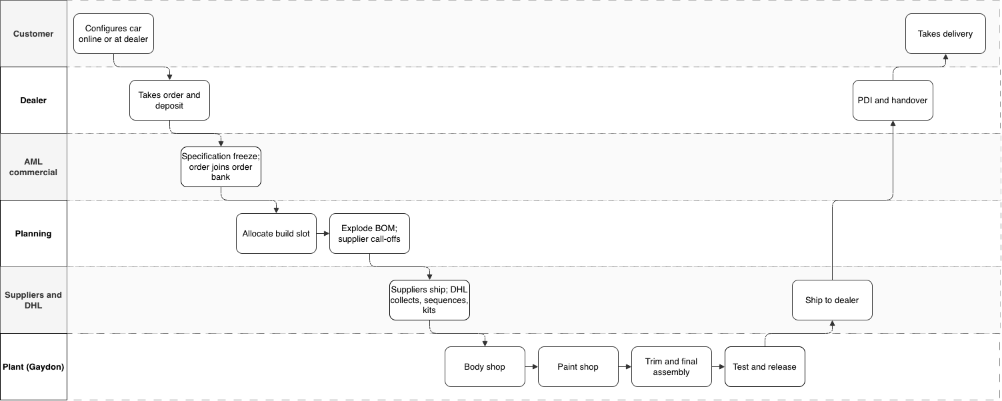
Figure 2: Cross-functional map of the car-order-to-delivery process
An order starts when a customer configures a car online or through a dealer, who takes the deposit. Q Collection options “don’t require an additional build lead time”, whereas Q Commission projects are “agreed prior to production” and add weeks to months. Once the specification is frozen, the order joins the order bank, which held about five months of core cover in Q3 2026. Planning then allocates a build slot, which since mid-2025 includes checking US-bound cars against the tariff quota. It also converts the bill of materials into supplier call-offs, and DHL collects, sequences and kits the parts.
The build has four stages:
- Body shop. A robot applies adhesive; panels are hand-placed in jigs and riveted, and the aluminium structure is oven-cured. The cure sets the pace.
- Paint shop Primer is hand-flatted, then colour and clear coat are applied, and the finish is polished by hand. At 25–50 hours this is the largest single block of labour.
- Trim and final assembly. The bought-in powertrain, wiring and E/E modules and hand-stitched trim are fitted, and the software is flashed.
- Test and release. A settle run, water-leak test and rolling-road test (Gaydon has no test track) are followed by sign-off from a named inspector.

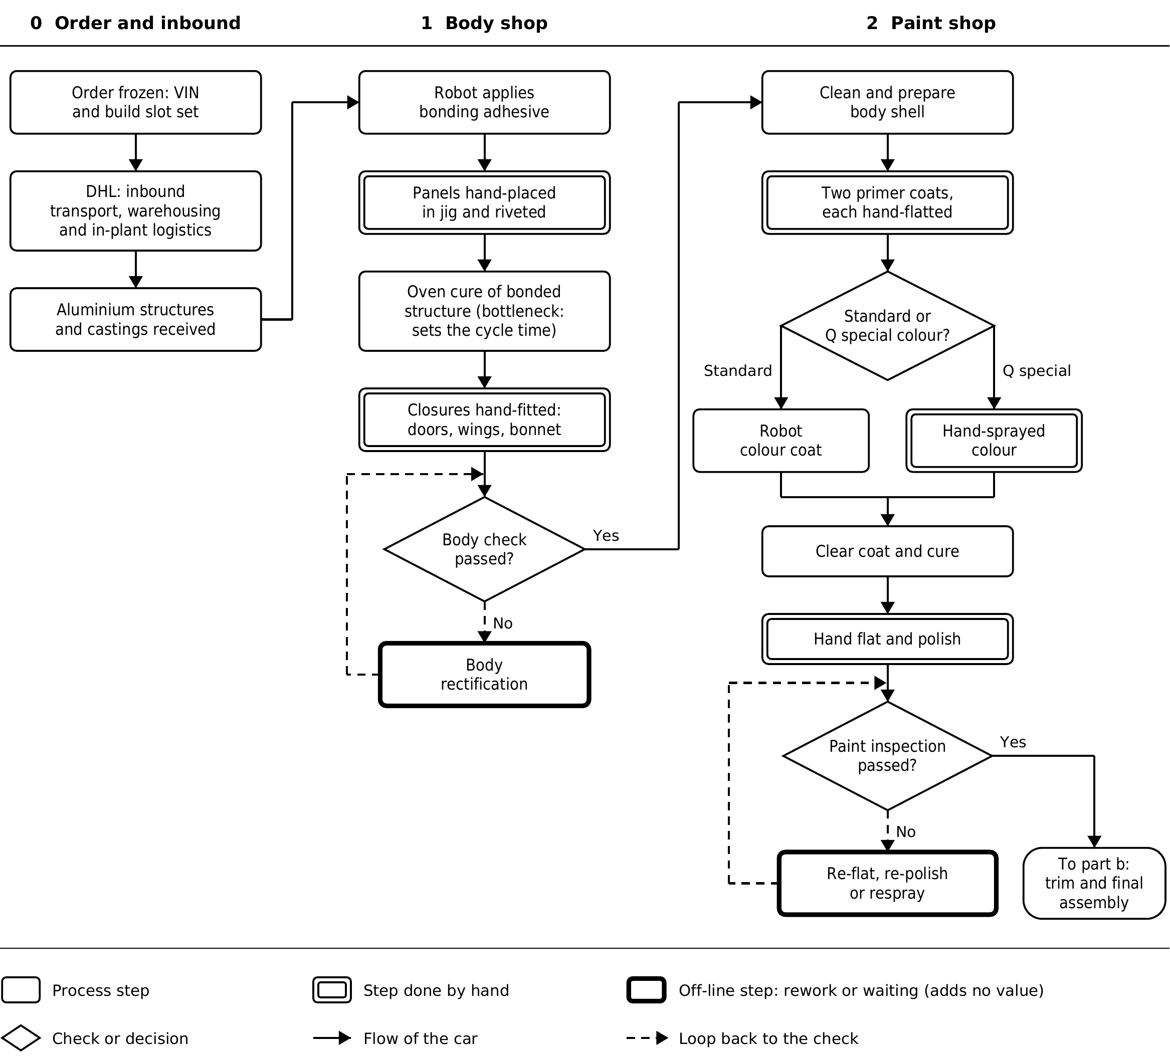
Figure 3: Flowchart of the Gaydon core-car build
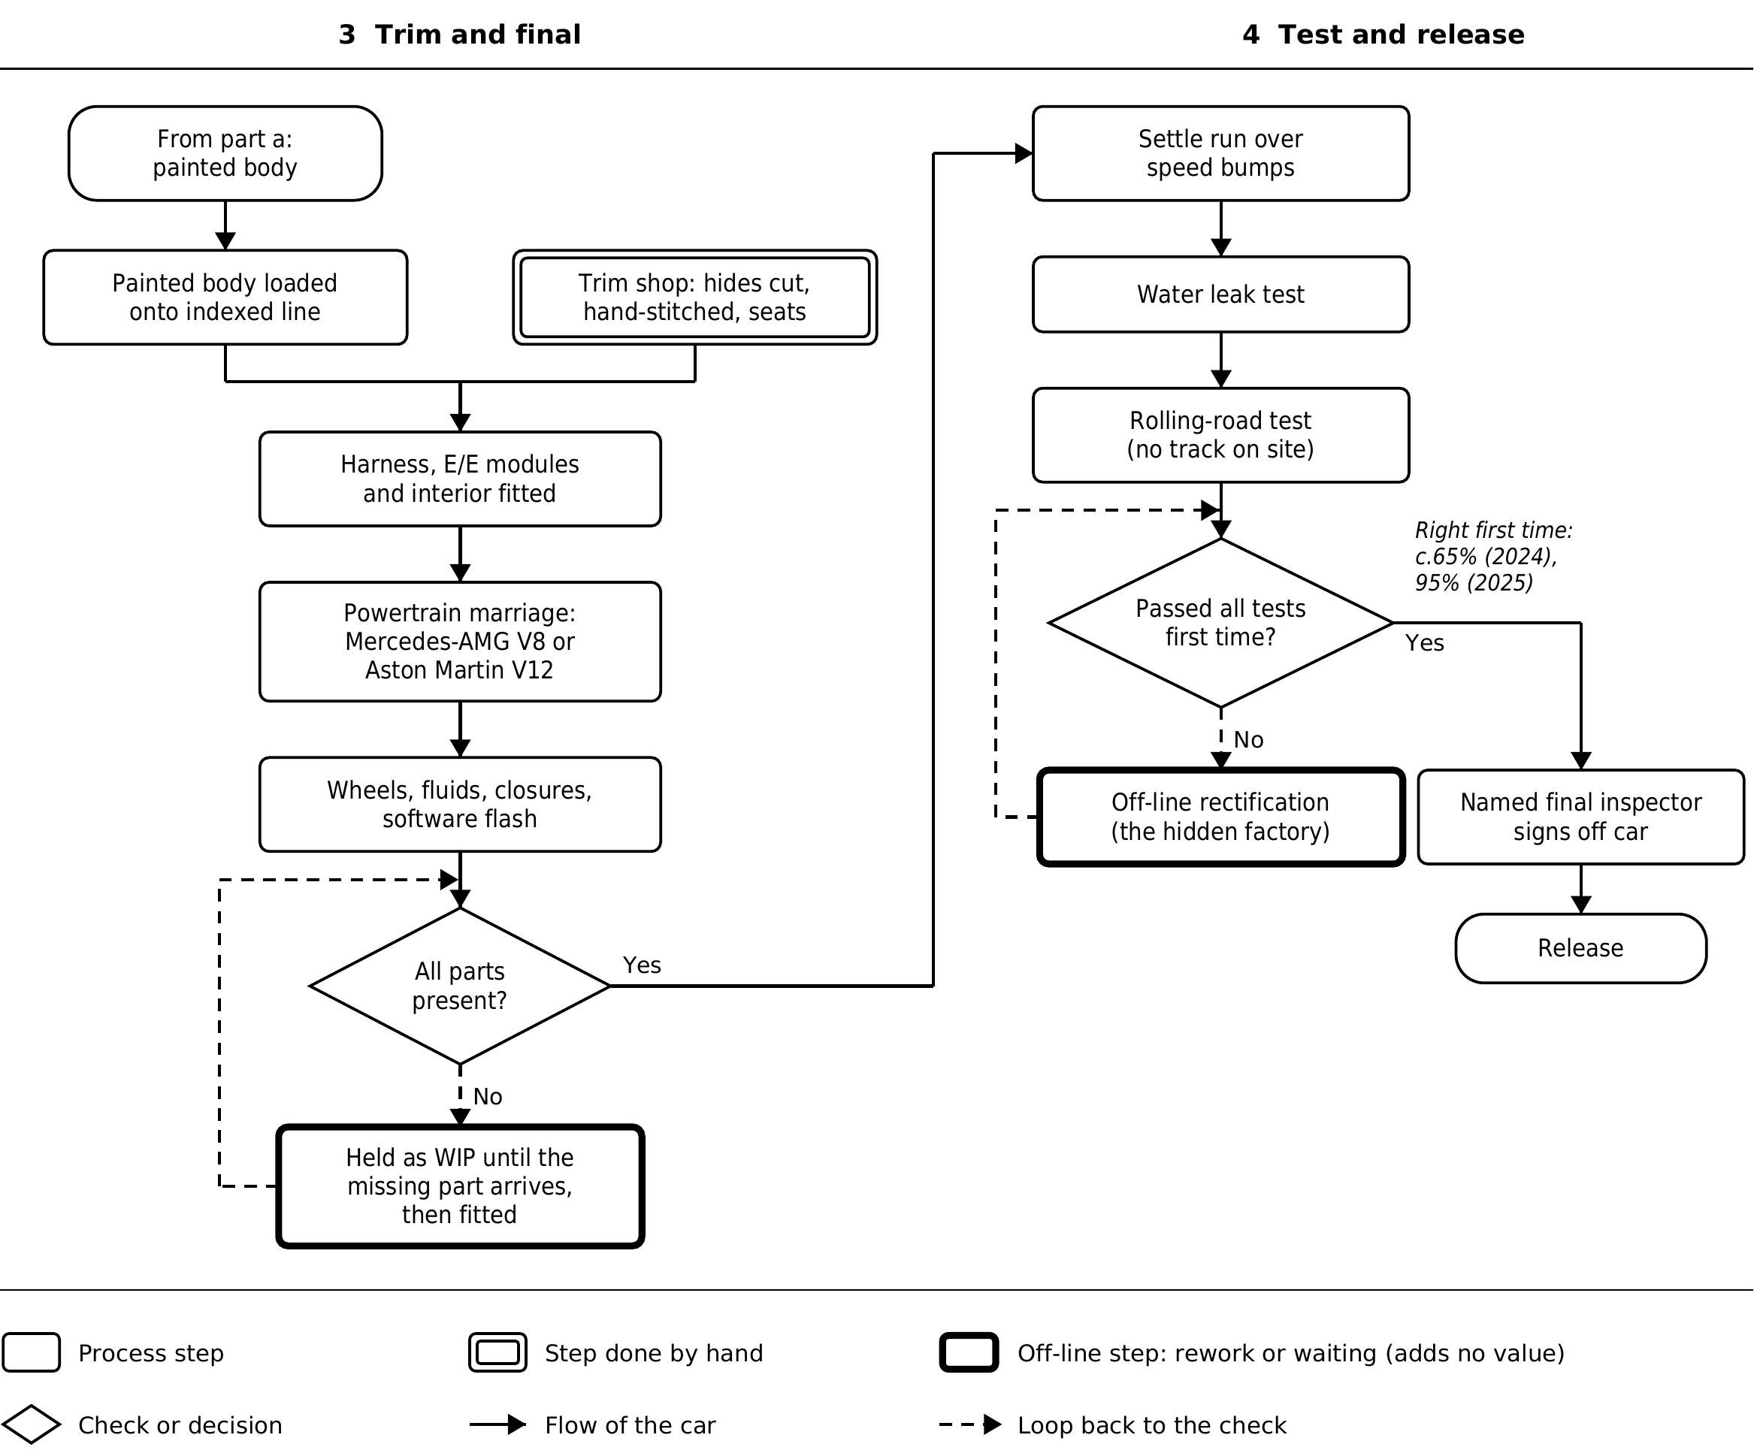
Figure 4: Flowchart of the Gaydon core-car build

2.3 Process analysis
Three findings follow:

2.3.1 Commitment precedes confirmation.
A car is given a slot and a planned kit, and nothing on the map stops entering the line with the kit incomplete. AML places the customer-order decoupling point early, at specification of freeze (Naylor, Naim and Berry, 1999), but material supply is not synchronised with it.

2.3.2 Defects are found late.
Quality is assured mainly at the end of the line, and defects enter a rework route that is in effect a hidden factory (Womack, Jones and Roos, 1990). Jidoka (stopping at the first abnormality) exposes problems where they arise, because their cost rises downstream (Ohno, 1988).

2.3.3 Waiting is mostly queue.
The build, at about 200 labour-hours (Aston Martin Lagonda, 2017), is small against an order bank of about five months. Owners report five to eight months, though this is anecdotal (PistonHeads, 2026). AML publishes no factory flow time, so this is inference, but it matches the 3DayCar finding that order processing, not manufacturing, drives delay (Holweg and Pil, 2004). Some waiting is deliberate scarcity, and build-to-order earns higher margins (Lawson, Pil and Holweg, 2018). The question is whether the queue is a managed order book or cars waiting for parts.
AML is therefore strongest where the customer meets the process, in specification and personalisation, and weakest where it depends on suppliers, software and first-time quality.

2.4 Evaluation and Redesign
AML’s Failures arises when the process commits to build before it has confirmed supply or quality, so problems surface at the end of the line, where they cost most. Missing parts were found at the final assembly in 2022, and defects after final test in 2024. Three changes address this.
1. Full-kit gate. A car is released to the body shop only when its critical parts are confirmed; otherwise, the slot is held, and the next kitted order is built.
2. Inspection at source. Defects are caught between stages, and software validation becomes a planned process step
3. Committed delivery week. Each core order is given a delivery week when its slot is allocated.

3. Supply Chain management strategies

3.1 Supply chain structure and key partners
Aston Martin is a low-volume luxury car maker that wholesaled 5,448 cars in 2025 (Aston Martin Lagonda, 2026a). Its supply chain has four stages (Figure 3.1). Upstream, a global network of raw-material and component suppliers feeds a few strategic tier-1 partners, which the company names as “Lucid, Geely and Mercedes Benz AG” (Aston Martin Lagonda, 2026c). The most important is Mercedes-Benz. Under a Strategic Cooperation Agreement signed in 2020, it gives Aston Martin access to powertrains for conventional, hybrid and electric cars and to its electrical/electronic architecture, in exchange for new Aston Martin shares (Attwood, 2020; Aston Martin Lagonda, 2026a). Lucid supplies electric powertrain components under a 2023 agreement with a minimum future spend of £177.0m (Aston Martin Lagonda, 2026a). In the middle of the chain, Gaydon builds the sports cars and St Athan in Wales builds the DBX SUV (Aston Martin Lagonda, 2026a). Downstream, cars are shipped worldwide and sold through 156 dealerships (Aston Martin Lagonda, 2026a). Information flows the other way: dealers pass customer orders and specifications back to the plants, which then order parts from suppliers.
In Slack, Brandon-Jones and Burgess’s (2022) terms, these are partnership relationships: long-term, technology-sharing and secured by shares or spending commitments. They are also single sourcing, as each critical technology comes from one partner. This gives a small firm technology it could not afford to develop alone, but it concentrates risk. The company itself notes that the ultra-luxury car market “is heavily dependent on high-quality, specialised suppliers” (Aston Martin Lagonda, 2026c).
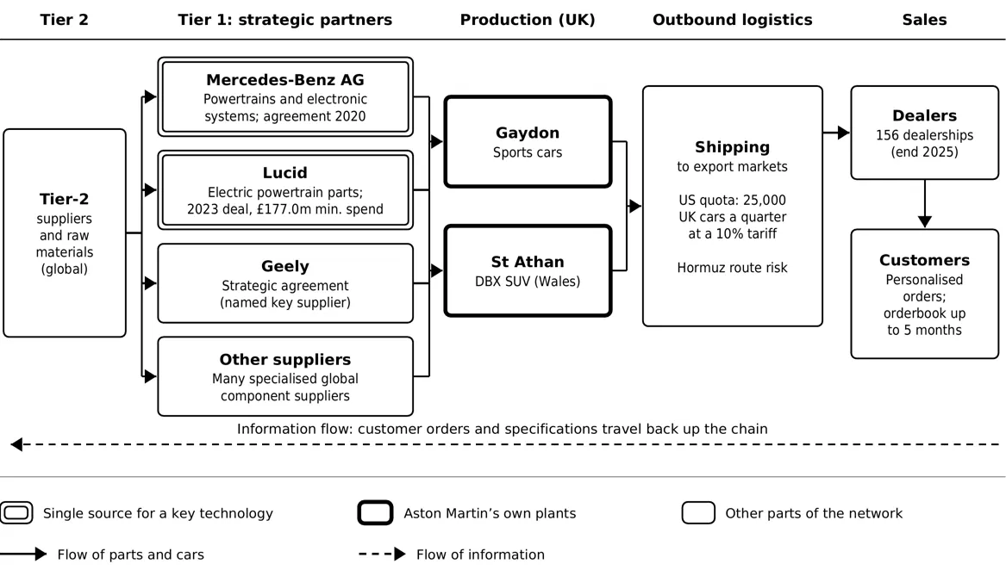
Figure 5: Aston Martin’s simplified supply network (compiled from Aston Martin Lagonda, 2026a; 2026c; Attwood, 2020)

3.2 Supply chain strategy: lean, agile or hybrid?
Fisher (1997) argues that the supply chain should match the product. Aston Martin’s cars are innovative products. They are expensive (average selling price £241,000 in H1 2026), personalisation generates about 17% of core revenue, and demand is volatile: wholesales fell 10% in 2025 before rising 21% in H1 2026 (Aston Martin Lagonda, 2026a; 2026c). For such products, Fisher recommends a responsive, agile supply chain that values speed and flexibility over lowest cost.
However, Aston Martin also shows lean features. Rather than developing its own engines and electronics, it buys proven modules from partners. In 2025 it cut capital spending by £60m and operating costs by £51m, and it is reducing its workforce by up to 20% (Aston Martin Lagonda, 2026a; 2026b). These efficiency measures are typical of lean thinking.
The best description is therefore a hybrid, or “leagile”, supply chain (Christopher, 2016). Before the decoupling point, standard modules such as engines and electrical systems arrive from partners through planned, long-term agreements: the lean part. After it, each car is finished to the customer’s specification from an orderbook that extends up to five months (Aston Martin Lagonda, 2026a): the agile part. Lee’s (2004) Triple-A model supports this view. The partnerships provide alignment, and moving all-electric drivetrains to 2030–2035, “aligned to regulatory requirements and customer needs”, shows adaptability (Aston Martin Lagonda, 2026b). Agility, however, is limited by external constraints.

3.3 Evaluation

3.3.1 Responsiveness
Personalisation is a strength, but external shocks weaken responsiveness. In 2025 the company reported “supply chain challenges that ultimately impacted volumes, efficiency and margins” (Aston Martin Lagonda, 2026a). Since 2026, only 25,000 UK-made cars per quarter can enter the US at a 10% tariff, on a first-come, first-served basis. This “limits the Group’s ability to accurately forecast” and forces it to “carefully manage U.S. imports towards the end of each quarter” (Aston Martin Lagonda, 2026c). Conflict affecting “logistics routes through the Straits of Hormuz” adds further uncertainty (Aston Martin Lagonda, 2026c). There are signs of improvement: H1 2026 wholesales rose 21%, which the company links to “a more balanced production cadence” (Aston Martin Lagonda, 2026c).

3.3.2 Cost-efficiency
Low volumes give Aston Martin little purchasing power. Gross margin fell from 36.9% in 2024 to 29.4% in 2025, partly because of about £65m of extra warranty, quality and dealer-support costs (Aston Martin Lagonda, 2026a). Earlier production also ran ahead of retail demand: aged dealer stock “remained elevated” in 2026, and the dealer support needed to clear it cut the core average selling price by 5% in H1 (Aston Martin Lagonda, 2026c; 2026d). In Fisher’s (1997) terms, this is the cost of a mismatch: pushing innovative products into dealer stock against forecasts, instead of building to order, leads to markdowns. Cost discipline is now helping, with gross margin recovering to 37.4% in Q3 2026 (Aston Martin Lagonda, 2026d).

3.3.3 Competitiveness
Partnerships are the main source of competitiveness: Mercedes-Benz and Lucid technology lets a small company compete with much larger rivals. But single sourcing creates dependence. Toyota is a useful benchmark. After the 2011 earthquake it listed 500 priority parts and required suppliers to hold two to six months of critical chips, which helped it keep producing during the 2021 chip shortage (Reuters, 2021; Shih, 2022). Aston Martin’s reports recognise its “reliance on a stable network of global suppliers” but give little public detail on similar safeguards. In 2025 it also raised concerns about its own supply chain after a cyber-attack on a major UK car maker (Aston Martin Lagonda, 2026a; Williams, 2025). Table 3.1 summarises this evaluation.
Table 2: Evaluation of Aston Martin’s supply chain strategy
Criterion | Strengths | Weaknesses | Key evidence
Responsiveness | Cars built to customer specification; stable core orderbook | Supply chain challenges; US tariff quota; Strait of Hormuz logistics risk | Orderbook of up to 5 months; quota of 25,000 UK cars per quarter
Cost-efficiency | Shared partner technology; £60m capex and £51m opex cuts in 2025 | Low volumes; warranty and dealer-support costs; aged dealer stock | Gross margin 29.4% (2025), recovering to 37.4% (Q3 2026)
Competitiveness | Access to Mercedes-Benz and Lucid technology a small firm could not build alone | Dependence on single-source partners; little published resilience planning | £177m minimum spend with Lucid; Toyota benchmark

3.4 Overall judgement
Aston Martin’s leagile supply chain fits its innovative, high-value products and gives it technology it could not afford alone. However, low volumes, single-source partnerships and tariff constraints make it costly and fragile. Toyota-style resilience (mapping tier-2 suppliers, holding buffer stock of critical parts, adding second sources where possible and wholesaling closer to real retail demand) would improve responsiveness and protect margins.

4. Inventory management and control
For a heritage British marque like Aston Martin Lagonda (AML), stock management has little in common with high-volume automotive logistics. Where mass-market carmakers rely on scale and standardised parts to reduce unit costs, Aston Martin operates a low-volume, build-to-order model across Gaydon (sports cars) and St Athan (the DBX SUV) [Cite: AML Annual Report]. Producing roughly 6,000 to 7,000 vehicles a year means inventory decisions sit directly between protecting cash flow and maintaining the bespoke quality expected on a £200,000 car.

4.1 The Profile of Held Inventory
Aston Martin’s balance sheet splits stock into three conventional categories, though ultra-luxury manufacturing skews capital allocation (Aston Martin Lagonda Financial Statements].

4.1.1 Raw Materials and Bought-In Components
Unlike high-volume brands that stamp steel in-house, Aston Martin buys complex sub-assemblies and artisanal materials:
- Technical Assemblies: AML partners with Mercedes-AMG for twin-turbo V8 engines and electrical architectures, alongside specialist batteries for limited hybrids like the Valhalla [Cite: Autocar].
- Structural Materials: Extruded bonded aluminium sections, pre-preg carbon fibre panels, and magnesium castings.
- Artisanal Stock: Full-grain Scottish hides from Bridge of Weir, Alcantara, and custom pigments for the Q by Aston Martin division [Cite: AML Sustainability Report].

4.1.2 Work-in-Progress (WIP)
WIP is Aston Martin's most delicate inventory. Because nearly every car on the line is tied to a specific buyer, WIP is non-fungible; technicians cannot swap a custom door card if a part is delayed. With models like the DB12 taking 200+ hours to build by hand—including 50 hours in painting—WIP moves slowly [Cite: Operations Case Study]. If a single microchip fails to arrive, a six-figure asset sits stranded, locking up working capital.

4.1.3 Finished Goods and Heritage Parts
In luxury, holding unsold finished stock is fatal to brand equity. "Lot rot" forces discounting and ruins residual values. Consequently, finished goods mostly comprise customer-allocated cars in transit to dealers and a small demonstrator fleet [Cite: AML Annual Report]. Alongside new cars, the firm holds slow-moving classic spares at Aston Martin Works in Newport Pagnell, which command high margins and protect heritage value.
Table 3: djd
Inventory type | Typical Example at AML | Capital Tied Up | Main Operational Risk
Raw Materials | AMG V8 engines, bonded aluminium, carbon fibre, leather | Very High | Single-source bottlenecks
Work-in-Progress | Partially built Vantage, DB12, and DBX707 chassis | Extreme | "Incomplete car" syndrome if parts are delayed
Finished Goods | Allocated cars in transit, press fleets | High | Overproduction destroys pricing power
Heritage Spares | Legacy body panels and mechanical parts | Moderate | Slow stock turn, though obsolescence risk is minimal

4.2 Inventory Control Techniques in Practice
Managing thousands of unique part numbers across small runs requires balancing lean scheduling with pragmatic buffering [Cite: Slack et al., Operations Management].

4.2.1 Just-In-Time (JIT) and Just-In-Sequence (JIS)
Aston Martin runs a pull-based JIT system governed by its Master Production Schedule [Cite: Christopher, Logistics & Supply Chain Management]. Because buyers specify bespoke trims, keeping trackside buffer stock of every permutation is impossible. Instead, once a specification is locked, Tier-1 suppliers are notified electronically. Major sub-assemblies arrive Just-In-Sequence (JIS) — loaded onto lorries to come off the tail-lift in the exact order matching chassis roll down the Gaydon track.

4.2.2 ABC Stratification (Pareto Analysis)
Procurement splits stock using ABC analysis based on annual spend and risk [Cite: Lysons & Farrington]:
- Class A (70–80% value, ~10% volume): Powertrains, carbon-ceramic brakes, and bespoke castings. Scheduled via MRP II software and strict oversight.
- Class B (15–20% value, ~20% volume): Suspension components, glass, and screens, managed via automated reorder points with modest safety buffers.
- Class C (~5% value, ~70% volume): Rivets, structural adhesives (vital for bonded aluminium), and consumables. Handled via Vendor-Managed Inventory (VMI) and shop-floor Kanban setups.

4.2.3 Adapting Economic Order Quantity (EOQ) via Modular Platforms
Textbook EOQ formulas assume steady demand — rarely applicable to seasonal sports cars [Cite: Silver et al.]. However, Aston Martin sidesteps small-batch ordering penalties by sharing hidden components. Using a common bonded aluminium underbody and electrical architecture across the Vantage, DB12, and Vanquish allows procurement to bulk-order structural extrusions without compromising exterior exclusivity [Cite: AML Investor Presentation].

4.3 Evaluating Operational Performance
Aston Martin’s track record shows that textbook lean theory often struggles against low-volume manufacturing realities.

4.3.1 The "Incomplete Car" Trap and Cash Flow Volatility
The weakness of running JIT at Aston Martin’s scale is a lack of supplier clout. When a niche carmaker ordering 6,000 units a year hits a global supply crunch, it drops to the back of the queue [Cite: Cox, Power Regimes]. During supply chain squeezes and supplier insolvencies between 2022 and 2025, Aston Martin suffered from the "incomplete car" problem [Cite: FT Coverage]. Cars sat 98% finished at Gaydon awaiting minor electronic control units or trim. Because cars cannot be invoiced until signed off, WIP inventory ballooned by tens of millions—trapping working capital and delaying revenue.

4.3.2 Moving from "Push" to "Pull" to Protect Margins
Historically, Aston Martin’s worst habit was building unallocated cars to hit wholesale targets—a "push" model that flooded dealerships and forced heavy discounting [Cite: Economist Analysis]. Under Lawrence Stroll’s turnaround, the business pivoted to a retail-led "pull" model, building strictly to order. Refusing speculative finished stock has lifted core Average Selling Prices past £180,000 and pushed gross margins toward 40% [Cite: AML Results].

4.3.3 Balancing JIT with "Just-In-Case" Resilience
Ultimately, pure JIT proved too fragile for a niche manufacturer reliant on specialist suppliers. To protect throughput, Aston Martin has adopted selective "Just-In-Case" (JIC) buffering [Cite: Sheffi, The Resilient Enterprise]. By dual-sourcing vulnerable components and holding strategic semiconductor buffers, AML accepts slightly higher holding costs to avoid the far heavier penalty of a stalled assembly line.

5. Sustainability in Operations and Supply Chain Management
Aston Martin governs environmental and social responsibility through its ‘Racing Green’ strategy, which targets a 42% reduction in absolute Scope 1 and 2 emissions by 2030 and a 90% absolute reduction across Scopes 1, 2, and 3 by 2050 against a 2022 baseline, a commitment submitted to the Science Based Targets initiative (SBTi) for validation in 2024. In 2024, direct Scope 1 emissions from facility heating and paint ovens totalled 8,575 tCO₂e, while market-based Scope 2 emissions stood at 599 tCO₂e through Renewable Energy Guarantees of Origin (REGO) electricity contracts across 11 of 12 UK sites. Manufacturing operations also maintained zero waste to landfill and reduced per-vehicle water consumption by 16% relative to 2022.
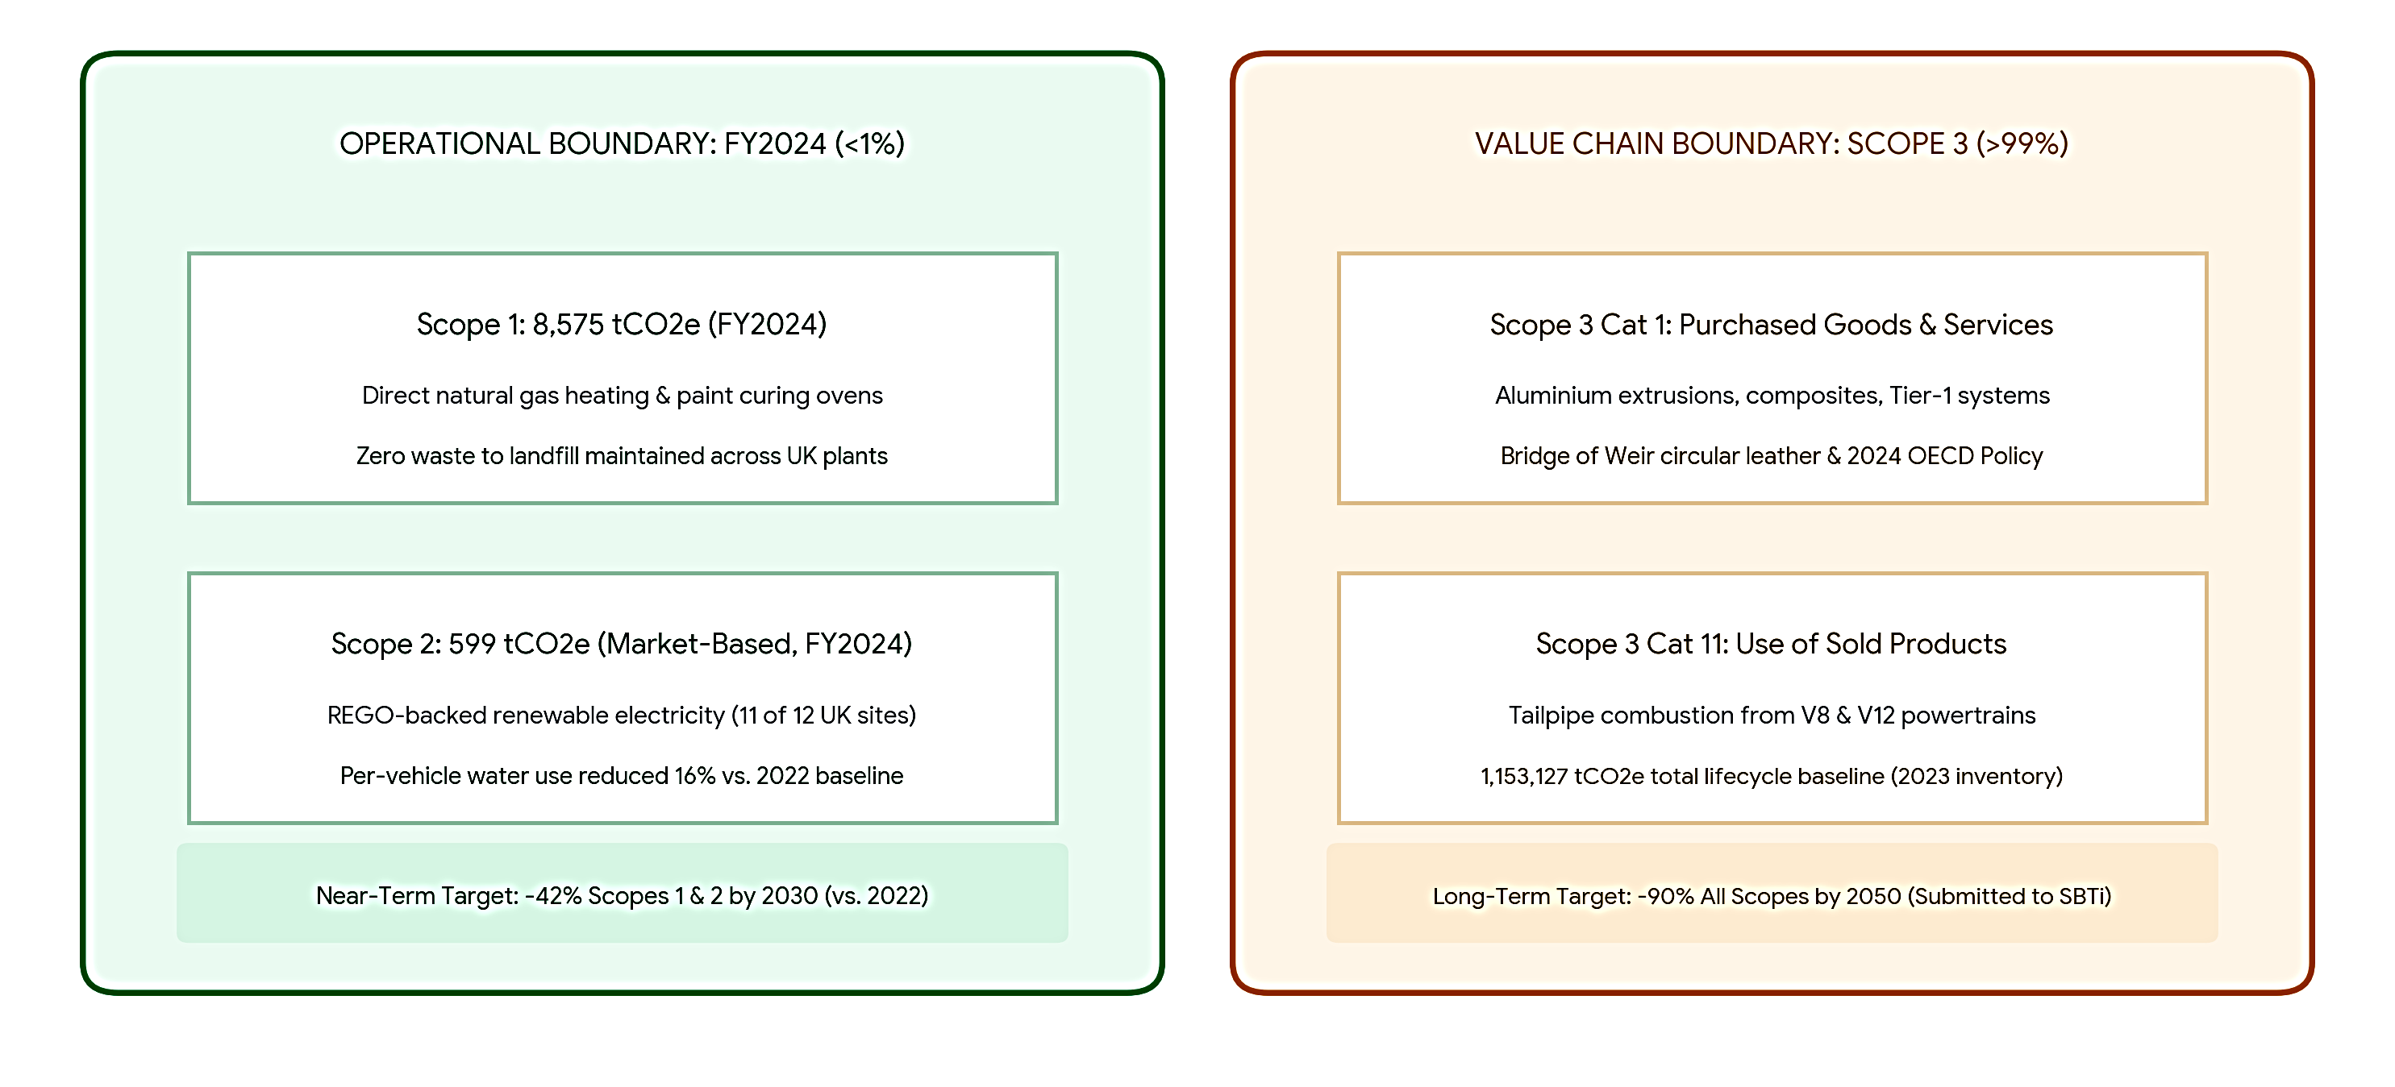
Figure 6: Greenhouse Gas Accounting Boundary and Value-Chain Decarbonisation Profile

Evaluated through the Natural Resource-Based View, internal pollution prevention has progressed, whereas value-chain product stewardship remains challenging. Scope 3 emissions represent over 99% of the 1,153,127 tCO₂e lifecycle baseline (2023 inventory), driven primarily by Category 1 purchased goods and Category 11 tailpipe combustion from high-displacement V8 and V12 engines. While circular leather sourcing from Bridge of Weir reduces interior trim impact, wider supply-network governance faces structural limits. The 2024 Responsible Procurement Policy adopts OECD due diligence standards, and internal Accident Frequency Rates improved from 0.35 in 2024 to 0.30 in 2025. Analytically, however, low production volumes (approx. 5,500 units) may constrain buyer leverage when auditing sub-tier raw material suppliers.
From a stakeholder perspective, management must balance competing expectations between luxury clients demanding traditional combustion performance and regulatory bodies enforcing fleet electrification. Citing slower luxury electric vehicle adoption and liquidity management amid £1,380 million in net debt, Aston Martin delayed pure battery-electric launches to prioritise plug-in hybrids such as the Valhalla supercar. While factory decarbonization supports local credibility, Scope 3 tailpipe dominance leaves long-term viability dependent on executing powertrain transitions before zero-emission mandates restrict global market access.

6. Conclusion

References
Aston Martin Lagonda Global Holdings plc (2017) Gaydon headquarters. 22 February. Available at: https://www.astonmartin.com/en-gb/our-world/news/2017/2/22/gaydon-headquarters (Accessed: 6 November 2026).
Aston Martin Lagonda Global Holdings plc (2021) FY 2020 results press release. 25 February. Available at: https://www.astonmartin.com/-/media/corporate/corporatearchive/documents/results-centre/2020%E2%80%94results-centre/fy%E2%80%942020/aston-martin-lagonda-fy-2020-results%E2%80%94press-release.pdf (Accessed: 6 November 2026).
Aston Martin Lagonda Global Holdings plc (2024a) Annual report and accounts 2023. Gaydon: Aston Martin Lagonda Global Holdings plc. Available at: https://www.astonmartin.com/-/media/corporate/corporatearchive/documents/annual-reports/aston-martin-lagonda-annual-report-2023-interactive.pdf
Aston Martin Lagonda Global Holdings plc (2024b) Responsible procurement policy. Gaydon: Aston Martin Lagonda Global Holdings plc. Available at: https://www.astonmartin.com/-/media/corporate/corporatearchive/documents/2024-responsible-procurement-policy.pdf
Aston Martin Lagonda Global Holdings plc (2025a) Annual report and accounts 2024: delivering sustainable growth. Gaydon: Aston Martin Lagonda Global Holdings plc. Available at: https://www.astonmartin.com/-/media/corporate/corporatearchive/documents/2025-gm/2024-annual-report-and-accounts.pdf
Aston Martin Lagonda Global Holdings plc (2025b) H1 2025 results. Gaydon: Aston Martin Lagonda Global Holdings plc. Available at: https://www.astonmartin.com/-/media/corporate/documents/h1-results-2025/aston-martin-lagonda-h1-2025-results.pdf
Aston Martin Lagonda Global Holdings plc (2026a) Preliminary results FY2025. RNS announcement, 25 February. Available at: https://www.ticker.app/lse/AML/rns/2026-02-25/Preliminary-Results-FY2025/2503U (Accessed: 7 November 2026).
Aston Martin Lagonda Global Holdings plc (2026b) FY 2025 results presentation. 25 February. Available at: https://www.directorstalkinterviews.com/wp-content/uploads/2026/02/Aston-Martin-Lagonda-FY-2025-Results-Presentation.pdf (Accessed: 7 November 2026).
Aston Martin Lagonda Global Holdings plc (2026c) Interim results for the half-year ended 30 June 2026. RNS announcement, 29 July. Available at: https://www.ticker.app/lse/AML/rns/2026-07-29/Interim-results-for-the-half-year-ended-30-June-26/2588O (Accessed: 7 November 2026).
Aston Martin Lagonda Global Holdings plc (2026d) Results for Q3 and 9 months ended 30 September 2026. RNS announcement, 28 October. Available at: https://www.ticker.app/lse/AML/rns/2026-10-28/Results-for-Q3-and-9-months-ended-30-Sept-2026/7038A (Accessed: 7 November 2026).
Aston Martin Lagonda Global Holdings plc (2026e) Annual report and accounts 2025. Gaydon: Aston Martin Lagonda Global Holdings plc. Available at: https://www.astonmartin.com/-/media/corporate/corporatearchive/documents/annual-reports/aston-martin-lagonda-annual-report-2025.pdf
Attwood, J. (2020) ‘Mercedes-Benz to take 20% stake in Aston Martin, offers access to tech’, Autocar Professional, 28 October. Available at: https://www.autocarpro.in/news-international/mercedesbenz-to-take-20-stake-in-aston-martin-offers-access-to-tech-77581 (Accessed: 7 November 2026).
Business Matters (2024) ‘Aston Martin shares slump after profit warning amid supply chain struggles’, Business Matters Magazine, 30 September. Available at: https://bmmagazine.co.uk/news/aston-martin-shares-slump-after-profit-warning-amid-supply-chain-struggles/
Christopher, M. (2016) Logistics and supply chain management. 5th edn. Harlow: Pearson.
Fisher, M.L. (1997) ‘What is the right supply chain for your product?’, Harvard Business Review, 75(2), pp. 105–116.
Freeman, R.E. (2010) Strategic management: a stakeholder approach. Cambridge: Cambridge University Press.
Hart, S.L. (1995) ‘A natural-resource-based view of the firm’, Academy of Management Review, 20(4), pp. 986–1014.
Holweg, M. and Pil, F.K. (2004) The second century: reconnecting customer and value chain through build-to-order. Cambridge, MA: MIT Press.
Lawson, B., Pil, F.K. and Holweg, M. (2018) ‘Multi-modal order fulfillment: concept and application’, Production and Operations Management, 27(2), pp. 269–284. doi: https://doi.org/10.1111/poms.12801.
Lee, H.L. (2004) ‘The triple-A supply chain’, Harvard Business Review, 82(10), pp. 102–112.
Naylor, J.B., Naim, M.M. and Berry, D. (1999) ‘Leagility: integrating the lean and agile manufacturing paradigms in the total supply chain’, International Journal of Production Economics, 62(1–2), pp. 107–118. doi: https://doi.org/10.1016/S0925-5273(98)00223-0.
Ohno, T. (1988) Toyota production system: beyond large-scale production. Portland, OR: Productivity Press.
PistonHeads (2026) DB12 S incoming [forum thread]. Available at: https://www.pistonheads.com/gassing/topic.asp?h=0&f=70&t=2128763 (Accessed: 6 November 2026).
Reuters (2021) ‘How Toyota thrives when the chips are down’, Nippon.com, 9 March. Available at: https://www.nippon.com/en/news/reu20210309KBN2B1004/ (Accessed: 7 November 2026).
Shih, W.C. (2022) ‘What really makes Toyota’s production system resilient’, Harvard Business Review, 15 November.
Slack, N., Brandon-Jones, A. and Burgess, N. (2022) Operations management. 10th edn. Harlow: Pearson.
Slack, N., Chambers, S. and Johnston, R. (2009) Operations management. 6th edn. Harlow: Financial Times Prentice Hall.
Williams, J. (2025) ‘Aston Martin braced for heavy losses as impact of JLR hack adds to supply chain woes’, Car Dealer Magazine, 7 October. Available at: https://cardealermagazine.co.uk/aston-martin-braced-for-heavy-losses-as-impact-of-jlr-hack-adds-to-supply-chain-woes/319163 (Accessed: 7 November 2026).
Womack, J.P., Jones, D.T. and Roos, D. (1990) The machine that changed the world. New York: Rawson Associates.

Group Contribution Table
Group Member | Contribution
Ghanima Albaidan | Section 1&5
Abdiwak Benti Debella | Section 2
Otabek Muradov | Section 3
Bei Dei Teoh | Section 4

