* 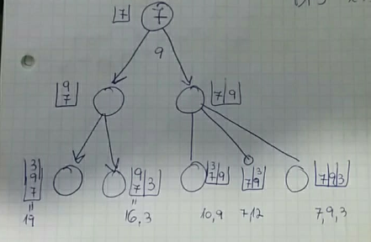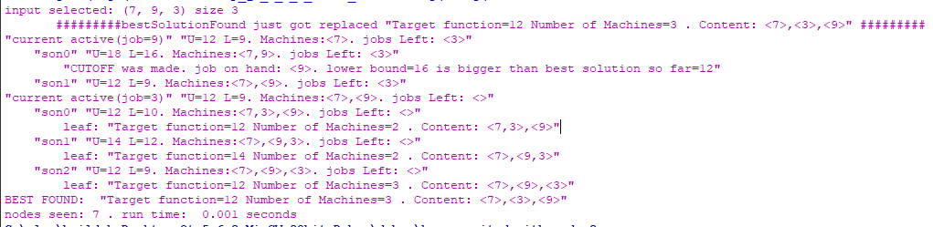Notice the root is the first job. We initialize it separately.
* Each machine is wrapped with <a1,a2,..,an>
* Cut off made => no point to prone that node
* Whenever a new best is found you see “######....
  + This example is a weak example since the best doesn’t get

replaced. We have another example with 3 jobs that the best

get replaced ( {7,9,2} ). We chose this because we have

a drawing of the tree