Automatic Labeling of Tweets for Stigma Analysis on Social Networks

- Introduction
Text data annotation is a tedious task, going manually threw hundreds of thousands of text section is not feasible by a single individual. When dividing the task between multiple annotators, inconsistency and biases arise.
In this work we present a framework for automatic labeling given a small set of manually annotated data. We operate in the domain of short text (Tweets) collected for the study of stigmatic diseases in social network. Using machine learning techniques on small-scale labeled data , the trained models are applied to a large unlabeled dataset. The automatically annotated data is then used to perform further text mining analysis on the problem.
We consider the problem of stigma analysis of posts in social networks. We collected tweets associated with keywords associated with three diseases, HIV, ASTMA and FIBROMILOGIA. All the tweets were collected during April-May 2016, and are either associated with one of the specified keywords, or were identified as authored by a user carrying the disease. The aim is to categorize a large set of tweets into: 1) organizations talking about the diseases, 2) tweets of individual that talk about themselves and the disease, 3) tweets of individuals that are not referring themselves as carrying the disease, 4) and tweets that are sarcastic or humoristic with reference to the disease.

- Methodology
We utilize a large collection of tweets extracted using search keywords associated with the disease. In addition, twitters caring the disease (mainly HIV but also ASTMA) where identified as part of the maual labeling process and all their public tweets where harvested. A small percentage of the tweets were labeled manually.
We implemented a framework consisting of tweets feature extraction, classifier training, and inference on unlabeled data.
First we extracted features using ‘bag of words’ with the popular tf/idf metric, in addition we add to the corpus all bi-grams. When classifying text in general and tweets in particular, there are attributes in the text that their existence is of importance while their content is of less relevance (i.e. urls, numbers, user references, etc.). Considering the attributes existence and not their content (in the bi-gram scheme) significantly boosts accuracy as shown in the results. In order to classify with high accuracy, we utilized features form and developed some of our own.
Concretely, we applied a common parsing to identify attributes in the tweets:
- Emoticons – after collecting all the Unicode number of the relevant emoticons we checked 3 options of testing the tweets:
  - Replacing all the emoticons with one word
  - Splitting the emoticons into 3 "hardcoded" words (Positive, negative, Sarcastic)
  - Leaving the emoticons as is
- User reference – if the tweet contains any reference to another twitter user we:
  - Count the number of references
  - Changed the references to ‘@REF’
  - Leaving the reference as is
- Checking if all of the letters are upper case (and if they are and only some reference isn’t so doing upper case to all)
- Stemming and lemmatization
- Punctuation – counting the appearances of all punctuation in every tweet.
- Deleting URLs and replacing the url with hardcoded "URL"
- Replacing hash tags with uppercase words.
- Numbers contained in Tweets numbers are switched with the word "NUM".

The parser must apply in a specific order to prevent intersection between two feature parser. We used the following order:
- URL
- Reference
- Hashtags
- Numbers
- Emoticons
- Punctuation
- All Caps
- Stemming and lemmatization

We tested four classifiers, (1) Linear Support Vector Machine (SVM), (2) Radial Bases Function Support Vector Machine (RBF-SVM), (3) Naïve Base (NB), and (4) Logistic Regression (LR) to find the one with the best fit to our problem and achieve best results. The classifiers where chosen to test a variety of different approaches, linear (SVM/LR/NB) vs non-linear models (RBF-SVM), statistical attributes (NB) vs loss function (SVM/LR), and different loss functions (SVM) vs (LR).
To evaluate each feature combination and each classifier (with multiple classifier parameters) we used 5-fold cross validation using the labeled examples to choose best features-classifier-parameter combination. Using the best combination, the classifier was trained on all the labeled data. The F1-micro metric was used for evaluation.
We tested all 4 classifiers on 2 problems – shown in table 1.

 | Linear SVM | RBF SVM | LR | Naïve Base
Asthma  User – ORG | 0.843 | 0.739 | 0.839 | 0.765
Asthma  Self-Other | 0.764 | 0.703 | 0.753 | 0.704
Table 1 The preliminary experiment shows us that using the non-linear classifier and Naïve Base classifier are suited for this problem.

Between the two other classifiers we decided to use LR, the training time of LR was significantly faster (up to 10 times) from linear SVM but, with comparable accuracy.

- Results
In this section we present our classifier performance on the labeled data, while reviewing subjectively the overall results on the unlabeled data.

  - Cross validation

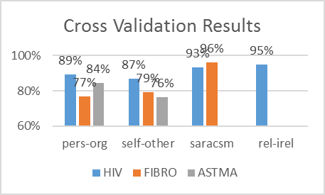
Figure 1 Cross validation results of best features-classifier combination, on various tasks.

Using the cross validation results we infere the quality of the features and classifier chosen for the problem. The best result in the cross validation was 96%, while the avarage across all 9 experiments was 87%. These results reflect high confidance in the choosen methodolegy.
An important conclusion from this experiment is that the HIV problems were the easiest while FIBRO was the hardest. We attribute those results to the amount and quality of labled data, which was segnificantly more in HIV than the other problems.
Another interesting observation is that the sarcasm problem, which is a quality known that computers do not master yet, shows to be the easiest task with the highest accuracy. In figure 2 we can see the top contributing features for sarcasm classification.
  - Words influencing classification
As we can see in Figure 3, users are using terms like: “my inhaler”, “I” and “I have” as opposite to organization that regularly using URL and tweeters references in their tweets.
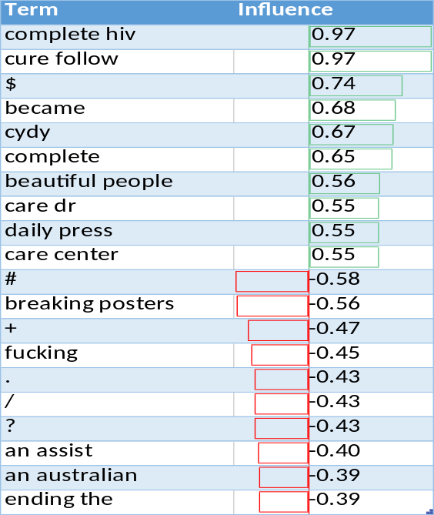
Figure 2 Most influencing features on the HIV sarcasm problem.

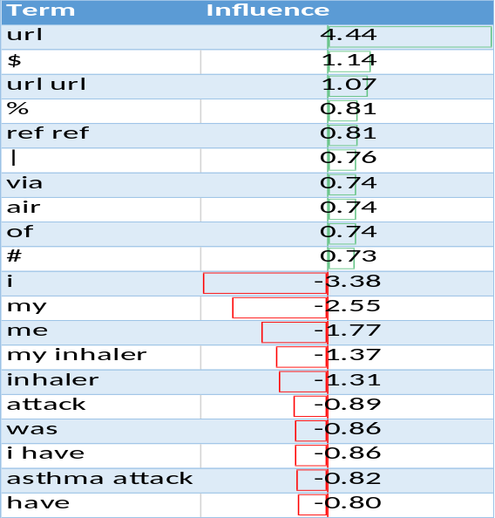
Figure 3 Most influencing features on ASTHMA organization vs. user problem

  - Influence of developed features
We developed features to improve classification accuracy. In this section we analyze the influence of the different features combination on the cross validation results.
We could not identify a single feature that boosted f-measure results. The most conversional feature was the “stemming and lemmatization” on one hand this feature helped gain up to 1% of f-measure (HIV and Fibro) but on the other hand it reduced the f-measure by 4.5% on Asthma. The large variance caused the mean f-measure to be the least accurate when using this feature.
In Figure 4. We see that each problem has its own best combination of features. Using cross validation to Identify best feature combination helped us gain up to 1.5% in f-measure.

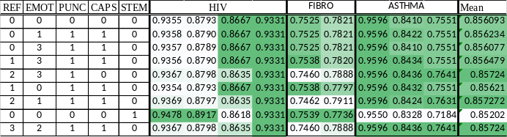
Figure 4 Feature combination vs cross validation results. Right column: mean result
- Unlabled data
Under the assumption that the training data was drawn from the same distribution as the unlabeled data, the good Cross validation results should reflect high accuracy on the unlabeled data. Unfortunately, we don’t have tools for evaluating the automatically classified tweets and we rely on our (biased) subjective observation. Next, we present some samples from the automatic classification.

Tweets examples:
- "I WOKE UP TO A HORRIBLE ASTHMA ATTACK AND I TOOK MY INHALER BUT STILL COULDN'T BREATHE WELL" marked as self ("I","my inhaler"," ASTHMA ATTACK")
- "I hate random asthma attacks.,." ("I", "asthma attacks")
False examples:
- "Sulochana Dongre was suffering from extreme asthma attacks and often had the breath knocked out... https://t.co/o4ZIy2lG5c"
This tweet was missed classified as user instead organization. It was originally published by a hospital, it is likely this was misclassified because of the personal notion it was written in. Usually organizations use a predefined template which is customized to promote its content. The manual labeling process utilized this observation to label organizations tweets. The unproportional representation of tweets originated by organizations with “personal touch” most likely caused bias in the classification.
- “Living with Fibromyalgia,My story: Please RT: https://t.co/FFndjbg6sr”
This tweet was misclassified as user not talking about themselves. We Identified to key features influencing the classification (1) RT (2) URL. ‘RT’ is a marking for retweet, when it indicates a retweet it appears at the beginning. Adding feature RT at the beginning might have benefit such case.

- Conclusion
We have shown a survey of a variety of approaches to solve the inference problem from small labeled data to large unlabeled data. The variance of the influence of the different features was not significant, while the variance of the influence of the classifier had moderate influence.
In some problems we reached accuracy of 96% f-measure while on the worst case we reached 76% f-measure. Although these results seem good, due to the high variance it is hard to rely on the inferred labels for future automatic analysis.
To improve accuracy, we suggest 2 improvements:
- Labeling only samples with high accuracy while ignoring those without.
- Use labeled data that represents the real distribution of the data. This data is highly unbalanced thus we suggest applying appropriate techniques for unbalanced classification.

Appendix
Appendix A – Results resources
Our results are gathered in a shared Dropbox folder: https://goo.gl/n8yRRs.
There are two types of results:
- Running log file with evaluation f1-micro scores and best/worst classification terms/features.
- Self-annotated data, the tweets are split to files by classifier problem and taxonomy.

Appendix B – Reproducing the experiments
The application is written in python and is downloadable from: https://goo.gl/DYCcBp
Software pre-requisites:
- Python 2.7
  - numpy, scipy, sklearn, genism, nltk
Running all the experiments are done via one python script.
Running:
- invoke $ python test.py

