* Data size
  + 5000
    - 65.1
  + 15000
    - 68.5
  + 20000
    - 70.15
  + 30000
    - 69.4
  + 50000
    - 71.4
* Data size - 22084
  + Sample only if 45 words
  + 80.2580%

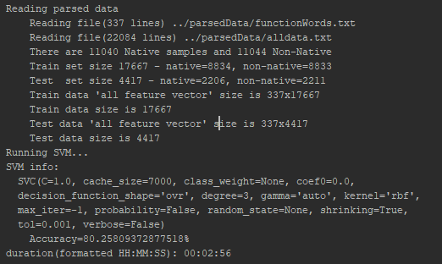

* + Added f_words – acc 81.57

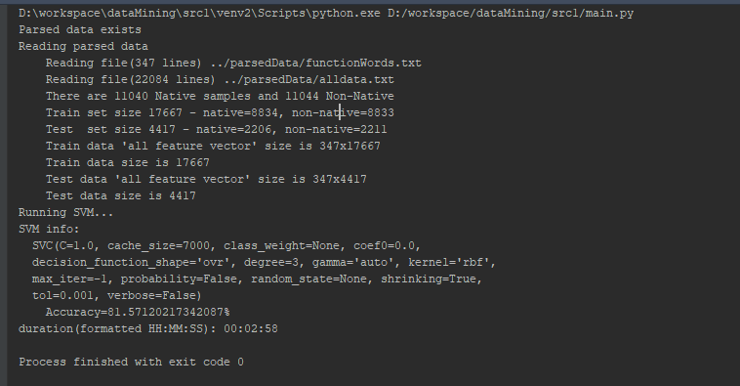

* Last attempt

