* Main display, how much each cluster voted and what's his economic right-left stand is:

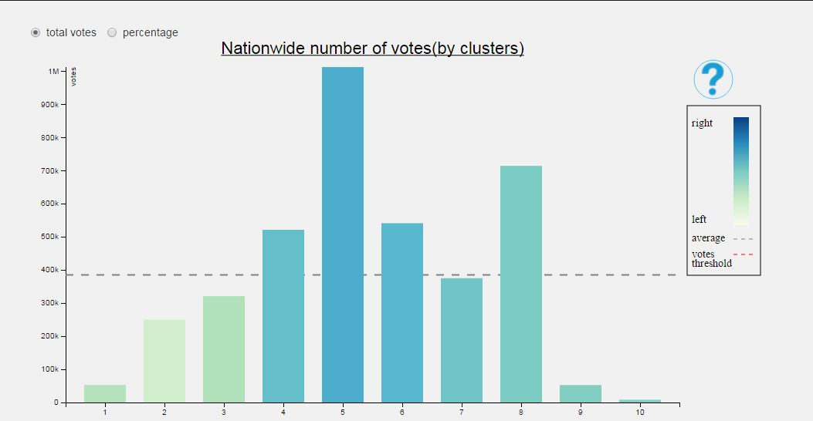

* + Column height- How many people voted from those who have a right to vote in each cluster – percent or total number.
  + Color of the Column- for who (economic right-left) the cluster voted (see legend in top right of the view).
* Clicking on the background of the main view will send the user the secondary view. The 2015 election results and the economic right left map of each party:

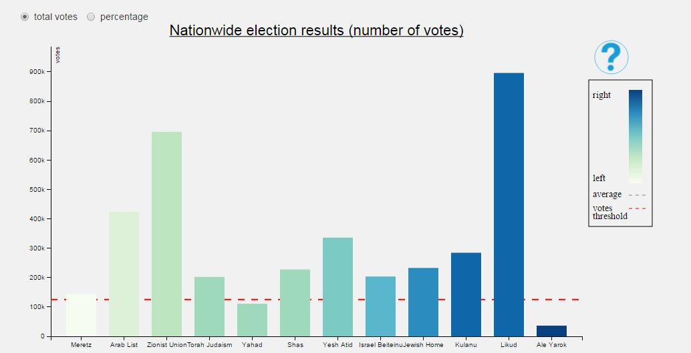

* + Column height- How many people voted for the party – percent or total number.
  + Color of the Column- economic right-left of each party.
* Clicking on a column of a party will send the user to a display of a specific party:

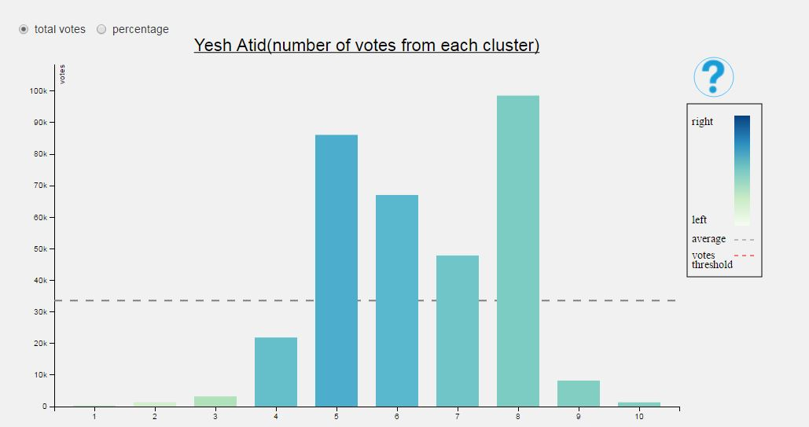

* + Column height- How many people voted from each cluster – percent or total number.
  + Color of the Column- to who the cluster voted (see legend in top right of the view).
* Clicking on a column of a cluster will send the user to a display of a specific cluster:

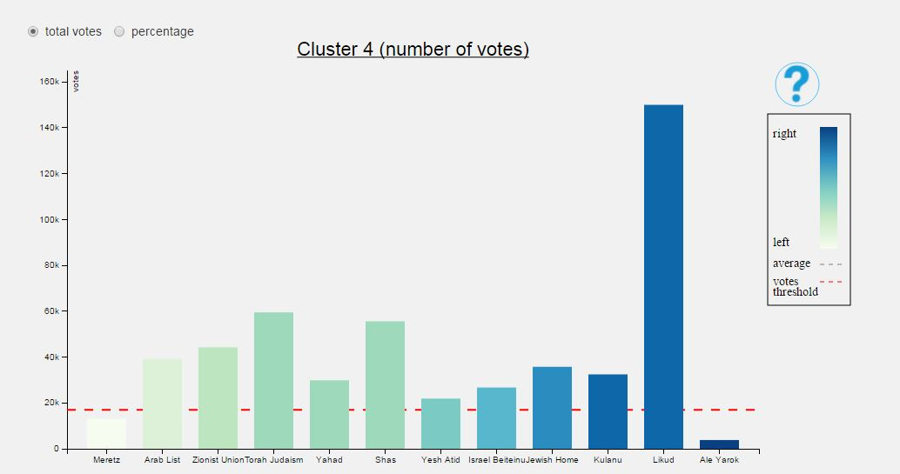

* + Column height- How many people voted for this party from each cluster – percent or total number.
  + Color of the Column- the party's economic right left stand (see legend in top right of the view).