v

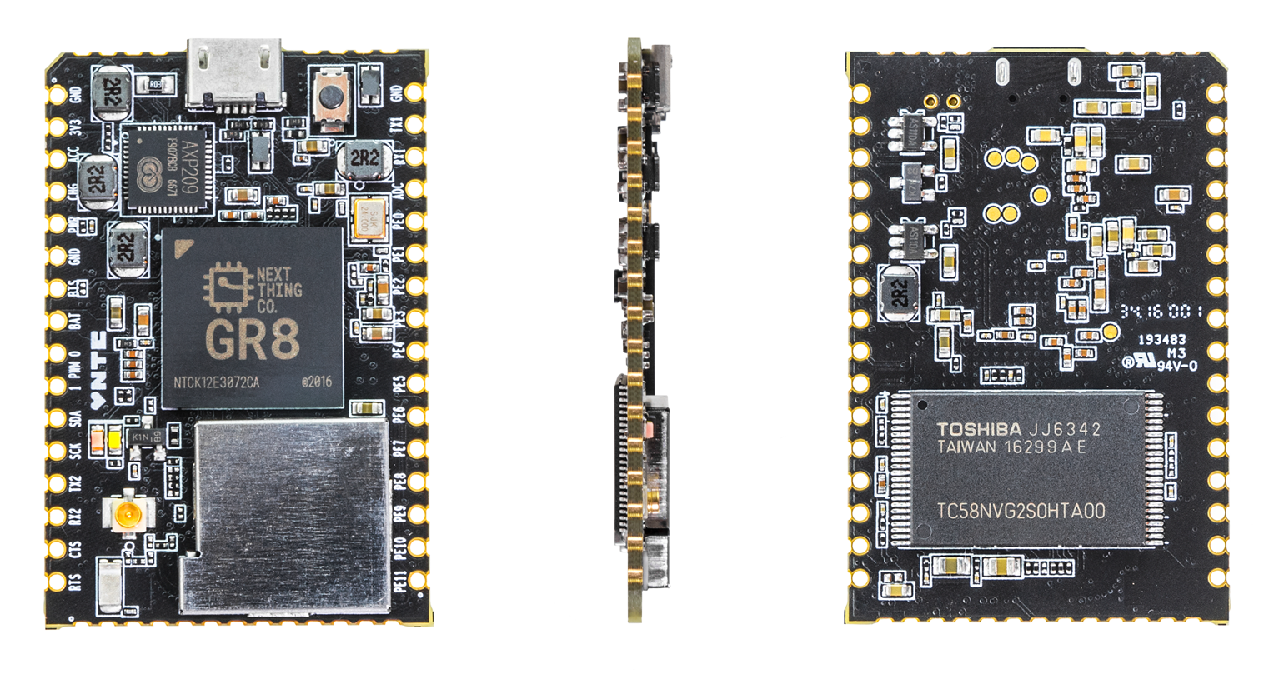

**C.H.I.P. Pro Datasheet**

Version 1.0

2016-10-11

# Revision History

|  |  |  |
| --- | --- | --- |
| **Revision** | **Date** | **Description** |
| v0.1 | Oct. 09, 2016 | Initial Internal Release |
| v1.0 | Oct. 11, 2016 | Initial Public Release |
| V1.01 | Dec. 20, 2016 | Updated PCB Footprint and Pinout Map |

# Declaration

This page left intentionally blank. \(•◡•)/

# Table of Contents

1. Overview 7

2. Features 8

2.1. CPU 8

2.2. GPU 8

2.3. Memory 8

2.4. System Peripherals 8

2.5. Video Engine 10

2.6. Display Subsystem 10

2.7. Camera Parallel Interface 10

2.8. Audio Subsystem 10

2.9. External Peripherals 11

2.10. Power System 12

2.11. Device Package 12

3. Block Diagram 13

4. Pin Description 15

4.1. Pin Characteristics 15

4.2. GPIO Multiplexing Functions 17

4.3. Detailed Pin/Signal Description 18

5. Electrical Characteristics 20

5.1. Absolute Maximum Ratings 20

5.2. Recommended Operating Conditions 20

5.3. DC Electrical Characteristics 21

5.4. Power Consumption Summary 21

5.5. Oscillator Electrical Characteristics 22

5.6. Power Up/Down and Reset Specification 21

6. Pin Assignment 23

7.Mechanical and Packaging Information 24

7.1. PCB Footprint 25

8. Schematic 26

# About This Documentation

From the desk of Gustavo Huber

When Dave, Thomas, and I started Next Thing Co. in 2013, it was with a simple goal: we wanted to create things that would inspire creativity, and help people chase their own ideas of what needed to exist.

We considered this goal both in terms of how economically accessible we could make our products (they had to be $99 or less), as well as how much “pain” we could remove from the design process for others (they had to be open source and well-documented).

Our first attempt was a software-defined camera named OTTO, built around an off-the-shelf embedded module. But early in development, we knew that our end-goals were at risk. The $39 module made it impossible to ship product priced under $99. It lacked Mainline Linux support, a reliable tool-chain, documentation and functional drivers making software development a cat-and-mouse game of bug tracking. But thanks to lots of long days, and some good friends both in Shenzhen and back home in Oakland, we built and shipped out 500 OTTOs -- a serious feat.

Almost exactly a year later, we shipped out the first of what is now over 100,000 C.H.I.P.s delivered worldwide. At $9, C.H.I.P. was the fruition of our vision from a year prior: accessible, powerful technology, available to everyone for hobby, education, or products. In so many words, we were building the tools that we wished we’d had before.

The reaction was (and continues to be) astounding! Tweets and emails come from far and wide to tell us about impossible projects banged together in an afternoon, classrooms full of proud 10-year-old game developers who had never before written a line of code, and seasoned engineers brought back to memories of discovering their passion on a Commodore 64, 40 years prior. Yet, just as building OTTO showed us the tools we were missing, building C.H.I.P has taught us what it takes to scale production to keep up with [even unprecedented] demand.

So it is with great pleasure that I invite you to explore, without non-disclosure agreements or any other obstructive formalities, this datasheet for C.H.I.P. Pro: the newest addition to the Next Thing Co. family.

Thanks to the experience and support from our friends at Allwinner and Nanya, C.H.I.P. Pro is built from the ground up for clean and reliable design. From in-package DDR3 DRAM in the GR8 SiP (which allows us to buy known-good-die DRAM rather than market components), to keeping the onboard NAND, Bluetooth, Wifi, and power management that made C.H.I.P. so useful, C.H.I.P. Pro takes care of all the nuts and bolts, letting you get to the fun parts faster.

With Next Thing Co. and the thriving Chipster community from bbs.nextthing.co at your side, we can’t wait to see what you’ll do with C.H.I.P. Pro!

/Gustavo

Co-founder, Hardware Guy

# Overview

At Next Thing Co., we work to make it easy to integrate computer hardware in products. C.H.I.P. Pro is powered by GR8, a system-in-package (SiP) that was designed by Next Thing Co. GR8 features a 1GHz Allwinner R8 ARM Cortex-A8 processor, Mali400 GPU, and 256MB of Nanya DDR3 DRAM. in a 14mm x 14mm FBGA package.

C.H.I.P. Pro is a system-on-module (SoM) that has 512MB of high-speed NAND storage flashed with our GadgetOS. It can be powered by USB or battery, intelligently managed by the AXP209 power management unit.

The module offers all the popular interfaces you’d expect. With two UARTs, a Two Wire Interface, a parallel camera interface, SPI, two PWM channels, a USB 2.0 OTG, and a USB 2.0 Host, C.H.I.P. Pro is packed full of I/O expandability. Comprehensive audio handling includes a built-in 24-bit ADC/DAC for analog audio, One Wire Audio digital out, and I2S digital audio for interfacing with professional audio codecs.

C.H.I.P. Pro is CE, IC, and FCC part 15 modularly certified, making integration into end products easy. The on-board Realtek 8723DS combination module provides compliant Wi-Fi B/G/N and Bluetooth 4.2 Low-Energy connectivity. A software controlled antenna path selects between the on-board chip antenna or a uFL antenna connector where several pre-certified antennas can be added to boost wireless transmit and receive range.

Rated to operate between 2.9V-6V in temperatures ranging between 0 and 70 degrees Celsius and measures 45 mm x 30 mm.

**C.H.I.P. Pro is $16 in any quantity and includes custom factory flashing via Next Thing Co.’s Gadget software tools for orders of 1000 or more. The minimum order quantity for C.H.I.P. Pro is one.**

We can’t wait to see how you’ll integrate C.H.I.P Pro in to your next product.

## Applications

* Physical Computing
* Voice Recognition
* Smart “Clapper”
* Animated GIF Camera
* Smart Consumer Devices
* Portable Audio Devices
* Cyber Dog Robot Toys

# Features

## CPU

* ARM CortexTM-A8
* ARMv7 Instruction set plus Thumb-2 Instruction Set
* 32KB Instruction Cache and 32KB Data Cache
* 256KB L2 Cache
* NEONTM SIMD Extensions
* Jazelle RCT Acceleration

## GPU

* Mali400
* Supports Open GL ES 1.1/ 2.0 and Open VG 1.1

## Memory

**Boot ROM**

* On-chip Boot ROM
* Supports NAND Flash, SPI NOR Flash, SD Card and USB OTG

**NANYA DDR3 SDRAM**

* In-package 256MB 16-bit DDR3 memory

**NAND Flash**

* 512MB SLC NAND

**SD/MMC**

* One SD/MMC Host Controllers (SMHC)
* Compatible with eMMC v4.4, SD Physical Layer Specification v2.0, SDIO Card Specification v2.0
* 1-/4-/8-bit bus width
* Supports block size of 1 to 65535 bytes
* Dedicated DMA for fast and uninterrupted data transfer

## System Peripherals

**CCM – Clock Control Module**

* Seven PLLs driven by a main external Oscillator and an on-chip RC Oscillator
* Supports clock configuration and clock generated for corresponding modules
* Supports software-controlled clock gating and software-controlled reset for corresponding modules

**DMA – Direct Memory Access**

* Eight channels Normal DMA (NDMA) and eight channels Dedicated DMA (DDMA)
* Supports memory-to-memory, memory-to-peripheral, peripheral-to-memory data transfer types
* Transfer data width of 8/16/32-bits
* Programmable DMA burst size

**PWM – Pulse Width Modulation**

* Two outputs
* Supports continuous and pulse waveforms
* 0% to 100% adjustable duty cycle
* Up to 24 MHz output frequency

**Asynchronous Timer**

* Six Asynchronous Timers with interrupt-based operation
* A watchdog timer to generate reset signal or interrupt
* Two 33-bit Audio/Video Sync (AVS) counter to synchronize video and audio
* One 64-bit counter

**Synchronous Timer**

* Two Synchronous Timers with interrupt-based operation

**Interrupt Controller**

* Normal interrupt requests (nIRQ) and fast interrupt requests (FIQ)
* Supports 96 interrupt sources
* Four level priority controller
* External interrupt can be triggered according to edge or level-sensitivity

**LRADC – Low Resolution Analog-to-Digital Converter**

* Analog-to-Digital Converter with 6-bit resolution suitable for multi-button input
* Supports multiple button press detection
* Supports single, normal and continuous work mode
* Sampling frequency up to 250 Hz

**Crypto Engine**

* Supports AES, DES, 3DES, SHA-1, MD5
* Supports ECB, CBC modes for AES/DES/3DES
* 128-bit, 192-bit and 256-bit key size for AES
* 160-bit hardware Pseudo Random Number Generator (PRNG) with a 175 bit seed

## Video Engine

**Video Decoding**

* Supports multi-format video decoding of VP6/8, AVS, H.264, H.263, and MPEG-1/2/4
* Up to 1080p@30fps resolution

**Video Encoding**

* Supports encoding in H.264 MP format
* Up to 720p@30fps resolution

## Display Subsystem

**Display Processing**

* Four moveable and size-adjustable layers
* Multi-format image input
* Image enhancement processor
* Alpha blending /anti-flicker
* Hardware cursor
* Output color correction (luminance/hue/saturation)

## Image Input

* Supports 8-bit CMOS sensor parallel interface
* Supports BT656 interface
* Maximum still capture resolution on parallel interface up to 5M
* Maximum video capture resolution on parallel interface up to 1080p@30fps
* Pixel clock up to 150MHz

## Audio Subsystem

**Audio Codec – Audio Compression / Decompression Module**

* On-chip 24-bit DAC for playback and ADC for recording
* Supports analog/digital volume control
* Supports 44.1 kHz, 48 kHz, 96 kHz, and 192 kHz sample rates
* Stereo microphone input
* Stereo headphone amplifier

**I2S/PCM – Inter-IC Sound / Pulse Code Modulation**

* Selectable I2S or PCM on shared pins
* Full-duplex synchronous serial interface
* Configurable as a master or a slave
* Audio data resolutions of 16, 20, 24
* I2S Audio data sample rate from 8 kHz to 192 kHz
* Left Justified or Right Justified I2S
* PCM supports 8-bit or 16-bit linear, 8-bit u-law, or 8-bit A-law companding sample format
* One 128x24-bits FIFO for data transmit and one 64x24-bits FIFO for data receive
* Programmable FIFO thresholds

**OWA - One Wire Audio**

* IEC-60958 transmitter functionality
* Channel status insertion
* Hardware parity generation
* One 32×24bits FIFO (TX) for audio data transfer
* Programmable FIFO thresholds

## External Peripherals

**USB – Universal Serial Bus**

* One USB 2.0 OTG controller
* Complies with USB 2.0 Specification
* Supports High-Speed (HS,480 Mbit/s), Full-Speed (FS,12 Mbit/s) and Low-Speed (LS,1.5 Mbit/s) in host mode
* Supports High-Speed (HS, 480 Mbit/s), Full-Speed (FS, 12 Mbit/s) in device mode
* Up to 10 user-configurable endpoints in device mode
* One USB Host controller
* Complies with Enhanced Host Controller Interface(EHCI)Specification, Version 1.0, and the Open Host Controller Interface(OHCI) Specification, Version 1.0a
* Supports High-Speed (HS, 480 Mbit/s), Full-Speed (FS, 12 Mbit/s), and Low-Speed (LS, 1.5 Mbit/s) mode

**TWI - Two Wire Interface**

* One TWI (Two-Wire Interface) controller
* Supports Standard mode (up to 100 kbit/s) and Fast mode (up to 400 kbit/s)
* Configurable as a master or a slave
* Capable of 10-bit addressing

**UART - Universal Asynchronous Receiver/Transmitter**

* Two UART controllers
  + UART0 with 2 wires
  + UART1 with 4 wires
* Compatible with industry-standard 16550 UARTs
* Support for word length from 5 to 8 bits, an optional parity bit, and 1, 1.5 or 2 stop bits
* Programmable parity (even, odd and no parity)

**SPI – Serial Peripheral Interface**

* One SPI controller with one Chip Select signal
* Full-duplex synchronous serial interface
* Configurable as a master or a slave
* Configurable Polarity, phase and clock frequency

## Power System

**AXP209 Power Management Unit**

* Intelligent Power Select allows for three separate inputs: VBus, Charge-In, and Battery
* Li-Po Battery Charging with Fuel Gauge Functionality

**2x LY8088 Switching Regulators**

* 1.3A 2.3V-6V Input, 1.5MHz Synchronous Step-Down Converter

## Package

* Double-sided PCBA, 45mm x 30mm
  + SMT-ready castellated edges
  + Bread-board-friendly staggered through-holes
* Pin count: 53
* Short side pitch: 2mm
* Long side pitch: 2.54mm

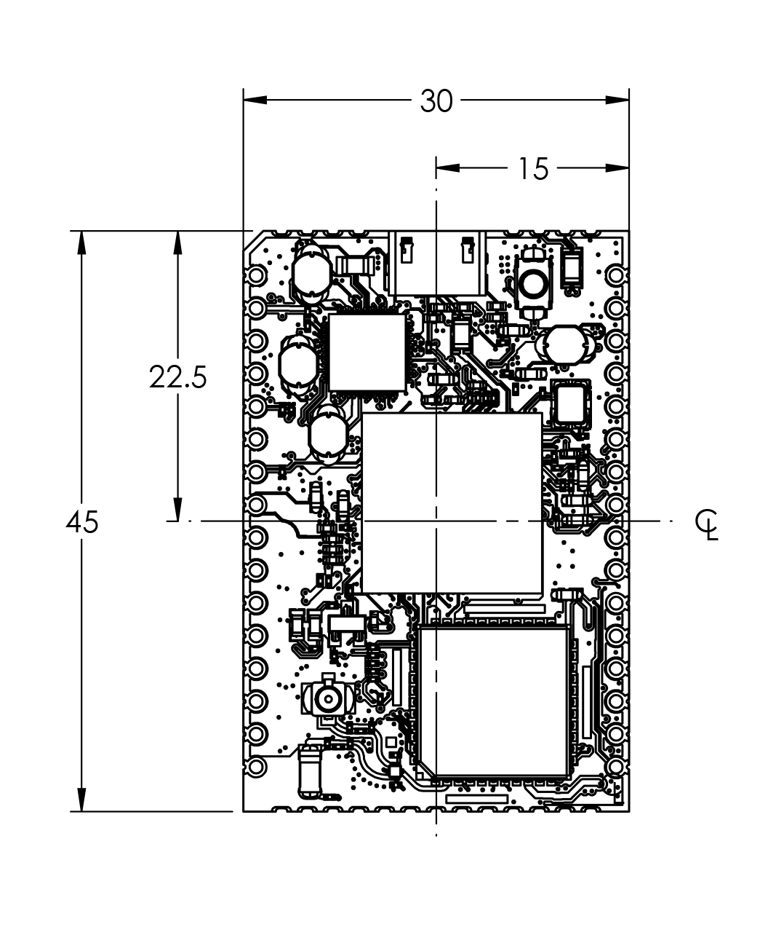

All measurements are in mm .

# Block Diagram

Figure 3.1 demonstrates a block diagram of C.H.I.P Pro.

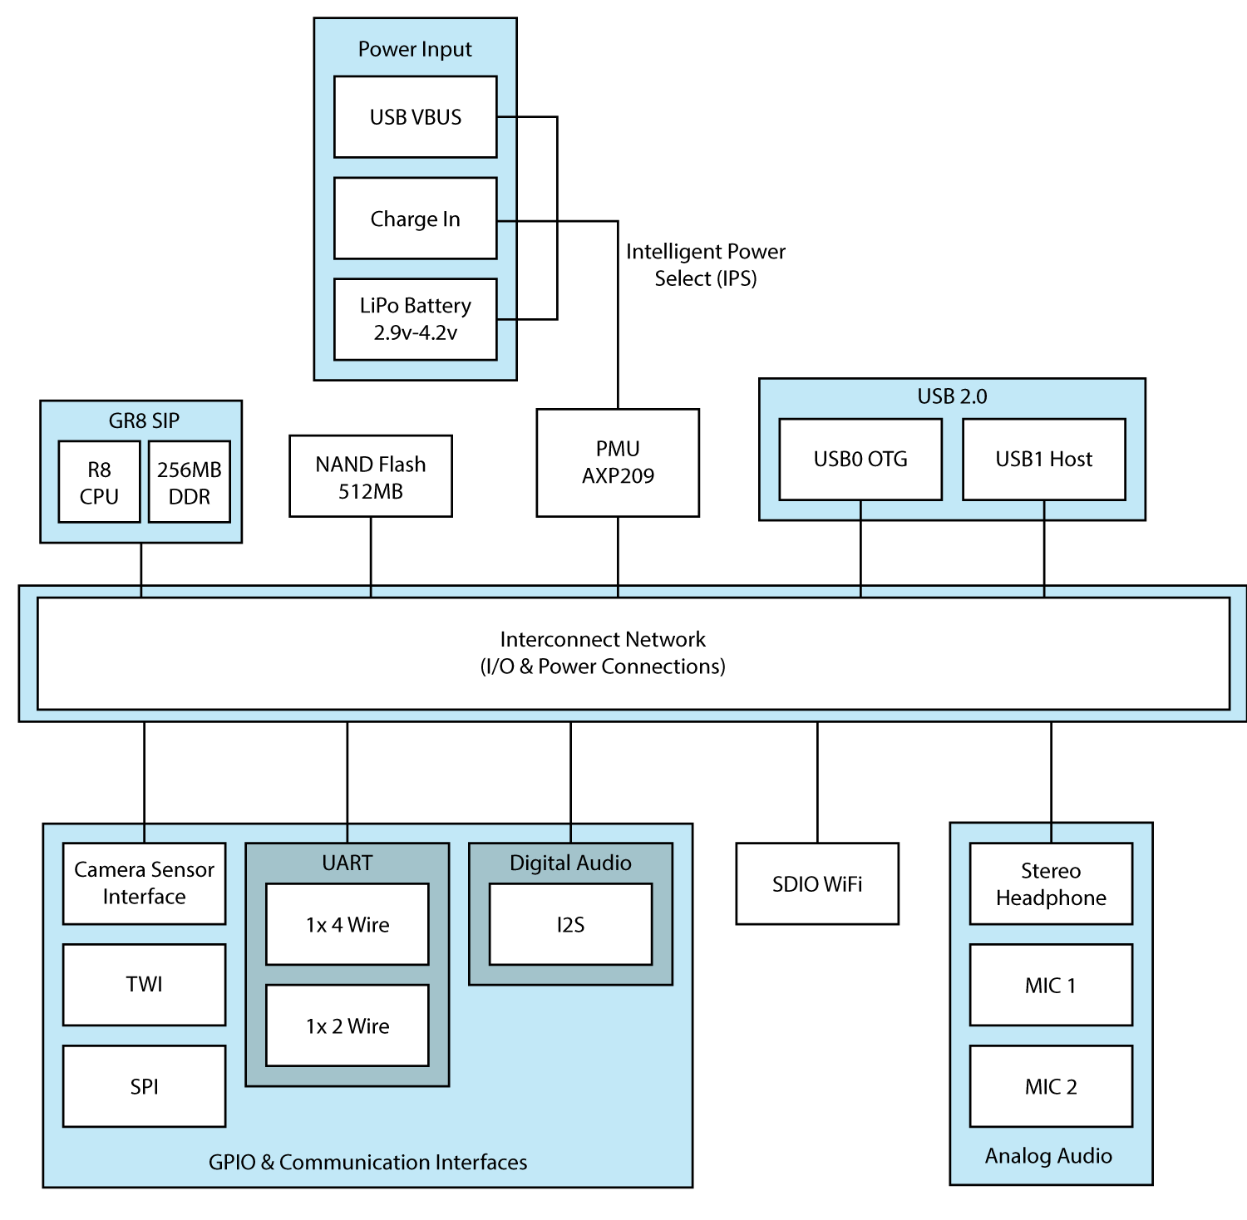

Figure 3.1:. C.H.I.P. Pro Block Diagram

Figure 3.2 shows a typical application diagram of C.H.I.P. Pro. A 3A 5V Switching Regulator Power Supply provides power to C.H.I.P. Pro via it’s Charge-In port. A power-button pulls the PWRON pin to ground to turn on the module.

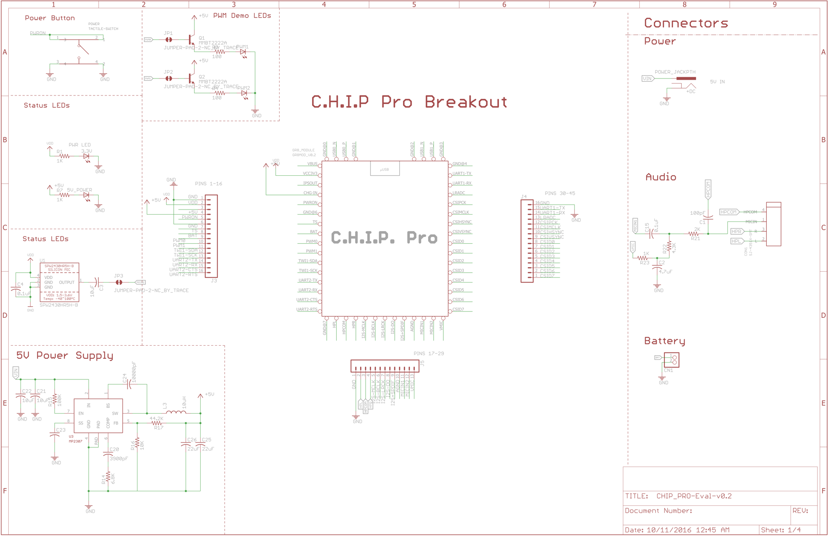

Figure 3.2: C.H.I.P. Pro Typical Application Diagram

# Pin Description

## Pin Characteristics

Table 4-1 lists the characteristics of C.H.I.P Pro pins from the following aspects: Pin Number, Pin Name, Type, Reset State, Default Pull Up/Down, and Buffer Strength.

1. **Pin Number:** Through-holes + Castellated Edges
2. **Pin Name**: Names of signals multiplexed on each pin No.
3. **Type:** Signal direction

I : Input

O: Output

I/O: Input / Output

A: Analog

AIO: Analog Input / Output

OD: Open Drain

P: Power

G: Ground

1. **Pin Reset State:** The state of the terminal at reset (power up)

Z: High-impedance

1. **Pull Up/Down:** Denotes the presence of an internal pull up or pull down resister

Pull up and pull down resistor can be enabled or disabled via software.

1. **Buffer Strength:** Drive strength of the associated output buffer.

Table 4‑1. Pin Characteristics

| **Pin #** | **Pin Name** | **Default Function** | **Type** | **Reset State** | **Default Pull Up/Down** | **Buffer Strength (mA)** |
| --- | --- | --- | --- | --- | --- | --- |
| **PORT B** | | | | | | |
| 9 | PB2 | GPIO | I/O | Z | NO PULL | 20 |
| 21 | PB5 | GPIO | I/O | Z | NO PULL | 20 |
| 22 | PB6 | GPIO | I/O | Z | NO PULL | 20 |
| 23 | PB7 | GPIO | I/O | Z | NO PULL | 20 |
| 24 | PB8 | GPIO | I/O | Z | NO PULL | 20 |
| 25 | PB9 | GPIO | I/O | Z | NO PULL | 20 |
| 12 | PB15 | GPIO | I/O | Z | NO PULL | 20 |
| 11 | PB16 | GPIO | I/O | Z | NO PULL | 20 |
| **PORT D** | | | | | | |
| 13 | PD2 | GPIO | I/O | Z | NO PULL | 20 |
| 14 | PD3 | GPIO | I/O | Z | NO PULL | 20 |
| 15 | PD4 | GPIO | I/O | Z | NO PULL | 20 |
| 16 | PD5 | GPIO | I/O | Z | NO PULL | 20 |
| **PORT E** | | | | | | |
| 41 | PE0 | GPIO | I/O | Z | NO PULL | 20 |
| 40 | PE1 | GPIO | I/O | Z | NO PULL | 20 |
| 39 | PE2 | GPIO | I/O | Z | NO PULL | 20 |
| 38 | PE3 | GPIO | I/O | Z | NO PULL | 20 |
| 37 | PE4 | GPIO | I/O | Z | NO PULL | 20 |
| 36 | PE5 | GPIO | I/O | Z | NO PULL | 20 |
| 35 | PE6 | GPIO | I/O | Z | NO PULL | 20 |
| 34 | PE7 | GPIO | I/O | Z | NO PULL | 20 |
| 33 | PE8 | GPIO | I/O | Z | NO PULL | 20 |
| 32 | PE9 | GPIO | I/O | Z | NO PULL | 20 |
| 31 | PE10 | GPIO | I/O | Z | NO PULL | 20 |
| 30 | PE11 | GPIO | I/O | Z | NO PULL | 20 |
| **PORT G** | | | | | | |
| 44 | PG3 | GPIO | I/O | Z | NO PULL | 20 |
| 43 | PG4 | GPIO | I/O | Z | NO PULL | 20 |
| **USB** | | | | | | |
| 52 | USB0-DM | - | A I/O | - | - | - |
| 51 | USB0-DP | - | A I/O | - | - | - |
| 48 | USB1-DM | - | A I/O | - | - | - |
| 47 | USB1-DP | - | A I/O | - | - | - |
| 50 | VCC-USB | - | P | - | - | - |
| **Audio Codec** | | | | | | |
| 26 | AGND | - | G | - | - | - |
| 19 | HPCOM | - | AO | - | - | - |
| 18 | HPL | - | AO | - | - | - |
| 20 | HPR | - | AO | - | - | - |
| 27 | MICIN1 | - | AI | - | - | - |
| 28 | MICIN2 | - | AI | - | - | - |
| 29 | VMIC | - | AO | - | - | - |
| **LRADC** | | | | | | |
| 42 | LRADC0 | - | AI | - | - | - |
| **Power** | | | | | | |
| 2 | VDD-3V3 | - | P | - | - | - |
| 4 | CHG-IN | - | P | - | - | - |
| 8 | BAT | - | P | - | - | - |
| **GND** | | | | | | |
| 1, 6, 17, 45, 46, 49, 50, 53 | GND | - | G | - | - | - |

## GPIO Multiplexing Functions

The following table provides a description of the GR8 GPIO multiplexing functions.

Table 4.2: Multiplexing Functions

|  |  |  |  |  |  |  |  |
| --- | --- | --- | --- | --- | --- | --- | --- |
| **Port** | **Multi0** | **Multi1** | **Multi2** | **Multi3** | **Multi4** | **Multi5** | **Multi6** |
| **Port B** | | | | | | | |
| PB2 | Input | Output | PWM0 |  |  |  | EINT16 |
| PB5 | Input | Output | I2S-MCLK |  |  |  | EINT19 |
| PB6 | Input | Output | I2S-BCLK |  |  |  | EINT20 |
| PB7 | Input | Output | I2S-LRCK |  |  |  | EINT21 |
| PB8 | Input | Output | I2S-DO |  |  |  | EINT22 |
| PB9 | Input | Output | I2S-DI |  |  |  | EINT23 |
| PB15 | Input | Output | TWI1-SCK |  |  |  |  |
| PB16 | Input | Output | TWI1-SDA |  |  |  |  |
| **Port D** | | | | | | | |
| PD2 | Input | Output | LCD-D2 | UART2-TX |  |  |  |
| PD3 | Input | Output | LCD-D3 | UART2-RX |  |  |  |
| PD4 | Input | Output | LCD-D4 | UART2-CTS |  |  |  |
| PD5 | Input | Output | LCD-D5 | UART2-RTS |  |  |  |
| **Port E** | | | | | | | |
| PE0 | Input |  |  | CSI-PCLK | SPI2-CS0 |  | EINT14 |
| PE1 | Input |  |  | CSI-MCLK | SPI2-CLK |  | EINT15 |
| PE2 | Input |  |  | CSI-HSYNC | SPI2-MOSI |  |  |
| PE3 | Input | Output |  | CSI-VSYNC | SPI2-MISO |  |  |
| PE4 | Input | Output |  | CSI-D0 | SDC2-D0 |  |  |
| PE5 | Input | Output |  | CSI-D1 | SDC2-D1 |  |  |
| PE6 | Input | Output |  | CSI-D2 | SDC2-D2 |  |  |
| PE7 | Input | Output |  | CSI-D3 | SDC2-D3 |  |  |
| PE8 | Input | Output |  | CSI-D4 | SDC2-CMD |  |  |
| PE9 | Input | Output |  | CSI-D5 | SDC2-CLK |  |  |
| PE10 | Input | Output |  | CSI-D6 | UART1-TX |  |  |
| PE11 | Input | Output |  | CSI-D7 | UART1-RX |  |  |
| **Port G** | | | | | | | |
| PG3 | Input | Output | SDC1-CMD |  | UART1-TX |  | EINT3 |
| PG4 | Input | Output | SDC1-CLK |  | UART1-RX |  | EINT4 |
| PG13 | Input | Output |  | PWM1 |  |  | EINT13 |

***Note:*** PE0/PE1/PE2 are for input only.

## Detailed Pin/Signal Description

Table 4.3 shows the detailed function of every pin/signal based on the different interface.

Table 4.3: Detailed Pin/Signal Description

| **Pin/Signal Name** | **Description** | **Type** |
| --- | --- | --- |
| **TWI – Two Wire Interface** | | |
| TWI1-SCK | TWI1 Clock | I/O |
| TWI1-SDA | TWI1 Data/Address | I/O |
| **PWM – Pulse Width Modulation** | | |
| PWM0 | Pulse Width Module Channel0 Output | O |
| PWM1 | Pulse Width Module Channel1 Output | O |
| **I2S – Inter-IC Sound** | | |
| I2S-MCLK | I2S Master Clock | O |
| I2S-BCLK | I2S Bit Clock | I/O |
| I2S-LRCK | I2S Left/Right Channel Select Clock | I/O |
| I2S-DO | I2S Data Output | O |
| I2S-DI | I2S Data Input | I |
| **OWA – One Wire Audio** | | |
| OWA-DO | OWA Data Output | O |
| **SPI – Serial Peripheral Interface** | | |
| SPI2-CS0 | SPI0 Chip Select Signal (active low) | I/O |
| SPI2-CLK | SPI0 Clock Signal | I/O |
| SPI2-MISO | SPI0 Master Data In, Slave Data Out | I/O |
| SPI2-MOSI | SPI0 Master Data Out, Slave Data In | I/O |
| **UART – Universal Asynchronous Receiver/Transmitter** | | |
| UART1-TX | UART0 Data Transmit | O |
| UART1-RX | UART0 Data Receive | I |
| UART2-TX | UART1 Data Transmit | O |
| UART2-RX | UART1 Data Receive | I |
| UART2-CTS | UART1 Data Clear to Send | I |
| UART2-RTS | UART1 Data Request to Send | O |
| **CSI – Camera Sensor Interface** | | |
| CSI-PCLK | CSI Pixel Clock | I |
| CSI-MCLK | CSI Master Clock | O |
| CSI-HSYNC | CSI Horizontal Sync | I |
| CSI-VSYNC | CSI Vertical Sync | I |
| CSI-Data[7:0] | CSI Data Bit | I |
| **SD/MMC** | | |
| SDC2-D[3:0] | SDC2 Data Bit [3:0] | I/O |
| SDC2-CLK | SDC2 Clock | O |
| SDC2-CMD | SDC2 Command Signal | I/O |
| **External Interrupt** | | |
| EINT[3,4,13,19,24] | External Interrupt Input | I |
| **USB** | | |
| USB0-DM | USB0 D- Signal | A I/O |
| USB0-DP | USB0 D+ Signal | A I/O |
| USB1-DM | USB1 D- Signal | A I/O |
| USB1-DP | USB1 D+ Signal | A I/O |
| VCC-USB | USB Power Supply | P |
| **Audio Codec** | | |
| AGND | Audio Codec Analog Ground | G |
| HPCOM | Headphone Common Reference Output | AO |
| HPL | Headphone Left Channel Output | AO |
| HPR | Headphone Right Channel Output | AO |
| MICIN1 | Microphone Input | AI |
| MICIN2 | Microphone Input | AI |
| VMIC | Bias Voltage Output for Main Microphone | AO |
| **LRADC – Low Resolution Analog-to-Digital Converter** | | |
| LRADC0 | ADC Input for Channel 0 for Multi-Button Input | AI |

# Electrical Characteristics

## Absolute Maximum Ratings

The absolute maximum ratings are those values beyond which damage to the device may occur. Table 5-1 specifies the absolute maximum ratings over the operating junction temperature range of commercial temperature devices. Functional operation of the device at these or any other conditions beyond those indicated in the operational sections of this standard may cause damage to the device.

Table 5.1: Absolute Maximum Ratings

|  |  |  |  |  |  |
| --- | --- | --- | --- | --- | --- |
| **Symbol** | **Parameter** | | **Min** | **Max** | **Unit** |
| II/O | In/Out Current for Input and Output | | -40 | 40 | mA |
| CHG-IN | Supply Voltage for Charge-In | | -0.3 | 6.0 | V |
| BAT | Supply Voltage for Battery-in | | -0.3 | 4.2 | V |
| VBus | Supply Voltage for Vbus | | -0.3 | 5.0 | V |
| TSTG | Storage Temperature | | -40 | 125 | °C |
| VESD | Electrostatic Discharge | Human Body Model(HBM)(1) | -4000 | 4000 | V |
| Charged Device Model(CDM)(2) | -500 | 500 | V |
| ILatch-up | Latch-up I-test performance current-pulse injection on each IO pin(3) | | Pass | | |
| Latch-up over-voltage performance voltage injection on each IO pin(4) | | Pass | | |

1). Test method: JEDEC JS-001-2014(Class-3A). JEDEC document JEP155 states that 500V HBM allows safe manufacturing with a standard ESD control process.

2). Test method: JEDEC JS-002-2014(Class-C2A). JEDEC document JEP157 states that 250V CDM allows safe manufacturing with a standard ESD control process.

3). Current test performance: Pins stressed per JEDEC JESD78D(Class I, Level A) and passed with I/O pin injection current as defined in JEDEC.

4). Over voltage performance: Supplies stressed per JEDEC JESD78D(Class I, Level A) and passed voltage injection as defined in JEDEC.

## Recommended Operating Conditions

All C.H.I.P Pro modules are used under the operating conditions contained in Table 5-2.

Table 5.2: Recommended Operating Conditions

|  |  |  |  |  |  |
| --- | --- | --- | --- | --- | --- |
| **Symbol** | **Parameter** | **Min** | **Typ** | **Max** | **Unit** |
| Ta | Ambient Operating Temperature | 0 | - | +70 | °C |
| CHG-IN | Supply Voltage for Charge Input | 4.8 | 5~5.5 | 6.0 | V |

## DC Electrical Characteristics

Table 5.3 summarizes the DC electrical characteristics of C.H.I.P Pro.

Table 5.3: DC Electrical Characteristics

|  |  |  |  |  |  |
| --- | --- | --- | --- | --- | --- |
| **Symbol** | **Parameter** | **Min** | **Typ** | **Max** | **Unit** |
| VIH | High-Level Input Voltage | 0.7 * VCC-IO | - | VCC-IO + 0.3 | V |
| VIL | Low-Level Input Voltage | -0.3 | - | 0.3 * VCC-IO | V |
| RPU | Input Pull-up Resistance | 50 | 100 | 150 | KΩ |
| RPD | Input Pull-down Resistance | 50 | 100 | 150 | KΩ |
| IIH | High-Level Input Current | - | - | 10 | uA |
| IIL | Low-Level Input Current | - | - | 10 | uA |
| VOH | High-Level Output Voltage | VCC-IO -0.2 | - | VCC-IO | V |
| VOL | Low-Level Output Voltage | 0 | - | 0.2 | V |
| IOZ | Tri-State Output Leakage Current | -10 | - | 10 | uA |
| CIN | Input Capacitance | - | - | 5 | pF |
| COUT | Output Capacitance | - | - | 5 | pF |

## Power Consumption Summary

At the time of this document's publication we are still testing the C.H.I.P. Pro power consumption. For the latest document version, please see our git repository at TKTK.

## Oscillator Electrical Characteristics

C.H.I.P. Pro contains a single 24.000MHz oscillator.

The 24.000MHz frequency is used to generate the main source clock for PLL and the main digital blocks, the clock is provided through X24MIN. Table 5-4 lists the 24.000MHz crystal specifications.

Table 5.4: 24MHz Crystal Characteristics

|  |  |  |  |  |  |
| --- | --- | --- | --- | --- | --- |
| **Symbol** | **Parameter** | **Min** | **Typ** | **Max** | **Unit** |
| 1/(tCPMAIN) | Crystal Oscillator Frequency Range | - | 24.000 | - | MHz |
| tST | Startup Time | - | - | - | ms |
|  | Frequency Tolerance at 25 °C | -50 | - | +50 | ppm |
|  | Oscillation Mode | Fundamental | | | – |
|  | Maximum Change Over Temperature Range | -50 | - | +50 | ppm |
| PON | Drive Level | - | - | 300 | uW |
| CL | Equivalent Load Capacitance | 12 | 18 | 22 | pF |
| RS | Series Resistance(ESR) | - | 25 | - | Ω |
|  | Duty Cycle | 30 | 50 | 70 | % |
| CM | Motional Capacitance | - | - | - | pF |
| CSHUT | Shunt Capacitance | 5 | 6.5 | 7.5 | pF |
| RBIAS | Internal Bias Resistor | 0.4 | 0.5 | 0.6 | MΩ |

## Power Up/Down and Reset Specifications

Power up and power down sequence requirements for the GR8 SiP are handled by the on-board Power System provided by the AXP209 PMU and companion switching regulators.

# Pin Assignment

## Pin Map

The following pin map demonstrates the alternate pin mux configurations possible in a top view of the C.H.I.P. Pro.

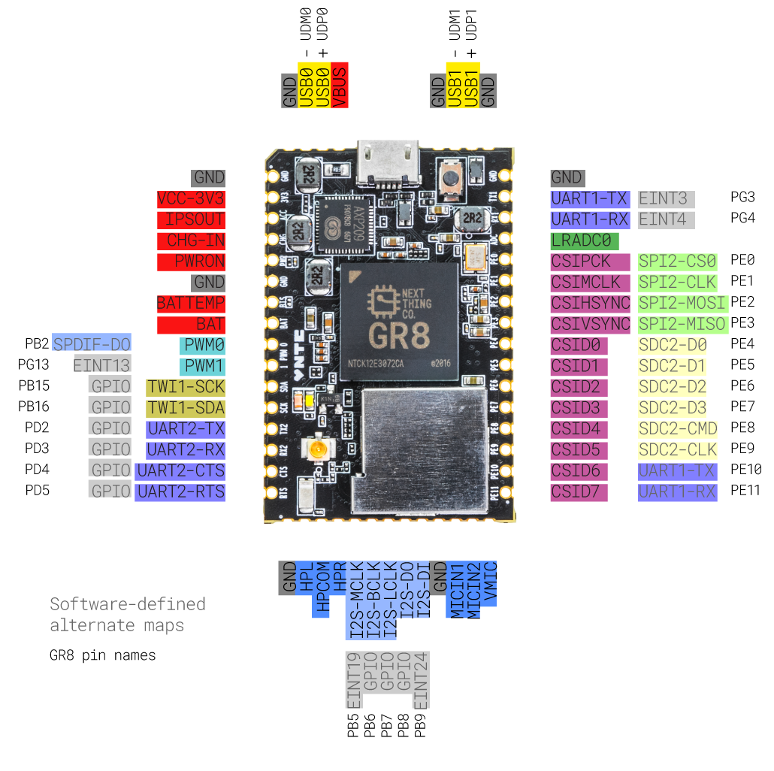

# Mechanical and Packaging Information

The following diagram shows the package specification of C.H.I.P. PRO including the top, bottom, side views and details of the 45 mm x 30 mm SoM.

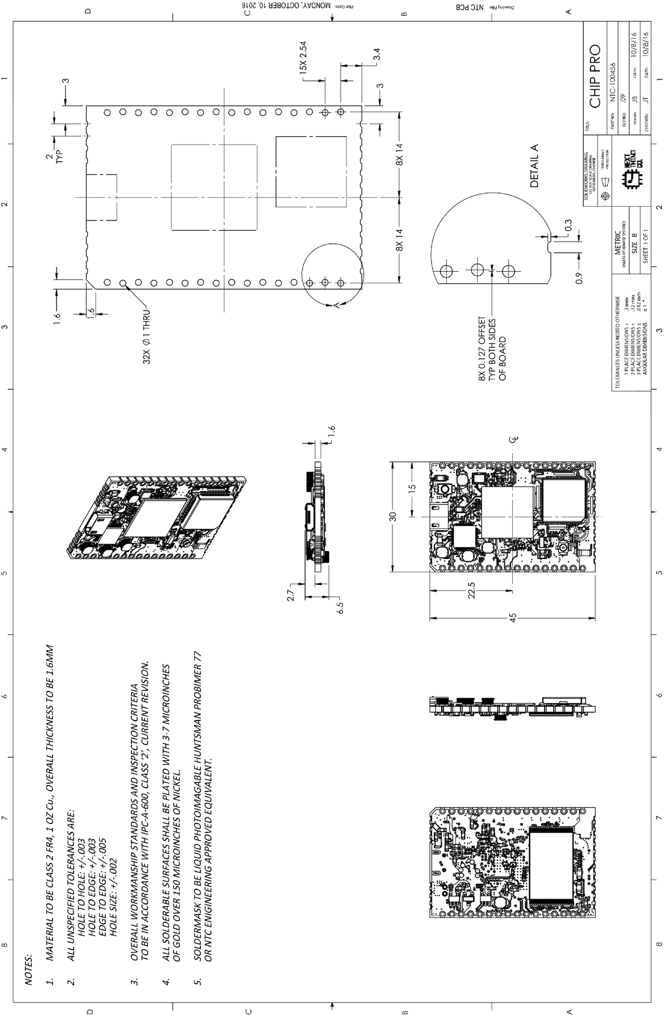

## Recommended PCB Footprint

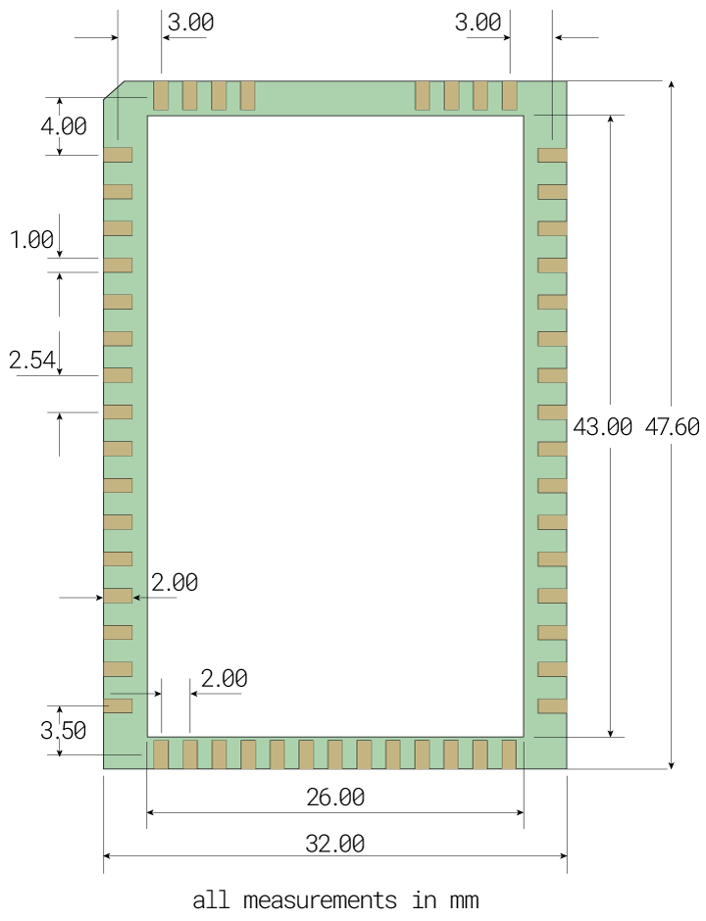

# Schematic

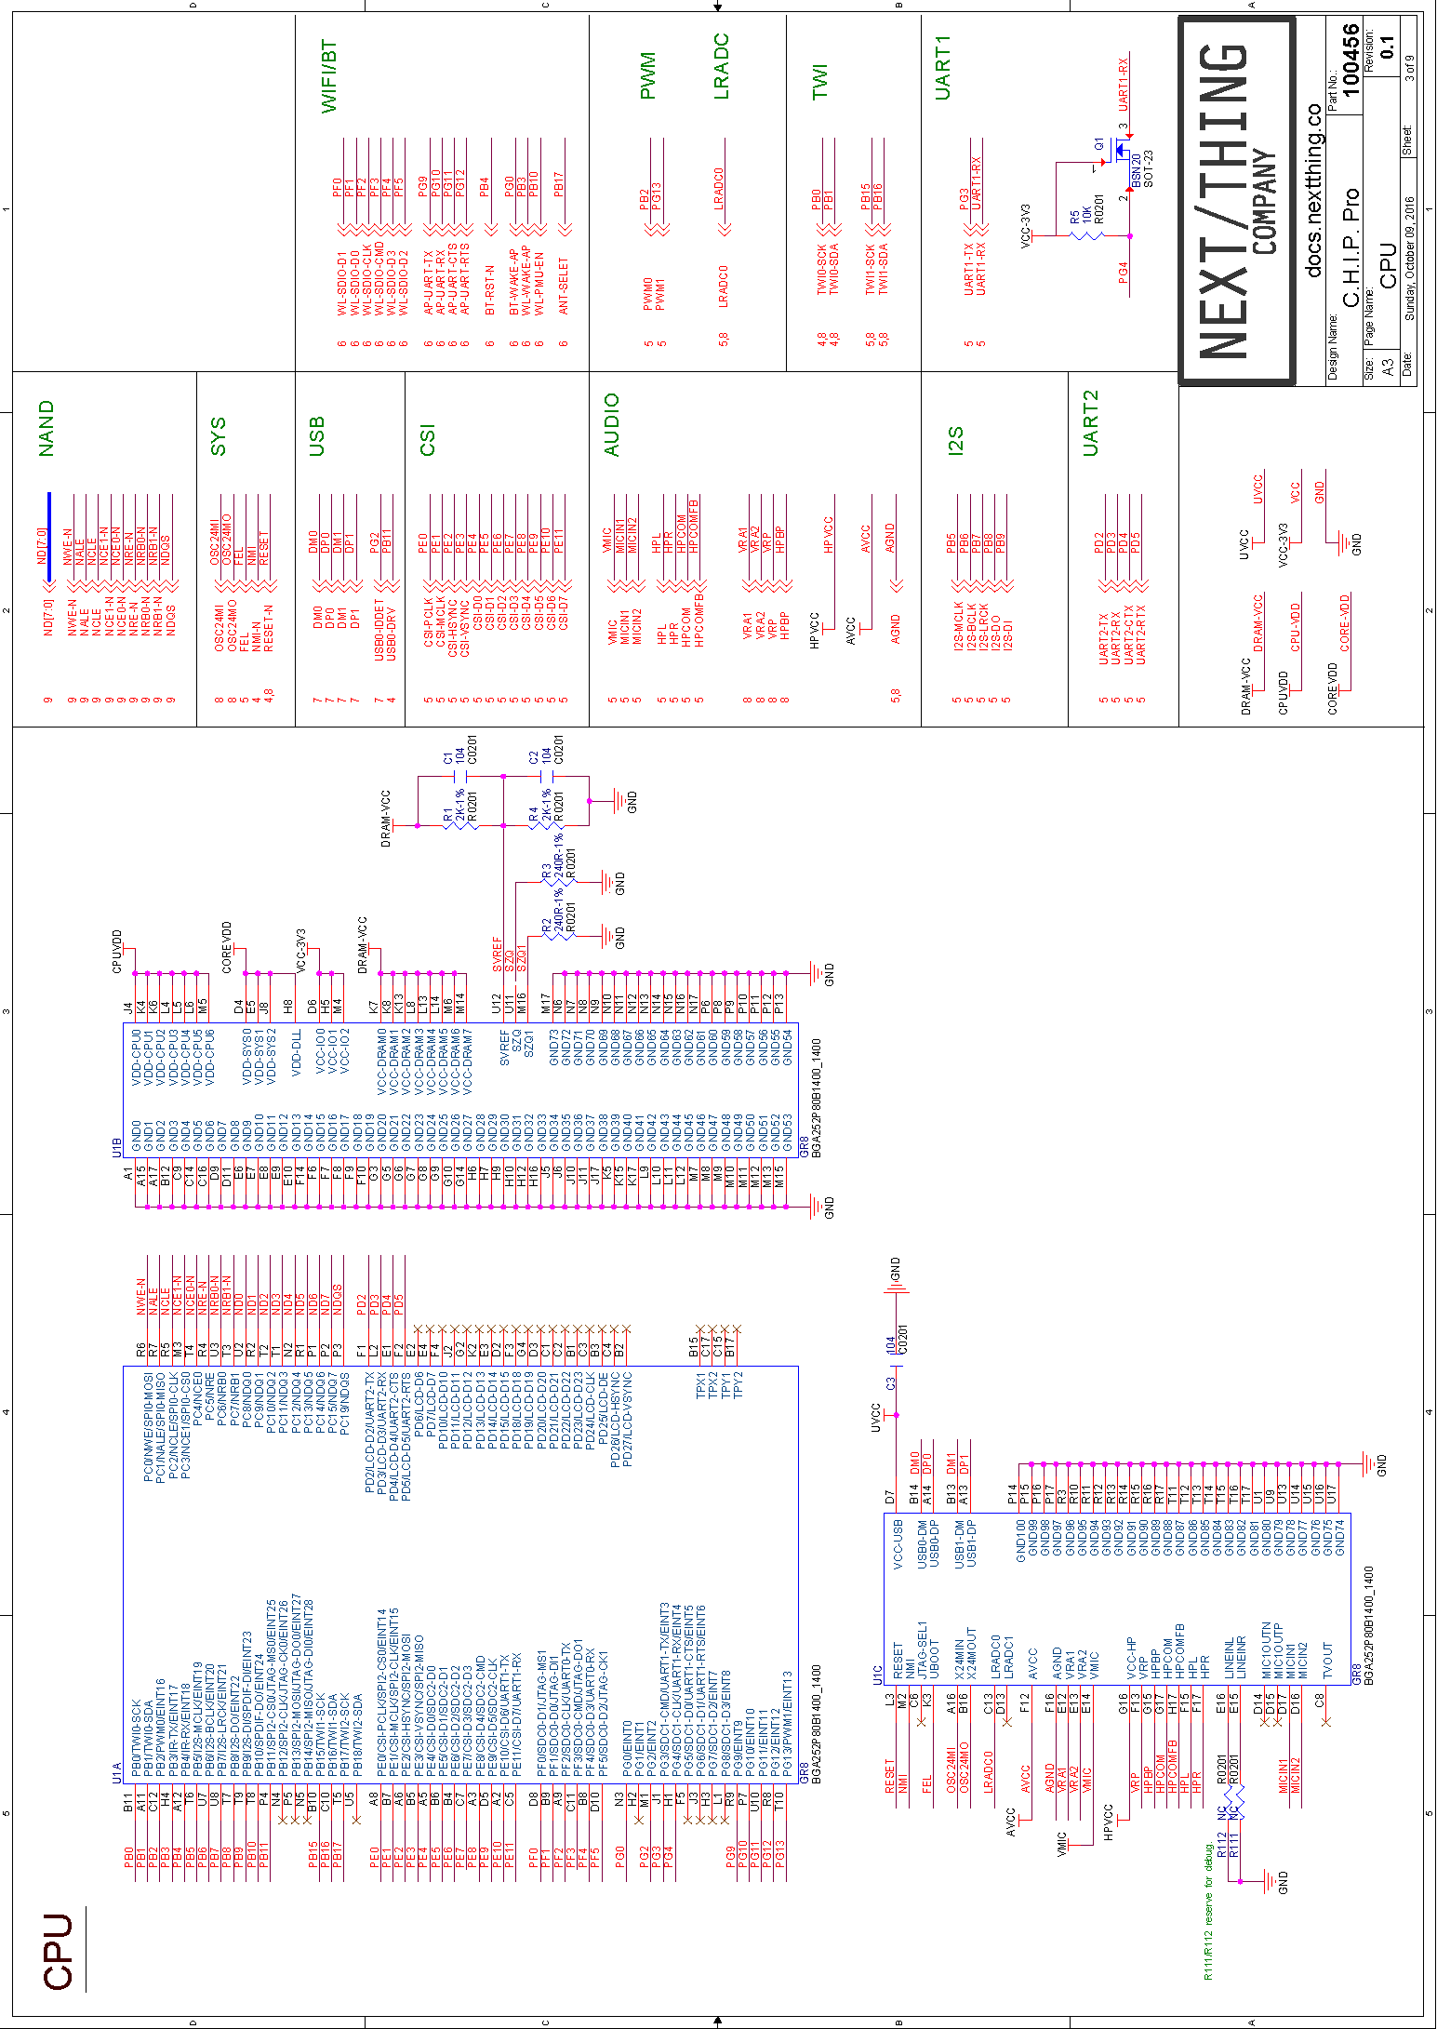

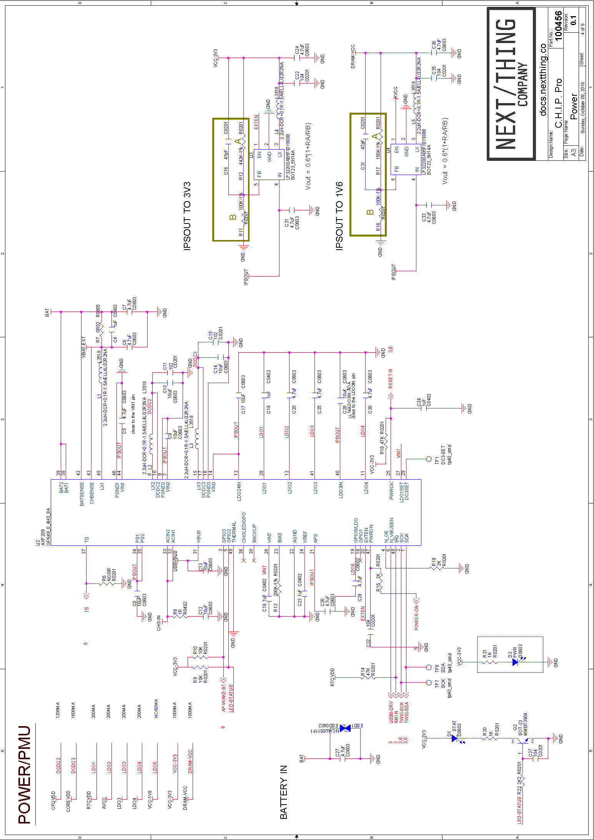

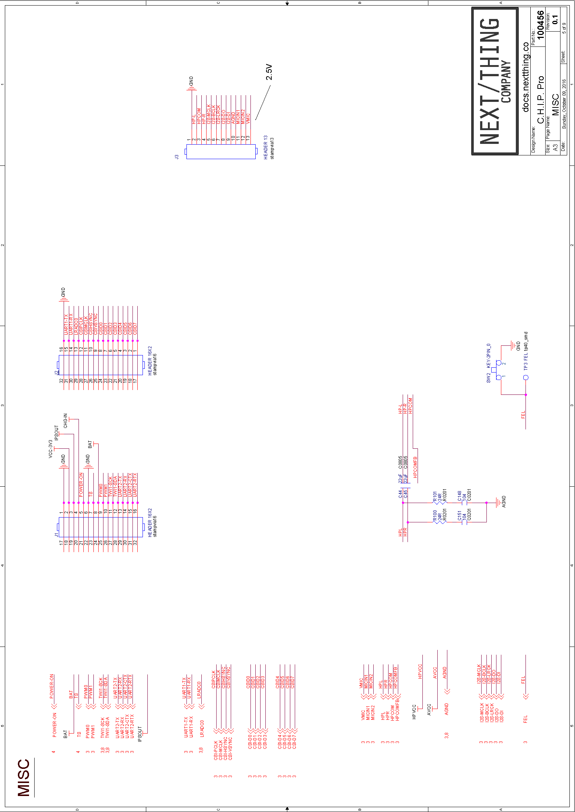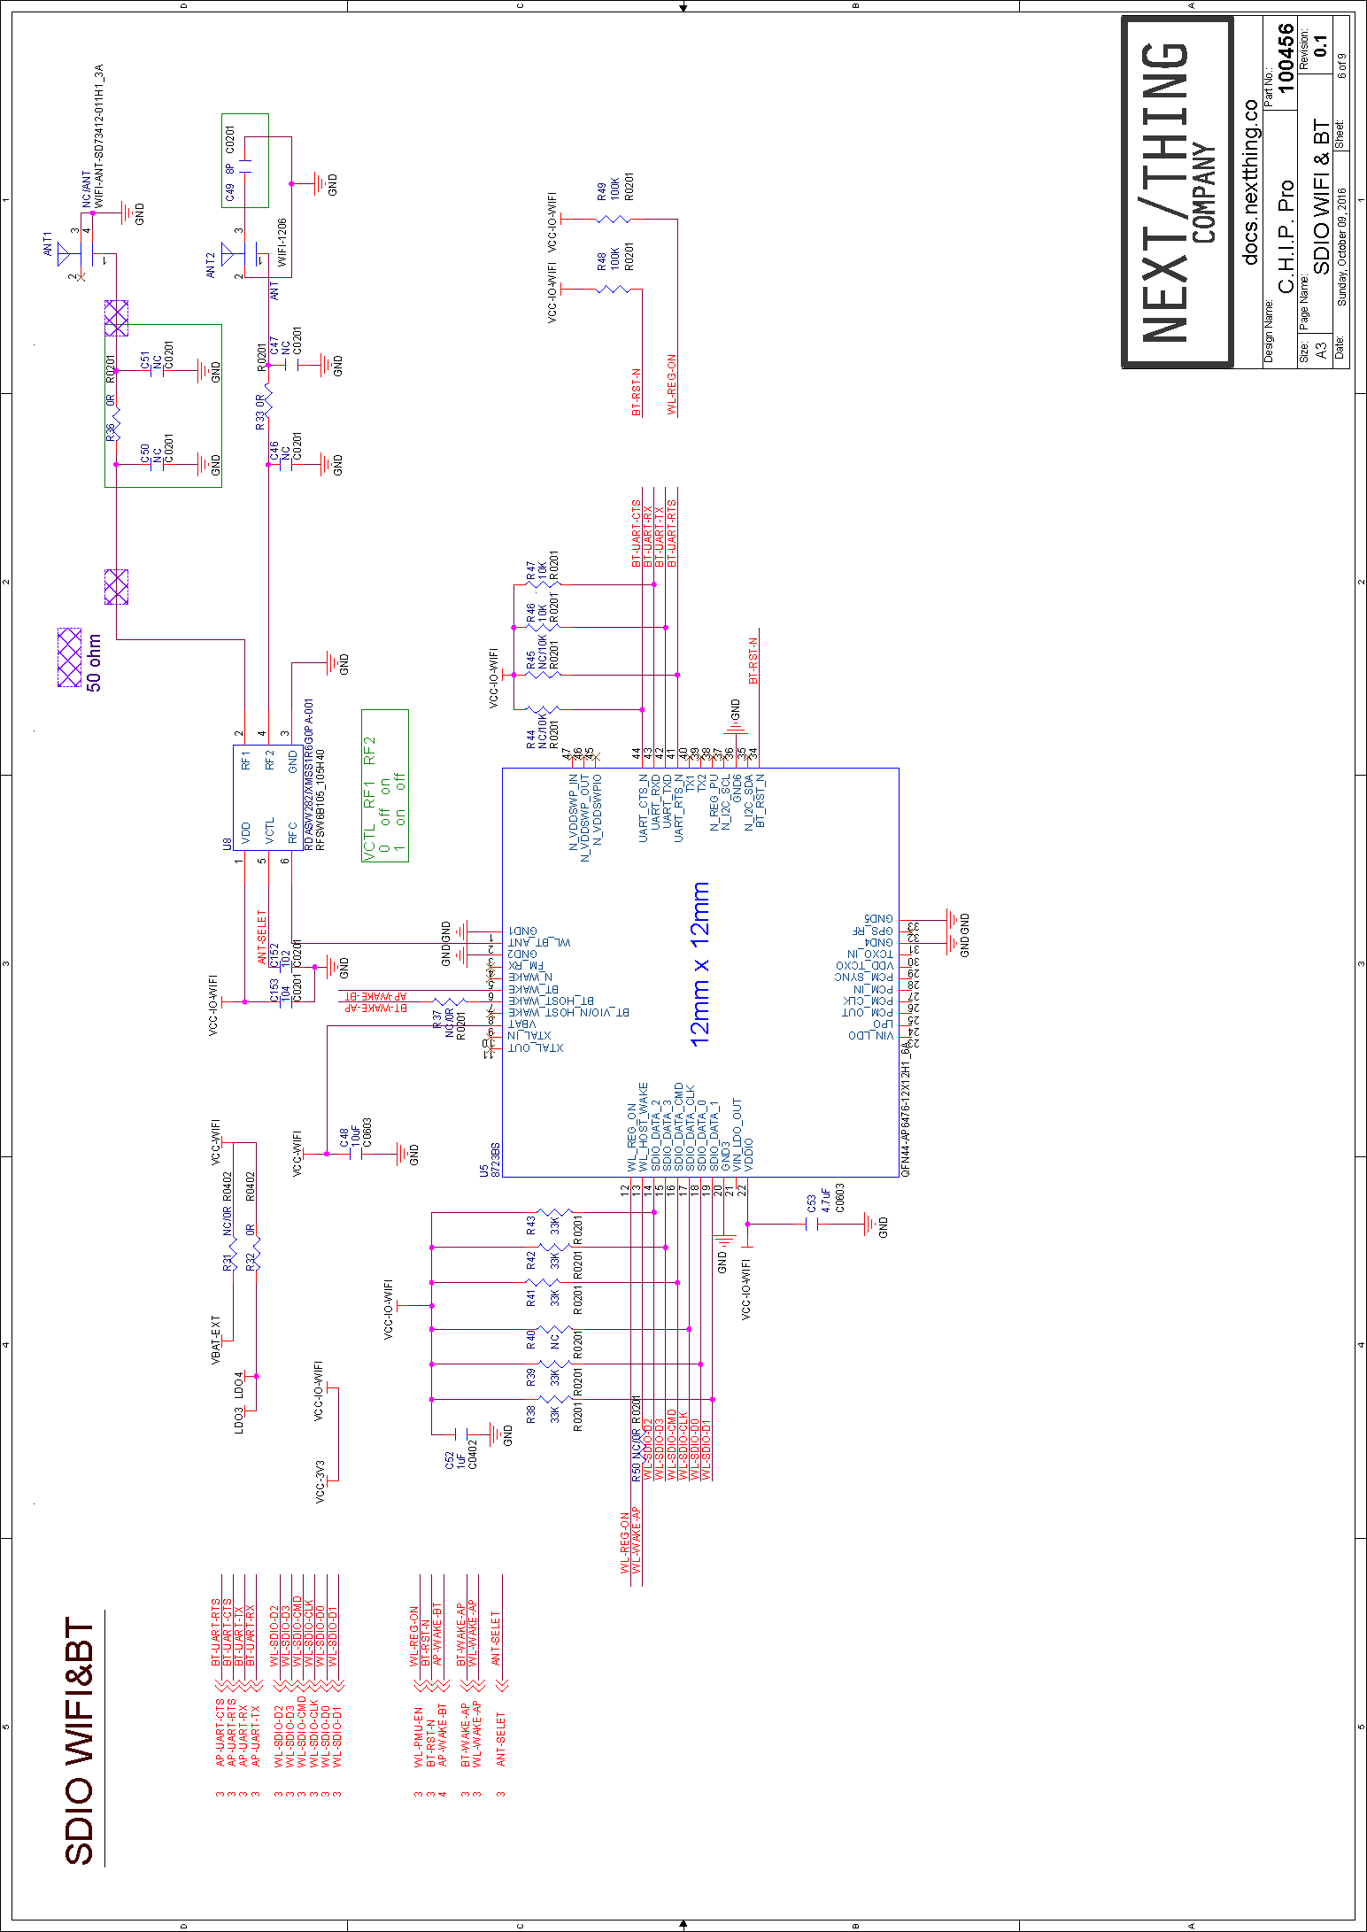

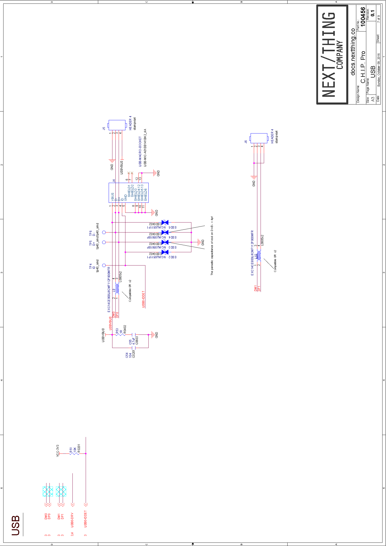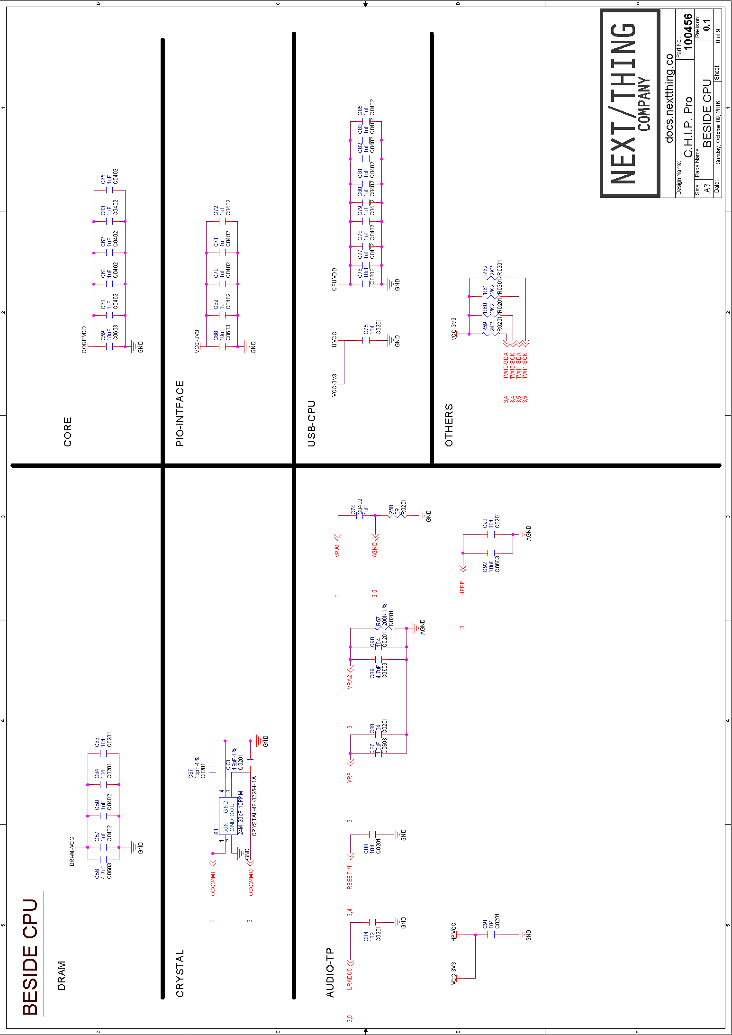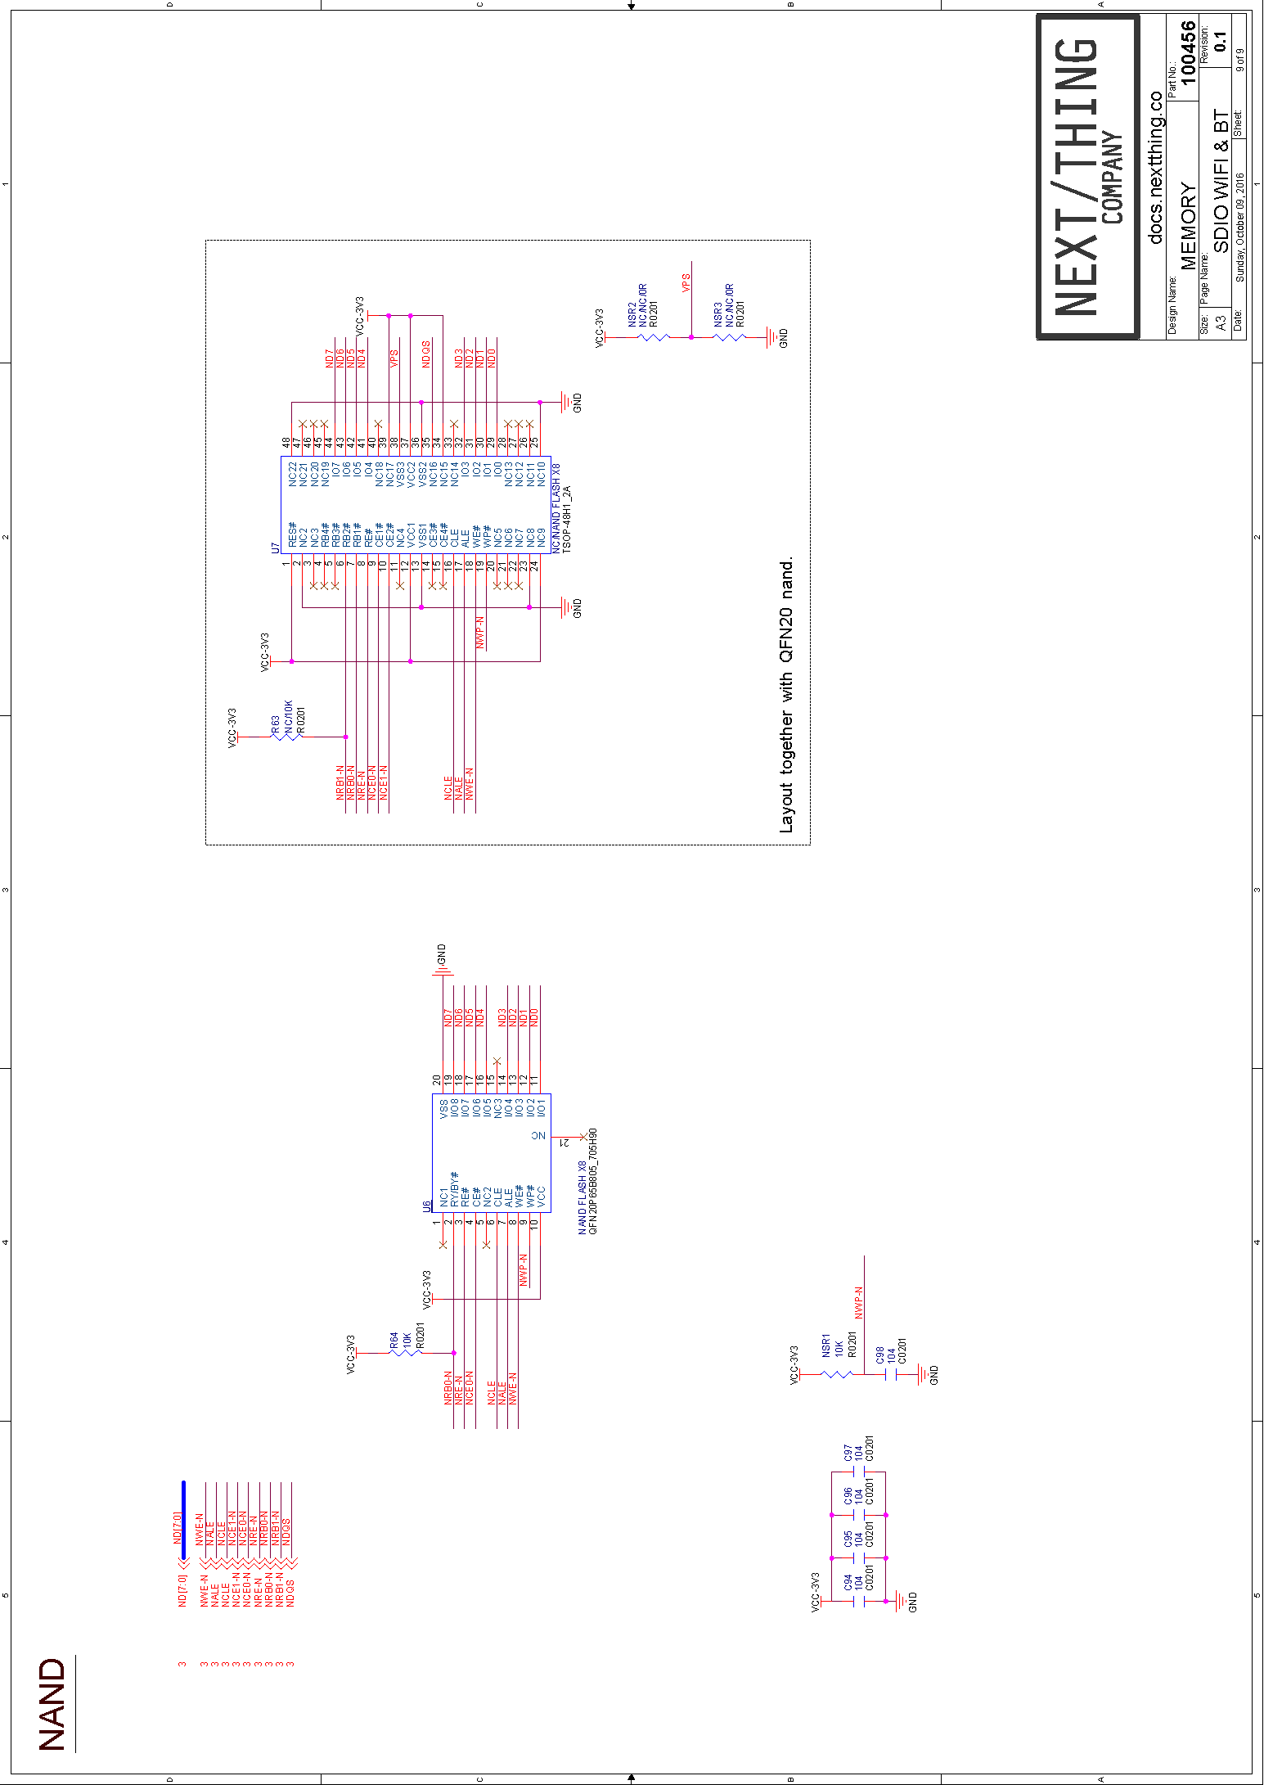

Copyright © 2016 Next Thing Co. All Rights Reserved.

**Join the discussion @** <http://bbs.nextthing.co/c/CHIP-Pro>

**Contact Us**

Sales:

[Sales@NextThing.co](mailto:Sales@NextThing.co)

Technical Questions:

[Hardware@NextThing.co](mailto:Hardware@NextThing.co)

www.getchip.com