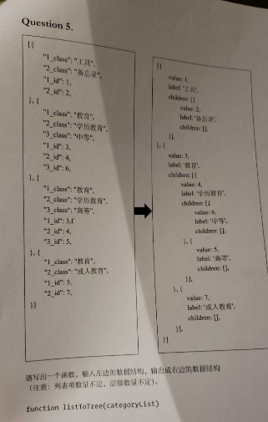

请仔细分析，给出思路和代码

**<?php***/**  
 * Created by PhpStorm.  
 * User: guoju  
 * Date: 2018/12/18  
 * Time: 10:29  
 */*$a = [  
 [  
 **'1_class'**=>**'工具'**,  
 **'2_class'**=>**'备忘录'**,  
 **'1_id'**=>1,  
 **'2_id'**=>2,  
 **'3_id'**=>3,  
 **'3_class'**=>**'hello'** ],  
 [  
 **'1_class'**=>**'aaa'**,  
 **'2_class'**=>**'bbb'**,  
 **'1_id'**=>1,  
 **'2_id'**=>2,  
 **'3_id'**=>3,  
 **'3_class'**=>**'ccc'** ]  
];  
  
$r = [];  
**foreach** ($a **as** $k => $aa) {  
 $r = listtotree($aa);  
}  
$rr = *json_encode*($r);  
  
**function** listtotree($a){  
 $arr = [];  
 **foreach** ($a **as** $k => $v) {  
 $d = *explode*(**'_'**,$k);  
 **if** ($d[1]==**'id'**){  
 $arr[$d[0]][**'value'**] = $v;  
 } **elseif**($d[1]==**'class'**){  
 $arr[$d[0]][**'label'**] = $v;  
 }  
 $arr[$d[0]][**'pid'**]= $d[0]-1;  
 }  
  
 *ksort*($arr);  
 $result = digui($arr, 0);  
 **return** $result;  
}  
  
**function** digui($a, $pid){  
 $result = [];  
 **foreach** ($a **as** $k => $v) {  
 **if** ($v[**'pid'**]==$pid){  
 **unset**($v[**'pid'**]);  
 $v[**'children'**] = digui($a, $k);  
 $result[] = $v;  
 }  
 }  
 **return** $result;  
}