Auditing OlmoEarth Inference Quality Without Labels
First experiments. 2026-08-31. Repo: olmoearth_inferenceX (experimental).

1. Problem
OlmoEarth fine-tuned models produce predictions over regions where no ground-truth labels exist. Supervised eval metrics cannot say anything there. The goal of this project is an audit signal: take an inference output and rank where it is most likely wrong, with the evidence attached. The output is a ranked list of suspect windows and risk-coverage curves, not a single accuracy number, because trustworthiness has no universal ground truth to certify against.

2. Approach
The LLM community has spent several years on the same problem under the name hallucination detection: judging outputs with no reference answer. Those techniques mostly do not depend on language, so they should port to earth observation, the same way the RoPE fix in OlmoEarth v1.2 ported an LLM mechanism to fix the v1 striping artifact.
Signal | LLM technique it ports | OlmoEarth mechanism
Model disagreement | Self-consistency / SelfCheckGPT (Manakul et al., EMNLP 2023) | Nano, Tiny and Base predictions diverge on suspect windows
Perturbation stability | Semantic entropy (Farquhar et al., Nature 2024) | Tile-grid phase shifts; catches positional artifacts such as the v1 striping
Geographic grounding | Retrieval-grounded fact checking | Predictions checked against reference river centerlines (GRIT, GRWL, OSM)
Embedding dissimilarity | Internal-state probing (INSIDE; semantic entropy probes) | Distance from training distribution in embedding space; no reruns needed

Two rules keep the audit honest. First, the signals are validated on partner projects that do have labels, then run where labels do not exist; labels grade the signals but never train them. Second, every ranking is compared against the max-softmax confidence of the model itself, since any technique that cannot beat the model's own confidence is not worth shipping.

3. Setup
- Models: OlmoEarth v1 Nano (128-d) and Base (768-d), public HuggingFace checkpoints, CPU inference, patch size 4. All v1 / v1_1 / v1_2 checkpoints are public, so multi-model and cross-version comparisons need no infrastructure.
- Imagery: single Sentinel-2 L2A scenes from Planetary Computer, dry season 2024, under 5% cloud, 128x128 pixel windows at 10 m.
- Weak truth: ESA WorldCover 2021 water class, pooled to the patch grid.
- Reference geography: OSM waterway centerlines.

4. Experiment 1: where do two models disagree?
Nano and Base embeddings over the Zambezi at Kazungula. For each patch, the local cosine-similarity structure of the two models is correlated: high correlation means both models represent the patch and its neighborhood the same way. Calibration first: on pure random input the mean agreement is 0.59, not 0, because the models share patchification and normalization. All agreement numbers must be read against that floor.
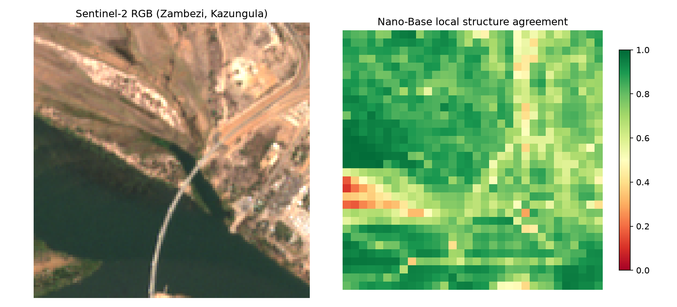
Figure 1. Sentinel-2 RGB at Kazungula (left) and Nano-Base local structure agreement (right). Open water agrees at 0.9+; disagreement concentrates on the shoreline and traces the bridge.
Disagreement is not noise. It clusters at boundaries and thin structures, which is where segmentation errors live. Mean agreement 0.78 against the 0.59 floor.

5. Experiment 2: the full audit slice
Every stage of the audit pipeline, each at minimal depth. Water heads (logistic regression on frozen embeddings) trained at Katima Mulilo, evaluated at Kazungula, about 110 km away, so the split is spatial. Signals computed on the eval window: model disagreement (absolute difference of the two water probabilities), geographic grounding (OSM centerline patches that both models predict dry), and the max-softmax baseline. All scored against WorldCover via risk-coverage.
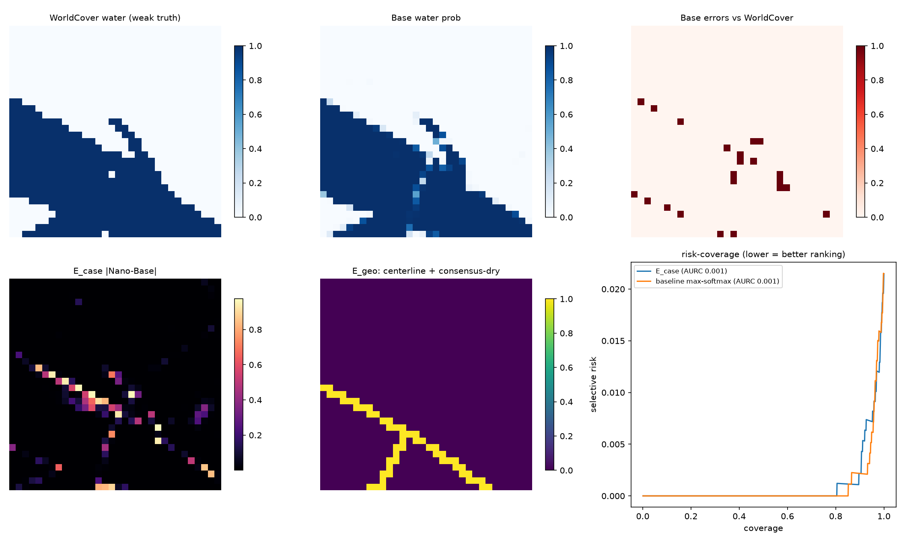
Figure 2. Full slice at Kazungula: weak truth, Base prediction, errors, disagreement map, centerline check, and risk-coverage curves.
Metric | Value | Note
Nano head accuracy at eval AOI | 0.973 | vs WorldCover
Base head accuracy at eval AOI | 0.979 | vs WorldCover
Base overall error rate | 0.021
AURC, model disagreement signal | 0.0011 | lower is better
AURC, max-softmax baseline | 0.0009 | baseline wins here
Centerline patches / consensus-dry | 52 / 0 | no false break alarms

6. Findings
- Spatial transfer works: heads trained 110 km away reach 97-98% accuracy on a distinct reach of the river.
- Prediction disagreement visibly traces the shoreline, consistent with the boundary-tracking seen at embedding level.
- The geographic check is clean on an easy scene: 52 centerline patches, zero false break alarms.
- The honest headline: on an easy dry-season scene with a 400 m river, the max-softmax baseline slightly beats the disagreement signal (AURC 0.0009 vs 0.0011). The model's own confidence is sufficient when the task is easy. The audit signals must earn their keep on hard cases: narrow channels, flood-season wetland margins, and correlated errors that confidence cannot see. That is the next experiment, and building the baseline in from day one is what makes the comparison trustworthy.
- Part of the residual error is weak-truth drift (2021 labels vs 2024 scene, moving sandbars), not model error.

7. Next steps
- A deliberately hard scene: sub-patch river width or flood-season Barotse floodplain, where the baseline should fail first.
- Add Tiny for a three-model disagreement signal.
- v1 vs v1_2 comparison on identical windows (positional-artifact signal).
- Confirm whether tiled inference exports keep per-class probabilities or argmax only; the disagreement signals gain power with probabilities.

