Locating Errors in OlmoEarth Probe Predictions Without Labels
Experiments exp01-exp25 with post-audit corrections, the Sen1Floods11 expert-label result, Ai2's fine-tuned AWF model run end to end, assessments of a served production output, and three tests of the reference-error reading. 2026-09-02. Repository: github.com/2imi9/olmoearth_inferenceX. Standing record: docs/TECHNIQUES.md and docs/results/.

1. Problem and scope
Earth observation models are applied to regions without labels, where supervised evaluation says nothing. This work asks whether the windows where a prediction is wrong can be ranked without labels. The audited predictors are linear probes on frozen OlmoEarth v1 encoders: a binary water head trained on one WorldCover-labelled 128x128 Sentinel-2 scene at Katima Mulilo, and a nine-class head on the AWF expert labels. Ai2's published fine-tuned AWF model is run end to end in section 3.8, and one served output, the published land cover change rasters, is assessed as served in section 3.7. The output is a ranked audit scored by risk-coverage curves; section 3.8 also states accuracy with its coverage and calibration.

2. Signals and protocol
- E_case, cross-model disagreement: two models (OlmoEarth v1 Nano and Base) predict the same window differently.
- E_system, tiling instability (tile-phase in the scripts): the prediction changes when the input grid is shifted by one to three pixels; shifted maps are aligned on a pixel canvas before comparison.
- E_dist, embedding distance: mean cosine distance from a window's embedding to the five nearest patches of the head's training scene. This is distance to the training scene, not to the encoder's pretraining data.
- E_geo, map check: the patch lies on an OSM river centerline and the model predicts dry.
In machine-learning terms the evaluation is selective prediction. Each signal gives every 40 m patch a suspicion score. AURC (area under the risk-coverage curve) is the error rate among accepted patches, averaged over acceptance levels as patches are accepted in order of increasing suspicion; lower is better. AURC is computed as its expectation under random tie-breaking, because two signals take few distinct values. Errors on the river scenes are disagreements between the head and ESA WorldCover 2021 water, treated as truth; on the AWF task they are disagreements with expert point labels. Every signal is compared against two references: the model's own confidence (max-softmax, scored as the negative absolute logit so that saturated probabilities do not tie) and a pixel statistic computed without any model (the NDWI gradient). Labels are used only to evaluate signals. Training and evaluation areas are always geographically separate.
Scene set: 29 river scenes across southern Africa were fetched under a pre-registered rule committed before any scene was fetched (candidates at fixed fractions along OSM geometries of eight named rivers, 0.2 degree separation, inclusion iff the head commits at least 8 errors). Two scenes that entered through a cache import rather than the rule were excluded after audit, leaving 27. Cross-scene tests are exact sign tests on untied pairs and sign-flip permutation tests on mean excess-AURC differences; per-scene intervals use a 4x4-patch block bootstrap and are indicative only.

3. Results

3.1 Three scenes
AURC (lower = ranks errors better) | In-domain: AWF expert point labels (63 errors) | Ambiguous wetland margins: Barotse, vs WorldCover 2021 (97 errors) | Reference omits the river: Zambezi delta, vs WorldCover 2021 (29 disagreements)
model's own confidence (baseline) | *0.0363 | 0.0684 | 0.0234
cross-model disagreement (E_case) | 0.0670 | 0.0235 | 0.0103
tiling instability (E_system, aligned) | 0.0489 | *0.0127 | 0.0009
embedding distance (E_dist) | 0.1338 | 0.0289 | 0.0014
pixel statistic, no model (control) | 0.1658 | 0.0384 | *0.0005
Table 1. Tie-aware AURC per signal. Asterisk marks the best signal per column. Third column: the reference contains no water on this scene, so its disagreements are reference omissions; a no-model statistic ranks them best, so the column shows only that confidence fails there.

3.2 The 27 rule-selected scenes
Signal vs confidence baseline | better / worse / tied | sign test p (untied) | mean-diff permutation p | block-bootstrap interval favours / against | best signal on N scenes
cross-model disagreement | 10 / 17 / 0 | 0.248 | 0.162 | 3 / 9 | 3
tiling instability (aligned) | 26 / 1 / 0 | <0.001 | 0.000 | 18 / 0 | 12
embedding distance | 13 / 14 / 0 | 1.000 | 0.007 | 11 / 5 | 3
pixel statistic (control) | 14 / 13 / 0 | 1.000 | 0.631 | 9 / 7 | 9
confidence baseline itself | - | - | - | - | 0
Table 2. Cross-scene statistics against the confidence baseline (exp13). Best-signal tally: baseline 0, E_case 3, tiling instability 12, E_dist 3, control 9.
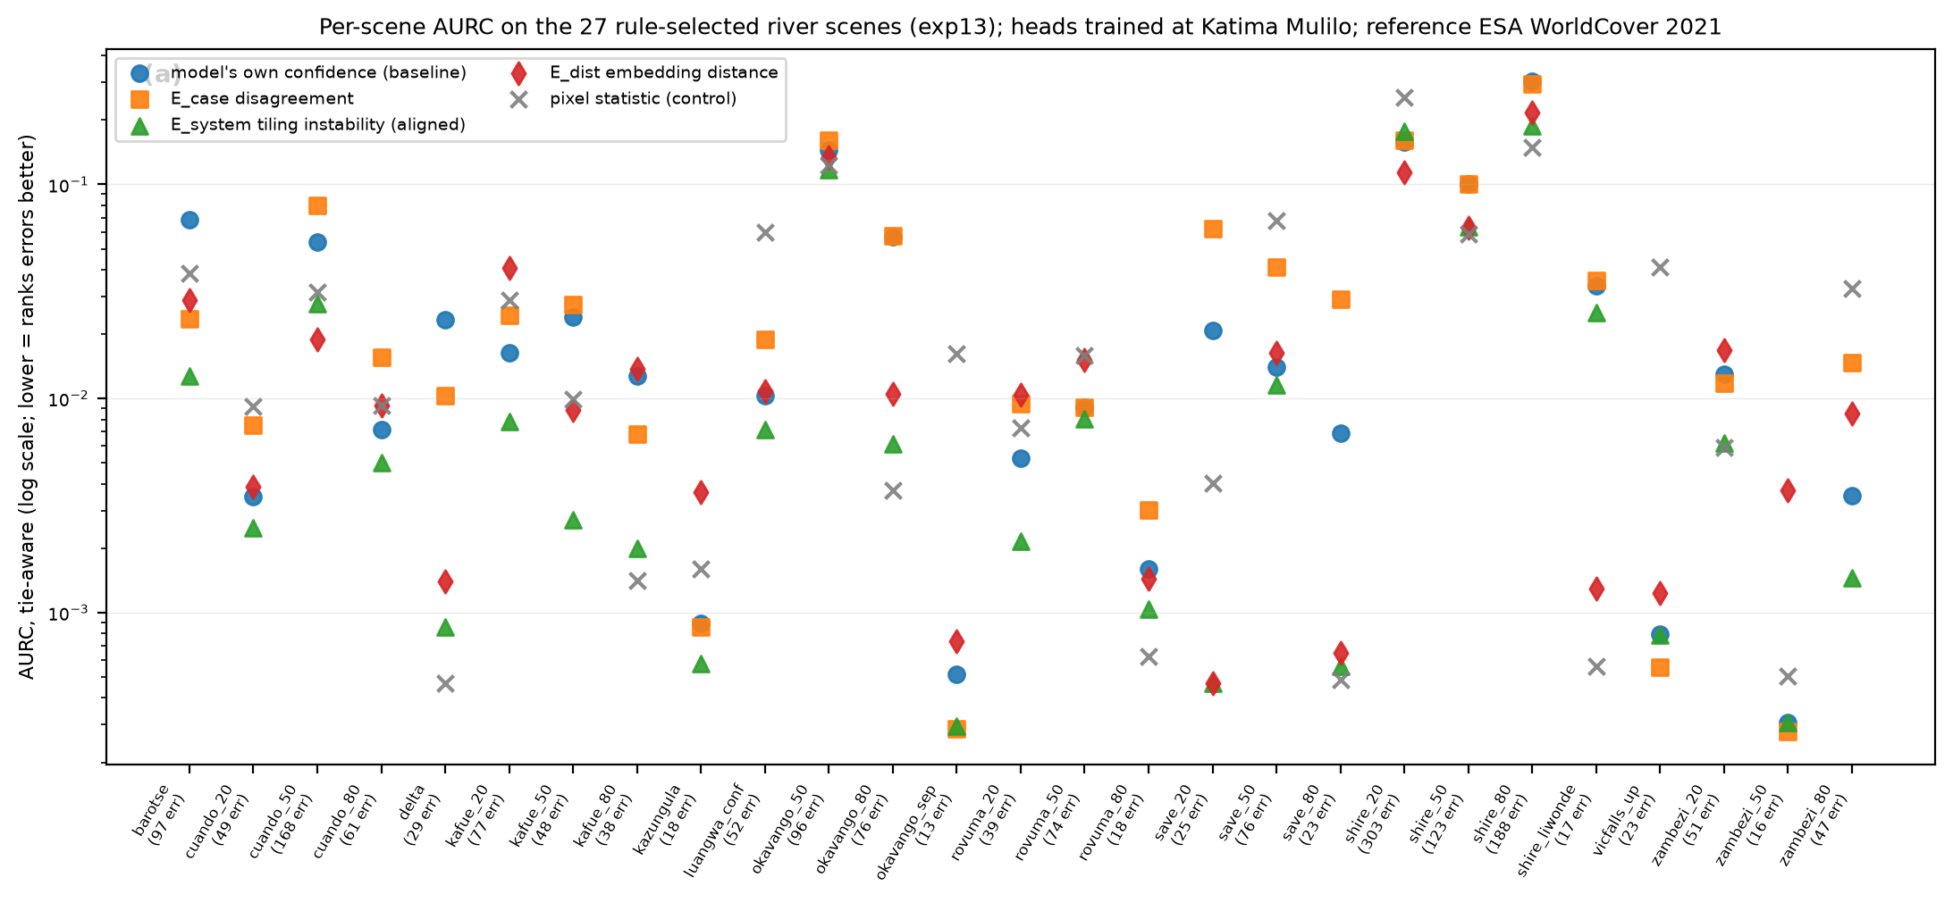
Figure 1. Per-scene tie-aware AURC for the five signals on the 27 rule-selected scenes.
Tiling instability, with the shifted grids aligned, ranks errors better than the model's own confidence on 26 of 27 scenes (p < 0.001; permutation p < 0.001), and better than the pixel control on 18 of 27. Its block-bootstrap interval excludes zero in its favour on 18 scenes and against on 0. It is the best of the five signals on 12 scenes and best or second on 24. The same signal computed without alignment, as in earlier experiments, showed no significant effect (17 of 27); that error is recorded as an erratum.
A boundary ablation (exp14) asked whether the perturbation adds anything beyond proximity to a boundary in the model's own prediction map. A zero-cost indicator, the fraction of a patch's eight neighbours with a different hard label, is statistically indistinguishable from tiling instability across scenes (boundary better on 12, tiling instability on 15, p = 0.701). By itself the indicator beats confidence on 19 of 27 (p = 0.052) and the pixel control on 22 of 27 (p = 0.002). The supported statement is that errors concentrate at the boundaries of the model's own prediction map and that boundary proximity ranks them at least as well as the perturbation, at zero extra inference; the perturbation signal carries the stronger statistical support against confidence.
Cross-model disagreement is not a general signal: better than confidence on 10 of 27 (p = 0.248), with block-bootstrap intervals against it on 9 scenes. It is strong on specific ambiguous scenes, for example the Barotse floodplain, where it also beats the pixel control. Embedding distance shows no scale-free advantage (13 of 27, p = 1.000); a mean-difference permutation test gives p = 0.007 but is carried by a few high-error scenes. The pixel control is the best signal on 9 scenes, which are the scenes where the reference map omits obvious water. Confidence is the best signal on 0 of 27 dense river scenes.
Prepending the map check (E_geo) to boundary proximity does not help: better on 5, worse on 9, unchanged on 13 of 27 scenes (p = 0.424). E_geo flags are 1.5 times as error-enriched as a random patch (pooled precision 0.12 over 413 flags, base error rate 0.081), but 9 scenes carry 1-51 flags at precision zero, where OSM marks a river that both the model and WorldCover call dry. Under this reference, the check mostly detects disagreement between two reference maps; its sensitivity cannot be stated without width-filtered centerlines or expert truth.
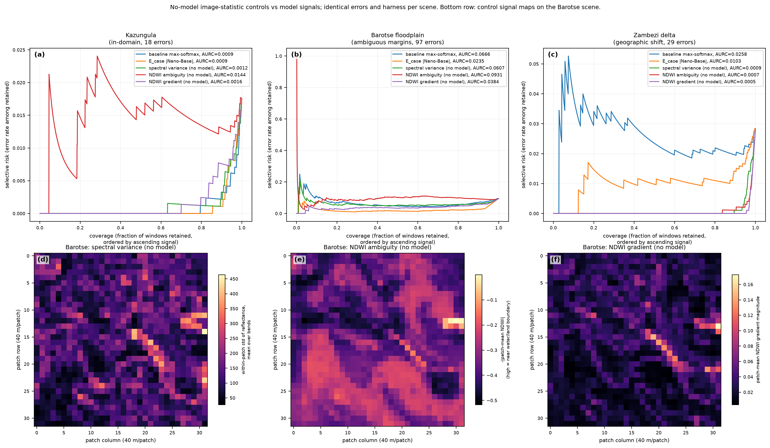
Figure 2. Risk-coverage curves for Kazungula, Barotse and the delta with the no-model controls on the same errors (exp06); bottom row, control signal maps for Barotse.

3.3 Expert labels and model families
On the AWF task (1459 expert-labelled points, twelve-month Sentinel-2 stacks, the project's own spatial split; 63 errors after the loader was corrected to warp the 20 m and 60 m band groups onto the 10 m grid), a linear head on frozen Base embeddings reaches 81.7% (the project's fine-tuned model: 89.5%). There the model's own confidence is the best signal tested (AURC 0.0363 vs 0.0489 for per-window tiling instability, 0.0670 for disagreement, 0.1338 for embedding distance and 0.1658 for a spectral-variability control). The earlier explanation, that point labels carry no boundary context, was tested in exp16 by applying the head densely to every patch of each validation crop: labelled patches are not interior (paired against a random patch of the same map, sign p = 0.008), and the boundary score is strongly error-associated (Fisher p = 2e-12), yet it ranks errors worse than confidence (tie-aware AURC 0.0636 vs 0.0363; cluster-bootstrap interval on the difference [0.0023, 0.0562]). Conditionally on the logit margin it adds little (likelihood-ratio p = 0.002; standardized coefficients 3.53 vs 0.52): with nine classes the argmax flips between neighbours wherever margins are small, so the prediction-boundary score is largely a coarse proxy for low confidence. The explanation is withdrawn; the in-domain result stands.
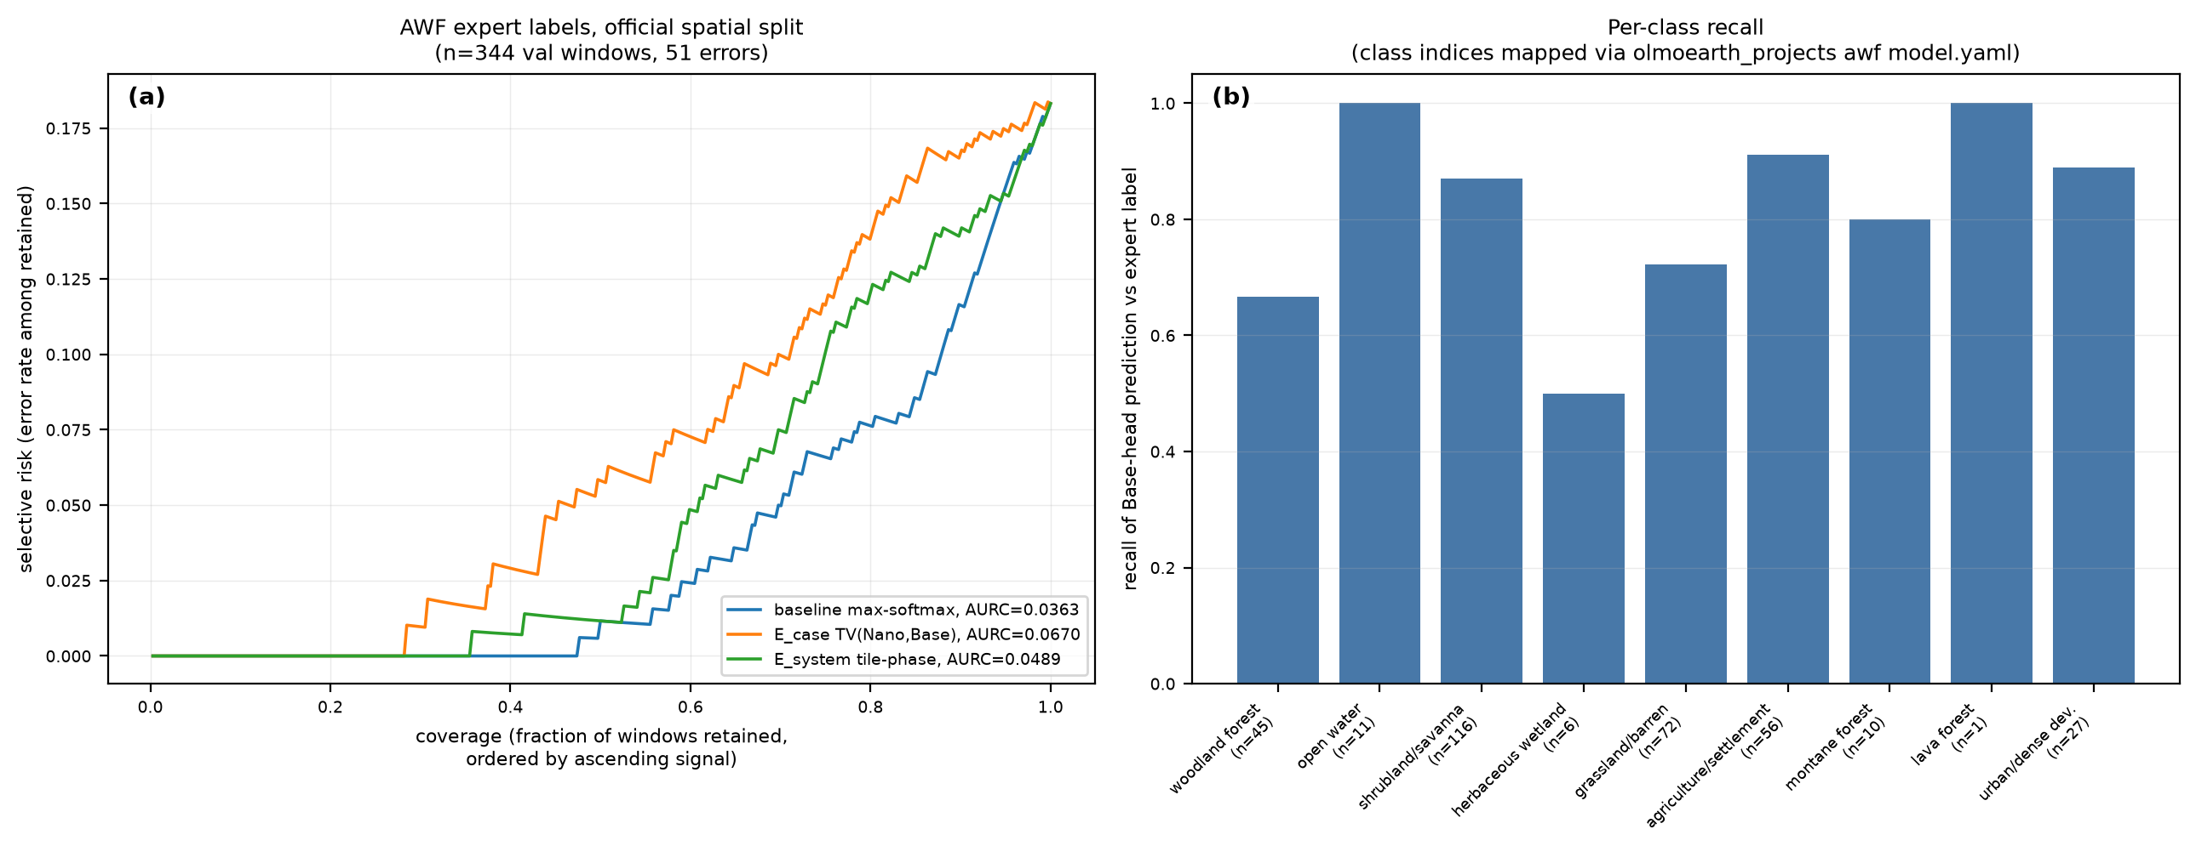
Figure 3. AWF expert-label task (exp04, corrected loader): risk-coverage on the official spatial split and per-class recall.
- A disagreement partner needs uncorrelated errors, not higher accuracy: pairing Base with the stronger v1-Large ranks errors worse than pairing it with Nano (mean AURC 0.0197 vs 0.0129; exp10), and averaging three OlmoEarth models is no better than the best pair (exp03, exp04, exp07). No partner from outside the family has been tested.
- Label-free reliability estimation by Dawid-Skene is invalid within one model family: it inflates every model's accuracy (+0.11, +0.11, +0.06) and inverts their order, because the family errs together (exp07). The inflation gap is a direct measure of correlated error.
- Occluding input patches and measuring instability (exp08) ranks errors worse than every other signal; perturbations that remove content measure context reliance, not error.

3.4 Dense expert labels: Sen1Floods11
All water-task comparisons above score against ESA WorldCover, a weak reference. Sen1Floods11, Ai2's own flood evaluation set, provides hand-labelled flood-water masks; a water head was trained on 600 tiles of its validation split and the signals were scored on Bolivia, a geographically held-out region (441 tiles, 351 with enough errors to score), and on 800 test tiles (exp18). Against these labels the model's own confidence is the best signal. On Bolivia, aligned tiling instability is better on 163 tiles and worse on 187 (sign test p = 0.22); band-set disagreement 111 versus 239 (p = 7e-12); the boundary indicator 134 versus 217 (p = 1e-5); two-model disagreement 84 versus 265; embedding distance 22 versus 329; the pixel control 79 versus 271. On the test split tiling instability is significantly worse (173 versus 305, p = 2e-9). Pooled over all patches, confidence has the lowest excess AURC on both splits (0.0105 and 0.0096). Errors still concentrate at prediction boundaries (75% of error patches versus 21% of correct ones), but confidence ranks them better than boundary proximity or instability.
The central conclusion: the WorldCover-referenced advantages of tiling instability (26 of 27 scenes) and band-set disagreement (21 of 27) do not transfer to expert truth. The explanation first proposed, that a large share of the counted errors were reference errors detectable by boundary-type signals, was tested in exp23 (section 3.9) with the measurable component of reference error in exp24 (section 3.10) with imagery from the map's own year, and in exp25 (section 3.11) with seasonal water removed, and is not supported by any of them; why the reference-defined wins do not transfer is open. Until a signal beats confidence on expert-labelled dense maps, the repository's positive water-task claims are claims about detecting disagreement with a weak reference, not about detecting model error. Caveats: Sentinel-2 Level-1C chips were fed through the encoder's L2A path; the task is flood water rather than permanent water; the head is trained on tiles from the same regions as the test split, with Bolivia as the clean spatial hold-out. None plausibly favours confidence over the other signals.

3.5 Evidence from inside the encoder
The v1-Base encoder (12 pre-norm ViT blocks, 768-d, 12 heads, no register tokens; token sequence laid out H, W, T, S, where S indexes the three Sentinel-2 band-set tokens per patch) was hooked for one forward pass per scene, and five label-free signals were derived from its internals and scored on the 27 rule-selected scenes (exp17). Band-set disagreement, the spread among water predictions from heads trained separately on the 10 m, 20 m and 60 m band-set tokens that all earlier experiments averaged away, beats confidence on 21 of 27 scenes (exact sign test p = 0.006) and the pixel control on 16 of 27, with no second model. It outperforms the two-model disagreement signal (10 of 27). Depth-probe disagreement (heads on each block's tokens, spread over the last six blocks) is marginal (19 of 27, p = 0.052). Logit-lens decision settling, late-block representation drift, and last-block attention entropy rank errors worse than confidence (0, 3 and 3 of 27) and are rejected. The band-set probe's errors are more correlated with the final head (phi 0.75) than Nano's (0.61) yet its disagreement ranks errors better, so a useful disagreement partner is one that sees a different view of the input rather than one with decorrelated errors.

3.6 OlmoEarth v1 versus v1.2
v1.2-Base was loaded on the current olmoearth_pretrain code in an isolated environment (exp19); v1 features recomputed with that code match the cached ones exactly. v1.2 uses rotary position encodings (rope_3d_mixed) and tokenizes Sentinel-2 as a single band-set token per patch, so the band-set signal has no v1.2 counterpart. Rotary encoding does not reduce sub-patch tiling instability: the mean per-patch spread across 0-3 px shifts is 0.046 for v1.2 against 0.032 for v1, smaller for v1.2 on only 6 of 31 scenes. Against WorldCover, tiling instability ranks each version's own errors better than its confidence (v1 26 of 27, v1.2 25 of 27), which the Sen1Floods11 result reads as detection of reference error; cross-version disagreement is worse than confidence for v1's errors and not significant for v1.2's.

3.7 A served production output: the land cover change rasters
The published allenai/olmoearth_lcc rasters (encoder v1.2-Base fine-tuned; 9-band uint8 BigTIFFs served in EPSG:3857 at about 9.55 m) were read over HTTP range requests at ten 512-px windows in the Zambezi, Chobe and Barotse region and assessed with the recipe the earlier experiments support (exp20). Per the dataset card, band 1 is the change probability, bands 4-5 the source and destination land cover classes, and bands 6-7 the probabilities of the change-category heads. The product exports no confidence for the land cover classes, so the model's own confidence, the best signal on every expert-labelled testbed above, cannot be run on its class map; bands 6-7 are not a substitute, since they sit at 255 on 80 to 99% of pixels because the category head answers "none" wherever no change is predicted.
Boundary proximity, the one label-free cue the product allows, was scored on its water map against ESA WorldCover 2021 water, the one class whose legends coincide. Six of the ten windows contain water; disagreement is 0.2 to 2.4% of 4-px windows. The boundary fraction ranks disagreements below random on 6 of 6 (Kazungula AURC 0.0013 against 0.0156 random and 0.0001 oracle); a 5% review budget by boundary captures a median 0.88 of disagreements (0.61 to 0.98); the boundary share is 0.92 among disagreements against 0.01 among agreements. Legends and dates differ (the reference is three years older than the product), so these are reference disagreements rather than counted model errors; full-legend disagreement with WorldCover is a median 49%, dominated by tree, shrub, grass and built-up semantics, and is reported as context only.
The change probability itself is sharply separated: a median 2.7% of pixels are flagged at 0.5 and a median 1.2% fall between 0.25 and 0.75. Its ambiguity concentrates on the edges of flagged regions, 2.7% of edge windows against 0.08% of interior windows, so the boundary finding replicates label-free on the product. Where change is flagged, the predicted transitions are plausible for the region (tree to grassland or built-up at Kazungula and Katima, grassland to crops at Barotse, water to wetland at Linyanti); no change reference was available, so these are sanity checks. Two errors were caught during this experiment: an early run treated band 6 as a class confidence, and the assessor's oracle had the wrong sign; both are corrected in the repository.
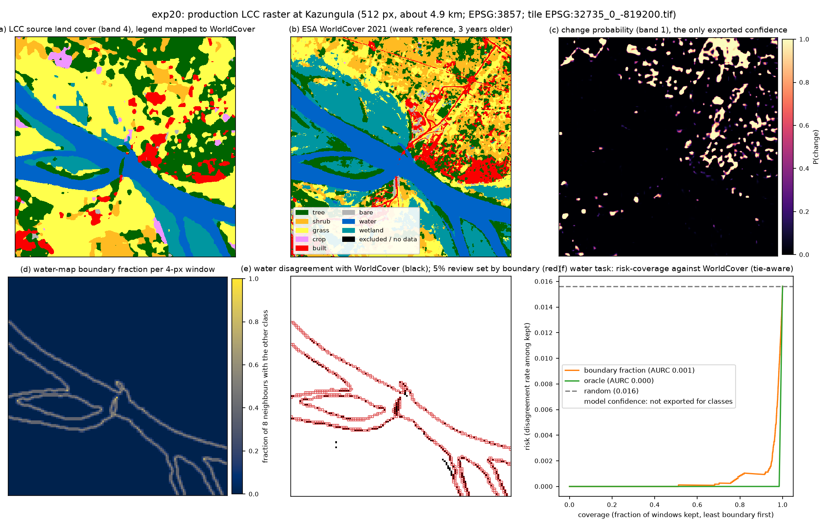
Figure 4. Kazungula window of the served product (exp20): source land cover, WorldCover 2021, the change probability, the water-map boundary fraction, water disagreements with the 5% review set chosen by boundary, and the risk-coverage curve against WorldCover.

3.8 Periodic artifacts in the served product
The served rasters are the Web Mercator zoom-14 grid warped from the 10 m UTM inference grid, so any grid-imposed artifact appears at a period predictable from each window's geometry: an encoder patch of 4 UTM px maps to 4.34 to 4.42 served px, an inference window of 128 UTM px to about 140 served px. Column and row profiles of the class-map boundary indicator, of the change-probability gradient, and of WorldCover 2021 warped to the same grid (a control with no model grid) were computed over 5 windows of 4096 served px after correcting the shear of the UTM grid lines, and tested with whitened periodograms: confirmatory tests at the predicted periods and an exploratory Bonferroni-corrected scan (exp22). The test was validated on lattice-free synthetic maps before use (no false positives in ten null maps; seams affecting 5 to 10% of rows detectable), and one earlier synthetic generator that carried a lattice of its own was discarded.
Result: the largest peak of 19 of 20 product profiles lies on the encoder patch lattice (1, 2 or 4 patches), with Bonferroni p at most 6e-08, and the observed periods track each window's UTM-to-Mercator ratio; the control's largest peak never reaches p = 0.006. The product's class boundaries and change probabilities are quantized to the 40 m patch grid. At the inference-window periods (64 to 512 UTM px), judged on the fundamental ordinate, the product profiles reach p < 0.01 at the rate expected under the null (class map: none of ten profiles at any window period; gradient: one), and seams injected into the real maps set the detection limit at 5 to 10% of affected rows for the 128-px period and 10 to 20% for 256 px. Within those limits, the served v1.2 product shows no window-seam striping; whether rotary encoding removed a seam signal that v1 had cannot be tested without a v1 product.
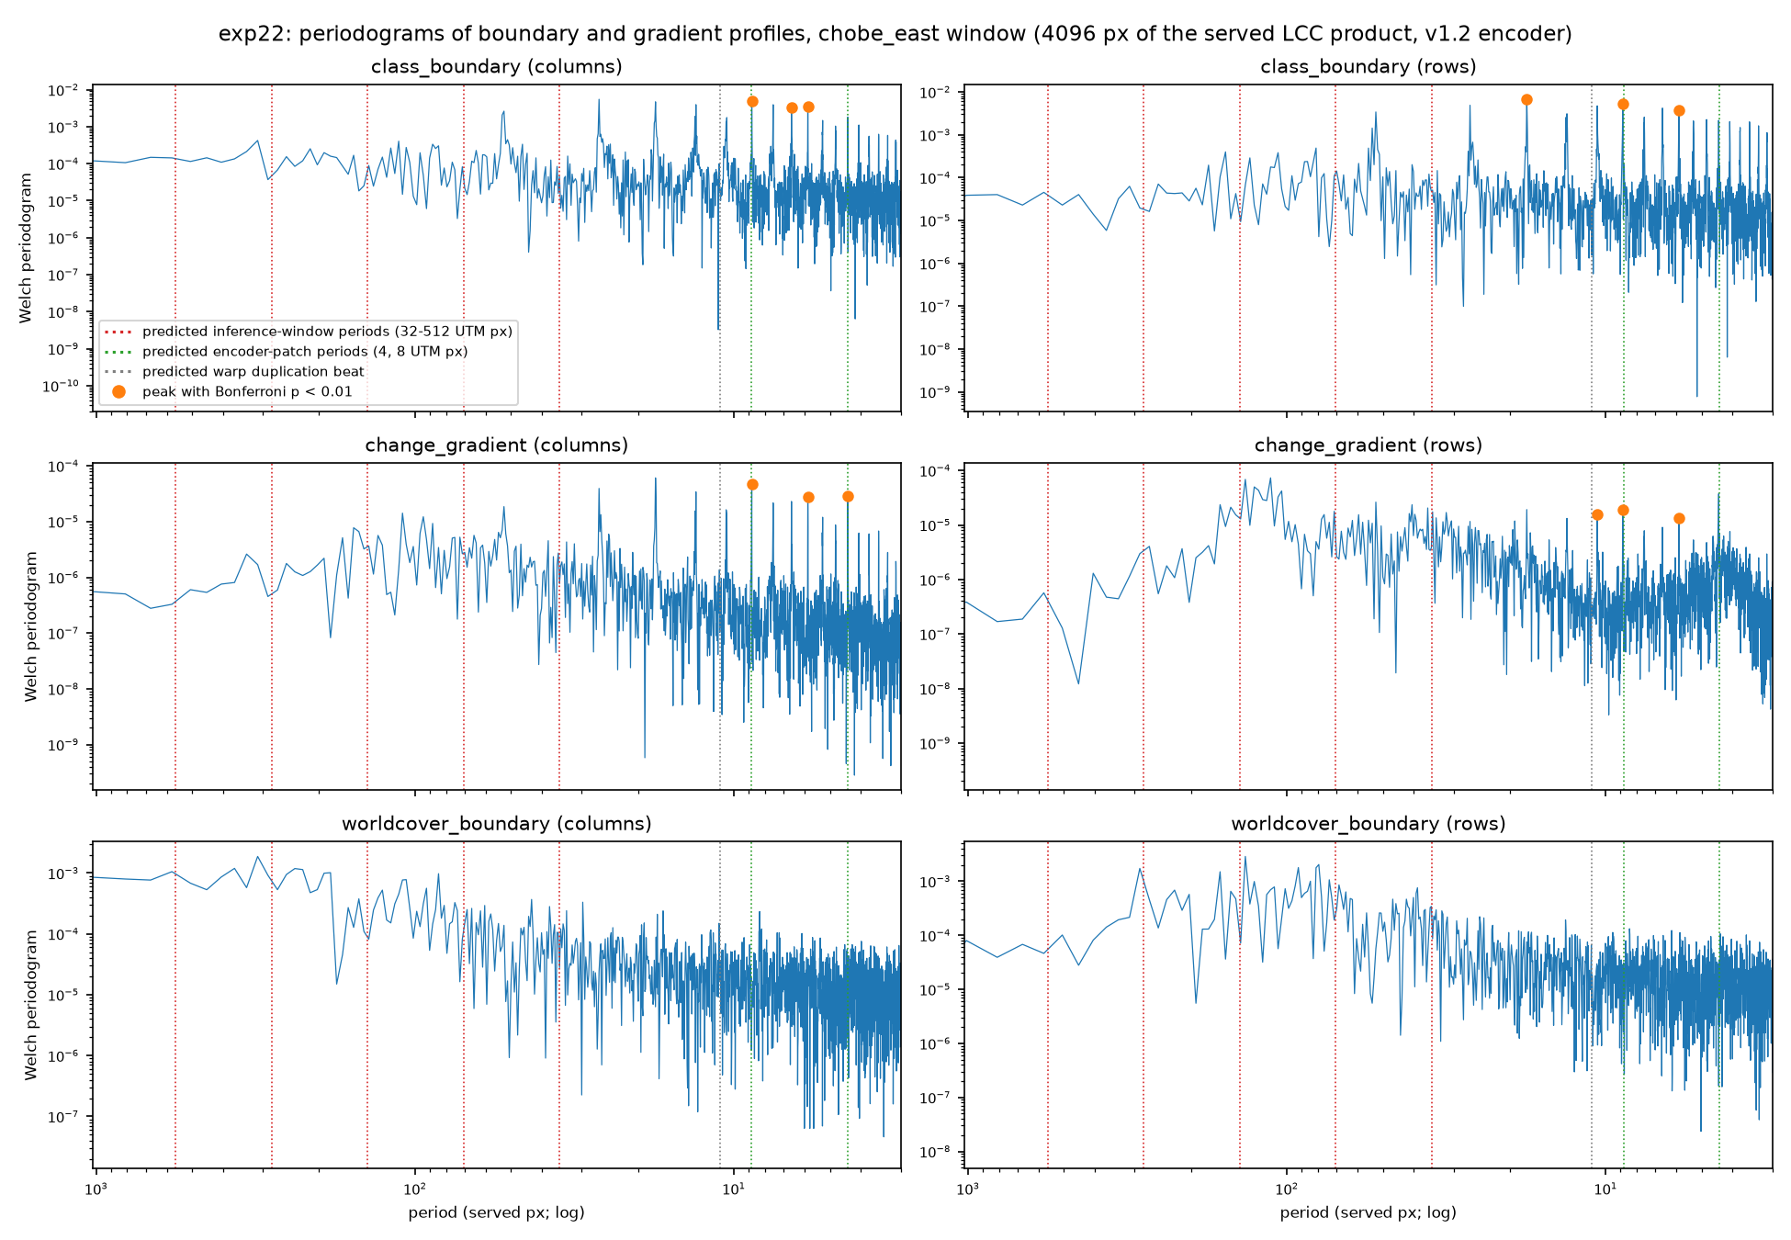
Figure 5. Periodograms of the boundary and gradient profiles for one window (exp22): predicted inference-window periods (red), patch periods (green), warp beat (grey); significant peaks marked. The control (bottom row) shows no lattice.

3.9 Does reference instability explain the WorldCover wins?
The reading of section 3.4 was tested with a measurable component of reference error: patches where ESA WorldCover's own 2020 (v100) and 2021 (v200) versions disagree about water, on 24 of the 27 rule scenes (exp23; three Kafue scenes dropped because the re-read image no longer matched the cache). Three tests were fixed before looking. Enrichment: version-unstable patches are a median 10.8% of the head's disagreements against 0.8% of its agreements (17 of 24 scenes in that direction, sign p = 0.003), so reference instability is real but covers only about 10% of the disagreements. Mechanism: among disagreements, the set flagged by tiling instability is no more often reference-unstable than the set flagged by confidence (8 better, 8 worse, 8 tied). Decisive: with unstable patches removed from scoring, tiling instability still beats confidence on 21 of 23 scenes (sign p = 7e-05) against 22 of 23 on all patches of the same scenes, and the boundary indicator on 18 of 23 against 15 of 23. The advantage is unchanged.
The explanation that the WorldCover-referenced wins were detection of reference error is therefore withdrawn as an explanation and recorded as an open question. This test cannot rule out reference errors shared by both versions (narrow and seasonal water) or genuine change between 2021 and the 2024 imagery; re-running the scenes with imagery from WorldCover's own year is the next step. The fact the reading tried to explain, that no signal beats confidence on hand-labelled data, stands.
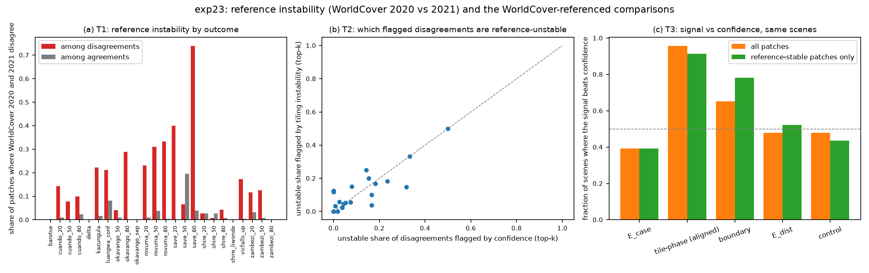
Figure 6. exp23: (a) share of version-unstable patches among disagreements and agreements per scene; (b) unstable share of the disagreements flagged by tiling instability against those flagged by confidence; (c) fraction of scenes where each signal beats confidence on all patches and on reference-stable patches only.

3.10 Does the year gap explain the WorldCover wins?
The remaining measurable candidate was temporal mismatch: the 2021 map scored against 2024 imagery. The same scenes were re-fetched with imagery from May to September 2021, WorldCover 2021 was warped onto each 2021 window's own grid, features were computed exactly as before, and the water head was retrained within the year on the Katima 2021 scene (exp24). On the 26 scenes with at least 8 disagreements in both years, tiling instability beats confidence on 23 of 26 within 2021 (sign p = 9e-05; median E-AURC gain +0.0172) against 25 of 26 with 2024 imagery on the same scenes (gain +0.0047); the boundary indicator on 20 against 18; cross-model disagreement, embedding distance and the control stay at or below even in both years. The per-scene gain is not larger in 2024 (10 larger, 16 smaller). 2021 carries more disagreements than 2024 (2337 against 1845, more on 20 of 27 scenes), as single dates in the 2021 wet-to-dry transition against an annual map would.
The year gap therefore does not explain the WorldCover-referenced wins either. Two explanations remain untested: the mismatch between a single-date image and an annual composite map, whose seasonal water margins are boundary-structured and cannot be represented by the map, and a genuine difference between the WorldCover-defined task and date-matched expert labels. The next test splits patches by the seasonality of surface water.
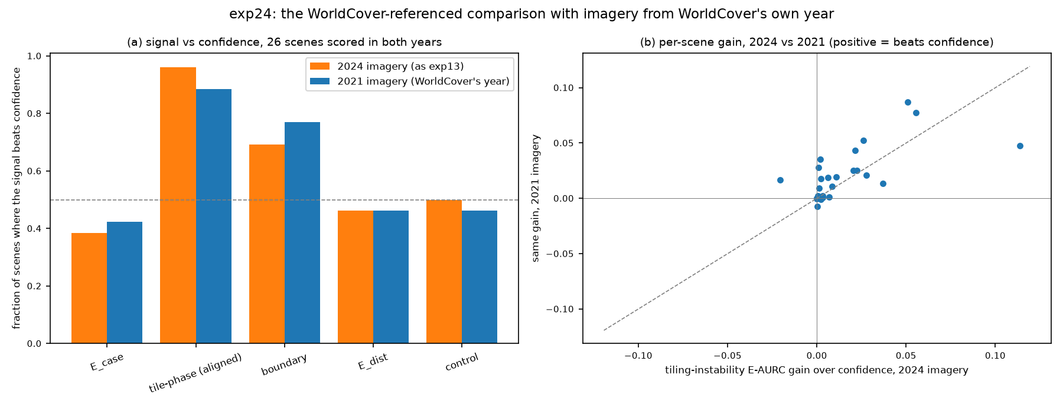
Figure 7. exp24: (a) fraction of scenes where each signal beats confidence with 2024 imagery and with 2021 imagery, same scenes; (b) per-scene tiling-instability gain over confidence in the two years.

3.11 Do the wins live on seasonal water margins?
The last measurable candidate was the mismatch between a single-date image and an annual composite: seasonal water margins are water on some dates and not on others, and they are boundary-structured. The JRC Global Surface Water seasonality layer (months with water in 2020, 30 m) was warped onto every scene grid, and a 4-px patch was called seasonal if any pixel holds water for 1 to 11 months (median 9% of patches per scene). Seasonal patches are a median 39% of the disagreements against 8% of the agreements with 2024 imagery (21 of 27 scenes, sign p = 0.000) and 41% against 9% with 2021 imagery, so the margins do carry a disproportionate share of the disagreements. Removing them from scoring changes nothing: tiling instability beats confidence on 22 of 24 scenes in 2024 (sign p = 4e-05) and 22 of 23 in 2021, against 23 of 24 and 20 of 23 on all patches of the same scenes; the boundary indicator behaves the same way (exp25).
Three measurable components of reference-versus-image mismatch have now been removed one at a time, reference-version instability (exp23), the year gap (exp24) and seasonal water (exp25), and the WorldCover-referenced advantage of tiling instability over confidence survives each. What remains is either reference error shared by both WorldCover versions and unrelated to seasonality, or a genuine property of the WorldCover-defined task that date-matched hand labels do not share. The next step is a hand check of the disagreements tiling instability ranks first against the imagery itself.
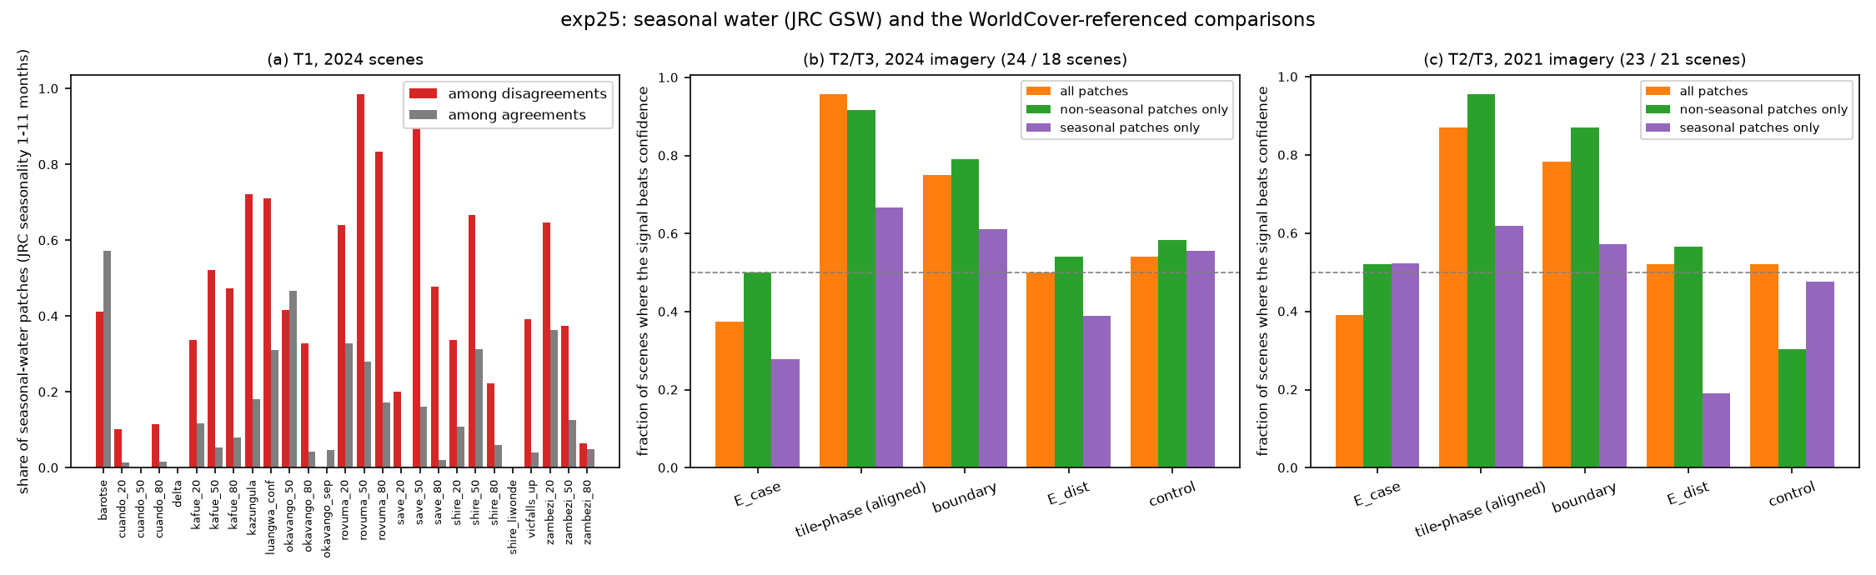
Figure 8. exp25: (a) share of seasonal-water patches among disagreements and agreements per 2024 scene; (b, c) fraction of scenes where each signal beats confidence on all patches, on non-seasonal patches only, and on seasonal patches only, for 2024 and 2021 imagery.

3.8 Ai2's fine-tuned AWF model, end to end
Ai2 publishes its fine-tuned models. allenai/OlmoEarth-v1-FT-AWF-Base is a fully fine-tuned v1-Base encoder (203 of 231 tensors changed; backbone unfrozen at epoch 20 of 55) with a 1x1 convolution head, trained by rslearn from the AWF project's model.yaml. It was replicated without rslearn (exp21): the encoder weights load strictly into olmoearth_pretrain's v1-Base encoder, tokens are mean-pooled over timesteps and band sets as rslearn's wrapper does, timestamps follow the wrapper's legacy month indices, and the pooled features are bilinearly upsampled four times before the 1x1 convolution. On the 344 expert-labelled validation points of the official spatial split the replica reaches 0.881 accuracy on 16-px crops (the training regime) and 0.878 on 32-px crops, against 0.895 reported by Ai2; the frozen-encoder probe of exp16 reaches 0.817 on the same points, and 28 of the fine-tuned model's 41 errors are also probe errors.
The signal comparison on the fine-tuned model repeats the expert-label result. With tie-aware AURC and a cluster bootstrap over the 30 annotation tasks (16-px crops): confidence 0.0262; aligned tiling instability 0.0235 (difference interval [-0.0068, 0.0010], not significant); boundary indicator 0.0765, disagreement with the frozen probe 0.0852 and the NDVI temporal-variability control 0.0937, all significantly worse; oracle 0.0076, random 0.119. At a 20% review budget confidence captures 0.63 of the errors and tiling instability 0.71. Boundary share is 0.63 among errors against 0.34 among correct points.
Stated for a user of the model: keeping the 80% most confident points raises accuracy from 0.881 to 0.945, and the 90% most confident to 0.919. The model is overconfident: expected calibration error 0.080 over ten bins, with the 299 points above 0.9 top-1 probability 0.93 accurate at a mean stated confidence of 0.99. Per-class recall ranges from 0.50 (herbaceous wetland, n 6) to 1.00 (urban, n 27); woodland forest is 0.73 (n 45).
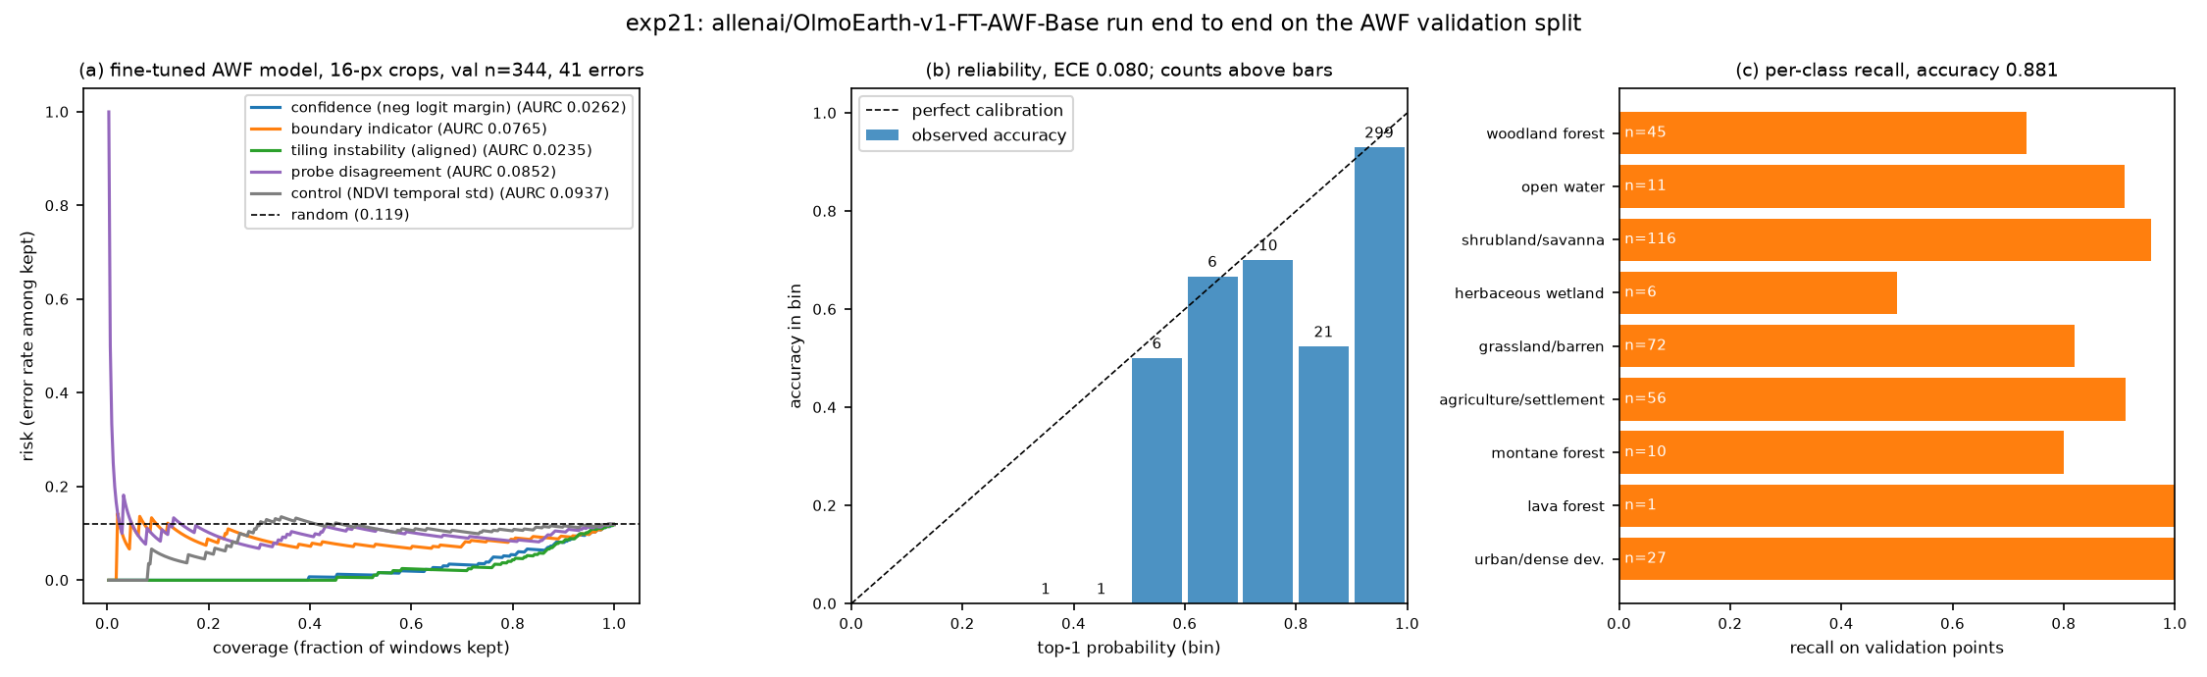
Figure 5. The fine-tuned AWF model on the validation split (exp21): risk-coverage of the five signals, reliability diagram with bin counts, and per-class recall.

4. Audit and corrections
After the experiments, a 204-agent adversarial audit (five finder lenses, three independent skeptics per finding, one synthesis) confirmed 53 findings and refuted 13. The material ones and their corrections: (1) a sign test that scored tied scenes as losses, which had turned 'no benefit' into 'rejected'; (2) an explanation attributing a change in a permutation p-value to excess AURC, which cannot change any paired difference; (3) AURC computed with a stable sort over heavily tied scores, so several numbers depended on raster order; (4) two scenes counted as rule-selected that had entered through a cache import; (5) an AWF loader that stretched the 20 m and 60 m bands instead of georeferencing them; (6) several miscounts and overstatements, including 'equivalent' for a non-significant difference and an enrichment figure computed as an unweighted mean over scenes. All numbers in this report were regenerated from the corrected CSVs by script. The earlier unaligned tiling-instability computation and the withdrawn explanations are recorded as errata in the repository rather than removed.

5. Positioning
Boundary-concentrated error is well known in semantic segmentation and land-cover validation (trimap and Boundary-IoU evaluation; mixed-pixel effects, Foody 2002; Radoux and Bogaert 2017), and ensembles, test-time augmentation, confidence thresholds and embedding-distance monitors are standard practice. What this work adds is the label-free selective-prediction audit protocol for earth-observation probes, with a pre-registered scene rule, no-model controls on every comparison, and a quantified comparison of each signal against the model's own confidence. The signal designs were adapted from LLM hallucination-detection methods, which face the same problem of judging outputs with no reference answer; that lineage is an origin, not a claim of novelty for the mechanisms.

6. Limitations
- The reference on the river scenes is ESA WorldCover 2021 applied to 2024 imagery, and it is least reliable on exactly the interesting terrains; its own version instability accounts for about 10% of the counted disagreements (exp23), and the remaining share of reference error is unknown.
- The water results are for one task family, one region (southern African rivers), one training scene, and linear probes; only one fine-tuned model (AWF) has been run end to end, and only on point labels.
- 27 scenes with small per-scene error counts; per-scene bootstrap intervals are biased for this rank statistic and are indicative only; cross-scene tests carry the inference.
- The only expert-labelled evidence is a nine-class point-label task; there the boundary score is a proxy for low confidence (exp16), and no dense expert-labelled few-class map has been tested.
- E_geo sensitivity is confounded by disagreement between reference maps.
- The served production output was assessed against WorldCover and label-free only; the olmoearth_lcc dataset's annotated points are the model's training labels, so no held-out expert reference exists for it yet.

7. Next
- Hand-check the disagreements that tiling instability ranks first on two or three WorldCover scenes against the imagery itself, now that version instability, the year gap and seasonal water have all been ruled out as explanations (exp23 to exp25).
- Find an independent expert reference for the served change product; the olmoearth_lcc annotated points are the model's training labels and cannot serve as a held-out test.
- Run the other published fine-tuned checkpoints (Mangrove, ForestLossDriver, LFMC, EcosystemTypeMapping) through the exp21 replica for generality of the confidence result and the tiling-instability tie.
- Ask for a class-head confidence (top-1 minus top-2 logit) in the LCC export alongside bands 4-5; without it the recipe's primary signal cannot run on the product.
- Run the periodic-artifact test on a v1-encoder product if one is served, to show whether rotary encoding removed a seam signal that v1 had.
- Add an error-rater model from outside the OlmoEarth family for E_case and Dawid-Skene.
- Replace OSM centerlines with GRWL centerlines filtered by width, then re-measure E_geo precision.

