Locating Errors in OlmoEarth Probe Predictions Without Labels
Experiments exp01-exp20 with post-audit corrections, the Sen1Floods11 expert-label result, and a first assessment of a served production output. 2026-09-02. Repository: github.com/2imi9/olmoearth_inferenceX. Standing record: docs/TECHNIQUES.md and docs/results/.

1. Problem and scope
Earth observation models are applied to regions without labels, where supervised evaluation says nothing. This work asks whether the windows where a prediction is wrong can be ranked without labels. The audited predictors are linear probes on frozen OlmoEarth v1 encoders: a binary water head trained on one WorldCover-labelled 128x128 Sentinel-2 scene at Katima Mulilo, and a nine-class head on the AWF expert labels. The production model has not been run here; one of its served outputs, the published land cover change rasters, is assessed as served in section 3.7. The output is a ranked audit scored by risk-coverage curves, not an accuracy estimate.

2. Signals and protocol
- E_case, cross-model disagreement: two models (OlmoEarth v1 Nano and Base) predict the same window differently.
- E_system, tiling instability (tile-phase in the scripts): the prediction changes when the input grid is shifted by one to three pixels; shifted maps are aligned on a pixel canvas before comparison.
- E_dist, embedding distance: mean cosine distance from a window's embedding to the five nearest patches of the head's training scene. This is distance to the training scene, not to the encoder's pretraining data.
- E_geo, map check: the patch lies on an OSM river centerline and the model predicts dry.
In machine-learning terms the evaluation is selective prediction. Each signal gives every 40 m patch a suspicion score. AURC (area under the risk-coverage curve) is the error rate among accepted patches, averaged over acceptance levels as patches are accepted in order of increasing suspicion; lower is better. AURC is computed as its expectation under random tie-breaking, because two signals take few distinct values. Errors on the river scenes are disagreements between the head and ESA WorldCover 2021 water, treated as truth; on the AWF task they are disagreements with expert point labels. Every signal is compared against two references: the model's own confidence (max-softmax, scored as the negative absolute logit so that saturated probabilities do not tie) and a pixel statistic computed without any model (the NDWI gradient). Labels are used only to evaluate signals. Training and evaluation areas are always geographically separate.
Scene set: 29 river scenes across southern Africa were fetched under a pre-registered rule committed before any scene was fetched (candidates at fixed fractions along OSM geometries of eight named rivers, 0.2 degree separation, inclusion iff the head commits at least 8 errors). Two scenes that entered through a cache import rather than the rule were excluded after audit, leaving 27. Cross-scene tests are exact sign tests on untied pairs and sign-flip permutation tests on mean excess-AURC differences; per-scene intervals use a 4x4-patch block bootstrap and are indicative only.

3. Results

3.1 Three scenes
AURC (lower = ranks errors better) | In-domain: AWF expert point labels (63 errors) | Ambiguous wetland margins: Barotse, vs WorldCover 2021 (97 errors) | Reference omits the river: Zambezi delta, vs WorldCover 2021 (29 disagreements)
model's own confidence (baseline) | *0.0363 | 0.0684 | 0.0234
cross-model disagreement (E_case) | 0.0670 | 0.0235 | 0.0103
tiling instability (E_system, aligned) | 0.0489 | *0.0127 | 0.0009
embedding distance (E_dist) | 0.1338 | 0.0289 | 0.0014
pixel statistic, no model (control) | 0.1658 | 0.0384 | *0.0005
Table 1. Tie-aware AURC per signal. Asterisk marks the best signal per column. Third column: the reference contains no water on this scene, so its disagreements are reference omissions; a no-model statistic ranks them best, so the column shows only that confidence fails there.

3.2 The 27 rule-selected scenes
Signal vs confidence baseline | better / worse / tied | sign test p (untied) | mean-diff permutation p | block-bootstrap interval favours / against | best signal on N scenes
cross-model disagreement | 10 / 17 / 0 | 0.248 | 0.162 | 3 / 9 | 3
tiling instability (aligned) | 26 / 1 / 0 | <0.001 | 0.000 | 18 / 0 | 12
embedding distance | 13 / 14 / 0 | 1.000 | 0.007 | 11 / 5 | 3
pixel statistic (control) | 14 / 13 / 0 | 1.000 | 0.631 | 9 / 7 | 9
confidence baseline itself | - | - | - | - | 0
Table 2. Cross-scene statistics against the confidence baseline (exp13). Best-signal tally: baseline 0, E_case 3, tiling instability 12, E_dist 3, control 9.
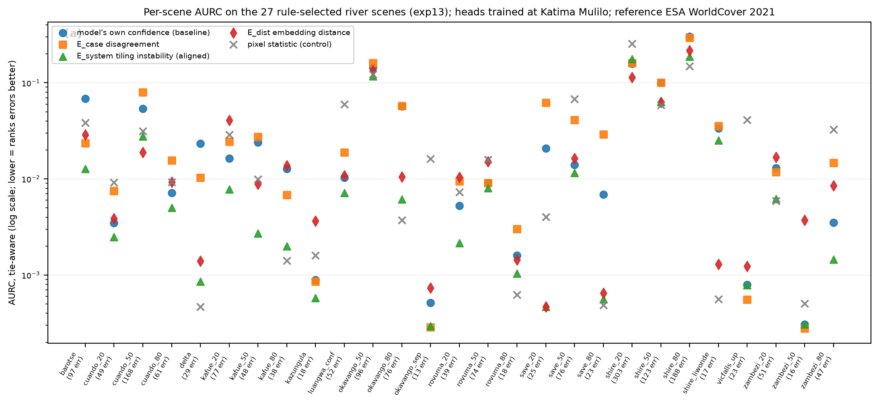
Figure 1. Per-scene tie-aware AURC for the five signals on the 27 rule-selected scenes.
Tiling instability, with the shifted grids aligned, ranks errors better than the model's own confidence on 26 of 27 scenes (p < 0.001; permutation p < 0.001), and better than the pixel control on 18 of 27. Its block-bootstrap interval excludes zero in its favour on 18 scenes and against on 0. It is the best of the five signals on 12 scenes and best or second on 24. The same signal computed without alignment, as in earlier experiments, showed no significant effect (17 of 27); that error is recorded as an erratum.
A boundary ablation (exp14) asked whether the perturbation adds anything beyond proximity to a boundary in the model's own prediction map. A zero-cost indicator, the fraction of a patch's eight neighbours with a different hard label, is statistically indistinguishable from tiling instability across scenes (boundary better on 12, tiling instability on 15, p = 0.701). By itself the indicator beats confidence on 19 of 27 (p = 0.052) and the pixel control on 22 of 27 (p = 0.002). The supported statement is that errors concentrate at the boundaries of the model's own prediction map and that boundary proximity ranks them at least as well as the perturbation, at zero extra inference; the perturbation signal carries the stronger statistical support against confidence.
Cross-model disagreement is not a general signal: better than confidence on 10 of 27 (p = 0.248), with block-bootstrap intervals against it on 9 scenes. It is strong on specific ambiguous scenes, for example the Barotse floodplain, where it also beats the pixel control. Embedding distance shows no scale-free advantage (13 of 27, p = 1.000); a mean-difference permutation test gives p = 0.007 but is carried by a few high-error scenes. The pixel control is the best signal on 9 scenes, which are the scenes where the reference map omits obvious water. Confidence is the best signal on 0 of 27 dense river scenes.
Prepending the map check (E_geo) to boundary proximity does not help: better on 5, worse on 9, unchanged on 13 of 27 scenes (p = 0.424). E_geo flags are 1.5 times as error-enriched as a random patch (pooled precision 0.12 over 413 flags, base error rate 0.081), but 9 scenes carry 1-51 flags at precision zero, where OSM marks a river that both the model and WorldCover call dry. Under this reference, the check mostly detects disagreement between two reference maps; its sensitivity cannot be stated without width-filtered centerlines or expert truth.
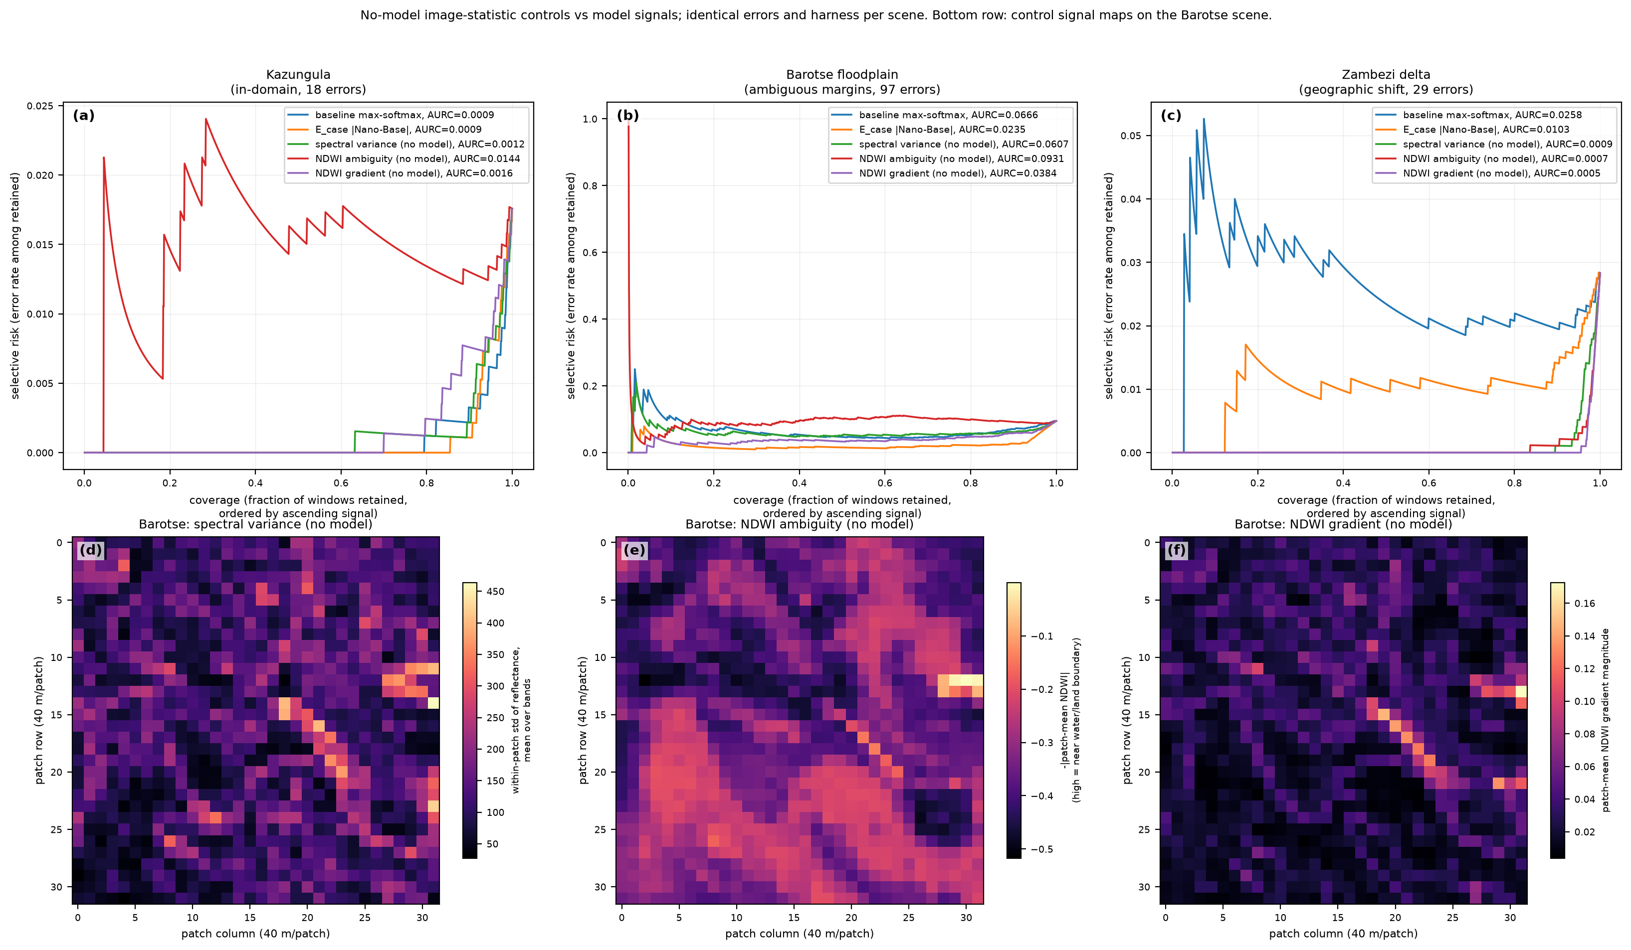
Figure 2. Risk-coverage curves for Kazungula, Barotse and the delta with the no-model controls on the same errors (exp06); bottom row, control signal maps for Barotse.

3.3 Expert labels and model families
On the AWF task (1459 expert-labelled points, twelve-month Sentinel-2 stacks, the project's own spatial split; 63 errors after the loader was corrected to warp the 20 m and 60 m band groups onto the 10 m grid), a linear head on frozen Base embeddings reaches 81.7% (the project's fine-tuned model: 89.5%). There the model's own confidence is the best signal tested (AURC 0.0363 vs 0.0489 for per-window tiling instability, 0.0670 for disagreement, 0.1338 for embedding distance and 0.1658 for a spectral-variability control). The earlier explanation, that point labels carry no boundary context, was tested in exp16 by applying the head densely to every patch of each validation crop: labelled patches are not interior (paired against a random patch of the same map, sign p = 0.008), and the boundary score is strongly error-associated (Fisher p = 2e-12), yet it ranks errors worse than confidence (tie-aware AURC 0.0636 vs 0.0363; cluster-bootstrap interval on the difference [0.0023, 0.0562]). Conditionally on the logit margin it adds little (likelihood-ratio p = 0.002; standardized coefficients 3.53 vs 0.52): with nine classes the argmax flips between neighbours wherever margins are small, so the prediction-boundary score is largely a coarse proxy for low confidence. The explanation is withdrawn; the in-domain result stands.
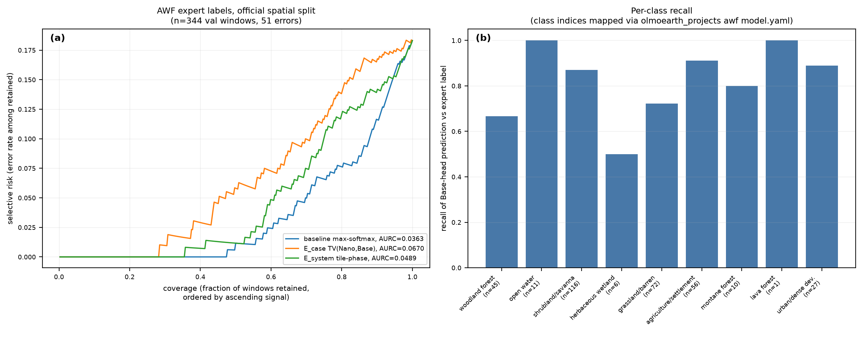
Figure 3. AWF expert-label task (exp04, corrected loader): risk-coverage on the official spatial split and per-class recall.
- A disagreement partner needs uncorrelated errors, not higher accuracy: pairing Base with the stronger v1-Large ranks errors worse than pairing it with Nano (mean AURC 0.0197 vs 0.0129; exp10), and averaging three OlmoEarth models is no better than the best pair (exp03, exp04, exp07). No partner from outside the family has been tested.
- Label-free reliability estimation by Dawid-Skene is invalid within one model family: it inflates every model's accuracy (+0.11, +0.11, +0.06) and inverts their order, because the family errs together (exp07). The inflation gap is a direct measure of correlated error.
- Occluding input patches and measuring instability (exp08) ranks errors worse than every other signal; perturbations that remove content measure context reliance, not error.

3.4 Dense expert labels: Sen1Floods11
All water-task comparisons above score against ESA WorldCover, a weak reference. Sen1Floods11, Ai2's own flood evaluation set, provides hand-labelled flood-water masks; a water head was trained on 600 tiles of its validation split and the signals were scored on Bolivia, a geographically held-out region (441 tiles, 351 with enough errors to score), and on 800 test tiles (exp18). Against these labels the model's own confidence is the best signal. On Bolivia, aligned tiling instability is better on 163 tiles and worse on 187 (sign test p = 0.22); band-set disagreement 111 versus 239 (p = 7e-12); the boundary indicator 134 versus 217 (p = 1e-5); two-model disagreement 84 versus 265; embedding distance 22 versus 329; the pixel control 79 versus 271. On the test split tiling instability is significantly worse (173 versus 305, p = 2e-9). Pooled over all patches, confidence has the lowest excess AURC on both splits (0.0105 and 0.0096). Errors still concentrate at prediction boundaries (75% of error patches versus 21% of correct ones), but confidence ranks them better than boundary proximity or instability.
The reading that follows is the report's central conclusion: the WorldCover-referenced advantages of tiling instability (26 of 27 scenes) and band-set disagreement (21 of 27) do not transfer to expert truth. The parsimonious explanation is that under WorldCover a large share of the counted errors were reference errors, which are boundary-structured and therefore detectable by boundary-type signals, whereas the model's own errors on hand-labelled data are ranked best by its own confidence. Until a signal beats confidence on expert-labelled dense maps, the repository's positive water-task claims are claims about detecting disagreement with a weak reference, not about detecting model error. Caveats: Sentinel-2 Level-1C chips were fed through the encoder's L2A path; the task is flood water rather than permanent water; the head is trained on tiles from the same regions as the test split, with Bolivia as the clean spatial hold-out. None plausibly favours confidence over the other signals.

3.5 Evidence from inside the encoder
The v1-Base encoder (12 pre-norm ViT blocks, 768-d, 12 heads, no register tokens; token sequence laid out H, W, T, S, where S indexes the three Sentinel-2 band-set tokens per patch) was hooked for one forward pass per scene, and five label-free signals were derived from its internals and scored on the 27 rule-selected scenes (exp17). Band-set disagreement, the spread among water predictions from heads trained separately on the 10 m, 20 m and 60 m band-set tokens that all earlier experiments averaged away, beats confidence on 21 of 27 scenes (exact sign test p = 0.006) and the pixel control on 16 of 27, with no second model. It outperforms the two-model disagreement signal (10 of 27). Depth-probe disagreement (heads on each block's tokens, spread over the last six blocks) is marginal (19 of 27, p = 0.052). Logit-lens decision settling, late-block representation drift, and last-block attention entropy rank errors worse than confidence (0, 3 and 3 of 27) and are rejected. The band-set probe's errors are more correlated with the final head (phi 0.75) than Nano's (0.61) yet its disagreement ranks errors better, so a useful disagreement partner is one that sees a different view of the input rather than one with decorrelated errors.

3.6 OlmoEarth v1 versus v1.2
v1.2-Base was loaded on the current olmoearth_pretrain code in an isolated environment (exp19); v1 features recomputed with that code match the cached ones exactly. v1.2 uses rotary position encodings (rope_3d_mixed) and tokenizes Sentinel-2 as a single band-set token per patch, so the band-set signal has no v1.2 counterpart. Rotary encoding does not reduce sub-patch tiling instability: the mean per-patch spread across 0-3 px shifts is 0.046 for v1.2 against 0.032 for v1, smaller for v1.2 on only 6 of 31 scenes. Against WorldCover, tiling instability ranks each version's own errors better than its confidence (v1 26 of 27, v1.2 25 of 27), which the Sen1Floods11 result reads as detection of reference error; cross-version disagreement is worse than confidence for v1's errors and not significant for v1.2's.

3.7 A served production output: the land cover change rasters
The published allenai/olmoearth_lcc rasters (encoder v1.2-Base fine-tuned; 9-band uint8 BigTIFFs served in EPSG:3857 at about 9.55 m) were read over HTTP range requests at ten 512-px windows in the Zambezi, Chobe and Barotse region and assessed with the recipe the earlier experiments support (exp20). Per the dataset card, band 1 is the change probability, bands 4-5 the source and destination land cover classes, and bands 6-7 the probabilities of the change-category heads. The product exports no confidence for the land cover classes, so the model's own confidence, the best signal on every expert-labelled testbed above, cannot be run on its class map; bands 6-7 are not a substitute, since they sit at 255 on 80 to 100% of pixels because the category head answers "none" wherever no change is predicted.
Boundary proximity, the one label-free cue the product allows, was scored on its water map against ESA WorldCover 2021 water, the one class whose legends coincide. Six of the ten windows contain water; disagreement is 0.2 to 2.4% of 4-px windows. The boundary fraction ranks disagreements below random on 6 of 6 (Kazungula AURC 0.0013 against 0.0156 random and 0.0001 oracle); a 5% review budget by boundary captures a median 0.88 of disagreements (0.61 to 0.98); the boundary share is 0.92 among disagreements against 0.01 among agreements. Legends and dates differ (the reference is three years older than the product), so these are reference disagreements rather than counted model errors; full-legend disagreement with WorldCover is a median 49%, dominated by tree, shrub, grass and built-up semantics, and is reported as context only.
The change probability itself is sharply separated: a median 2.7% of pixels are flagged at 0.5 and a median 1.2% fall between 0.25 and 0.75. Its ambiguity concentrates on the edges of flagged regions, 2.7% of edge windows against 0.08% of interior windows, so the boundary finding replicates label-free on the product. Where change is flagged, the predicted transitions are plausible for the region (tree to grassland or built-up at Kazungula and Katima, grassland to crops at Barotse, water to wetland at Linyanti); no change reference was available, so these are sanity checks. Two errors were caught during this experiment: an early run treated band 6 as a class confidence, and the assessor's oracle had the wrong sign; both are corrected in the repository.
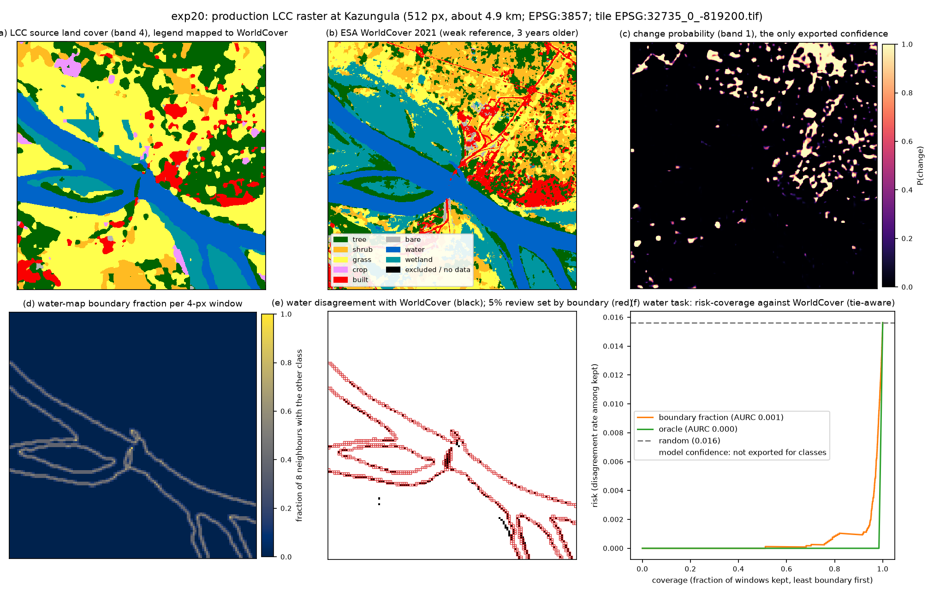
Figure 4. Kazungula window of the served product (exp20): source land cover, WorldCover 2021, the change probability, the water-map boundary fraction, water disagreements with the 5% review set chosen by boundary, and the risk-coverage curve against WorldCover.

4. Audit and corrections
After the experiments, a 204-agent adversarial audit (five finder lenses, three independent skeptics per finding, one synthesis) confirmed 53 findings and refuted 13. The material ones and their corrections: (1) a sign test that scored tied scenes as losses, which had turned 'no benefit' into 'rejected'; (2) an explanation attributing a change in a permutation p-value to excess AURC, which cannot change any paired difference; (3) AURC computed with a stable sort over heavily tied scores, so several numbers depended on raster order; (4) two scenes counted as rule-selected that had entered through a cache import; (5) an AWF loader that stretched the 20 m and 60 m bands instead of georeferencing them; (6) several miscounts and overstatements, including 'equivalent' for a non-significant difference and an enrichment figure computed as an unweighted mean over scenes. All numbers in this report were regenerated from the corrected CSVs by script. The earlier unaligned tiling-instability computation and the withdrawn explanations are recorded as errata in the repository rather than removed.

5. Positioning
Boundary-concentrated error is well known in semantic segmentation and land-cover validation (trimap and Boundary-IoU evaluation; mixed-pixel effects, Foody 2002; Radoux and Bogaert 2017), and ensembles, test-time augmentation, confidence thresholds and embedding-distance monitors are standard practice. What this work adds is the label-free selective-prediction audit protocol for earth-observation probes, with a pre-registered scene rule, no-model controls on every comparison, and a quantified comparison of each signal against the model's own confidence. The signal designs were adapted from LLM hallucination-detection methods, which face the same problem of judging outputs with no reference answer; that lineage is an origin, not a claim of novelty for the mechanisms.

6. Limitations
- The reference on the river scenes is ESA WorldCover 2021 applied to 2024 imagery, and it is least reliable on exactly the interesting terrains; part of what is counted as error is reference error.
- One task family (water), one region (southern African rivers), one training scene, and linear probes rather than the production model.
- 27 scenes with small per-scene error counts; per-scene bootstrap intervals are biased for this rank statistic and are indicative only; cross-scene tests carry the inference.
- The only expert-labelled evidence is a nine-class point-label task; there the boundary score is a proxy for low confidence (exp16), and no dense expert-labelled few-class map has been tested.
- E_geo sensitivity is confounded by disagreement between reference maps.
- The served production output was assessed against WorldCover and label-free only; the olmoearth_lcc dataset's own annotated change points, which would be expert labels on the production model's output, have not been used yet.

7. Next
- Score the served change product's band 1 against the dataset's annotated change points: expert labels on the production model's own output.
- Ask for a class-head confidence (top-1 minus top-2 logit) in the LCC export alongside bands 4-5; without it the recipe's primary signal cannot run on the product.
- Measure striping at production-tile scale on the served rasters; exp19 measured only sub-patch instability.
- Add an error-rater model from outside the OlmoEarth family for E_case and Dawid-Skene.
- Replace OSM centerlines with GRWL centerlines filtered by width, then re-measure E_geo precision.

