Locating Errors in OlmoEarth Probe Predictions Without Labels
Experiments exp01-exp16 with post-audit corrections. 2026-09-01. Repository: github.com/2imi9/olmoearth_inferenceX. Standing record: docs/TECHNIQUES.md and docs/results/.

1. Problem and scope
Earth observation models are applied to regions without labels, where supervised evaluation says nothing. This work asks whether the windows where a prediction is wrong can be ranked without labels. The audited predictors are linear probes on frozen OlmoEarth v1 encoders: a binary water head trained on one WorldCover-labelled 128x128 Sentinel-2 scene at Katima Mulilo, and a nine-class head on the AWF expert labels. The production land-cover model has not been run. The output is a ranked audit scored by risk-coverage curves, not an accuracy estimate.

2. Signals and protocol
- E_case, cross-model disagreement: two models (OlmoEarth v1 Nano and Base) predict the same window differently.
- E_system, tiling instability (tile-phase in the scripts): the prediction changes when the input grid is shifted by one to three pixels; shifted maps are aligned on a pixel canvas before comparison.
- E_dist, embedding distance: mean cosine distance from a window's embedding to the five nearest patches of the head's training scene. This is distance to the training scene, not to the encoder's pretraining data.
- E_geo, map check: the patch lies on an OSM river centerline and the model predicts dry.
In machine-learning terms the evaluation is selective prediction. Each signal gives every 40 m patch a suspicion score. AURC (area under the risk-coverage curve) is the error rate among accepted patches, averaged over acceptance levels as patches are accepted in order of increasing suspicion; lower is better. AURC is computed as its expectation under random tie-breaking, because two signals take few distinct values. Errors on the river scenes are disagreements between the head and ESA WorldCover 2021 water, treated as truth; on the AWF task they are disagreements with expert point labels. Every signal is compared against two references: the model's own confidence (max-softmax, scored as the negative absolute logit so that saturated probabilities do not tie) and a pixel statistic computed without any model (the NDWI gradient). Labels are used only to evaluate signals. Training and evaluation areas are always geographically separate.
Scene set: 29 river scenes across southern Africa were fetched under a pre-registered rule committed before any scene was fetched (candidates at fixed fractions along OSM geometries of eight named rivers, 0.2 degree separation, inclusion iff the head commits at least 8 errors). Two scenes that entered through a cache import rather than the rule were excluded after audit, leaving 27. Cross-scene tests are exact sign tests on untied pairs and sign-flip permutation tests on mean excess-AURC differences; per-scene intervals use a 4x4-patch block bootstrap and are indicative only.

3. Results

3.1 Three scenes
AURC (lower = ranks errors better) | In-domain: AWF expert point labels (63 errors) | Ambiguous wetland margins: Barotse, vs WorldCover 2021 (97 errors) | Reference omits the river: Zambezi delta, vs WorldCover 2021 (29 disagreements)
model's own confidence (baseline) | *0.0363 | 0.0684 | 0.0234
cross-model disagreement (E_case) | 0.0670 | 0.0235 | 0.0103
tiling instability (E_system, aligned) | 0.0489 | *0.0127 | 0.0009
embedding distance (E_dist) | 0.1338 | 0.0289 | 0.0014
pixel statistic, no model (control) | 0.1658 | 0.0384 | *0.0005
Table 1. Tie-aware AURC per signal. Asterisk marks the best signal per column. Third column: the reference contains no water on this scene, so its disagreements are reference omissions; a no-model statistic ranks them best, so the column shows only that confidence fails there.

3.2 The 27 rule-selected scenes
Signal vs confidence baseline | better / worse / tied | sign test p (untied) | mean-diff permutation p | block-bootstrap interval favours / against | best signal on N scenes
cross-model disagreement | 10 / 17 / 0 | 0.248 | 0.162 | 3 / 9 | 3
tiling instability (aligned) | 26 / 1 / 0 | <0.001 | 0.000 | 18 / 0 | 12
embedding distance | 13 / 14 / 0 | 1.000 | 0.007 | 11 / 5 | 3
pixel statistic (control) | 14 / 13 / 0 | 1.000 | 0.631 | 9 / 7 | 9
confidence baseline itself | - | - | - | - | 0
Table 2. Cross-scene statistics against the confidence baseline (exp13). Best-signal tally: baseline 0, E_case 3, tiling instability 12, E_dist 3, control 9.
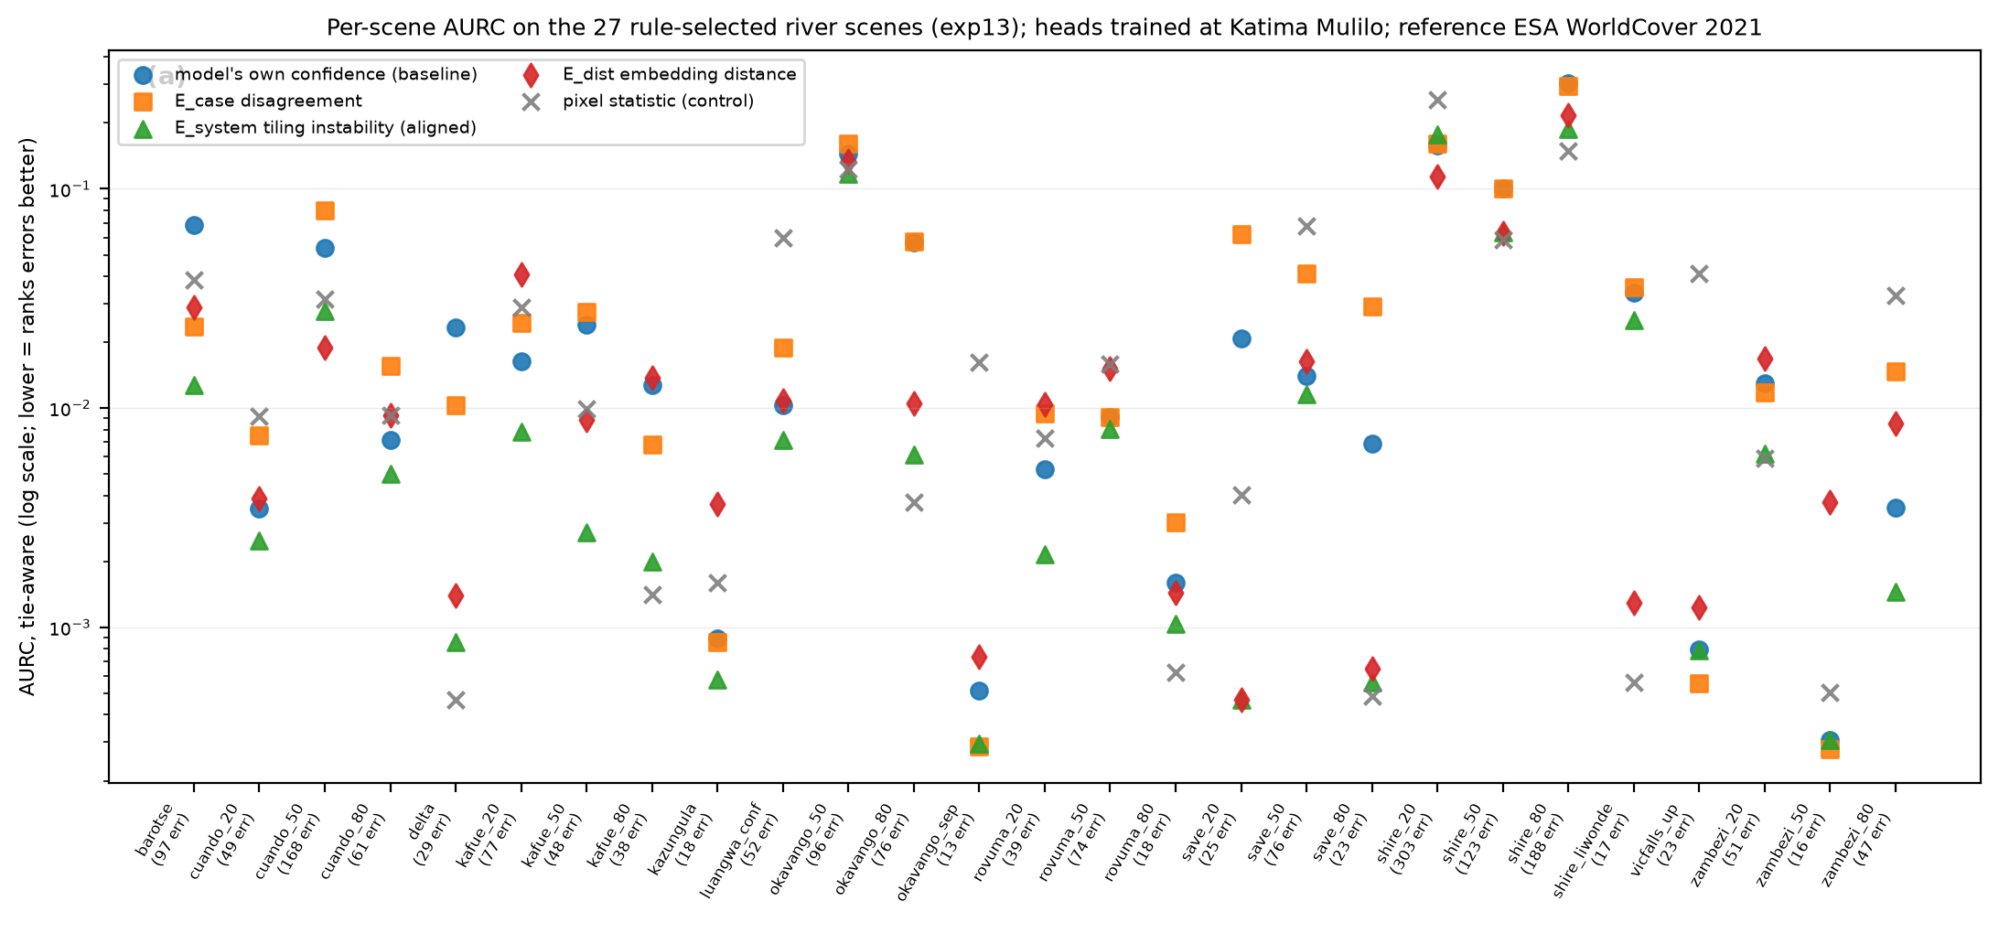
Figure 1. Per-scene tie-aware AURC for the five signals on the 27 rule-selected scenes.
Tiling instability, with the shifted grids aligned, ranks errors better than the model's own confidence on 26 of 27 scenes (p < 0.001; permutation p < 0.001), and better than the pixel control on 18 of 27. Its block-bootstrap interval excludes zero in its favour on 18 scenes and against on 0. It is the best of the five signals on 12 scenes and best or second on 24. The same signal computed without alignment, as in earlier experiments, showed no significant effect (17 of 27); that error is recorded as an erratum.
A boundary ablation (exp14) asked whether the perturbation adds anything beyond proximity to a boundary in the model's own prediction map. A zero-cost indicator, the fraction of a patch's eight neighbours with a different hard label, is statistically indistinguishable from tiling instability across scenes (boundary better on 12, tiling instability on 15, p = 0.701). By itself the indicator beats confidence on 19 of 27 (p = 0.052) and the pixel control on 22 of 27 (p = 0.002). The supported statement is that errors concentrate at the boundaries of the model's own prediction map and that boundary proximity ranks them at least as well as the perturbation, at zero extra inference; the perturbation signal carries the stronger statistical support against confidence.
Cross-model disagreement is not a general signal: better than confidence on 10 of 27 (p = 0.248), with block-bootstrap intervals against it on 9 scenes. It is strong on specific ambiguous scenes, for example the Barotse floodplain, where it also beats the pixel control. Embedding distance shows no scale-free advantage (13 of 27, p = 1.000); a mean-difference permutation test gives p = 0.007 but is carried by a few high-error scenes. The pixel control is the best signal on 9 scenes, which are the scenes where the reference map omits obvious water. Confidence is the best signal on 0 of 27 dense river scenes.
Prepending the map check (E_geo) to boundary proximity does not help: better on 5, worse on 9, unchanged on 13 of 27 scenes (p = 0.424). E_geo flags are 1.5 times as error-enriched as a random patch (pooled precision 0.12 over 413 flags, base error rate 0.081), but 9 scenes carry 1-51 flags at precision zero, where OSM marks a river that both the model and WorldCover call dry. Under this reference, the check mostly detects disagreement between two reference maps; its sensitivity cannot be stated without width-filtered centerlines or expert truth.
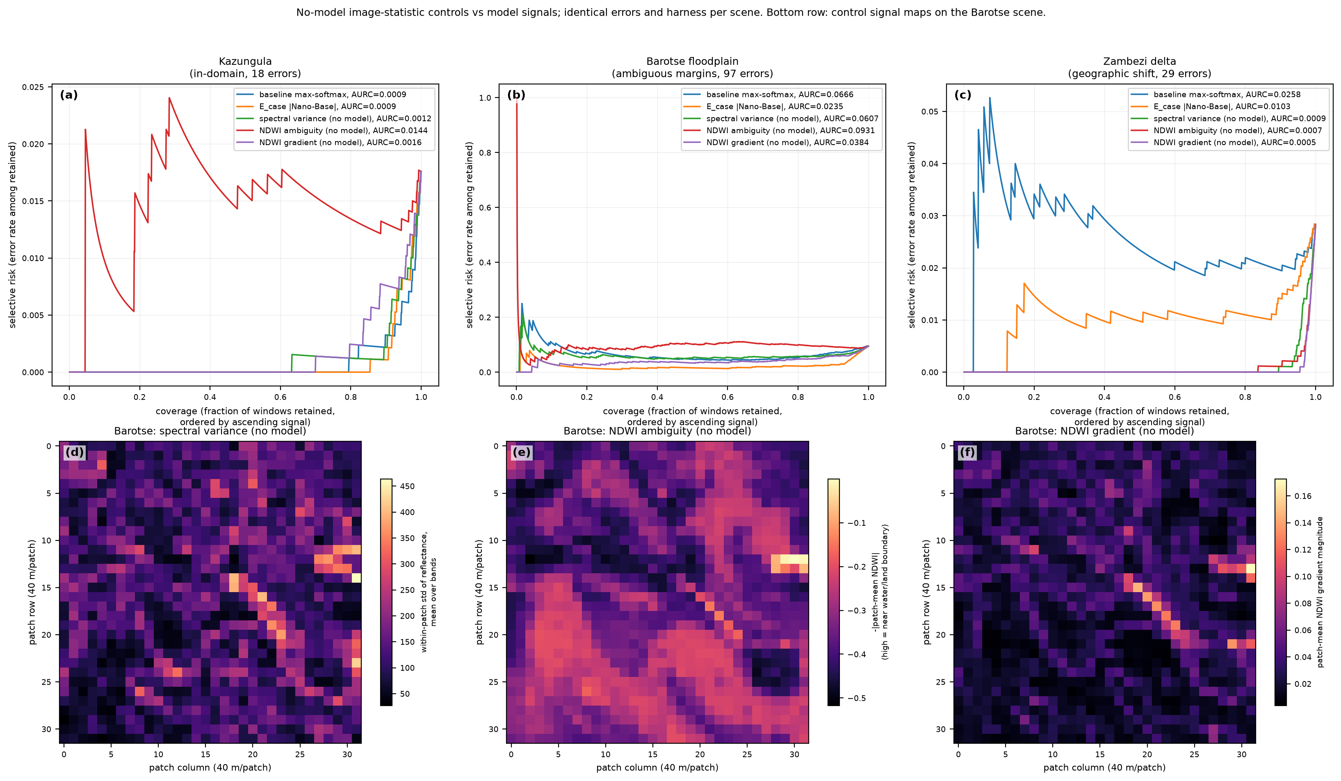
Figure 2. Risk-coverage curves for Kazungula, Barotse and the delta with the no-model controls on the same errors (exp06); bottom row, control signal maps for Barotse.

3.3 Expert labels and model families
On the AWF task (1459 expert-labelled points, twelve-month Sentinel-2 stacks, the project's own spatial split; 63 errors after the loader was corrected to warp the 20 m and 60 m band groups onto the 10 m grid), a linear head on frozen Base embeddings reaches 81.7% (the project's fine-tuned model: 89.5%). There the model's own confidence is the best signal tested (AURC 0.0363 vs 0.0489 for per-window tiling instability, 0.0670 for disagreement, 0.1338 for embedding distance and 0.1658 for a spectral-variability control). The earlier explanation, that point labels carry no boundary context, was tested in exp16 by applying the head densely to every patch of each validation crop: labelled patches are not interior (paired against a random patch of the same map, sign p = ${X.interior.sign_p.toFixed(3)}), and the boundary score is strongly error-associated (Fisher p = ${X.fisher.p.toExponential(0)}), yet it ranks errors worse than confidence (tie-aware AURC ${X.aurc.boundary.toFixed(4)} vs ${X.aurc.baseline.toFixed(4)}; cluster-bootstrap interval on the difference [${X.ci.cluster.boundary.lo.toFixed(4)}, ${X.ci.cluster.boundary.hi.toFixed(4)}]). Conditionally on the logit margin it adds little (likelihood-ratio p = ${X.lrt.p.toFixed(3)}; standardized coefficients ${X.lrt.coef_margin.toFixed(2)} vs ${X.lrt.coef_bnd.toFixed(2)}): with nine classes the argmax flips between neighbours wherever margins are small, so the prediction-boundary score is largely a coarse proxy for low confidence. The explanation is withdrawn; the in-domain result stands.
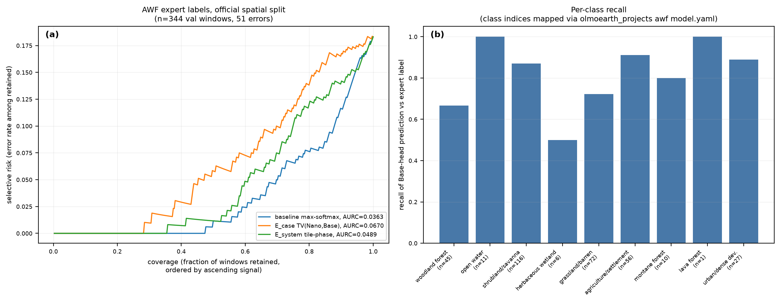
Figure 3. AWF expert-label task (exp04, corrected loader): risk-coverage on the official spatial split and per-class recall.
- A disagreement partner needs uncorrelated errors, not higher accuracy: pairing Base with the stronger v1-Large ranks errors worse than pairing it with Nano (mean AURC 0.0197 vs 0.0129; exp10), and averaging three OlmoEarth models is no better than the best pair (exp03, exp04, exp07). No partner from outside the family has been tested.
- Label-free reliability estimation by Dawid-Skene is invalid within one model family: it inflates every model's accuracy (+0.11, +0.11, +0.06) and inverts their order, because the family errs together (exp07). The inflation gap is a direct measure of correlated error.
- Occluding input patches and measuring instability (exp08) ranks errors worse than every other signal; perturbations that remove content measure context reliance, not error.

4. Audit and corrections
After the experiments, a 204-agent adversarial audit (five finder lenses, three independent skeptics per finding, one synthesis) confirmed 53 findings and refuted 13. The material ones and their corrections: (1) a sign test that scored tied scenes as losses, which had turned 'no benefit' into 'rejected'; (2) an explanation attributing a change in a permutation p-value to excess AURC, which cannot change any paired difference; (3) AURC computed with a stable sort over heavily tied scores, so several numbers depended on raster order; (4) two scenes counted as rule-selected that had entered through a cache import; (5) an AWF loader that stretched the 20 m and 60 m bands instead of georeferencing them; (6) several miscounts and overstatements, including 'equivalent' for a non-significant difference and an enrichment figure computed as an unweighted mean over scenes. All numbers in this report were regenerated from the corrected CSVs by script. The earlier unaligned tiling-instability computation and the withdrawn explanations are recorded as errata in the repository rather than removed.

5. Positioning
Boundary-concentrated error is well known in semantic segmentation and land-cover validation (trimap and Boundary-IoU evaluation; mixed-pixel effects, Foody 2002; Radoux and Bogaert 2017), and ensembles, test-time augmentation, confidence thresholds and embedding-distance monitors are standard practice. What this work adds is the label-free selective-prediction audit protocol for earth-observation probes, with a pre-registered scene rule, no-model controls on every comparison, and a quantified comparison of each signal against the model's own confidence. The signal designs were adapted from LLM hallucination-detection methods, which face the same problem of judging outputs with no reference answer; that lineage is an origin, not a claim of novelty for the mechanisms.

6. Limitations
- The reference on the river scenes is ESA WorldCover 2021 applied to 2024 imagery, and it is least reliable on exactly the interesting terrains; part of what is counted as error is reference error.
- One task family (water), one region (southern African rivers), one training scene, and linear probes rather than the production model.
- 27 scenes with small per-scene error counts; per-scene bootstrap intervals are biased for this rank statistic and are indicative only; cross-scene tests carry the inference.
- The only expert-labelled evidence is a nine-class point-label task; there the boundary score is a proxy for low confidence (exp16), and no dense expert-labelled few-class map has been tested.
- E_geo sensitivity is confounded by disagreement between reference maps.

7. Next
- Test boundary proximity against expert-labelled dense maps, and compute a per-token boundary indicator on the AWF windows so the point-label explanation is tested rather than assumed.
- Add an error-rater model from outside the OlmoEarth family for E_case and Dawid-Skene.
- Replace OSM centerlines with GRWL centerlines filtered by width, then re-measure E_geo precision.
- Extend the harness to comparing two inference results over time (change attribution) on the published LCC product.

