Final Chatbot Design Specification

Introduction
The chatbot I will create will able to book flights and gain information regarding holiday
destinations around the world. It will be enhanced to recognize various type of images and give flight recommendations based on these images. It can be used by a group of people to organize travel locations through the toy world reasoning system. It will be trained on movie dialogue to respond to any questions it is not able to through the rule or similarity based systems, and can derive formulas for prices trends from flight details with reinforcement learning.

Requirements

Chatbot
Get flight prices between two cities given the city names
Get basic information on a city
Get weather information today in a given city
Get flight prices between two cities given the city names and date
Get basic information on airlines
Get weather information on a given date
Set current and desired city to get information without having to retype the name each time

Image classification
Recognise various wildlife subjects
Give flight recommendations based on the recognition

Toy World Reasoning System
Be able to update people’s location through flights they book
Have a logic based system for where people are
Be able to answer various questions about groups of people in different locations

Sequence to Sequence Network Extension
Answer a variety of normal questions without predefined rules trained from movie dialogue to give realistic answers

Reinforcement Learning Extension
Be able to collect data from various travel dates to develop a trend in the data

Individual Modules

Chatbot
The chatbot will be built using the aiml library for the rule based responses. This is the simplest way to create a chat bot however, it is limited by the amount of predefined responses that can be set up, so to add to this, I will be implementing a similarity based system using a bag of words model along with tf/idf and cosine similarity to compare new response to previous defined one, though this differs as the exact match is not needed for the chatbot to reply.

Image Classification
For the image recognition portion of the program, a convolutional neural network will be trained to recognise different wildlife subjects, this will then be linked with the chatbot to gain information about the airline about these places to book flights there.

Toy World Reasoning System
For the reasoning system I will be creating a system that can help the user keep track of travel companions current locations, be able to book flights from one person to another using their names and update this when people do fly to each other. The system will also use logic based rules to answer questions about groups of people, like if there any British people in New Zealand, or are all British people in England.

Sequence to Sequence Network Extension
The sequence to sequence network will be used to speak to the user when no other responses can be generated, this will allow the chatbot to feel more like a human assistant and less like a robot. This part will be implemented using a transformer network as to provide more accurate responses.

Reinforcement Learning Extension
The reinforcement learning will be used to gather data points from various travel dates, it will then be used to derive a formula that maps the flight prices over a given amount of time. It will do this through the deap library using genetic programming.

Flow Chart
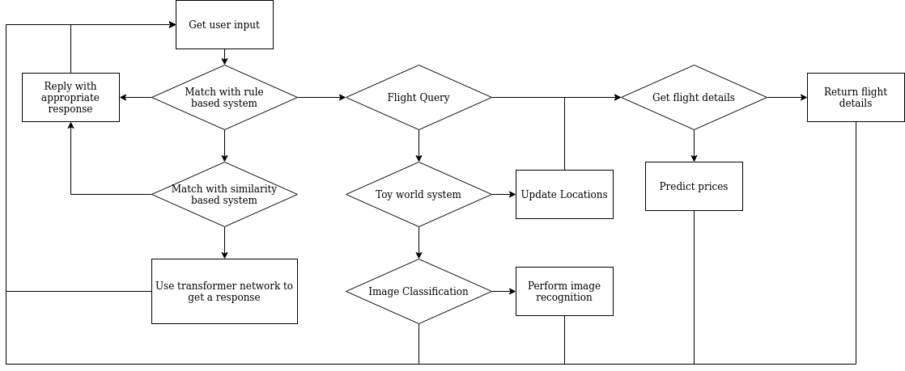

Reflection
This project over all ended up going well, all modules interacted together seamlessly and produced theier required functionality. The domain worked well as it allowed for many of the modules to fit nicely however, the image classification was hard to fit as the initial plan was way out of scope for this program. The transformer network is also one part that could have been improved, though it does give an output to any user question this is normally not relevant and it tended to apologise a lot. Given a chance to do this again, I would try and find a better suited data set. Microsoft had a promising dataset but there was too little time to properly parse and train a model on this. The reinforcement learning turned out a lot better then originally planned though testing it came very close to deriving a function from real world data points. I managed to get a squared error of about 30 at best, this was after about an hour on letting it run and it was still making improvements. Given further fine tuning of the parameters, I think this could get very close to being optimal. The core functionality of the system turned out very well until the API got turned off, it could get updated flight information in a variety of ways, from setting home points to getting any places given and even with the toy world reasoning system it could get flights from person to person. With more time I would improve the image classification to either reconginse more subjects or to reconginse landmarks, I researched this during the image classification and it was a google challenge for $3000 so this sort of functionality with any kind of accuracy was far too difficult for the time given. I would also change the toy world reasoning system, this was the hardest part to fit to my domain, given the chance to do it again I would probably choose a different domain where this could be more accurately applied. If I was to start the whole project again, I would have picked a different domain, though the domain worked very well with the main chatbot, the other components where very hard to fit and finding appropriate datasets was even harder. I would probably go for a movie based system as this had a lot more application and appropriate datasets.

